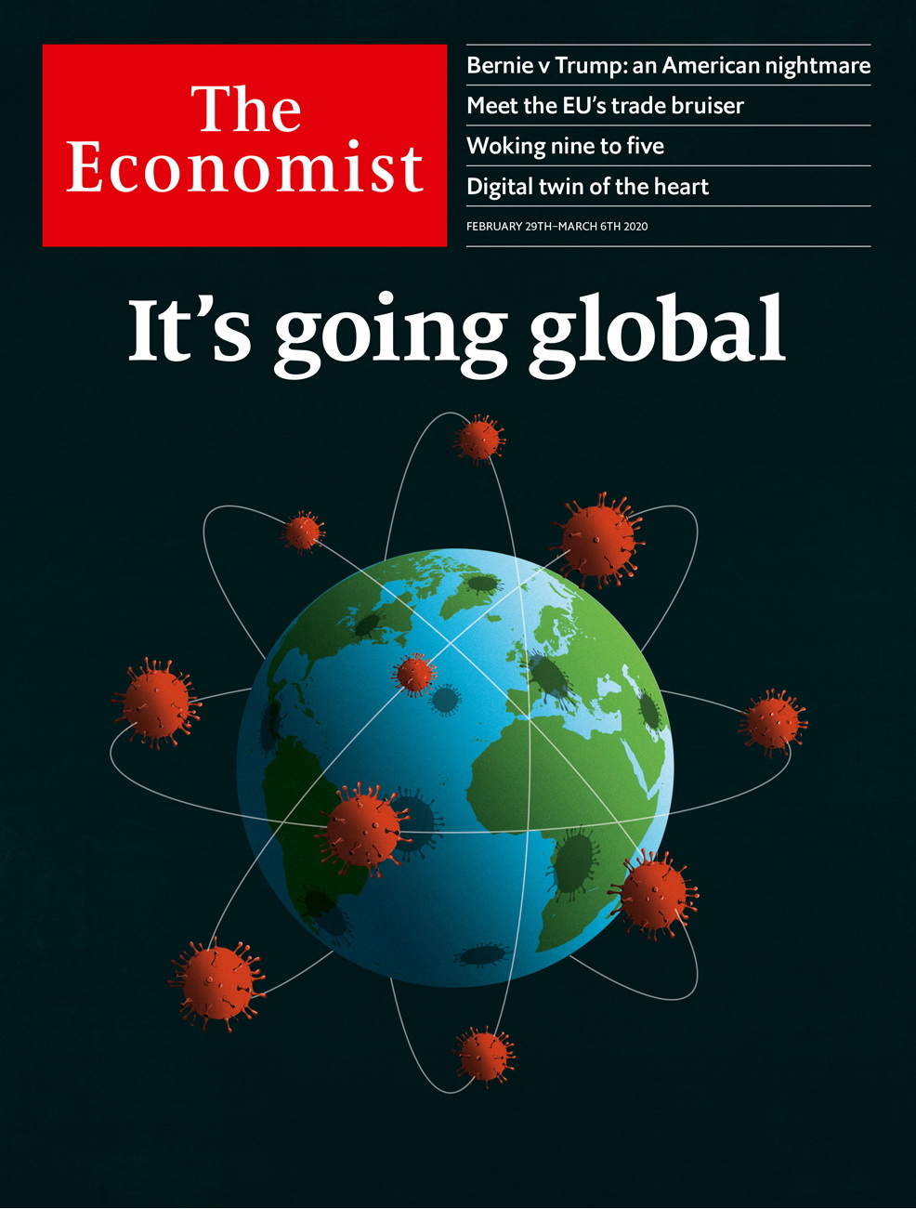

# Table of Contents

The world this week

Politics this week

Business this week

Leaders

Bernie Sanders: America’s nightmare

The pandemic: Going global

The war in Afghanistan: This way out

Argentina and the IMF: New partners, old dance

Free speech at work: Woking nine to five

Letters

Letters to the editor: On companies, gender, Qatar, war, Brexit, committees

Briefing

Covid-19: Flattening the curve

United States

The Democratic primary: That Berning feeling

Harvey Weinstein: Celebrity justice

The Supreme Court: Roberts rules

High-skilled immigration: The invisible wall

Lexington: The primary problem

The Americas

Guyana: An opportunity to score

Carnival in Brazil: Rain delay

Bello: Political theatre

Asia

Afghanistan: Can it be?

Thai politics: Too forward

Political reform in Kazakhstan: Democracy is on its way

Malaysian politics: The old men and the seats

Banyan: The trumpets sound

Japanese abroad: The endangered tourist

Sectarian violence in India: A tale of two neighbourhoods

China

Surveillance technology: Code red

Remote learning: Getting to know your teacher

Chaguan: Globalisation under quarantine

Middle East and Africa

Israeli politics: Take three

Israel: In search of a one-party solution

The death of Hosni Mubarak: A soldier’s tale

South Africa’s budget: Comrade cosmonaut

African trade: Africa’s beef with America

Europe

Extremism in Germany: The threat within

Jean Vanier: Feet of clay

Austria’s Jews: Charity confiscated

Tech in Serbia: Return of the geeks

Italy’s troubled steel factory: Down at heel

Britain

The future of research: The £18bn question

Heathrow: It won’t fly

The politics of pop: Taking back control

Farming after Brexit: A green and poorer land

Barricaded Britain: Beauty or safety?

Shooting ranges: The legal battlefield

Life expectancy: Groundhog day

Menstruation: Scotland’s free periods

Bagehot: The man who dares to be dull

International

Speech at work: None of your business

Business

ASML: Industrial light and magic

Luxury goods: Unbedevilling Prada

Social networks: A friendly portrait

Bartleby: When rank leads to rancour

Diversity in America Inc: The benefits of being bold

Oil in North America: Of tar sands and shale beds

Schumpeter: Bob Iger’s magic kingdom

Finance and economics

Covid-19 and market turmoil: Spread and stutter

Covid-19 and China’s economy: Marching orders

Buttonwood: Benchmark blues

Americans’ personal finances: Land of the frugal

The information economy: Data, data everywhere

European Union trade: Hulk Hogan

Who wants to run a bank?: Bank bosses in Europe

Free exchange: Motive power

Science and technology

Cardiology: The heart’s digital twin

Armed forces: War on attrition

Planetology: Beneath the surface

Defending delivery drones: Incoming!

Geomythology: Fossilised folk tales

Books and arts

Thomas Cromwell, special adviser: The bedchamber and the axe

Photography and memory: Out of shot

Lincoln’s second inaugural: Immortal words

Johnson: Double-take

Graphic detail

Football and inequality: A game of two halves

Obituary

Katherine Johnson: The girl who asked questions

Economic Indicators

Economic data, commodities and markets



### Friday, February 28, 2020

|  |  |
| --- | --- |
| The world this week | 3 |
| Leaders | 5 |
| Letters | 1 |
| Briefing | 1 |
| United States | 5 |
| The Americas | 3 |
| Asia | 7 |
| China | 3 |
| Middle East and Africa | 5 |
| Europe | 5 |
| Britain | 9 |
| International | 1 |
| Business | 8 |
| Finance and economics | 8 |
| Science and technology | 5 |
| Books and arts | 4 |
| Graphic detail | 1 |
| Obituary | 1 |
| Economic Indicators | 1 |

|  |  |  |
| --- | --- | --- |
|  | Sections | Leaders |

The world this week

Politics this week

.

Business this week

.

|  |  |  |
| --- | --- | --- |
|  | Sections | Leaders |

|  |  |  |  |
| --- | --- | --- | --- |
|  | Articles | Sections | Next |

# Politics this week

Feb 29th 2020 |

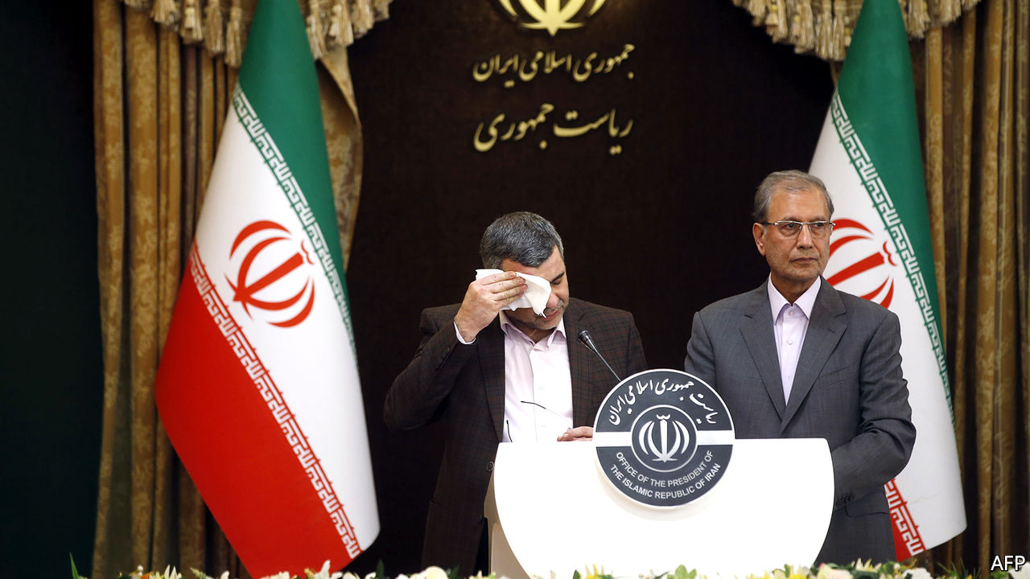

The WHO said that most new cases of covid-19, a novel type of coronavirus, are now being reported outside China. The number of cases surged in South Korea; Italy recorded hundreds of infections, more than in any country outside Asia; and there were worries that Iran was underreporting the spread of the epidemic within its borders. Iran’s deputy health minister tested positive for the disease. See article.

China postponed the annual sessions of its rubber-stamp parliament because of concerns about the outbreak of covid-19. The meetings had been due to start in Beijing in March and involve thousands of delegates. Despite a fall in the daily numbers of new cases in China, Xi Jinping, the president, said the epidemic was “still grim and complex”.

A Chinese court sentenced Gui Minhai, the co-owner of a bookshop in Hong Kong that sold gossipy works about China’s leaders, to ten years in prison for “illegally providing intelligence overseas”. Mr Gui is a Swedish citizen who is also claimed by China as its national. His detention has fuelled widespread alarm in Hong Kong about the erosion of political freedoms.

Mahathir Mohamad resigned as prime minister of Malaysia, after his own party, Bersatu, decided to leave the ruling coalition. He remains in office as a caretaker. Anwar Ibrahim, his long-time rival and leader of Parti Keadilan Rakyat, the biggest party in the coalition, has put himself forward as a replacement. It is unclear whether either man has the support of most MPs. See [article](https://www.economist.com/node/21780776).

The Afghan army, the insurgents of the Taliban and NATO forces all pledged to observe a week-long “reduction in violence” in Afghanistan’s civil war. If it holds until February 28th, America and the Taliban will sign a peace deal in Qatar on February 29th. See [article](https://www.economist.com/node/21780756).

Thailand’s constitutional court disbanded Future Forward, the country’s third-biggest political party, and banned its leaders from politics. It is the eighth party the court has dissolved since 2006. See article.

Narendra Modi, the prime minister of India, summoned a crowd of hundreds of thousands to cheer for Donald Trump. But the American president’s visit was marred by communal riots in Delhi, which claimed 33 lives. See article.

Taur Matan Ruak, the prime minister of East Timor, resigned after parliament voted down his budget. The president must now decide whether to name another prime minister or call elections.

## Foreign policymaking

Boris Johnson, Britain’s prime minister, announced a wide-ranging review of the country’s place in the world post-Brexit that seeks “innovative ways” to push overseas interests. Outside experts will be used to challenge “traditional Whitehall assumptions”, a nod to Dominic Cummings, Mr Johnson’s powerful special adviser, who has clashed with civil servants. Mr Cummings has criticised waste in the Ministry of Defence.

Sajid Javid, who resigned as Britain’s chancellor of the exchequer after a skirmish with Mr Cummings, attacked a move to align the Treasury more closely with thinking in the prime minister’s office. Mr Javid said that this was not in the national interest.

The race to be the next leader of Germany’s ruling Christian Democrats, and probable chancellor after Angela Merkel quits next year, now has only three runners. Armin Laschet, the premier of North Rhine-Westphalia, got a big boost when Jens Spahn, the up-and-coming federal health minister, said he would not contest the race, but would support him instead.

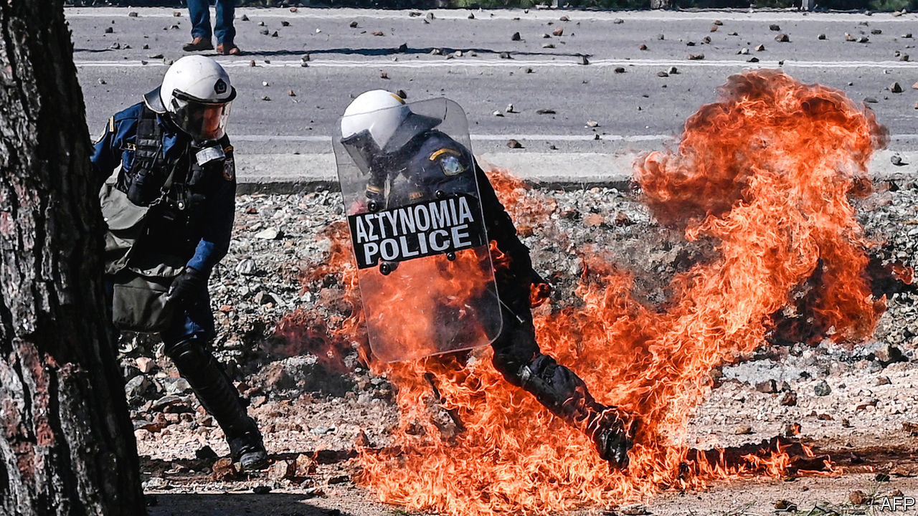

Residents of the Greek islands of Lesbos and Chios fought with riot police in an attempt to stop an expansion of detention camps to house more migrants arriving mostly from the Middle East via Turkey.

## Degrees of brutality

Hosni Mubarak, who ruled Egypt for three decades, died. The former despot was toppled during the Arab spring of 2011, amid protests over poverty and his repressive rule. He faced trial for corruption and murder, but mostly avoided punishment. Many Egyptians expressed nostalgia for Mr Mubarak, who ruled with a lighter touch than the current dictator, Abdel-Fattah al-Sisi. See article.

Hardliners won parliamentary elections in Iran, scooping three-quarters of the seats. The regime claimed a mandate for its confrontational stance towards America. But thousands of moderates and reformers were barred from running and, as a result, turnout was the lowest in a parliamentary election since the Islamic revolution in 1979. See [article](https://www.economist.com/middle-east-and-africa/2020/02/24/the-iranian-regime-risks-exacerbating-the-outbreak-of-covid-19).

Faure Gnassingbé, the president of Togo, won another term in an election marred by irregularities. Mr Gnassingbé has been in office since 2005, when he took over from his father, who had first seized power in 1967.

## The police in a state

A strike by police in Ceará, in north-eastern Brazil, led to a sharp rise in the number of murders in the state. At least 170 people have died since police stopped work on February 19th in a row over pay. A senator, Cid Gomes, was shot as he drove a digger towards striking police. The government has sent in the army.

Protests by police in Haiti against poor working conditions led to battles between them and the army. At least one soldier died. The country’s Carnival celebration was cancelled.

Bolivia’s Supreme Electoral Tribunal barred Evo Morales, a former president, from running for a seat in the Senate in elections due in May. Mr Morales left office in November after Bolivians protested against his re-election.

## Her day in court

Harvey Weinstein was found guilty of two of the charges brought against him in New York: of rape (by having sex with a woman against her will) and of forcing oral sex on a woman. He was acquitted of three charges, including the most serious. Scores of other women have accused him of sexual misconduct. See article.

The latest Democratic debate produced the usual fireworks. It was the last to be held before the South Carolina primary and Super Tuesday, when Democrats in 14 states will vote on who they want to be their presidential candidate. Bernie Sanders remains the firm favourite following his decisive win in Nevada. See article.

Meanwhile, it was reported that Russia is meddling in the primaries to get Mr Sanders elected, and is also stepping up plans to interfere in the general election to re-elect Donald Trump. So it is a win-win situation for the Kremlin if either Mr Sanders or Mr Trump is victorious in November. See article.

This article was downloaded by calibre from <https://www.economist.com/the-world-this-week/2020/02/29/politics-this-week>

|  |  |  |  |
| --- | --- | --- | --- |
|  | Articles | Sections | Next |

|  |  |  |  |
| --- | --- | --- | --- |
| Previous | Articles | Sections | Next |

# Business this week

Feb 29th 2020 |

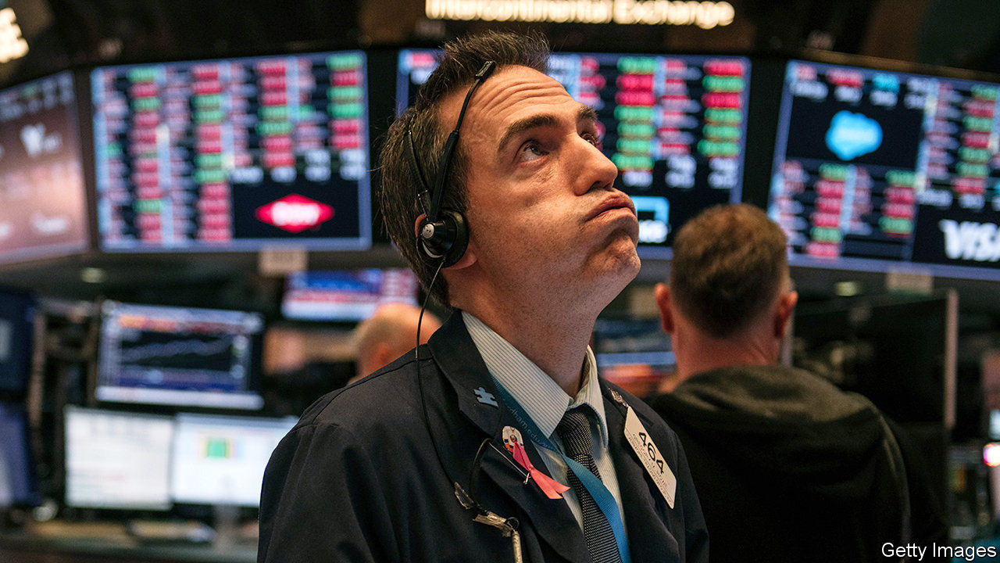

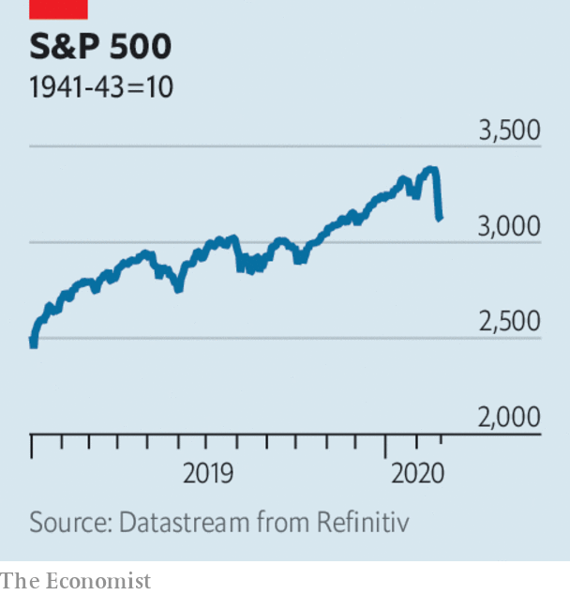

Global markets had a turbulent week amid heightened concern about the economic impact of the coronavirus outbreak. The S&P 500 index dropped by 3.4% in a day, its worst daily performance in two years; over a week it was down by 8% from the record high it had recently attained. Stockmarkets in Europe and Japan also swooned. As investors piled into safe assets, the yield on the ten-year US Treasury bond closed at its lowest-ever point. The VIX index, a measure of stockmarket volatility, spiked to its highest level in two years. See article.

Oil prices also fell sharply, as the coronavirus led forecasters to lower their projections for demand sharply. Brent crude traded below $53 a barrel, a big dip from the almost $70 it had reached at the start of the year. Curtailed travel because of the outbreak could cost the airline industry alone $29bn in lost revenue, according to one estimate.

A long list of companies warned about the impact of coronavirus on their business, including Microsoft, Anheuser-Busch InBev and Rio Tinto. The latter is a big provider of iron ore to China, where dozens of blast furnaces have been closed because of restrictions on movement.

Wells Fargo agreed to pay $3bn to settle with America’s Department of Justice and Securities and Exchange Commission over a mis-selling scandal. Between 2002 and 2016 thousands of employees at the bank who were under pressure to meet sales targets created millions of fake accounts for customers. The scandal dented the image of Wells Fargo, one of the few banks to emerge from the financial crisis with its reputation intact.

Mexico’s GDP shrank by 0.1% in 2019, the first full year in power for President Andrés Manuel López Obrador. Mr López Obrador came to office promising to turbocharge growth through a mixture of spending and investment, but last year was the economy’s worst performance in a decade. The central bank cut its forecast for growth this year. See article.

Sales from recorded music in America hit $11bn last year, the most in over a decade, though still some way short of the $14.6bn chalked up in 1999, when CDs ruled the charts. Four-fifths of music revenue now comes from streaming.

## The incredible journey

Although he has announced and then delayed his departure four times as Disney’s chief executive, Bob Iger took markets, and employees, by surprise when he stepped down from the job with immediate effect. After taking the reins in 2005 Mr Iger expanded Disney’s content catalogue by acquiring several film studios (culminating in 21st Century Fox last year), turning Disney into an entertainment behemoth. Mr Iger is staying on as executive chairman until 2021 to focus on the creative side of the business. Bob Chapek, the new CEO, fresh from running Disney’s theme parks, will report to Mr Iger. See article.

HP said it was “reaching out” to Xerox to explore whether a combination of the two companies would be in shareholders’ interests. But it also announced a $15bn share buy-back plan, almost half its market value, complicating the path for such a tie-up. Xerox has gone hostile in its $35bn takeover bid for the computer- and-printer maker.

In his annual letter to shareholders, Warren Buffett defended the investment strategy of Berkshire Hathaway, his holding company, which straddles insurance, stockmarket bets and industrial activities. Last year Berkshire’s share price recorded its worst performance set against the broader market in a decade. Still, it made a net profit of $81.4bn (mostly because of a change in accounting rules). Separately, Mr Buffett, a famous technophobe, revealed that he has started to use an iPhone, though only for calls. See [article](https://www.economist.com/business/2020/02/29/untangling-warren-buffetts-unique-firm).

A measure that would compel Apple to consider rights to freedom of expression in its dealings with China was backed by 40% of shareholders present at a meeting. A similar item had been voted on before but drew little support; investors today seem more eager to push companies to take up purpose-driven agendas.

## Just bag it and go

Amazon opened its first Go supermarket, which has no cashiers, simply charging customers through an app for items they have taken from shelves fitted with sensors. The supermarket in Seattle builds on technology used in two dozen convenience stores that Amazon operates. Teething problems include accurately weighing fruit and vegetables. Shoppers must put a product back in its correct place if they do not want to be charged for it, a potential nightmare for those who have enough trouble dealing with self-checkout machines.

Volkswagen’s boss said he was looking to employ a young green activist who can push the board to take a more aggressive stance against climate change. Sounds like an ideal job for Greta Thunberg.

This article was downloaded by calibre from <https://www.economist.com/the-world-this-week/2020/02/29/business-this-week>

|  |  |  |  |
| --- | --- | --- | --- |
| Previous | Articles | Sections | Next |

|  |  |  |
| --- | --- | --- |
| The world this week | Sections | Letters |

Leaders

Bernie Sanders: America’s nightmare

.

The pandemic: Going global

.

The war in Afghanistan: This way out

.

Argentina and the IMF: New partners, old dance

.

Free speech at work: Woking nine to five

.

|  |  |  |
| --- | --- | --- |
| The world this week | Sections | Letters |

|  |  |  |  |
| --- | --- | --- | --- |
|  | Articles | Sections | Next |

#### America’s nightmare

# Bernie Sanders, nominee

The senator from Vermont would present America with a terrible choice

Feb 27th 2020 |

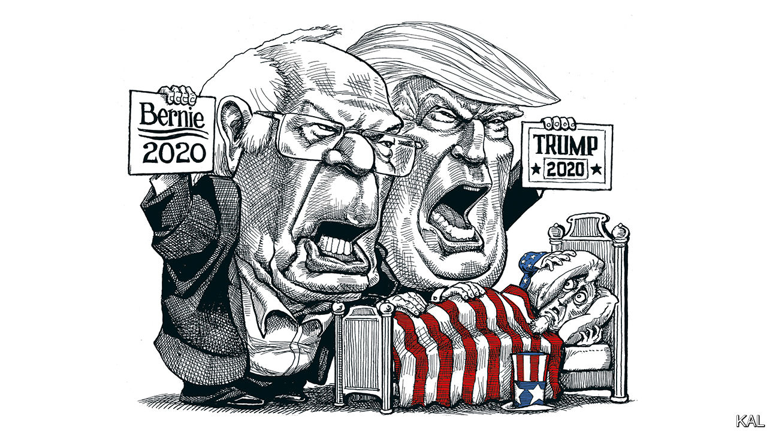

SOMETIMES PEOPLE wake from a bad dream only to discover that they are still asleep and that the nightmare goes on. This is the prospect facing America if, as seems increasingly likely, the Democrats nominate Bernie Sanders as the person to rouse America from President Donald Trump’s first term. Mr Sanders won the primary in New Hampshire, almost won in Iowa, trounced his rivals in Nevada and is polling well in South Carolina. Come Super Tuesday next week, in which 14 states including California and Texas allot delegates, he could amass a large enough lead to make himself almost impossible to catch.

Moderate Democrats worry that nominating Mr Sanders would cost them the election. This newspaper worries that forcing Americans to decide between him and Mr Trump would result in an appalling choice with no good outcome. It will surprise nobody that we disagree with a self-described democratic socialist over economics, but that is just the start. Because Mr Sanders is so convinced that he is morally right, he has a dangerous tendency to put ends before means. And, in a country where Mr Trump has whipped up politics into a frenzy of loathing, Mr Sanders’s election would feed the hatred.

On economics Mr Sanders is misunderstood. He is not a cuddly Scandinavian social democrat who would let companies do their thing and then tax them to build a better world. Instead, he believes American capitalism is rapacious and needs to be radically weakened. He puts Jeremy Corbyn to shame, proposing to take 20% of the equity of companies and hand it over to workers, to introduce a federal jobs-guarantee and to require companies to qualify for a federal charter obliging them to act for all stakeholders in ways that he could define. On trade, Mr Sanders is at least as hostile to open markets as Mr Trump is. He seeks to double government spending, without being able to show how he would pay for it. When unemployment is at a record low and nominal wages in the bottom quarter of the jobs market are growing by 4.6%, his call for a revolution in the economy is an epically poor prescription for what ails America.

In putting ends before means, Mr Sanders displays the intolerance of a Righteous Man. He embraces perfectly reasonable causes like reducing poverty, universal health care and decarbonising the economy, and then insists on the most unreasonable extremes in the policies he sets out to achieve them. He would ban private health insurance (not even Britain, devoted to its National Health Service, goes that far). He wants to cut billionaires’ wealth in half over 15 years. A sensible ecologist would tax fracking for the greenhouse gases it produces. To Mr Sanders that smacks of a dirty compromise: he would ban it outright.

Sometimes even the ends are sacrificed to Mr Sanders’s need to be righteous. Making university cost-free for students is a self-defeating way to alleviate poverty, because most of the subsidy would go to people who are, or will be, relatively wealthy. Decriminalising border-crossing and breaking up Immigration and Customs Enforcement would abdicate one of the state’s first duties. Banning nuclear energy would stand in the way of his goal to create a zero-carbon economy.

So keenly does Mr Sanders fight his wicked rivals at home, that he often sympathises with their enemies abroad. He has shown a habit of indulging autocrats in Cuba and Nicaragua, so long as the regime in question claims to be pursuing socialism. He is sceptical about America wielding power overseas, partly from an honourable conviction that military adventures do more harm than good. But it also reflects his contempt for the power-wielders in the Washington establishment.

Last is the effect of a President Sanders on America’s political culture. The country’s political divisions helped make Mr Trump’s candidacy possible. They are now enabling Mr Sanders’s rise. The party’s leftist activists find his revolution thrilling. They have always believed that their man would triumph if only the neoliberal Democratic Party elite would stop keeping him down. His supporters seem to reserve almost as much hatred for his Democratic opponents as they do for Republicans.

This speaks to Mr Sanders’s political style. When faced with someone who disagrees with him, his instinct is to spot an establishment conspiracy, or to declare that his opponent is confused and will be put straight by one of his political sermons. When asked how he would persuade Congress to eliminate private health insurance (something which 60% of Americans oppose), Mr Sanders replies that he would hold rallies in the states of recalcitrant senators until they relented.

A presidency in which Mr Sanders travelled around the country holding rallies for a far-left programme that he could not get through Congress would widen America’s divisions. It would frustrate his supporters, because the president’s policies would be stymied by Congress or the courts. On the right, which has long been fed a diet of socialist bogeymen, the spectacle of an actual socialist in the White House would generate even greater fury. Mr Sanders would test the proposition that partisanship cannot get any more bitter.

The mainstream three-quarters of Democrats have begun to tell themselves that Mr Sanders would not be so bad. Some point out that he would not be able to do many of the things he promises. This excuse-making, with its implication that Mr Sanders should be taken seriously but not literally, sounds worryingly familiar. Mr Trump has shown that control of the regulatory state, plus presidential powers over trade and over foreign policy, give a president plenty of room for manoeuvre. His first term suggests that it is unwise to dismiss what a man seeking power says he wants to do with it.

## Enter Sandersman

If Mr Sanders becomes the Democratic nominee, America will have to choose in November between a corrupt, divisive, right-wing populist, who scorns the rule of law and the constitution, and a sanctimonious, divisive, left-wing populist, who blames a cabal of billionaires and businesses for everything that is wrong with the world. All this when the country is as peaceful and prosperous as at any time in its history. It is hard to think of a worse choice. Wake up, America! ■

Dig deeper:  
Sign up and listen to Checks and Balance, our new [newsletter](https://www.economist.com/checksandbalance/) and [podcast](https://www.economist.com/podcasts/2020/02/21/checks-and-balance-our-new-weekly-podcast-on-american-politics) on American politics

This article was downloaded by calibre from <https://www.economist.com/leaders/2020/02/27/bernie-sanders-nominee>

|  |  |  |  |
| --- | --- | --- | --- |
|  | Articles | Sections | Next |

|  |  |  |  |
| --- | --- | --- | --- |
| Previous | Articles | Sections | Next |

#### The pandemic

# The virus is coming

Governments have an enormous amount of work to do

Feb 27th 2020 |



IN PUBLIC HEALTH, honesty is worth a lot more than hope. It has become clear in the past week that the new viral disease, covid-19, which struck China at the start of December will spread around the world. Many governments have been signalling that they will stop the disease. Instead, they need to start preparing people for the onslaught.

Officials will have to act when they do not have all the facts, because much about the virus is unknown. A broad guess is that 25-70% of the population of any infected country may catch the disease. China’s experience suggests that, of the cases that are detected, roughly 80% will be mild, 15% will need treatment in hospital and 5% will require intensive care. Experts say that the virus may be five to ten times as lethal as seasonal flu, which, with a fatality rate of 0.1%, kills 60,000 Americans in a bad year. Across the world, the death toll could be in the millions.

If the pandemic is like a very severe flu, models point to global economic growth being two percentage points lower over 12 months, at around 1%; if it is worse still, the world economy could shrink. As that prospect sank in during the week, the S&P 500 fell by 8% (see article).

Yet all those outcomes depend greatly on what governments choose to do, as China shows. Hubei province, the origin of the epidemic, has a population of 59m. It has seen more than 65,000 cases and a fatality rate of 2.9%. By contrast, the rest of China, which contains 1.3bn people, has suffered fewer than 13,000 cases with a fatality rate of just 0.4%. Chinese officials at first suppressed news of the disease, a grave error that allowed the virus to take hold. But even before it had spread much outside Hubei, they imposed the largest and most draconian quarantine in history. Factories shut, public transport stopped and people were ordered indoors. This raised awareness and changed behaviour. Without it, China would by now have registered many millions of cases and tens of thousands of deaths.

The World Health Organisation was this week full of praise for China’s approach. That does not, however, mean it is a model for the rest of the world. All quarantines carry a cost—not just in lost output, but also in the suffering of those locked away, some of whom forgo medical treatment for other conditions. It is still too soon to tell whether this price was worth the gains. As China seeks to revive its economy by relaxing the quarantine, it could well be hit by a second wave of infections. Given that uncertainty, few democracies would be willing to trample over individuals to the extent China has. And, as the chaotic epidemic in Iran shows, not all authoritarian governments are capable of it.

Yet even if many countries could not, or should not, exactly copy China, its experience holds three important lessons—to talk to the public, to slow the transmission of the disease and to prepare health systems for a spike in demand.

A good example of communication is America’s Centres for Disease Control, which issued a clear, unambiguous warning on February 25th. A bad one is Iran’s deputy health minister, who succumbed to the virus during a press conference designed to show that the government is on top of the epidemic.

Even well-meaning attempts to sugarcoat the truth are self-defeating, because they spread mistrust, rumours and, ultimately, fear. The signal that the disease must be stopped at any cost, or that it is too terrifying to talk about, frustrates efforts to prepare for the virus’s inevitable arrival. As governments dither, conspiracy theories coming out of Russia are already sowing doubt, perhaps to hinder and discredit the response of democracies.

The best time to inform people about the disease is before the epidemic. One message is that fatality is correlated with age. If you are over 80 or you have an underlying condition you are at high risk; if you are under 50 you are not. Now is the moment to persuade the future 80% of mild cases to stay at home and not rush to a hospital. People need to learn to wash their hands often and to avoid touching their face. Businesses need continuity plans, to let staff work from home and to ensure a stand-in can replace a vital employee who is ill or caring for a child or parent. The model is Singapore, which learned from SARS, another coronavirus, that clear, early communication limits panic.

China’s second lesson is that governments can slow the spread of the disease. Flattening the spike of the epidemic means that health systems are less overwhelmed, which saves lives. If, like flu, the virus turns out to be seasonal, some cases could be delayed until next winter, by which time doctors will understand better how to cope with it. By then, new vaccines and antiviral drugs may be available.

When countries have few cases, they can follow each one, tracing contacts and isolating them. But when the disease is spreading in the community, that becomes futile. Governments need to prepare for the moment when they will switch to social distancing, which may include cancelling public events, closing schools, staggering work hours and so on. Given the uncertainties, governments will have to choose how draconian they want to be. They should be guided by science. International travel bans look decisive, but they offer little protection because people find ways to move. They also signal that the problem is “them” infecting “us”, rather than limiting infections among “us”. Likewise, if the disease has spread widely, as in Italy and South Korea, “Wuhan-lite” quarantines of whole towns offer scant protection at a high cost.

## Scrub up

The third lesson is to prepare health systems for what is to come. That entails painstaking logistical planning. Hospitals need supplies of gowns, masks, gloves, oxygen and drugs. They should already be conserving them. They will run short of equipment, including ventilators. They need a scheme for how to set aside wards and floors for covid-19 patients, for how to cope if staff fall ill, and for how to choose between patients if they are overwhelmed. By now, this work should have been done.

This virus has already exposed the strengths and weaknesses of China’s authoritarianism. It will test all the political systems with which it comes into contact, in both rich and developing countries. China has bought governments time to prepare for a pandemic. They should use it. ■

This article was downloaded by calibre from <https://www.economist.com/leaders/2020/02/27/the-virus-is-coming>

|  |  |  |  |
| --- | --- | --- | --- |
| Previous | Articles | Sections | Next |

|  |  |  |  |
| --- | --- | --- | --- |
| Previous | Articles | Sections | Next |

#### The war in Afghanistan

# America and the Taliban have struck a deal

Now for the hard part

Feb 29th 2020 |

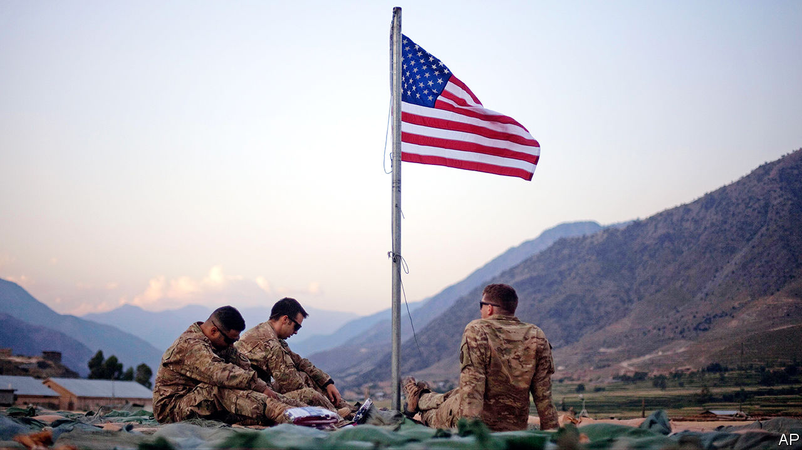

AFGHANISTAN HAS been at war for more than 40 years—longer than most of the world’s population has been alive. America and the insurgents of the Taliban have been battling for close to 19 years, making the conflict the longest America has ever fought. Some 2,500 American soldiers have died. The direct cost to American taxpayers is approaching $1trn. For Afghans, the toll is much higher. Roughly 3,500 civilians die every year, and their ravaged country is the poorest in Asia.

It can be only a good thing, therefore, that America and the Taliban plan to sign a peace agreement on Leap Day (February 29th), provided relative calm prevails until then. America will undertake to send home most of its 12,000 troops in Afghanistan. In exchange, the Taliban will promise not to grant sanctuary to foreign terror groups such as al-Qaeda, and to begin talks with Afghan politicians that will bring an end to the civil war (see [article](https://www.economist.com/node/21780756)).

This arrangement is far from perfect, in lots of ways. America could not force the Taliban to end hostilities altogether before the signing of the deal. Either because central commanders cannot control their disparate fighters or because they are unwilling to, the best the insurgents would offer was a “significant” reduction in violence. In addition, nobody can be sure what will emerge from the inter-Afghan talks. Elements of the liberal democracy that America attempted to build in Afghanistan are bound to be dismantled. By making peace with the Taliban on such woolly terms, America is in effect conceding that it cannot win the war, and that the very group that sheltered Osama bin Laden and repressed Afghans with a brutal form of Islamic government should once again have a big say in how the country is run.

Such a humiliation will be worth it as long as bloodshed decreases and the lot of ordinary Afghans improves. That, in turn, depends on the seriousness and sincerity of all involved. Many fear that the Taliban are feigning interest in peace, and intend to seize control of the government by gun or guile as soon as the GIs are gone. Others fear that President Donald Trump doubts the Taliban’s trustworthiness, too, but is pushing on regardless so as to secure a foreign-policy “victory” to burnish his re-election campaign. The entire peace agreement, by this interpretation, is a figleaf to disguise an abject American surrender.

That would not just be the crowning humiliation for America; it would consign Afghanistan to even greater misery. The civil war would intensify, as regional powers sought to take advantage of America’s absence by funnelling arms to their Afghan allies. And the Taliban could revert to their old ways, barring girls from school, banning music, stoning adulterers and so on.

The peace agreement tries to guard against such a dismal outcome by stringing out America’s departure. The withdrawal will stop, America’s generals insist, if the Taliban appear to be taking them for a ride. America will keep warplanes in Afghanistan during the talks, to support government forces if the Taliban resume the offensive.

The deterrent has to be credible for this week’s agreement to have any value. Mr Trump’s last-minute disavowal of a previous version of the accord may have helped, by showing that he is not prepared to accept peace on any terms. But even on its way out, America will have to maintain an active role in Afghan politics to see the inter-Afghan talks to a fruitful end. At the moment, it is not clear who leads the government: two candidates have claimed the job of president after a disputed election. America will not only have to knock heads to get civilian politicians to present a vaguely united front, but also cajole them to give the Taliban concessions that they have been hoping to avoid.

The signing of the peace accord, in short, is more of a beginning than an end. It does at least put an end in sight. But America will have to stick to its guns if it is to have any hope of persuading the Taliban to lay down theirs. ■

This article was downloaded by calibre from <https://www.economist.com/leaders/2020/02/29/america-and-the-taliban-have-struck-a-deal>

|  |  |  |  |
| --- | --- | --- | --- |
| Previous | Articles | Sections | Next |

|  |  |  |  |
| --- | --- | --- | --- |
| Previous | Articles | Sections | Next |

#### Debt negotiations

# The IMF tells Argentina’s creditors some harsh truths

The country’s debt is unsustainable, its creditors will take a hit, and the government needs a new IMF deal

Feb 29th 2020 |



THEY MIGHT not admit it, but Argentina and the IMF have things in common. Both are under new management. President Alberto Fernández took office in December, two months after Kristalina Georgieva became head of the fund. Both leaders want to clean up the mess they inherited. Argentina has failed to prosper after decades of debt-binges. The IMF has repeatedly bailed it out. The most recent, botched, rescue in 2018 was the 21st time it has become entangled in the country. Now talks are under way to sort out Argentina’s finances once again. At stake are the prospects of 45m Argentines, a mountain of money and the credibility of Ms Georgieva’s mission to reinvent the IMF.

The IMF is Argentina’s biggest creditor, holding $44bn of the $100bn-odd wad of foreign-law debt that Argentina wants to renegotiate. Last week the fund made clear that the country’s debt is unsustainable. Borrowing is approaching 90% of GDP. The country is reeling from the plunge in the peso, shrivelling reserves and a bitter recession. The belt-tightening required to repay all the debts was neither “economically nor politically feasible”, the fund said.

The easy bit that follows from this—which both Argentina and the IMF agree on—is beating up private creditors, who over the years have been as credulous as voters and the IMF’s technocrats. In 2017, for example, they piled into newly issued 100-year Argentine sovereign bonds that are now worth only 43 cents on the dollar. The government is expected to make a formal proposal for a debt restructuring next month. Some creditors grumble that the IMF should share more of the pain and take a big write-down, too. But the fund’s job is to lend when others will not. It is therefore entitled to insist on being repaid even when others are not. If it succeeds, the restructuring should lead to reductions in debt principal and interest costs worth perhaps 10-20% of GDP

Argentina will still need a new IMF loan to help repay the old one. But it has ruled out entering the kind of special programme the IMF has traditionally reserved for countries that are chronically incapable of living within their means. In the past these programmes have involved long-term loans, but also bossy demands for austerity at home. Instead Argentina has been lobbying the fund and G7 finance ministers for a cuddlier approach that prioritises growth. This chimes with Ms Georgieva’s ambitions to remake the IMF: instead of being the hard-nosed enforcer of global finance, she wants it to do more to help poor countries grow in the long run.

The trouble is that plenty of Argentine governments, investors and IMF staffers have counted on growth to restore Argentina’s health only to be disappointed. The IMF should avoid imposing needless humiliation or suffering on Argentina but it must also avoid indulging any delusions that it will suddenly become a thriving tiger economy.

Ms Georgieva should take a twin-track approach. First, instead of making numerous detailed demands, the fund should merely set a few hard targets for the budget deficit and inflation and let the government work out how to achieve them: by growing faster if possible, and if not, then by belt-tightening. Second, the fund should provide candid advice. Inflation, which exceeds 50% a year, cannot be tamed only through price-controls and arm-twisting the labour unions. Argentina’s growth prospects would be improved if the government spent less on pensions, civil servants and energy subsidies and more on investment. Growth would benefit if taxation were friendlier to exports and labour laws were less inimical to hiring. If both Argentina and the IMF want to give growth a chance, they should favour ruthless truth-telling. Fingers crossed, it will be 22nd time lucky.■

This article was downloaded by calibre from <https://www.economist.com/leaders/2020/02/29/the-imf-tells-argentinas-creditors-some-harsh-truths>

|  |  |  |  |
| --- | --- | --- | --- |
| Previous | Articles | Sections | Next |

|  |  |  |  |
| --- | --- | --- | --- |
| Previous | Articles | Sections | Next |

#### Social media and employment

# The case for free speech at work

Companies should be stopped from trying to silence their employees

Feb 29th 2020 |

CAN YOU really lose your job for posting an opinion on Twitter, or even for clicking “like” on somebody else’s message? Surprising though it may be to employees who expect firms to indulge their odd working hours, their tastes in coffee and their pets, the answer is often yes. Pascal Besselink, an employment lawyer in the Netherlands, reckons that about one in ten abrupt sackings there is connected to behaviour on social media.

Controversial opinions were once expressed in bars after work, and went no further. Today Twitter and other social media broadcast employees’ thoughts; they also make it easy for anyone who is offended to put together a mob and retaliate against the poster and their employer. Jittery firms respond by sacking the offender. Some, like General Motors, have introduced conduct codes which police workers’ speech even when they are not at work.

A firm may judge its self-interest correctly when it punishes workers who speak out. America’s National Basketball Association probably lost hundreds of millions of dollars this season because of a Chinese blackout imposed after the general manager of the Houston Rockets tweeted in support of democracy in Hong Kong. Sacking him would have been costly, too—but not that costly.

Though it is not necessarily in companies’ interests to allow the free expression of opinion, it is clearly in society’s interest. Free speech, including by employees, is a cornerstone of democracy. At the moment workers are too easily gagged.

In countries such as America most employees have scant protection against punitive employers. In others, laws written to protect religious freedom are being extended to govern other beliefs and views. British judges have decided that ethical veganism deserves legal protection. A think-tank was ruled to have acted legally when it did not renew the contract of a researcher after she tweeted that biological sex is immutable (see [article](https://www.economist.com/node/21780701)). This case-by-case evolution leaves employees and employers unsure which views are acceptable and where.

In laying down clearer rules, legislators should remember that offending and harassing are different. It is not reasonable for companies to try to prevent their employees from expressing displeasure at gay marriage, no matter how strongly others disagree—at least if that is not relevant to the job they do. But an employee who repeatedly says at work that gays are damned, even after being told to stop, has crossed the line into harassment. That should be grounds for dismissal.

There is also a difference between what people do at work and what they do outside. Speech is like a dress code. Just as companies can demand that their employees look the part while at work, they should be able to restrict what they say there, provided they are clear and fair about it. After people go home, though, they should be able to express their opinions freely, just as they are free to change into jeans and a T-shirt. A woman fired in 2004 by a housing firm for displaying a sticker backing John Kerry on her car was poorly treated. The situation is more complicated when it comes to public figures such as sports stars, who in effect sell their image as well as their labour.

Firms will lobby to preserve their freedoms. But robust laws against unfair dismissal that protect speech would help them stand up to complaints from angry mobs and the Chinese government. Politicians should hold their nerve. Many complain that their constituents have become so ideological and tribal that they have forgotten how to talk to those with opposing views. Geographical and technological spaces are increasingly segregated. That makes it all the more important that people encounter different views at work—and especially outside it.■

This article was downloaded by calibre from <https://www.economist.com/leaders/2020/02/29/the-case-for-free-speech-at-work>

|  |  |  |  |
| --- | --- | --- | --- |
| Previous | Articles | Sections | Next |

|  |  |  |
| --- | --- | --- |
| Leaders | Sections | Briefing |

Letters

Letters to the editor: On companies, gender, Qatar, war, Brexit, committees

.

|  |  |  |
| --- | --- | --- |
| Leaders | Sections | Briefing |

|  |  |  |  |
| --- | --- | --- | --- |
|  | Articles | Sections | Next |

#### On companies, gender, Qatar, war, Brexit, committees

# Letters to the editor

A selection of correspondence

Feb 29th 2020 |

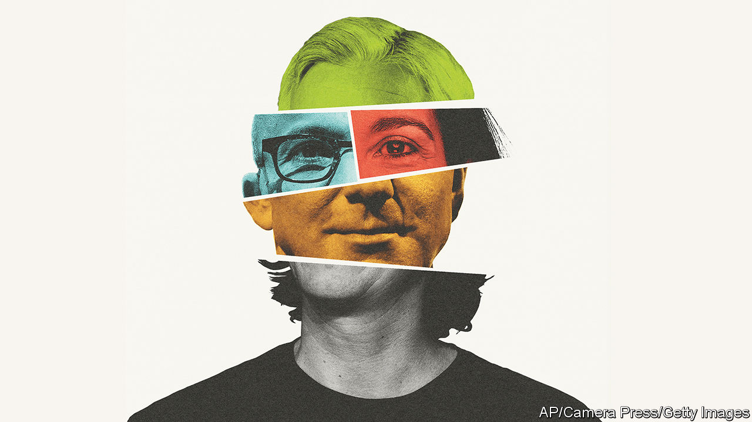

## Purpose-driven business

Last year you asked, “[What are companies for?](https://www.economist.com/leaders/2019/08/22/what-companies-are-for)” (August 24th 2019) and concluded that they should stick to business-as-usual in the form of shareholder primacy. This month you repeated this message, telling chief executives to “forget trying to run the world” and focus on serving the long-term interests of their business owners (“[Meet the new boss](https://www.economist.com/leaders/2020/02/06/what-it-takes-to-be-a-ceo-in-the-2020s)”, February 8th). Your consistency is laudable. However, this position ignores the adverse impact of market failures and the shareholder-first model that has contributed so much to our social and environmental crises, not least the existential threat of climate change.

Fortunately a growing number of companies out there recognise that this threatens the viability and legitimacy of business. They know that their purpose needs to include creating the long-term social and environmental capital that underpins their shareholder returns, and that this is in their own immediate interests in attracting and motivating talent, driving innovation, building trust and increasing performance.

This is a crucial year in which world leaders will explore a new deal for nature at the Convention on Biodiversity in China, and seek agreement on reaching net zero carbon emissions by 2050. Unless business plays a key role in tackling the world’s greatest challenges, it will certainly discover the true meaning of “disruption” on a global scale.

DAME POLLY COURTICE  
Director  
Institute for Sustainability Leadership  
University of Cambridge



You suggest that today’s bosses must “be physically fit to withstand the brutal workload” (“[Take me to a leader](https://www.economist.com/briefing/2020/02/06/corporate-headhunters-are-more-powerful-than-ever)”, February 8th). This is a modern prejudice. Is there any evidence that fitter bosses are higher performing? Sergio Marchionne and Herb Kelleher were chain- smokers who transformed their industries (cars and airlines). Bill Gates possibly skips cross-fit. And Warren Buffett proudly claims to eat “like a six-year-old”. Being fit is good in itself, but there is no concrete conclusion that CEOs absolutely need to be highly athletic. Good looks are surely a powerful halo effect, but let’s not bar bread-eaters from the corporate suite just yet.

CONAL CAMPBELL  
Celbridge, Ireland



## Gender preferences

The [Free exchange](https://www.economist.com/finance-and-economics/2020/02/06/economists-discover-the-power-of-social-norms) on social norms was muddled (February 8th). Apparently gender earnings disparities persist but (and this seems to disturb you) they may partly reflect different preferences by men and women. But look, the column says, preferences too can be changed; they are “socially determined”.

Why should policymakers, never mind economists, want to change these preferences? What, exactly, is wrong with women tending to prefer children and home and men preferring work and career? Economists laud division of labour in other businesses, why not in the family also? Just what principle lies behind the idea that men and women should have identical preferences?

PROFESSOR JOHN STADDON  
Department of Psychology and Neuroscience  
Duke University  
Durham, North Carolina

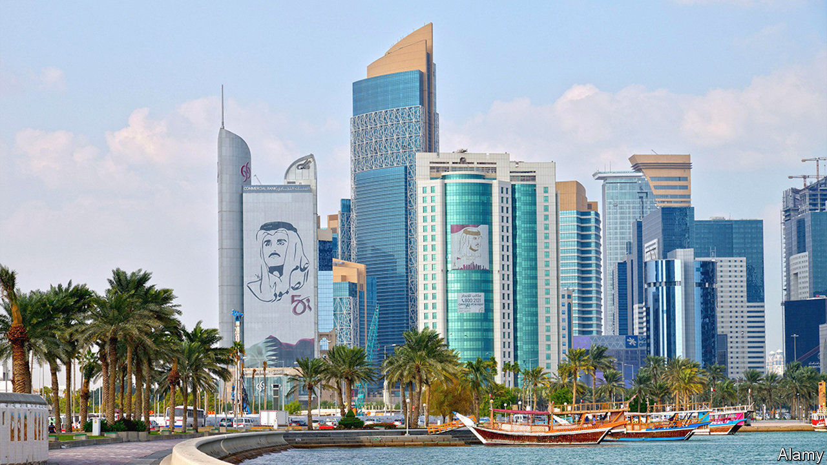

## Free speech in Qatar

Your article on Qatar did not reflect the reality of freedom of expression in the country and a law that has been amended to prevent the spread of false and malicious information (“[Tamim the gloriously tolerant](https://www.economist.com/middle-east-and-africa/2020/02/13/qatar-the-gulf-emirate-famed-for-openness-is-silencing-critics)”, February 15th). Similar legislation exists in many democratic countries. In France a law was introduced in 2018 to tackle the manipulation of information and its deliberate dissemination. As the target of sustained state-sponsored disinformation campaigns, “deep fakes” and cyberattacks, Qatar understands the dangers of information manipulation better than anyone. In line with the UN’s covenant on civil and political rights, to which Qatar is fully committed, this amendment was passed as a protection against major, co-ordinated hacking and disinformation operations trying to fracture the region. It is not open to abuse and will not limit expression, speech or reporting in or about Qatar.

No country has done more than Qatar to improve media freedom in the region. The debate on this amendment from within Qatar itself, including from local media and social-media users, demonstrates that individuals and platforms can criticise a law without consequence.

THAMER AL THANI  
Deputy director  
Government Communications Office  
Doha, Qatar

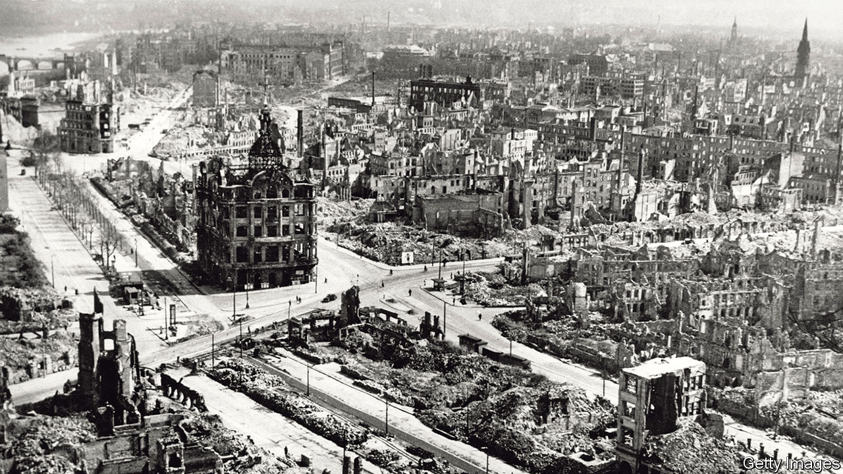

## Remembering a war atrocity

There are a lot of 75th commemoration events marking the second world war. One incident less famous than Dresden (“[The inferno](https://www.economist.com/books-and-arts/2020/02/06/the-destruction-of-dresden-the-florence-of-the-elbe)”, February 8th) was commemorated in the Dutch village of Putten last year. In early October 1944, 600 men were sent to German work camps in retaliation for the killing of a German officer by the resistance. Few returned. I was only five at the time but I still have vivid memories of the episode. Lots of similar stories can be told about other villages in occupied Europe that have gone mostly unreported. A recent novel, “The Weeping Woman of Putten” by Alyce Bailey, tells the tale.

WALTER SCHUIT  
Torrejón de Ardoz, Spain

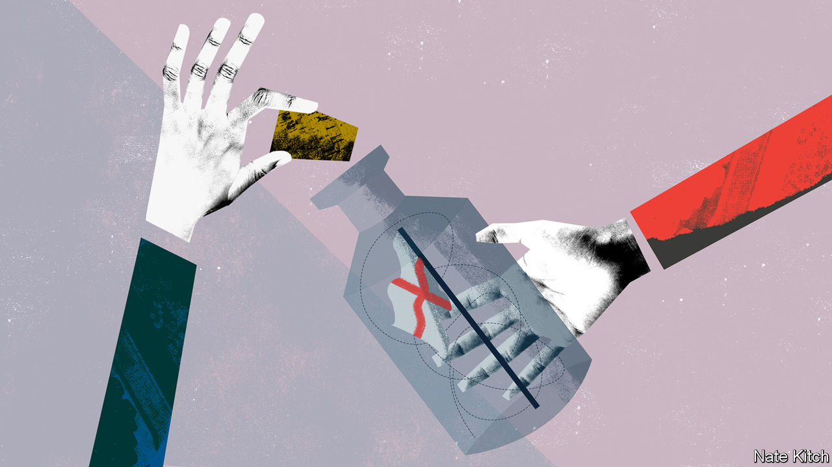

## The EU puts Europeans first

The Economist repeats a myth that Brexit was about England turning in on itself, as if supporting membership of the EU is a sign of internationalism ([Bagehot](https://www.economist.com/britain/2020/01/30/brexit-and-english-nationalism), February 1st). The opposite is true. The EU created a system that favours other Europeans over everyone else. This is most obviously manifest in freedom of movement, which allows any EU citizen to move to any EU country, while at the same time erecting barriers against immigration from outside the EU. Hard-core Remainers, convinced of their own enlightened liberalism, refuse to acknowledge this gross injustice. Oddly enough, supposedly xenophobic and uneducated Brexiteers have no difficulty understanding the unfairness and outdated Eurocentric nature of EU policies.

NICOLAS GROFFMAN  
Reading, Berkshire

Bagehot described Mark Francois as the “Captain Mainwaring of the European Research Group of MPs”. Mr Francois is more like Private Walker in “Dad’s Army”, the black-marketeer in Mainwaring’s platoon. The propaganda espoused by Mr Francois and his fellow Brexiteers included assurances that leaving “won’t cost you much”, Walker’s favourite line when plying his trade.

JOHAN ENEGREN  
Stockholm

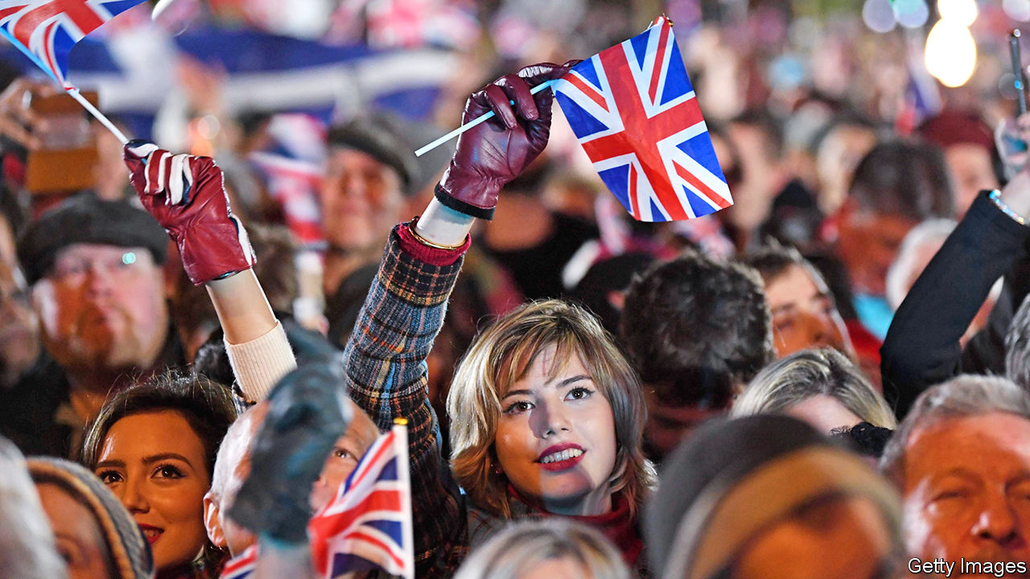

The picture accompanying the news on Brexit in [The world this week](https://www.economist.com/the-world-this-week/2020/02/08/politics-this-week) (February 8th) showed a number of Brexit supporters waving Union Flags that were upside down. As this is a recognised way of signalling distress, are they perhaps reflecting the belief of many in the country that trouble lies ahead?

CHARLES MORTELMAN  
London

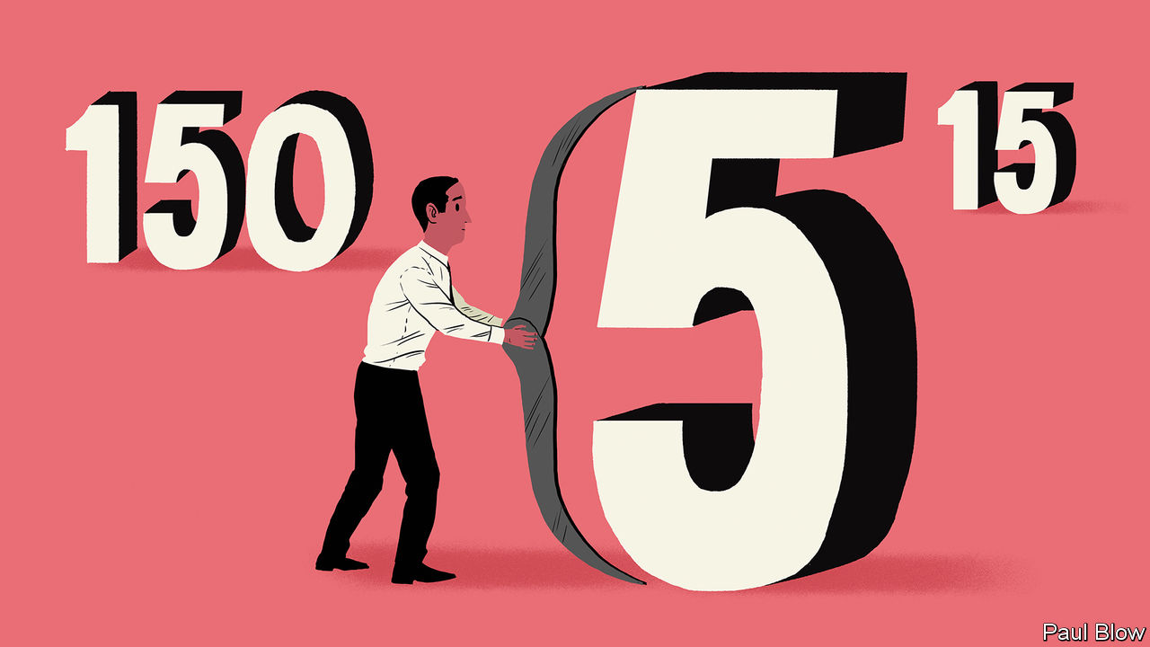

## Table for one

Regarding [Bartleby](https://www.economist.com/business/2020/01/23/the-number-of-the-best)’s “The number of the best” (January 25th) I have always understood that the ideal size of a committee is an odd number less than three.

PETER WILSON  
Kenilworth, Warwickshire

This article was downloaded by calibre from <https://www.economist.com/letters/2020/02/29/letters-to-the-editor>

|  |  |  |  |
| --- | --- | --- | --- |
|  | Articles | Sections | Next |

|  |  |  |
| --- | --- | --- |
| Letters | Sections | United States |

Briefing

Covid-19: Flattening the curve

.

|  |  |  |
| --- | --- | --- |
| Letters | Sections | United States |

|  |  |  |  |
| --- | --- | --- | --- |
|  | Articles | Sections | Next |

#### The world gets ready

# Covid-19 is now in 50 countries, and things will get worse

But there are proven ways to limit the damage

Feb 29th 2020 | LONDON AND MILAN

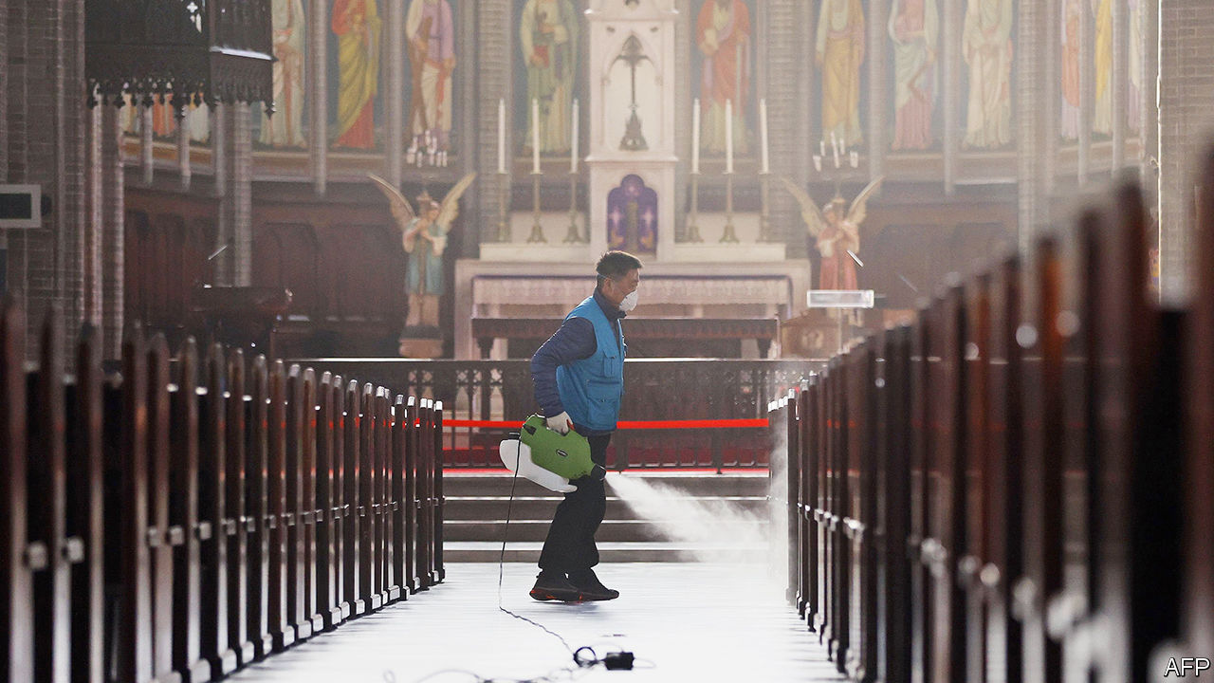

IN THE EARLY scenes of Michelangelo Antonioni’s “The Eclipse”, eerily empty Italian streets provide a stark contrast to the frenzy of the stockmarket floor. This week saw that striking juxtaposition played out for real. Under a sky of unbroken light-grey cloud, isolated figures hurried through the spaces between Milan’s towering office blocks and across its broad traffic-free avenues. Meanwhile, inside a frantic Borsa Italiana, share prices were collapsing.

On February 21st the Italian authorities announced that a cluster of 16 cases of covid-19, the disease associated with the novel virus SARS-CoV-2, had been detected around Codogno, a small town in Lombardy 60km south-east of Milan. By the next day the number was up to 60, and five elderly people had died. On the 23rd“red zones” were set up around the infected areas (see map). Inside the zones there is a strict lockdown; outside 500 police officers and soldiers stop people from leaving. On the same day the government of Lombardy ordered the closure of any establishment where large numbers of people gather, including cinemas, schools and universities. Inter Milan has missed a home match; the legendary opera house, La Scala, is shuttered; sightseers are barred from the cathedral—though worshippers are not.

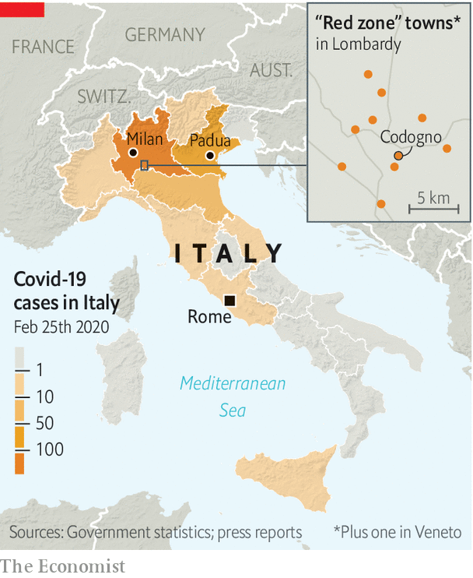

Iran, where the first covid-19 cases were reported two days before Italy’s, has also closed schools and cancelled football games. There too, though, worship continues, with what appear to have been dire consequences. The ceaseless flow of pilgrims to the mosques and shrines of Qom has continued despite the city being the site of the first cases.Ahmad Amirabadi Farahani, an MP from the city, said on February 24th that the death toll there had reached 50, though other officials deny this. Recent cases of covid-19 in Bahrain, Kuwait, Iraq, Lebanon and Pakistan are all thought to be linked to returnees from Iran.

The outbreaks in Italy and Iran, along with a large one in South Korea, have convinced many epidemiologists that attempts to keep the virus contained within China have run their course; it will now spread from second countries to third countries and on around the world. As of February 27th, cases had been reported in 50 countries (see chart 1). Studies suggest that the number of people who have left China carrying the disease is significantly higher than would be inferred from the cases so far reported to have cropped up elsewhere, strongly suggesting that the virus’s spread has been underestimated. Some public-health officials still talk in terms of the window for containment coming closer and closer to closing. In reality, it seems to have slammed shut.

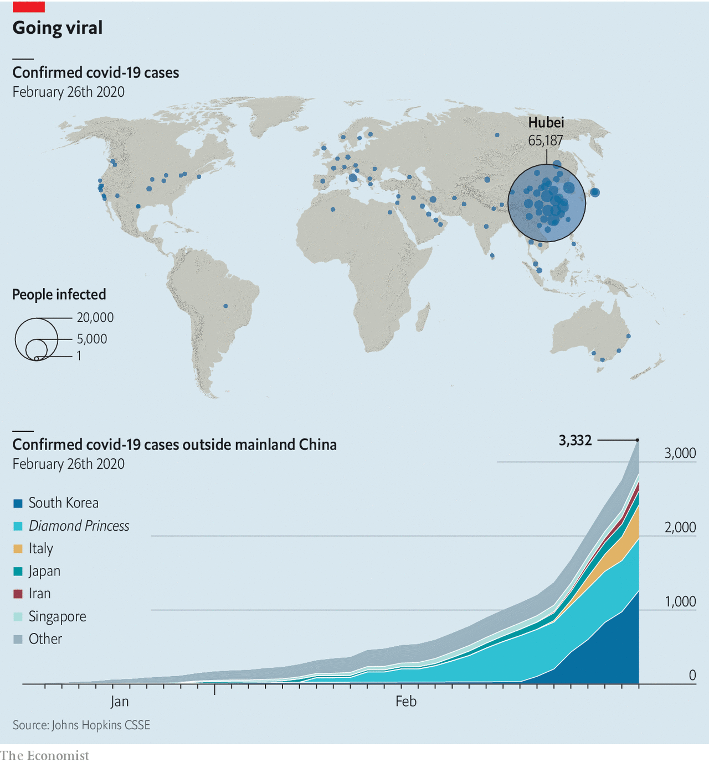

That is the message the world’s financial markets have taken; the Borsa Italiana in Milan was far from alone in its miseries. Investors had previously acted as though the economic impacts of covid-19 would be limited to China and those whose supply chains wind through it. The spread of the disease to South Korea, Iran and Italy caused a massive sell-off on February 24th. The next day prices fell further when the Centres for Disease Control and Prevention warned Americans to prepare for the virus.

As of the morning of February 27th, stock markets had fallen by 8% in America, 7.4% in Europe and 6.2% in Asia over the past seven days. The industries, commodities and securities that are most sensitive to global growth, cross-border commerce and densely packed public spaces got whacked particularly hard, with the prices of oil and shares in airlines, cruise-ship owners, casinos and hotel companies all tumbling. Investors have taken refuge in assets that are perceived to be safe: yields on ten-year Treasury bonds reached an all-time low of 1.3%. The place least hit was China, where a huge sell-off took place some time ago. Investors, like some public-health officials, are starting to think that the epidemic there is, for now, under control (see article). But if economic models developed for other diseases hold good, the rich world stands a distinct chance of slipping into recession as the epidemic continues. That will bring China, and everyone else, a fresh set of problems.

## The paths all taken

How the virus will spread in the weeks and months to come is impossible to tell. Diseases can take peculiar routes, and dally in unlikely reservoirs, as they hitchhike around the world. Two cases in Lebanon lead to worries about the camps in which millions of people displaced from Syria are now crowded together and exposed to the winter weather. But regardless of exactly how the virus spreads, spread it will. The World Health Organisation (WHO) has not yet pronounced covid-19 a pandemic—which is to say, a large outbreak of disease affecting the whole world. But that is what it now is.

Part of the WHO’s reticence is that the P-word frightens people, paralyses decision making and suggests that there is no further possibility of containment. It is indeed scary—not least because, ever since news of the disease first emerged from Wuhan, the overwhelming focus of attention outside China has been the need for a pandemic to be avoided. That many thousands of deaths now seem likely, and millions possible, is a terrible thing. But covid-19 is the kind of disease with which, in principle, the world knows how to deal.

The course of an epidemic is shaped by a variable called the reproductive rate, or R. It represents, in effect, the number of further cases each new case will give rise to. If R is high, the number of newly infected people climbs quickly to a peak before, for want of new people to infect, starting to fall back again (see chart 2). If R is low the curve rises and falls more slowly, never reaching the same heights. With SARS-CoV-2 now spread around the world, the aim of public-health policy, whether at the city, national or global scale, is to flatten the curve, spreading the infections out over time.

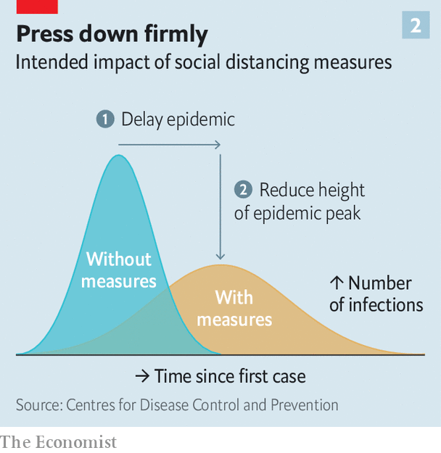

This has two benefits. First, it is easier for health-care systems to deal with the disease if the people infected do not all turn up at the same time. Better treatment means fewer deaths; more time allows treatments to be improved. Second, the total number of infections throughout the course of the epidemic can be lower.

To flatten the curve you must slow the spread. The virus appears to be transmitted primarily through virus-filled droplets that infected people cough or sneeze into the air. This means transmission can be reduced through physical barriers, good hygiene and reducing various forms of mingle—a strategy known as “social distancing”. Such measures are already routinely used to control the spread of the influenza virus, which spreads in a similar way and is responsible for hundreds of thousands of deaths a year.

Influenza, like many other respiratory diseases, thrives in cold and humid air. If covid-19 behaves the same way, spreading less as the weather gets warmer and drier, flattening the curve will bring an extra benefit. As winter turns to spring then summer, the reproductive rate will drop of its own accord. Dragging out the early stage of the pandemic means fewer deaths before the summer hiatus provides time to stockpile treatments and develop new drugs and vaccines—efforts towards both of which are already under way.

Ben Cowling, an epidemiologist at the University of Hong Kong, says that the intensity of the measures countries employ to flatten the curve will depend on how deadly SARS-CoV-2 turns out to be. It is already clear that, for the majority of people who get sick, covid-19 is not too bad, especially among the young: a cough and a fever. In older people and those with chronic health problems such as heart disease or diabetes, the infection risks becoming severe and sometimes fatal. How often it will do so, though, is not known.

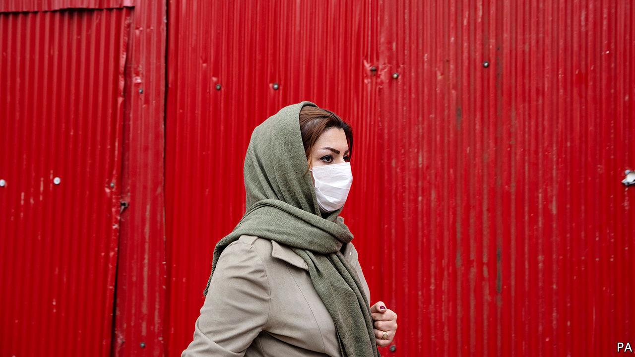

An epidemic’s fatality rate can only be definitively calculated after the fact: you take a population in which you know how many died and test a large random sample for antibodies against the pathogen in question—antibodies they will only have in their system if they were once infected. The Chinese authorities have just approved such tests, but they have yet to begin.

Estimates of the proportion of the infected made in the thick of things are, by contrast, liable to two different types of error. One affects the numerator—the number of the dead—and one the denominator—the number infected.

## Mixed fractions

The first stems from the fact that there are always some people destined to die who have not died yet. People who die from covid-19 typically do so some three weeks after the onset of symptoms. If you divide the number of the dead at a given time by the number infected up until then you will miss those who will die in the next few weeks, and your answer will be misleadingly small.

The second sort of error, typically seen near the beginning of an epidemic, pushes in the other direction. People diagnosed early on tend to be very ill. It takes further investigation, and broader public awareness, to turn up all the people suffering only mild symptoms. Before that is done, an underestimate of the number infected leads to an overestimate of the fatality rate.

Analysis of data from more than 40,000 Chinese patients who had tested positive for the virus by February 11th found that, at the time, about 80% had mild symptoms, 14% had symptoms severe enough to warrant hospital care and oxygen, and 5% were critical, requiring intensive care that often included mechanical aids to breathing. Based on that data, the fatality rate in Hubei, the province in which Wuhan sits, was 2.9%. Outside Hubei it was 0.4%.

There are various reasons why the rate in Hubei would be expected to be genuinely higher than elsewhere. Its hospitals had no warning of the sudden influx of covid-19 patients and were thus overwhelmed, whereas hospitals in other cities had more time to prepare, laying in respirators and oxygen. Hubei’s doctors had to work out how to treat a brand-new disease, whereas those elsewhere have been able to learn from both their successes and failures.

But many experts think that a lot of the difference stems from the early-stage small-denominator problem. In other places there has been time and an incentive for less severe cases to be diagnosed, and so the fraction that has proved fatal is lower. At the moment, epidemiologists reckon the true rate for covid-19 is in the range of 0.5-1%. For SARS, a disease caused by another coronavirus which broke out in 2003, the rate in China was never fully ascertained; but worldwide, the WHO put it at about 10%. The rate for seasonal flu in America is typically around 0.1%.

The fatality rate is not an inherent property of the virus; it also depends on the care received. This puts poorer countries at particular risk. They tend to have weaker public-health systems in the first place, and thus can expect higher levels of serious disease and death—including, sometimes, among overstretched and inappropriately protected front-line health-care workers. That puts further strains on their health systems. And this will all be exacerbated by the pandemic’s economic effects, which models suggest will also be greater in poorer countries. Higher fatality rates causes larger hits to the workforce. Service industries in poorer countries are less digitised, meaning they require face-to-face contact, and therefore are more likely to be avoided when consumers take fright. And poor countries risk capital flight when financial markets are spooked by risk. They could lose their ability to borrow and spend just when they need it most.

Better health care reduces the fatality rate. Better public-health interventions reduce the total rate of infections. Epidemiologists start their curve-producing models off with a “basic reproductive rate”, Ro. This is the rate at which cases lead to new cases in a population that has never seen the disease before (and thus has no immunity) and is doing nothing to stop its spread. Estimates of Ro for covid-19 based on data for Wuhan put it at between 2 and 2.5, according to the WHO. Academics reckon that an Ro around this range could see between 25% and 70% of the world becoming infected.

How an epidemic actually unfolds, though, depends not on Ro but on R, the effective reproductive rate. If policymakers and public-health officials are doing their job and a trusting public pays attention, this should be less than Ro. The lower it gets, the flatter the curve; get R below one, and the curve starts to slope down. That will not wipe out the virus completely. But it will eventually see it limited to sporadic outbreaks, usually when the rare infected person mingles with lots of vulnerable people (such as those in nursing homes).

## Back to school

It is possible that the huge efforts made in China have reduced R nearly this far—hence the current optimism there. Outside Hubei, cities which pre-emptively imposed travel restrictions and bans on large gatherings have seen flatter epidemic curves; the measure that made the biggest difference was closing down public transport. There is now a risk, though, that as people start going back to work and school new infections will start to rise (see article). Bruce Aylward, who led a WHO-appointed group of experts sent to investigate the situation in China, says the authorities have used the time when transmission was severely suppressed to prepare and re-equip hospitals.

As the pandemic unfolds, the reproductive rate in different parts of the world will differ according both to the policies put in place and the public’s willingness to follow them. Few countries will be able to impose controls as strict as China’s. In South Korea the government has invoked the power to forcibly stop any public activities, such as mass protests; schools, airports and military bases are closed. Japan is urging companies to introduce staggered working hours and virtual meetings, limiting both crowding on public transport and mingling at work. Other developed countries are mostly not going that far, as yet. Something that is acceptable in one country might result in barely any compliance, or even mass protests in another.

There will also be scapegoating and fear. In Novi Sanzhary, in Ukraine, a busload of evacuees from Wuhan was attacked. To assuage fears, the country’s health minister joined the evacuees in quarantine, demonstrating that she could do her job remotely. Other politicians will be less noble. In a world where disinformation on social media is already a much used tool, covid-19 will provide new opportunities for spreading fear, uncertainty and doubt. Disrupting attempts to slow the spread of SARS-CoV-2 by such means could be an easy way to weaponise it.

In countries with stronger public-health systems, data scientists will busily model the course of the epidemic as it unfolds. Such modelling already informs public-health choices during flu season in many countries, suggesting when various measures might be prudent. They could in principle be adapted to covid-19. But for the time being such adapted models will be a lot less useful than the ones for flu, because much less is known about covid-19’s basic biology. For example, the question of whether infected people can transmit the disease before they show any symptoms is a matter of quite hot debate. If they can, then putting heavy stress on having infected people isolate themselves will be much less effective than it would otherwise be, because many infectious people will not know that they carry the virus.



There is also no explanation for the low number of children so far diagnosed with the disease. Do they not get it? Or do they get very mild, or different, symptoms? Either way, this will make the dynamics of covid-19 quite different from those of flu, where high rates of spread among children are a big factor, and closing schools can bring large gains.

However well people put up with whatever social distancing is asked of them, covid-19 will hurt the economy. Until recently, market analysts expected China to have a slow first quarter but world GDP to be little affected. When on February 22nd the IMF revised its global growth forecast for the year, it was merely shaved down from 3.3% to 3.2%. A full blown pandemic can be expected to have a much deeper impact.

## Viral messaging

Work would be lost both to disease and to social distancing. The financial system was not much hit by this week’s market falls. Although the riskier corners of the debt markets suffered some jitters, the borrowing costs for the biggest Western banks remained fairly stable. However, large poorly understood risks are likely to reduce investment. Consumers could stop spending, both through fear and because controls on mingling reduce opportunities for various types of fun.

Such effects can be out of proportion to their cause. When South Korea had a small outbreak of 186 cases of Middle East Respiratory Syndrome in 2015, the hit to the economy totalled $8.2bn, or about $44m per infection, points out Olga Jonas of Harvard University. Cities with large service sectors are particularly vulnerable; the economic impact of SARS was greatest in places like Hong Kong and Beijing.

Some hints of what may be to come can be gleaned from an economic model of an influenza pandemic created by Warwick McKibbin and Alexandra Sidorenko, both then at Australian National University, in 2006. Covid-19 is not flu: it seems to hit people in the prime of their working life less often, which is good, but to take longer to recover from, which isn’t. But the calculations in their model—which were being updated for covid-19 as The Economist went to press—give some sense of what may be to come (see chart 3).

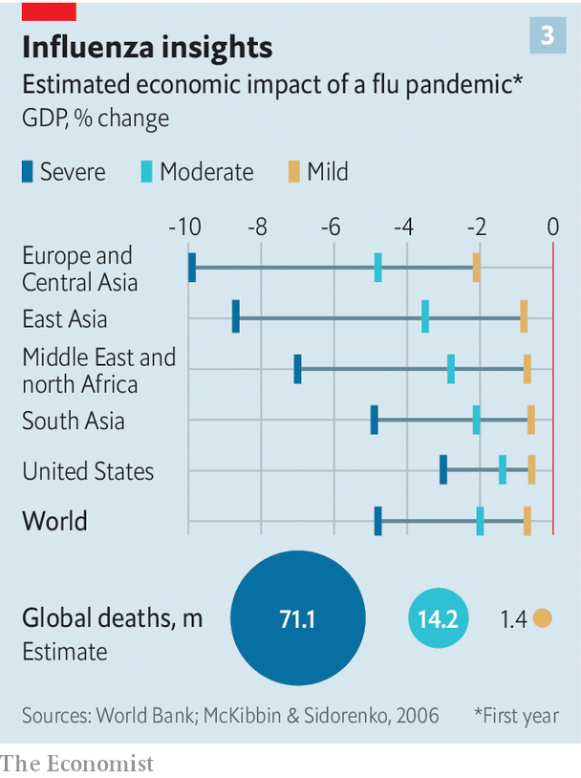

In their “severe” scenario, a pandemic similar to the Spanish flu outbreak of 1918-19, global GDP dropped by nearly 5%. If that were to happen today, it would cause a slump similar in size to that of 2009. In their “mild” scenario—30% of people infected, losing on average ten days’ work each, and a fatality rate of 0.25%—the cost was just 0.8% of global GDP. That would mean losing about a quarter of the global growth previously forecast for this year.

Mr McKibbin says the moderate scenario in that paper looks closest to covid-19, which suggests a 2% hit to global growth. That corresponds to calculations by Oxford Economics, a consultancy, which put the possible costs of covid-19 at 1.3% of GDP. Such a burden would not be evenly spread. Oxford Economics sees America and Europe both being tipped into recession—particularly worrying for Europe, which has little room to cut interest rates in response, and where the country currently most exposed, Italy, is already a cause for economic concern. But poor countries would bear the biggest losses from a pandemic, relative to their economies’ size.

As the world climbs the epidemic curve, biomedical researchers and public-health experts will rush to understand covid-19 better. Their achievements are already impressive; there is realistic talk of evidence on new drugs within months and some sort of vaccine within a year. Techniques of social distancing are already being applied. But they will need help from populations that neither dismiss the risks nor panic. The patrons at the Tempio Caffè, just off Milan’s Piazza Cavour, had it about right: not too disturbed, getting informed. Only one of the ten breakfasting on cappuccino and brioche was wearing a mask, and she was Chinese.■

This article was downloaded by calibre from <https://www.economist.com/briefing/2020/02/29/covid-19-is-now-in-50-countries-and-things-will-get-worse>

|  |  |  |  |
| --- | --- | --- | --- |
|  | Articles | Sections | Next |

|  |  |  |
| --- | --- | --- |
| Briefing | Sections | The Americas |

United States

The Democratic primary: That Berning feeling

.

Harvey Weinstein: Celebrity justice

.

The Supreme Court: Roberts rules

.

High-skilled immigration: The invisible wall

.

Lexington: The primary problem

.

|  |  |  |
| --- | --- | --- |
| Briefing | Sections | The Americas |

|  |  |  |  |
| --- | --- | --- | --- |
|  | Articles | Sections | Next |

#### That Berning feeling

# What does Bernie Sanders’s political revolution hope to accomplish?

The senator for Vermont is a European social democrat—of a 1970s vintage

Feb 29th 2020 | WASHINGTON, DC

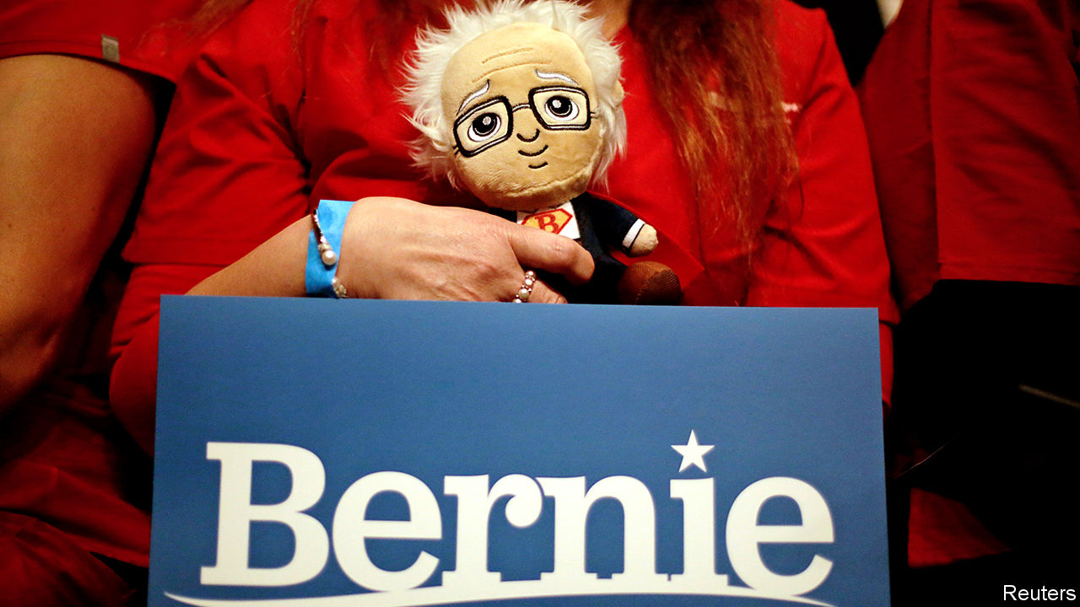

AMBITIOUS, EXHILARATED and a little nervous, a freshly elected Democratic congressman was buzzing with the possibilities of his new office when he first encountered Bernie Sanders. “You do realise this place is a complete waste of time, don’t you?” growled the independent senator from Vermont, by way of welcome to Capitol Hill. And, to be fair to Mr Sanders—and to the millions of Americans who set such great store by his integrity and plain speaking—he could not have summed up his own legislative history better. Mr Sanders has grumbled persistently about real problems—a broken health-care system and inequitable college education above all—while rarely making any headway in fixing them. During 30 years in Congress he has been primary sponsor of just seven bills that became law, two of which concerned the renaming of post offices in Vermont. An uncharitable observer might consider this the record of a blowhard.

Mr Sanders has taken his preference for speechifying to the big time. With only momentary interruptions, he has spent five years campaigning to be president—ever since he decided to play spoiler to Hillary Clinton’s coronation. America’s most famous socialist is running for the presidency on more or less the same set of problems he has emphasised for all those many years (plus a more recent focus on climate change). Though his proffered solutions, in the form of fantastical reforms and vast spending pledges, look ruinously expensive and unlikely to pass Congress, a committed faction of Democratic voters like them enough to have made Mr Sanders the indisputable front-runner. A candidate could scarcely have hoped for better results in the all-important early-primary states. Betting markets give him a 60% chance of winning the nomination. If he does well on March 3rd, Super Tuesday, when 14 states vote and one-third of delegates will be allocated, he will be uncatchable.

That worries many Democrats. Mr Sanders is a 78-year-old self-described socialist pulling his party hard to the left in an election in which the centre is wide open. Among those who feel the Bern, Mr Sanders’s ideological consistency over his three decades in Washington is usually the first thing they mention. Jeremy Corbyn’s supporters had similar feelings about their candidate, before he led the Labour Party off a cliff in Britain’s most recent general election. In some ways, Mr Sanders’s proposals are more radical than Mr Corbyn’s were. If he got his way, all American residents, including undocumented immigrants, would receive free health care, child care and education at state universities. Workers would have a jobs guarantee, seats on corporate boards and receive 20% of the equity of large firms. Billionaire clout would be broken by a wealth tax.

There are two hurdles to achieving all this: a general-election contest against Mr Trump, and gaining control of Congress.

Like a Goliath company swallowing start-ups to preserve its dominance, Mr Sanders has embraced all the new progressive-sounding ideas that have recently emerged—borrowing heavily from the innovations of Elizabeth Warren in America and Mr Corbyn in Britain. From Ms Warren, he has taken on the idea of a wealth tax—though with higher rates set at 8% at the top—co-determination of corporate boards, and the creation of federal charters for big corporations. From Mr Corbyn, he has borrowed the idea of national rent control and the forcible expropriation of corporate wealth to workers (though he has doubled Mr Corbyn’s suggested 10%, to 20%). The Green New Deal, proposed by climate activists and espoused by Alexandria Ocasio-Cortez, a first-term representative, has found a welcome home in his agenda.

Promises are expensive. Our accounting shows Mr Sanders proposing $52trn in additional spending over a decade—although some plans, like a federal jobs-guarantee, are impossible to price. He has proposed some revenue-raisers: the wealth tax, and a significant rise in payroll taxes for the middle class. But these look likely to cover just $24trn of the cost. Even this estimate is rosy. It assumes that nationalising the generation of clean electricity, rather than costing money, will raise $6.4trn; $4.4trn from a wealth tax that the European experience shows the rich are good at avoiding; and $2.4trn from a financial-transactions tax (the Tax Policy Centre, a think-tank, estimates that the maximum possible revenue is one-quarter as much).

Perhaps the Green New Deal is not as grand as all that, and the 20m jobs he anticipates do not materialise. Taking his maths as given, however, Mr Sanders seems to be setting himself up for additional annual deficits of $2.8trn per year, or 13% of current GDP. Given that one of his senior economic advisers is Stephanie Kelton, a proponent of “modern monetary theory” whose forthcoming book is called “The Deficit Myth”, this may not be a concern.

## Gimme, gimme, gimme

All these plans would need assent from Congress, which looks highly unlikely at the moment. But though Congress can tie the hands of the president on domestic matters, foreign affairs are less circumscribed. Some Democrats bristle at the thought of Mr Sanders at the helm of the national-security apparatus. Like old-school leftists, Mr Sanders has appeared blind to the horrible things left-wing governments have done to their own citizens in the name of solidarity—a tendency that will be a gift to Republican makers of attack-ads if he becomes the nominee. In the 1980s he campaigned for the Socialist Workers Party, which sought “the abolition of capitalism.” Mr Sanders wrote praise to the Sandinistas in Nicaragua, and attended a rally there on a visit in 1985 featuring the chant, “Here, there, everywhere, the Yankee will die.”

More recently, Mr Sanders has pledged not to use America’s military might for regime change, either overtly or covertly. Nor would he use it to secure American oil supplies. He has promised to use force only with congressional approval. His scepticism of America’s global role echoes Donald Trump’s, and has led some to caricature him as a left-wing isolationist.

That is not quite right. On the stump and in campaign materials, Mr Sanders has called for a foreign policy centred on human rights, economic fairness, democracy, diplomacy and peace. For voters of a certain age, that rhetoric may conjure up echoes of Jimmy Carter’s human-rights-focused foreign policy. But some of his advisers say Mr Sanders’s foreign policy would be more like Barack Obama’s.

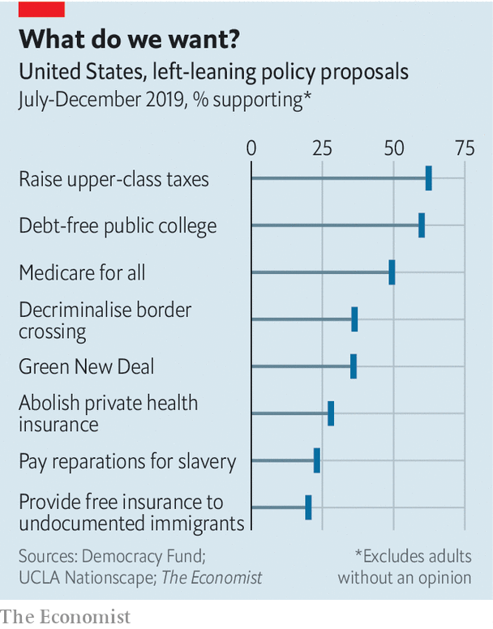

He shares Mr Obama’s belief in talking to America’s opponents, and said he will continue Mr Trump’s personal dialogues with Kim Jong-un, North Korea’s leader. He also wants to re-enter the nuclear deal with Iran. He would probably try to reset—to use an unlucky word—America’s relationships with Russia and China. Like his Democratic rivals, he has vowed to re-join the Paris Climate Agreement, and wants America to take a leading role in combating climate change. He does not share Mr Trump’s hostility towards NATO, and is unlikely to set out to further erode the country’s alliances. Mr Sanders has recently said that he would honour Article V commitments to NATO members, including for countries that do not meet their commitment to spend 2% of GDP on defence.

The president is also relatively unfettered in matters of trade policy. Like Mr Trump, Mr Sanders has been sceptical of America’s trade deals for decades. He seems never to have found one he liked. Not only did he vote against the deal that ultimately brought China into the World Trade Organisation (WTO), but he also voted for America to leave the WTO altogether. He has pledged to “immediately” renegotiate the recently signed USMCA and to “fundamentally rewrite all of our trade deals to deals to prevent the outsourcing of American jobs and raise wages.”

Mr Sanders is a more nuanced protectionist than Mr Trump. His criticisms of the USCMA include its omission of any references to climate change. Mr Sanders frames his attacks on past trade deals as reflecting his concern with labour, environmental and human-rights standards. Though he may be less erratic than Mr Trump and have purer intentions, his trade policies may not have better outcomes. Protection from foreign competition will make it easier for domestic companies to fatten their profit margins while providing worse services. If and when other governments retaliate by restricting their own markets, American workers will not be immune. His tenure in office might continue the country’s inward turn.

The presidency comes with other policy-making perks that Mr Sanders would wield: executive action gives considerable leeway in some domestic arenas. Some would be the standard stuff of Democratic administrations. Many of the Trump executive actions would be countermanded. Those that loosened environmental protections, attempted to destabilise health-insurance markets and tightened immigration restrictions would be the first to go. That might all be welcome. Mr Sanders has signalled he would also go further, banning the export of crude oil, legalising marijuana and allowing the import of prescription drugs. He would appoint heads of federal agencies from outside the Democratic mainstream. Taking a page from Ms Warren (who might occupy a post in a Sanders administration), he could appoint zealous enforcers for antitrust, consumer protection and labour-relations posts.

## Take a chance on me

Mr Sanders’s supporters argue that this programme is not electoral suicide but strategic brilliance. Head-to-head polling against Mr Trump shows Mr Sanders ahead by 3.6 percentage points nationally. In pivotal states like Michigan and Wisconsin, which Ms Clinton narrowly lost, he looks ahead by slim margins of five and one points, respectively.

Mr Sanders, his supporters argue, would expand the electorate, bringing in new and disengaged voters. His showings in the first three states give no evidence of such a stampede to the polls. A recent paper by David Broockman and Joshua Kalla, political scientists at Berkeley and Yale respectively, found that Mr Sanders would fare worse against Mr Trump than a moderate Democrat would, in part because he drives wavering voters away. To make up for that loss, he would have to raise youth turnout by 11 percentage points. To put it another way, the proportional increase among young voters would need to be significantly larger than the Obama-inspired African-American voter bump in 2008—far above historically plausible levels.

So far Mr Sanders has dealt only with primaries and caucuses, where his fellow Democrats have treated him comparatively gently, refraining from criticising his character and preferring to disagree with his policy. Mr Trump will be less kind and restrained—and will amplify his attacks with $1bn-worth, or more, of negative advertising. Whether the monied Democratic donors that Mr Sanders so evidently detests would put up enough cash to counteract this onslaught of digital and television advertisement is an open question. The fact that Mr Sanders once seemed enamoured enough of the Soviet Union to honeymoon there, that he plans to ban fracking (vital to the economy of Pennsylvania, a swing state), or that he would like to eliminate private health insurance and raise taxes to pay for undocumented immigrants to get free coverage, all seem untapped veins for negative advertisements. Whereas Mr Trump’s liabilities are well-covered and relatively well-known, Mr Sanders’s may not yet be known by less attentive voters—meaning that his slim lead in national polls could slip away. Drawing the contours of the coming general-election contest is a necessarily speculative exercise, but for Democrats it does not inspire confidence.

The choice could not look starker. Should Mr Sanders win the nomination, November’s election will pit a right-wing nativist with authoritarian tendencies who wants to Keep America Great against a democratic socialist who wants to turn it into the Sweden of the 1970s. The horseshoe theory of politics holds that the extreme left and extreme right sometimes resemble one another more than might be thought. Mr Sanders does not share Mr Trump’s contempt for the rule of law, which is important. But they do share a populist dislike of elites. As Mr Trump was, Mr Sanders is deeply distrusted by party stalwarts. The contempt between that camp and Mr Sanders’s is mutual. A day before his Nevada triumph, he tweeted: “I’ve got news for the Republican establishment. I’ve got news for the Democratic establishment. They can’t stop us.”

A further worry among moderate Democrats is that a Sanders-led ticket could doom their plan to seize control of Congress—it already looks unlikely because of the combination of Senate seats that are up for election this year. In 2018 Democrats engineered a takeover of the House by running moderate candidates focused on kitchen-table issues such as health care—not promising Medicare for All, but preserving and expanding the ACA. That resulted in a 36-seat majority, including victories in 31 districts that Mr Trump won in 2016. One first-term Democrat believes that “the easiest way to hand most of [those seats] back is to put Bernie Sanders at the top of the ticket.” Matt Bennett of Third Way, a centrist Democratic think-tank, warns that Medicare for All and Mr Sanders’s intent to provide free health care to undocumented immigrants “take an advantage that Democrats have on health care and turn it into a liability.”

Socialism may play well in cities and on college campuses, but not in the suburbs, which are vital to the current House majority. Some have already started to speak out. Joe Cunningham, who in 2018 flipped a South Carolina congressional seat last won by a Democrat in 1978, said earlier this month that “South Carolinians don’t want socialism,” and said he would not support “Bernie’s proposals to raise taxes on almost everyone”. In the wake of favourable comments he made about Fidel Castro on February 23rd, virtually every elected Democrat in Florida, a perennially important state in presidential elections, distanced themselves from him. Mr Sanders has a history of fringe political views (though so does Mr Trump). The fact that he even now seems incapable of muting his admiration for Cuban social policies worries Democrats. It risks turning what should be a referendum on Mr Trump, which should be a winning argument, into one on socialism, which could well be a losing one.

## SOS

The odds of Democrats winning the Senate, which are already long, could look even worse with a radical at the top of the ticket. Down-ballot Democrats could try to distance themselves, but Republicans will not let them. Martha McSally, a vulnerable incumbent Republican senator from Arizona trailing her Democratic challenger, Mark Kelly, in the polls, recently released an ad titled “Bernie Bro”, linking Mr Kelly to Mr Sanders’s unpopular policy to give free health care to undocumented immigrants. Doug Jones, the Democratic senator from Alabama, might find his chances of victory narrowed to zero. Against a candidate as unpopular as Mr Trump, Mr Sanders might still achieve victory—only to find that there are insufficient Democrats left on Capitol Hill to carry out his revolutionary marching orders.

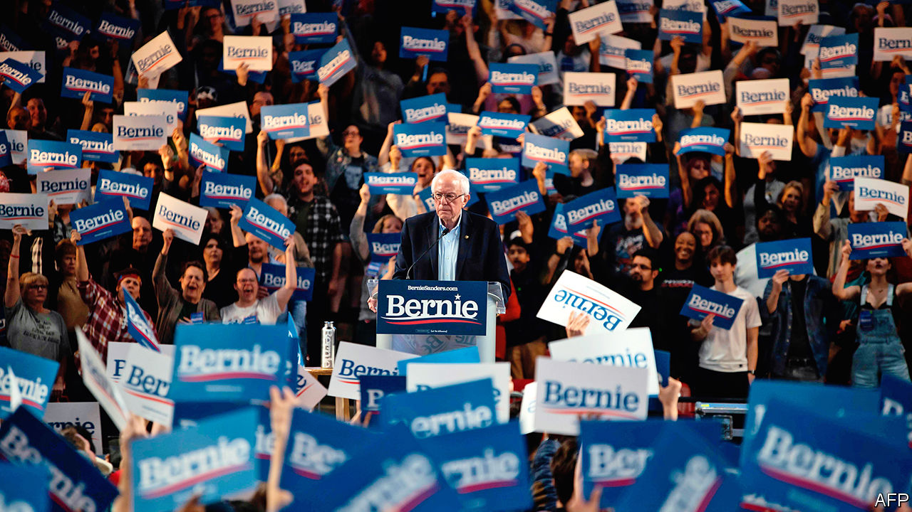

Ready for a political revolution

Sandernistas often vacillate between the idea that their agenda is the one, true route to restoring the American dream and the idea that it is merely a maximalist opening bid in the bruising negotiations with Congress. Rather than Medicare for All, for example, they might end up with a government agency that could provide public health insurance, if they wanted it, to middle-class people who did not qualify for Medicare. Mr Obama got so little done, the story goes, because he compromised with himself, rather than playing hardball. “The worst-case scenario?” asked Ms Ocasio-Cortez, not usually known for her pragmatism, in an interview with the Huffington Post. “We compromise deeply [on Medicare for All] and we end up getting a public option [which means allowing people to buy government-run health insurance]. Is that a nightmare?” Asked about it, Mr Sanders did not yield, saying that Medicare for All was “already a compromise”.

“There will be absolutely no difference between what Bernie has been fighting for in the primaries, in the Senate and in the House and what he will be fighting for as the Democratic nominee, and more importantly in the White House,” wrote Warren Gunnels, a longtime adviser on economic policy to the senator. Mr Sanders’s idea for how he would achieve victory, given the hard political maths facing the Democrats, is not terribly convincing. He says that he would use the bully pulpit of the presidency to shame Republican senators into voting for the good of their constituents. That is naivety befitting a novice, not a 30-year legislator. Mitch McConnell, the Republican majority leader in the Senate, has proved himself happy to halt all lawmaking for years, if necessary. The Sanders revolution would not shake his resolve.

The likeliest outcome for a Sanders presidency would therefore be a slew of ambitious legislative plans all gleefully thwarted by Mr McConnell. Should his political revolution take him inside the gates of the White House, it is likely to stop there. Perhaps after four years of this, Mr Sanders would kvetch to his successor that it, like Congress, is a lousy place to work.■

Dig deeper:  
Sign up and listen to Checks and Balance, our new [newsletter](https://www.economist.com/checksandbalance/) and [podcast](https://www.economist.com/podcasts/2020/02/21/checks-and-balance-our-new-weekly-podcast-on-american-politics) on American politics

This article was downloaded by calibre from <https://www.economist.com/united-states/2020/02/29/what-does-bernie-sanderss-political-revolution-hope-to-accomplish>

|  |  |  |  |
| --- | --- | --- | --- |
|  | Articles | Sections | Next |

|  |  |  |  |
| --- | --- | --- | --- |
| Previous | Articles | Sections | Next |

#### Celebrity justice

# Harvey Weinstein’s conviction is less significant than it seems

Celebrity trials change less than you might think

Feb 27th 2020 |

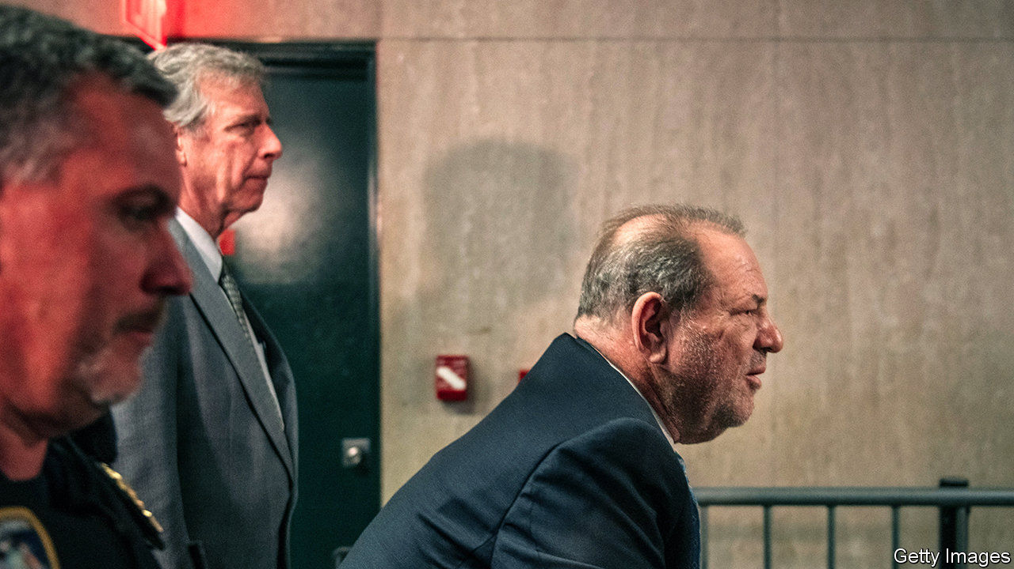

HE IS NO longer an “alleged” rapist and his Zimmer frame can return to the props department. On February 24th a Manhattan jury convicted Harvey Weinstein of rape and of a criminal sex act, acquitting him of the most serious charges of predatory sexual assault. The former film producer, who inadvertently accelerated #MeToo, is now in a New York hospital awaiting sentencing on March 11th. He faces between five and 29 years in prison. For his victims, the #MeToo movement and the office of the Manhattan District Attorney (DA), this is a resounding victory. “This is the new landscape for survivors of sexual assault in America. This is a new day,” said the DA, Cyrus Vance junior. Maybe. But celebrity justice is subject to different rules.

Mr Weinstein’s lawyers need not worry about being out of work any time soon. Donna Rotunno, who says her client “took it like a man,” insists that he will appeal. There are grounds to do so, including the judge’s decision to allow extra witnesses to testify about previous “bad acts” and concern over whether Mr Weinstein could have a fair trial in a city at the heart of the #MeToo media storm. Feminist flash-mobs performed in front of the courthouse, celebrities gathered outside, there was a daily Weinstein podcast. His lawyer scolded the media’s influence but also used it, publishing an appeal to the jury in a Newsweek op-ed as they started deliberations.

The appeals process could easily take a year, which Mr Weinstein is unlikely to spend at liberty. In the meantime, he faces criminal charges in Los Angeles and a stream of civil suits by women who claim he abused them. The difference is that he now faces them as a convicted rapist.

It therefore seems unlikely that he will sit out his retirement comfortably. But perhaps the more salient question is what this will change. Bennett Capers, a Brooklyn law professor, doubts there is a much wider significance. “Many will undoubtedly see this as possibly signalling a new era where prosecutors believe victims and pursue sexual assault cases, even against the powerful,” he says. But “will the verdict help everyday victims” like hotel workers, or where there is a single accuser?

The Weinstein conviction is being presented as a watershed moment that will change the way police, prosecutors and juries deal with such cases. No longer will women who report rape late, or whose testimonies are incomplete or complicated, face scepticism, goes the theory. In fact, after an initial bump, reporting rates of sexual violence in America as low as they were before #MeToo struck. [Public attitudes to what constitutes sexual harassment have barely changed over that time](https://www.economist.com/graphic-detail/2020/02/20/despite-metoo-opinions-on-sexual-harassment-have-barely-budged), according to polls by YouGov for The Economist.

Celebrity justice is not normal justice. Even the most public trials have less lasting impact than the frenzied coverage might suggest. The fact that the Weinstein case even made it to trial is an anomaly in sex crimes. As with other big celebrity trials, such as those of Phil Spector, Michael Jackson, O.J. Simpson and Bill Cosby, a lot of public money was invested in the investigation that led to Mr Weinstein’s conviction. This was matched in investment by the media. No amount of vetting would have been able to put together a jury that would not be influenced by fame of the subject and of his accusers. Celebrity trials can create unrealistic expectations in future jurors’ minds. Mr Weinstein had dozens of glamorous, public accusers. Most victims are alone and unknown.

The next stop for the Weinstein media circus will probably be Los Angeles, the birthplace of celebrity justice. The local record of convicting celebrities is poor and scarred by the very public decision of a jury to acquit Mr Simpson of murdering his wife and her friend Ron Goldman. It will be tempting to fixate on whether the DA can do any better with Mr Weinstein. But just as Mr Simpson’s acquittal, though dramatic, was largely irrelevant for the handling of most murder trials, so Mr Weinstein’s conviction may not prove the seismic moment for cases of sexual assault that many people assume it to be.■

This article was downloaded by calibre from <https://www.economist.com/united-states/2020/02/27/harvey-weinsteins-conviction-is-less-significant-than-it-seems>

|  |  |  |  |
| --- | --- | --- | --- |
| Previous | Articles | Sections | Next |

|  |  |  |  |
| --- | --- | --- | --- |
| Previous | Articles | Sections | Next |

#### Roberts rules

# The Supreme Court’s chief justice is poised to decide a clutch of controversies

Presidential authority, abortion and Donald Trump’s tax returns are all coming before the court

Feb 29th 2020 | NEW YORK

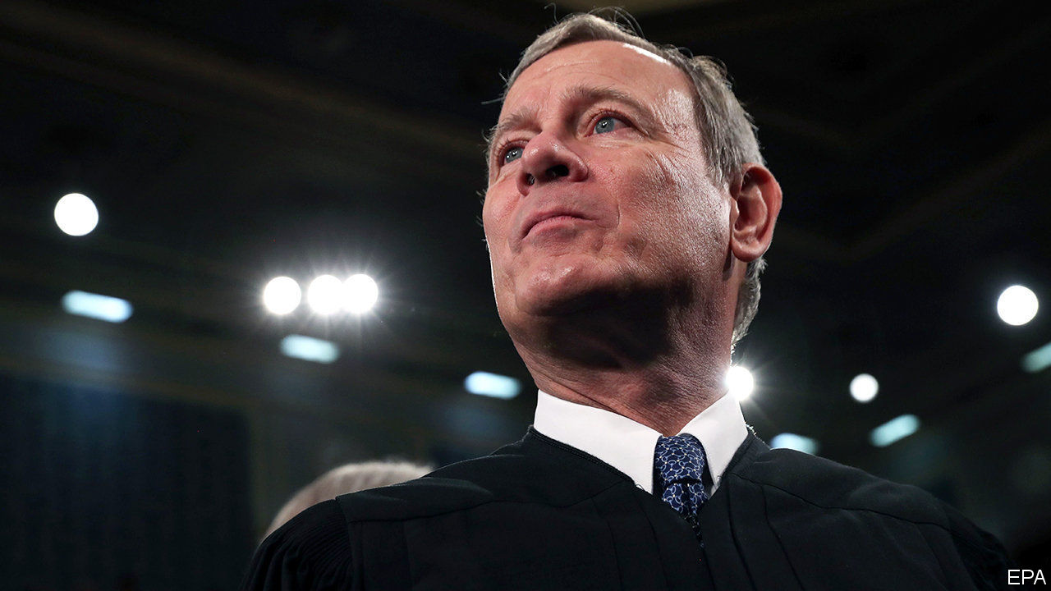

FOR YEARS after John Roberts was named chief justice by George W. Bush in 2005, he presided over the “Kennedy court”—a tribunal that swayed left or right depending on the views of his maverick colleague, Anthony Kennedy. But in October 2018, when Donald Trump replaced Mr Kennedy with the more conservative Brett Kavanaugh, Mr Roberts assumed the role of median justice—four colleagues to his right, four to his left. The chief became, in the most divisive cases, the tie-breaker.

He is breaking mostly to the right. Last June, Mr Roberts wrote 5-4 decisions on partisan gerrymandering (a win for conservatives) and the proposed citizenship question on the 2020 census (a victory for liberals). He has anchored a series of 5-4 votes allowing Mr Trump to implement hardline immigration policies. One such move on February 21st prompted Justice Sonia Sotomayor to charge her conservative colleagues with “erod[ing]” the court’s “fair and balanced decision-making process” by favouring “one litigant”—Mr Trump—“over all others”. The president responded on February 25th with the preposterous demand that Justices Sotomayor and Ruth Bader Ginsburg recuse themselves from all “Trump-related” matters.

This squabble is one that Mr Roberts, a zealous defender of the court’s impartiality and legitimacy, is desperate to avoid. Yet cultivating an image of non-partisanship will be tricky, because he is tackling a host of clashes on the most electric docket the Supreme Court has seen in recent memory. Already the justices have considered gun rights, a major church-state quandary, LGBT protections in the workplace and DACA, an Obama-era programme protecting unauthorised immigrants who were brought to America as children. While they work on decisions in those cases, still more controversies are on the way.

Two presidential priorities are on the docket next week. Seila Law v Consumer Financial Protection Bureau (CFPB)—could doom the federal agency established to protect consumers after the 2007-09 financial crisis. Congress set up the CFPB with a single director whom the president may replace only “for cause”—that is, for palpable misbehaviour. Seila Law asks if that structure is constitutional; the plaintiff, and the Trump administration, say it is not. The challengers contend that this “unduly inhibits the president’s ability to supervise the exercise of the executive power” under Article II of the constitution. With a conservative majority favouring a capacious conception of presidential power, the court is likely to agree. The CFPB’s future, and the president’s ability to sack directors of other agencies, hang in the balance.

Then the justices turn to one of the most explosive matters in American politics. In June Medical Services v Russo, the justices will review a decision that upheld a Louisiana law requiring abortion providers to have admitting privileges at a local hospital. Ostensibly reasonable, the rule is one of dozens of laws that states have enacted in recent years to shut down clinics while purporting to protect women. Russo is a reprise of a recent battle: the Supreme Court struck down an identical clinic regulation in Texas by a 5-3 vote in 2016. In that ruling, the court found that the requirement brought no plausible health benefits but, by shuttering clinics, imposed an “undue burden” on access to abortion. If the Louisiana law is upheld, plaintiffs say, only one abortion provider will remain in the state.

In a move aimed at undercutting Russo and future lawsuits, Louisiana is also asking the justices to reject the long-standing principle that clinics have standing to sue on their patients’ behalf. Melissa Murray, a law professor at New York University, thinks Chief Justice Roberts may resolve Russo by deciding that June Medical Services, the petitioner, lacks the legal right to sue. This “clean procedural exit ramp”, she says, may appeal to the chief as a way to duck a political firestorm in the midst of a presidential election. The impact of the shift may be profound, Ms Murray says, as it would stymie litigation to vindicate reproductive rights elsewhere. But, because few observers other than “lawyers and law professors” would grasp its significance, the court could deflect a public outcry.

The chief may be the swing vote again when the justices take up the question—at long last—of whether Mr Trump may keep his taxes and other financial records closed to New York prosecutors and members of the House of Representatives. The Manhattan district attorney says he needs years of Mr Trump’s financial documents for a grand-jury investigation into hush-money payments to the president’s alleged paramours. Congressional Democrats seek these and other papers to help them decide whether to tighten ethics rules. But in Trump v Mazars and Trump v Vance, Mr Trump’s lawyers are pushing back against the subpoenas. They claim Congress is overreaching and that the president has absolute immunity against any “criminal process”, including investigation, while in office. Questions involving the separation of powers are delicate. But Chief Justice Roberts cannot relish the prospect of covering for Mr Trump’s misbehaviour. ■

This article was downloaded by calibre from <https://www.economist.com/united-states/2020/02/29/the-supreme-courts-chief-justice-is-poised-to-decide-a-clutch-of-controversies>

|  |  |  |  |
| --- | --- | --- | --- |
| Previous | Articles | Sections | Next |

|  |  |  |  |
| --- | --- | --- | --- |
| Previous | Articles | Sections | Next |

#### The invisible wall

# The Trump administration doesn’t like high-skilled immigrants either

The White House is quietly making life hard for them

Feb 29th 2020 | WASHINGTON, DC

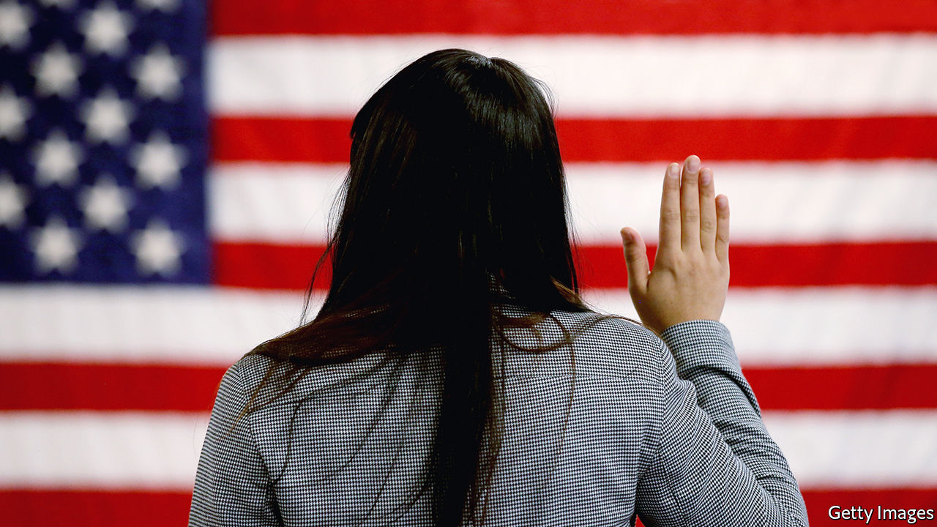

WHEN SURESH IYER, who designs trading technology for a large financial firm in New York, moved to America from Mumbai in 2013 he was not sure how long he would stay. But his career thrived, his wife moved to join him and soon they had a daughter. The family put down roots and decided they would like to settle permanently. But it is not easy. Mr Iyer—a pseudonym—is on an H1B visa, a temporary permit for highly-skilled workers. He and his wife qualify for green cards (and their daughter is an American citizen). But thanks to an annual cap on the number of cards available to Indian workers, they could be waiting decades to get them. Mr Iyer’s feels his life is on hold. “It is getting crazier and crazier,” he says.

Since long before his election in 2016 Donald Trump has attacked undocumented immigrants, whom he sees as criminals coming to sell drugs, commit crimes and steal jobs. His signature policy, to build a wall on the Mexican border, has been fitfully effected, though without the alligator moat he reportedly wanted. When Mr Trump first promised to construct the wall, he said it would have a “big beautiful door” to let in legal migrants. In fact, under his administration, legal migrants are finding themselves shut out too. It is not only those banned by the president’s more dramatic executive orders; families like Mr Iyer’s are being affected by the grinding of sand into the wheels of the immigration system. The American Immigration Lawyers Association (AILA), an industry group, calls this the president’s invisible wall.

Waiting times for almost all sorts of visas, permits and renewals have shot up. Applying for a green card while in the United States took six and a half months in 2016; it now takes almost a year. Work permits, typically issued to the spouses of certain foreign workers, which used to take two months to process, now take almost twice that on average. Overall the “adjudication rate”, or the share of applications processed in a given year, has fallen sharply, from 72% in 2015 to 56% last year. The number of visa forms outstanding is at its highest level ever, with 5.7m outstanding.

Is this gumming up of the system deliberate? It is hard to prove that, says Sarah Pierce, of the Migration Policy Institute, a think-tank. But several policies seem perfectly designed to lengthen queues. All employment-based green-card applicants must now have a face-to-face interview, which swallows up officials’ time. More and more applicants for work visas are being asked to provide supporting documents to show what their job will involve or prove their qualifications. Before Mr Trump took office, at most a fifth of workers were asked for extra evidence. In the final quarter of last year, three-fifths were.

And it is getting more expensive. Applying for a marriage-based green card, which costs $1,760 now, will rise to $2,750. Becoming a citizen will go from $640 to $1,170. Some people would even have to pay $50 to apply for asylum. Yet staffing is not increasing. In fact, as Greg Chen of AILA points out, some of the agency’s budget has even been directed towards Immigration and Customs Enforcement, the agency responsible for deportations.

When somebody was refused an extension to their visa in the past, they were usually trusted to leave the country (and most did). These days they are thrown straight into immigration courts for deportation, says Mr Chen. Many of these people probably qualified for a visa, and simply made a mistake in filling in their applications.

Some groups have been singled out. In April 2017 Mr Trump signed the “Buy American, Hire American” executive order. That tightened rules on the H1B visas, the one Mr Iyer uses, most of which go to Indian tech workers. Since Mr Trump’s executive order, denial rates have shot up, particularly at large Indian-owned consultancies. In 2016 Infosys, one such company which is the largest single recipient of H1Bs, was allowed 14,000 visas. Just 3% of applicants were rejected. By last year, the figure had fallen to just 3,200 and 36% of applicants were rejected. Consultancies are being told to provide evidence of exactly which clients their workers would be serving, for the three-year length of their visas. So much for that big beautiful door.■

This article was downloaded by calibre from <https://www.economist.com/united-states/2020/02/29/the-trump-administration-doesnt-like-high-skilled-immigrants-either>

|  |  |  |  |
| --- | --- | --- | --- |
| Previous | Articles | Sections | Next |

|  |  |  |  |
| --- | --- | --- | --- |
| Previous | Articles | Sections | Next |

#### Lexington

# The primary problem

The way American parties nominate their candidates is a recipe for a populist takeover

Feb 29th 2020 |

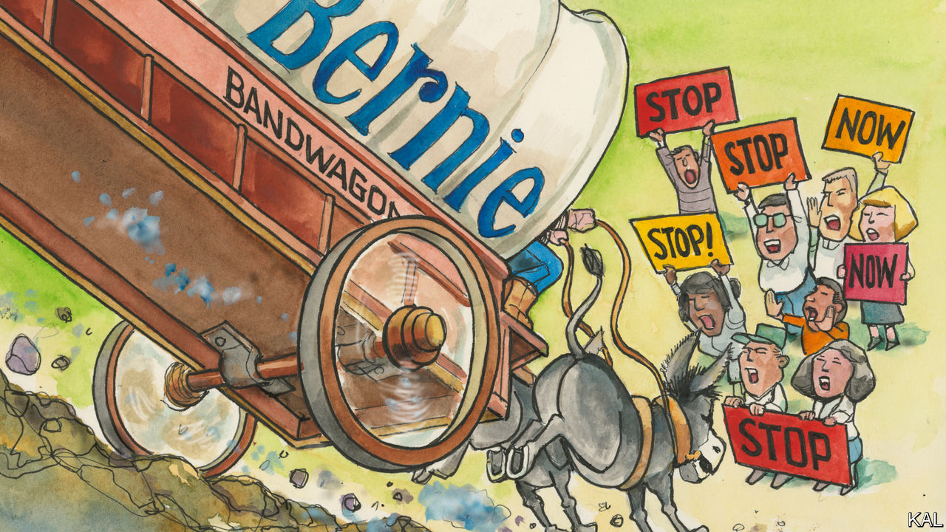

AFTER DONALD TRUMP secured the Republican presidential nomination in 2016, a scholarly tome called “The Party Decides” enjoyed brief notoriety. Its authors had argued that, though party officials no longer chose their candidates with secret pacts made in “smoke-filled rooms”, they still controlled the process through an informal system of nudges and winks to voters that might be called the “invisible primary”. The way the Republican establishment had decisively folded around George W. Bush provided evidence for this. Yet the triumph of Mr Trump, a walking-tweeting challenge to conservative orthodoxy, against the wishes of almost every elected Republican, demolished it. Having ceded power to their voters through the primary system—which both parties adopted fully in the 1970s and have made increasingly autonomous since then—party leaders had now finally lost control.

This week in Charleston, South Carolina, a seat of rebellion and insurgency, the Democratic establishment learned the same lesson. In the aftermath of Bernie Sanders’s thumping win in Nevada, it was the venue for the last televised debate before the primaries looming in South Carolina and the 14 Super Tuesday states that could give the grouchy Vermonter a decisive lead. As perhaps the last chance for Mr Sanders’s moderate opponents to turn their guns on him—and so save America’s surviving mainstream party from succumbing to populism like its rival—this was billed as a historic showdown. Mr Sanders’s armies of Twitter trolls bristled in anticipation of an “establishment plot” against him. A few brave centrists, led by the think-tank Third Way, promised them one. But from the debate’s “spin-room”—a vast media hangout from which Lexington watched the fray—the pushback was hard to detect.

Mr Sanders did take some heat. Pete Buttigieg, Amy Klobuchar, Joe Biden and Mike Bloomberg noted that his $60trn package of health-care and other plans was a fantasy. The former mayor of South Bend also expressed concern that Mr Sanders “telling people to look at the bright side of the Castro regime” might not win the heartland. Mr Biden (who had apparently been advised to shout more) attacked Mr Sanders’s past pandering to the gun lobby. And the senator, a lifelong democratic socialist and more recent Democrat, was booed when he bit back by pressing the former vice-president on trade. These hits were rehashed in the spin-room by campaign spokesmen as evidence that Mr Biden was back in the fight, that Mr Bloomberg is back on his feet, that Mr Sanders didn’t really care either way. And only the last sounded convincing. The debate to stop Mr Sanders underlined why this may now be impossible.

Start with the absurdity of counting on Mr Sanders’s moderate rivals to peg him back. They are the main reason for his rise. There are too many of them and none is a standout. Their bickering over tiny differences has fragmented the centre-left—and is utterly dull. This centre-left logjam has made Mr Sanders’s small left-wing base more potent, his leftist rhetoric more distinctive and, until now, his candidacy only indirectly threatening to his main rivals, which is why they hardly attacked him. The vanity campaigns of the Democrats’ billionaires have been even more helpful to him. Tom Steyer, a retired financier with no original ideas, has risen in South Carolina at Mr Biden’s cost by outspending the field. Mr Bloomberg, whose lavish campaign and dire political skills (again on display in Charleston) are drawing inevitable comparisons with the Wizard of Oz, has also badly reduced Mr Biden in the Super Tuesday states. Mr Sanders would be in a weaker position without them. The only way his rivals could pull back the populist senator would be by quitting and thinning the field. But, having a well-judged sense of each other’s weaknesses, they will not.

And no Democratic leader has said they should; including Barack Obama and Nancy Pelosi, whose cautionary words could actually make a difference. This underscores the fact that America’s populist drift is not inevitable. The paranoid, resentful style common to Mr Trump and Mr Sanders, despite their big differences, is not much more popular than it ever was. Even after bagging the first three states, Mr Sanders is backed by less than a third of Democrats. Yet he, like Mr Trump before him, is being propelled by ways in which social media, online fundraising and the free-floating primary system combine to reward extreme candidates: including chiefly that primary voters tend themselves to be unusually ideological, active on social media, and generous to politicians.

## What was once invisible

The good news is that some changes to the way the parties run their nominating process could make it less vulnerable to capture by zealots and, by extension, likelier to promote mainstream views that are more broadly representative. A new paper for the Brookings Institution by Raymond La Raja and Jonathan Rauch offers some suggestions, which would essentially involve reinstituting the invisible primary. They suggest, for example, that party insiders might vet candidates by setting tighter eligibility criteria and scoring them on a range of attributes. There was no intrinsic reason, they argue, why Mr Trump and Mr Sanders should have been allowed onto the debate stage of two parties they had recently joined and never prized above their personal ambitions. And against the objections of those who would recoil against such a technocratic fix, the authors argue that fetishising voter choice is not delivering democratic outcomes. “Without professional input,” they write, “the nominating process is vulnerable to manipulation by plutocrats, celebrities, media figures and activists.”

The problem is that establishment politicians are running scared of the fringe passions they helped unleash. If Mr Obama or Mrs Pelosi cannot bear to tell Mr Steyer to get out, who would lead a fight to exclude the Sandernistas from the Democratic mainstream? The idea is now unthinkable. Which means that on the left, as well as the right, a populist fire may have to rise and spread, before it can splutter, fail and Bern out.■

Dig deeper:  
Sign up and listen to Checks and Balance, our new [newsletter](https://www.economist.com/checksandbalance/) and [podcast](https://www.economist.com/podcasts/2020/02/21/checks-and-balance-our-new-weekly-podcast-on-american-politics) on American politics

This article was downloaded by calibre from <https://www.economist.com/united-states/2020/02/29/the-primary-problem>

|  |  |  |  |
| --- | --- | --- | --- |
| Previous | Articles | Sections | Next |

|  |  |  |
| --- | --- | --- |
| United States | Sections | Asia |

The Americas

Guyana: An opportunity to score

.

Carnival in Brazil: Rain delay

.

Bello: Political theatre

.

|  |  |  |
| --- | --- | --- |
| United States | Sections | Asia |

|  |  |  |  |
| --- | --- | --- | --- |
|  | Articles | Sections | Next |

#### A scoring opportunity

# Ahead of oil riches, Guyana holds a decisive election

The country’s rancorous politics could make it hard to use the bonanza well

Feb 29th 2020 | GEORGETOWN



AT ELECTION TIME, it is easy to tell which ethnic group dominates each of the villages strung out along Guyana’s Atlantic coast even without looking at the people. Where Afro-Guyanese are the main group, the green-and-yellow banners of the ruling coalition flutter. In Indo-Guyanese villages, it’s the red, gold and black of the opposition People’s Progressive Party (PPP). Voting in Guyana’s general election, due to be held on March 2nd, is likely to follow ethnic lines, as it has done for decades. This year the stakes are unusually high. That is because Guyana, South America’s third-poorest country, is about to be transformed by the petroleum that has begun to flow from vast offshore reservoirs.

Oil could change Guyana as radically as did sugar, which brought African slaves in the 18th century and indentured labourers from India in the 19th. By 2024 it could lift income per person from $5,000 to $19,000, nearly the same as in Poland. The IMF expects the economy to grow by 85% this year. By 2030 the government’s share of earnings from oil could reach $10bn in real terms, more than double last year’s GDP. This could “change us once and for all into a Singapore kind of country,” says the finance minister, Winston Jordan. Whichever party takes charge of the bounty could govern for decades. Mr Jordan calls the vote “the mother of all elections”.

Guyana, which has just 780,000 inhabitants, is better known for its problems than its successes. It has the world’s third-highest suicide rate and the highest rate of maternal mortality in South America. One reason is that it loses talent, including doctors and nurses. Its diaspora is nearly as large as its population. At least four-fifths of its university graduates leave the country. Children spend 12 years in school on average, but education is so poor they learn less than seven years’ worth of material. Most of the population, including that of Georgetown, the capital, is on the low-lying coast that is vulnerable to flooding. Two-fifths live on less than $5.50 a day.

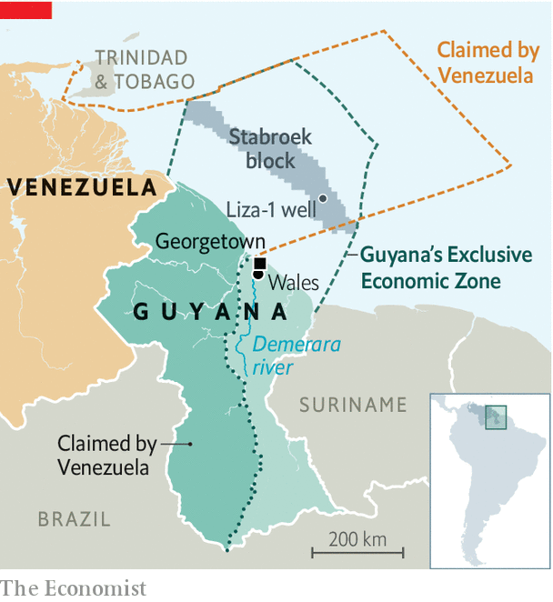

Oil riches could make life much better, but most Guyanese do not feel as if they have hit the jackpot. “We don’t know when oil comes whether we will get it or not,” says Hasser Bacchus, who lost his job cutting cane for GuySuCo, the state-owned sugar producer, which in 2017 shut down four estates and sacked 7,000 workers. He now ekes out a living plucking razor grass from abandoned sugar-cane fields in Wales, alongside the Demerara river, which he sells for bird seed at 200 Guyanese dollars (96 cents) a bundle. Alex Paul Singh, a former sugar worker who sells chickens by a roadside, thinks “oil could help Guyana a lot.” But if it’s not properly managed Guyana could become “like Nigeria or Venezuela”, whose oil-rich economies are subverted by corruption. Almost every Guyanese seems to be aware that, like a downpour on parched ground, a torrent of oil money could bring destruction rather than relief.

That worry makes Guyana’s polarised politics even more rancorous, which in turn increases the risk that the money will be misspent. The election is a delayed reaction to a vote of no-confidence in the government in 2018. That was caused by the defection of an Indo-Guyanese MP who belonged to the Alliance for Change (AFC), the junior partner of President David Granger’s A Partnership for National Unity (APNU), itself an alliance of parties. The government manoeuvred to postpone the election for a year. That infuriated the PPP and has delayed many of the decisions that a country on the cusp of oil riches would be expected to make.

The campaign has been inflamed by allegations that the government mishandled negotiations with ExxonMobil, which holds the licence to operate Liza-1, Guyana’s first productive oil well, and others in the promising Stabroek block. A report this month by Global Witness, a pressure group, claims that the deal signed in 2016 by Raphael Trotman, the natural-resources minister, so favoured Exxon that it made Guyana up to $55bn poorer than it should have been. That is 11 times the country’s GDP. After Exxon wined and dined him, the report claims, he signed a bad agreement. It entitles Guyana to a 2% royalty and just 50% of “profit oil”, ie, after deducting the operators’ costs. Global Witness says the government’s total take should be at least 69%. Bharrat Jagdeo, a former Guyanese president who remains the PPP’s most powerful figure, has said that Mr Trotman “shafted the country”.

The agreement may be evidence of Guyana’s weak position rather than malign intent. It has a history of unsuccessfully prospecting for oil that goes back to the 1930s, the government points out. Operators like Exxon needed big incentives to keep trying. And Guyana needs help in defending itself against Venezuela’s claim to two-thirds of its territory, including a big chunk of its offshore oil reserves. It is fighting Venezuela’s claim at the International Court of Justice in The Hague, which is due to hold preliminary hearings in late March.

## My bodyguards

The real muscle, Guyana believes, comes from Exxon and its Chinese partner in the Stabroek block, the China National Offshore Oil Corporation. “Our number-one interest was to get a big bad wolf onto the shelf,” says Mr Jordan, the finance minister. In Exxon, whose Venezuelan operation was acrimoniously nationalised in 2007, “we found the ideal one”. Rystad, a consultancy, disputes Global Witness’s estimate of the government’s share of oil. It puts the government’s take at 60%, in line with agreements struck by countries with similar characteristics.

To achieve Singapore’s living standards, Guyana will need a state that approaches Singaporean levels of effectiveness. It is not anywhere close. “Our systems are broken,” says Mr Jordan. “We can’t even run the existing spending that we’re doing.”

The government has begun to address these shortcomings. Guyana’s main defence against petroleum perils is its sovereign-wealth fund, called the Natural Resource Fund (NRF). All the money from oil, and perhaps from mines and forests, is to flow into an account at the New York Federal Reserve. To prevent inflation and Dutch disease—an overvalued exchange rate that makes other industries uncompetitive—and preserve the money for future Guyanese, the government has devised rules that restrict the drawdown. In the early years, when production is low, the government will be able to take out of the fund no more than two-thirds of the revenue that flows into it. At 102,000 barrels a day, the IMF’s forecast for this year, that would be about $230m, 18% of non-oil revenue. As the inflow increases and the fund grows, the share going to the budget will shrink but the absolute amount will rise. Mr Jordan rules out borrowing money against expected earnings, a practice that backfired on such countries as Ghana.

The principles for spending the money are in the “Green State Development Strategy”, which tries to reconcile Guyana’s new status as a petro-state with such goals as generating nearly all electricity from renewable and “clean” sources by 2040. Some of the cash will need to be spent on shoring up defences against rising sea levels. But the principles must be translated into projects. The institutions needed to implement them with competence and honesty are in their infancy. Greenery and prudence could be subverted by politics.

In principle, the PPP agrees with those aims. The green plan builds on a Low Carbon Development Strategy introduced by Mr Jagdeo when he was president in 2009. On use of oil money, he sounds more cautious than the government. He blasts the NRF law, because it gives the finance minister too much power. If Irfaan Ali, the PPP’s presidential candidate, wins, “we will repeal this and quickly replace it with one that moves politicians away from management of the fund,” Mr Jagdeo promises. Guyana needs a “national consensus” on how it manages its oil riches, he says. Mr Jordan wants much the same thing.

That is just what the country’s racially charged politics may prevent. Afro-Guyanese remember the PPP’s 23-year rule, until 2015, as a time of corruption and Indo-Guyanese triumphalism. Those of Indian origin hurl similar accusations at Mr Granger’s government, though the AFC brought more racial diversity to the coalition and independent observers regard the president himself as honest. Rage is especially intense near the shuttered sugar estates. If the APNU wins re-election, “people will not accept the results”, says an official from the Guyana Agricultural and General Workers’ Union, which represents sugar-cane workers and is linked to the PPP.

The antagonism is made sharper by Guyana’s electoral system, which awards seats in the National Assembly on the basis of proportional representation. After elections party leaders handpick the politicians who occupy the legislature’s 65 seats, including the 25 regional seats. They are thus more beholden to their leaders than to racially mixed groups of constituents.

The main hope for ending the standoff rests with mixed-race and indigenous Guyanese, whose weight in the population is increasing. An array of third parties is trying to break the duopoly. Lenox Shuman, the presidential candidate of the Liberty & Justice Party, which represents mainly indigenous people, hopes to be “the balance of power and bring reason to the house”. With more reason and less rancour, Guyana will have a better chance of making the most of its new riches. ■

This article was downloaded by calibre from <https://www.economist.com/the-americas/2020/02/29/ahead-of-oil-riches-guyana-holds-a-decisive-election>

|  |  |  |  |
| --- | --- | --- | --- |
|  | Articles | Sections | Next |

|  |  |  |  |
| --- | --- | --- | --- |
| Previous | Articles | Sections | Next |

#### Rain delay

# A beer company tries to keep Brazilian Carnival revellers dry

Cloud-seeding is not a foolproof method

Feb 29th 2020 | SÃO PAULO



THUNDERSTORMS OFTEN show up uninvited to Carnival in Brazil. The authorities in Rio de Janeiro used to share meteorological data with a group of spiritual mediums who claimed to have rain-dispelling powers. That ended with the election of an evangelical mayor in 2016.

This year’s attempt to sway the skies took place in São Paulo as part of a publicity stunt by the party’s official sponsor, Skol, a Brazilian beer brand. “The fun stops when it rains,” says Pedro Adamy, Skol’s marketing director. So do beer sales.

Enter a company called ModClima. A ModClima aeroplane painted with Skol’s logo spritzed water droplets into cumulus clouds to make rain fall before the clouds reached the city. According to a zippy YouTube video that has been viewed 12m times, “Giro na Chuva” (roughly, Reverse the Rain) is a “mission worthy of science fiction”.

Whether it’s science or fiction is up for debate. The use of cloud-seeding to increase rainfall dates back to the 1940s. But the United States government stopped funding it in the 1980s due to a lack of “scientific proof of the efficacy of intentional weather modification”, according to the National Research Council. A new paper based on experiments in Idaho found that seeding clouds with silver iodide increased snowfall on three occasions, but the authors say that more research is needed to figure out if it can reliably promote precipitation. Paulo Artaxo, a Brazilian physicist, says flatly that cloud-seeding is “useless”.

Still, governments and firms in many countries use the technology. The city of Beijing tried cloud-seeding to divert rain away from the Olympic games in 2008. São Paulo’s water company has signed million-dollar contracts with ModClima to induce rain over reservoirs, most recently during a drought in 2014-15. Although cloud-seeding normally uses a chemical such as silver iodide to provide a surface around which water or ice droplets form, ModClima says it has invented an “experimental” method that uses water alone. Droplets sprayed into clouds expand as they are lifted by air currents and collide with others, forming raindrops, the firm claims.

Carnival-goers cheered when the first two days were cloudy but dry. “Not all heroes wear capes,” one wrote on her retweet of Skol’s video. But at around 5pm on February 24th, the sky darkened and rain pelted down. Revellers at one block party left the Skol stands and flocked to a vendor selling plastic rain capes. “Only God can control the weather,” said the poncho man.■

This article was downloaded by calibre from <https://www.economist.com/the-americas/2020/02/29/a-beer-company-tries-to-keep-brazilian-carnival-revellers-dry>

|  |  |  |  |
| --- | --- | --- | --- |
| Previous | Articles | Sections | Next |

|  |  |  |  |
| --- | --- | --- | --- |
| Previous | Articles | Sections | Next |

#### Bello

# Mexico needs statecraft, yet its president offers theatre

AMLO shows little ability to get to grips with governing

Feb 29th 2020 |

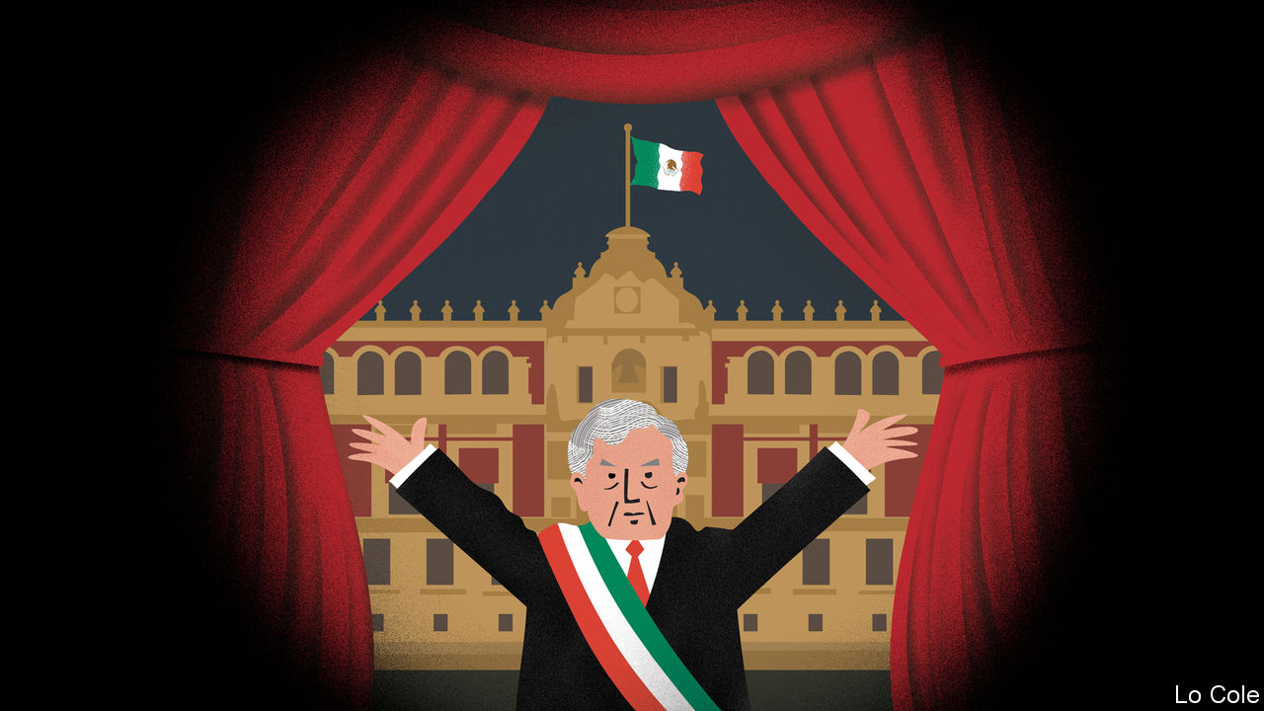

MEXICANS HAVE been outraged this month by two brutal murders: one of a woman whose body was mutilated by her partner, the other of a seven-year-old girl who was kidnapped and seemingly tortured. Needless to say, neither of these cases was the fault of Mexico’s president, Andrés Manuel López Obrador (known as AMLO). But he is the man in charge. When questioned at his early-morning press conferences about the wave of violence against women in his country, his first response was to blame a “progressive degradation [in Mexican society] which had to do with the neoliberal model” that he accuses his predecessors of adopting. He then claimed that feminist groups, who blame the violence on patriarchy and lawlessness, had been infiltrated by conservatives, and tried to change the subject.

This episode conforms to the pattern of AMLO’s 15 months in the presidency. If the motto of Porfirio Díaz, Mexico’s dictator from 1877 to 1911, was “little politics, much administration”, AMLO’s guiding formula seems to be almost the opposite. He inherited three big problems: rampant crime, including violence against women; slow economic growth; and corruption. On the first two issues, Mexico is at best treading water.

A 12-year war with drug gangs drove the murder rate up and helped spread insecurity across the country. AMLO promised to stop this and tackle the causes of crime, offering “hugs, not bullets”. His government has given scholarships to some 800,000 young dropouts, but there is little sign that this will help them get jobs. More significant is a new paramilitary National Guard, 70,000-strong and due to rise to 150,000 troops by 2021. When the new force was first conceived of a decade ago, the idea was that it would work to take back control of violent rural areas from the drug gangs. AMLO is spreading it thinly across the country (and using it to stop migrants crossing the southern border, at Donald Trump’s behest). It is replacing the federal police, whom he distrusts.

Although the number of murders rose last year to 34,582, a record since statistics began in 1990, the peak came in the third quarter of 2018. AMLO appears to have given instructions to the security forces to minimise the use of lethal force, according to Eduardo Guerrero, a security consultant, writing in Nexos, a magazine. The problem is that this may reduce violence, but not crime. “Between half and two-thirds of the country is not under the effective control of the state,” says a foreign security specialist. Two incidents last year illustrated that. In October troops in the city of Culiacán were ordered to release the son of Joaquín “El Chapo” Guzmán, a notorious drug trafficker, after his arrest triggered a battle. In November three Mormon women and six children with dual Mexican and American citizenship were murdered when gunmen shot at their vehicles near the northern border.

The economy is no brighter. It shrank slightly last year, the worst performance since 2009. Many economists blame AMLO’s policies. One of his first acts was to cancel a $13bn half-built airport in Mexico City. He has stalled private investment in energy, on nationalist grounds. The government will pay for AMLO’s pet $7.4bn railway in the south-east, after it failed to interest investors.

AMLO argues, correctly, that incomes of poorer Mexicans rose sharply last year, through handouts and an increase in the minimum wage. But there is little reason to believe that investment or growth will revive. The president promised not to increase taxes in his first three years. But this month he invited business leaders to a frugal dinner and asked them to buy tickets for a “lottery” whose proceeds would be used for medical equipment. This shakedown raised $80m and distracted attention from femicides, but will do nothing for business confidence.

This poor policy performance is bad for Mexico, but not necessarily for the president. Polls put his approval rating at between 55% and 72%. Many poorer Mexicans see him as honest and on their side. His potential Achilles heel is crime and insecurity. His remedy is likely to be more political theatre, at which he is a master. The undoubted corruption of the previous government of Enrique Peña Nieto may give him plenty of material. This month the former head of Pemex, the state oil company, was arrested in Spain. The Wall Street Journal then reported that prosecutors are investigating Mr Peña. (Both men deny wrongdoing.) AMLO claimed no knowledge of that. But it is hard to imagine that the showman will miss an opportunity like this.

This article was downloaded by calibre from <https://www.economist.com/the-americas/2020/02/29/mexico-needs-statecraft-yet-its-president-offers-theatre>

|  |  |  |  |
| --- | --- | --- | --- |
| Previous | Articles | Sections | Next |

|  |  |  |
| --- | --- | --- |
| The Americas | Sections | China |

Asia

Afghanistan: Can it be?

.

Thai politics: Too forward

.

Political reform in Kazakhstan: Democracy is on its way

.

Malaysian politics: The old men and the seats

.

Banyan: The trumpets sound

.

Japanese abroad: The endangered tourist

.

Sectarian violence in India: A tale of two neighbourhoods

.

|  |  |  |
| --- | --- | --- |
| The Americas | Sections | China |

|  |  |  |  |
| --- | --- | --- | --- |
|  | Articles | Sections | Next |

#### Can it be?

# America and the Taliban prepare to sign a peace deal

But ending Afghanistan’s long civil war will not be easy

Feb 29th 2020 | KABUL

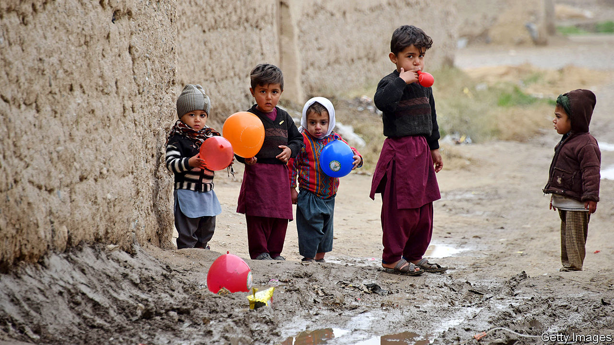

AFGHANISTAN AND optimism do not tend to go hand in hand, so the mood of quiet anticipation around the country in recent days has been striking. Afghans hope that America and the insurgents of the Taliban, who have been fighting one another for more than 18 years, will sign a peace deal on February 29th. That, in turn, hinges on whether the week-long “reduction in violence” that the two sides have promised is maintained until then. Even if the agreement is indeed signed as planned, however, peace remains a long way off.

The partial truce began on February 22nd, the product of more than 18 months of negotiations between the Taliban and America in Qatar. The two sides did not make public exactly how peaceful they expected one another to be, and America and its allies in NATO have not revealed their count of violent incidents. Afghan news reports say the Taliban are expected to spare towns and cities, as well as military bases and highways. The Taliban leadership told its fighters to “remain defensively alert” but “strictly refrain from entering enemy territory”. Afghan and American forces, for their part, said they would shoot only in self-defence, although they also vowed to continue fighting the Afghan wing of Islamic State.

Both sides seem to be sticking to these terms. According to the Afghanistan Analysts Network, a research group, a typical February in recent years has seen an average of 57 breaches of the peace every day. Afghan journalists reckon that since the truce began, clashes have fallen by more than 90%, to three or four a day. Although some Afghan soldiers and civilians have been killed, there have been far fewer deaths than usual, and no recriminations from either side. General Scott Miller, the commander of NATO forces, spoke on February 25th of a “downward trend in violence” which was “great for Afghanistan”.

The logic of the reduction in violence is twofold. First, the lull is a trust-building measure, to show the Taliban are serious about peace even if they are not prepared to agree to a complete ceasefire. Second, the calm is intended to demonstrate that the militants can control their fighters—a subject in some doubt, since the bigger conflict subsumes all manner of local disputes and tribal rivalries.

As The Economist went to press, it seemed likely that the truce would hold, and that the signing of the peace agreement would go ahead as planned in Doha, the capital of Qatar. The outlines of the deal remain as they were in September, when President Donald Trump abruptly called off talks in anger at continued Taliban attacks. America will quickly reduce its troops in Afghanistan from about 12,000 to about 8,600. In exchange, the Taliban will promise not to give shelter to foreign terrorists groups such as al-Qaeda, and to begin negotiations with civilian politicians and other community leaders about how Afghanistan should be run. During those negotiations, America will trim its garrison further. The ultimate goal is some sort of power-sharing agreement between Afghan politicians and the Taliban, an end to all hostilities and a withdrawal of all, or almost all, American troops.

American officials deny that Mr Trump is running for the door. The troop withdrawal will be “conditions-based”, insists Mark Esper, the secretary of defence. But exactly what those conditions are—and what happens if they are breached—has not been disclosed. The Taliban, too, have tried to persuade sceptics of their sincerity. Sirajuddin Haqqani, their fearsome deputy leader, best known for ordering indiscriminate car-bombings, used the opinion pages of the New York Times to declare his desire for an end to violence and the creation of an inclusive government.

Forging a political agreement among the Taliban, the government and Afghanistan’s many warlords and powerbrokers will be extremely hard, however. Symptomatic of the difficulties is a fierce row about who should be president. After a five-month count, the election commission recently declared that Ashraf Ghani had been re-elected in a vote that took place in September. His main rival, Abdullah Abdullah, disputes the results and says he is forming his own government.

“It is time to focus not on electoral politics, but on taking steps toward a lasting peace,” America’s State Department declared in a statement on February 25th. Mr Ghani has agreed to postpone his inauguration, American officials said, presumably to allow time to iron out the dispute.

Bigger arguments loom. “What kind of political system will there be and who will be grabbing the most part of the government, or the authority,” says Abdul Hakim Mujahid, a Taliban official turned peace-campaigner. “This will be the field of competition.” On one side are Afghans who want the Taliban to accept the current democratic constitution, with its protections for women and minorities. But some Taliban hardliners view the status quo as the product of American occupation, and want to reimpose the Islamic “emirate” the Taliban ran in the 1990s.

Whatever happens next, Afghans welcome the current respite. In some war-battered districts it has been celebrated with spontaneous sports matches and dancing. Mobile-phone service has also been restored in territory where it is frequently cut by militants. “We are thirsty for peace,” says Muhammad Ehsan, a politician from Kandahar. “It’s a priority for us.” The country is holding its breath. ■

This article was downloaded by calibre from <https://www.economist.com/asia/2020/02/29/america-and-the-taliban-prepare-to-sign-a-peace-deal>

|  |  |  |  |
| --- | --- | --- | --- |
|  | Articles | Sections | Next |

|  |  |  |  |
| --- | --- | --- | --- |
| Previous | Articles | Sections | Next |

#### Too forward

# Thailand’s courts ban the country’s third-biggest political party

Future Forward had presented itself as a way out of the schism that defines Thai politics

Feb 29th 2020 | BANGKOK

AS THEY WAITED inside headquarters to hear whether Future Forward would be dissolved, supporters of the plucky opposition party queued to buy its merchandise. For those already in possession of an orange T-shirt or cap, there were bags and umbrellas, as well as mugs reading “Keep calm and love democracy”. Purchases raised money for the party. But it was precisely Future Forward’s funding methods that led the constitutional court to dissolve it later in the afternoon of February 21st.

At issue was Future Forward’s acceptance of a loan of 191m baht ($6.1m) from Thanathorn Juangroongruangkit, a car-parts billionaire who leads the party, ahead of last year’s parliamentary election. Electoral law caps contributions from individuals at 10m baht, but Future Forward argued that a loan was a distinct category, not covered by this rule. The court disagreed, and judged the loan illegal. It disbanded the party and banned Mr Thanathorn and other party executives from politics for a decade. It stressed that they may not launch new parties.

The decision resolves just one of more than two dozen cases working their way through the legal system involving Future Forward, its leader or other members of the party. In November the constitutional court stripped Mr Thanathorn of his parliamentary seat. It ruled that he had violated election laws which bar those with shares in media firms from running for parliament. To reach that verdict, it ignored evidence that the firm in question was defunct and that Mr Thanathorn had anyway sold his shares. Even when the firm was in business, it had produced only glossy magazines—presumably not the sort of outlet legislators had in mind when they banned media moguls from dabbling in politics.

The legal onslaught against Future Forward began after its surprisingly strong showing in the election, at which a military junta that had seized control of the country in 2014 supposedly handed power back to civilians. Founded only in 2018, the party came third overall and drew particular support from young people. Its platform of taming the army, decentralising government and tackling business monopolies had wide appeal. Mr Thanathorn subsequently sought the position of prime minister. But Prayuth Chan-ocha, the junta-leader-turned-prime-minister, remained in office with the support of pro-army parties. The army had worked hard to ensure that the election would be held under conditions that favoured its supporters. Even so, it only just managed to scrape together a parliamentary majority.

In the short term, Mr Prayuth’s position has been strengthened by Future Forward’s demise. Nine of its 65 now-homeless MPs are joining Bhumjaithai, a party in the governing coalition. But the banning also demonstrates the hollowness of Mr Prayuth’s claim to have restored democracy. Indeed, students at several universities held candlelit vigils or mock funerals for democracy in the wake of the decision.

Although the constitutional court has dissolved eight political parties since 2006, until now the targets had been allies of Thaksin Shinawatra, a telecoms tycoon whose government was ousted in a coup that year, sparking a feud between pro-Thaksin “red shirts” and pro-army, monarchist “yellow shirts” that has dominated Thai politics ever since. Future Forward was neither clearly red nor yellow. Indeed, its colour, orange, spoke of a third way that could appeal to partisans of both tendencies. By banning it, the current regime has proved once and for all that it does not simply want to restore order and break the political logjam, as often claimed, but to run the country without opposition. ■

This article was downloaded by calibre from <https://www.economist.com/asia/2020/02/29/thailands-courts-ban-the-countrys-third-biggest-political-party>

|  |  |  |  |
| --- | --- | --- | --- |
| Previous | Articles | Sections | Next |

|  |  |  |  |
| --- | --- | --- | --- |
| Previous | Articles | Sections | Next |

#### Party-pooper

# Kazakhstan’s president says democracy is on its way

But the riot police seem to have arrived first

Feb 29th 2020 | ALMATY

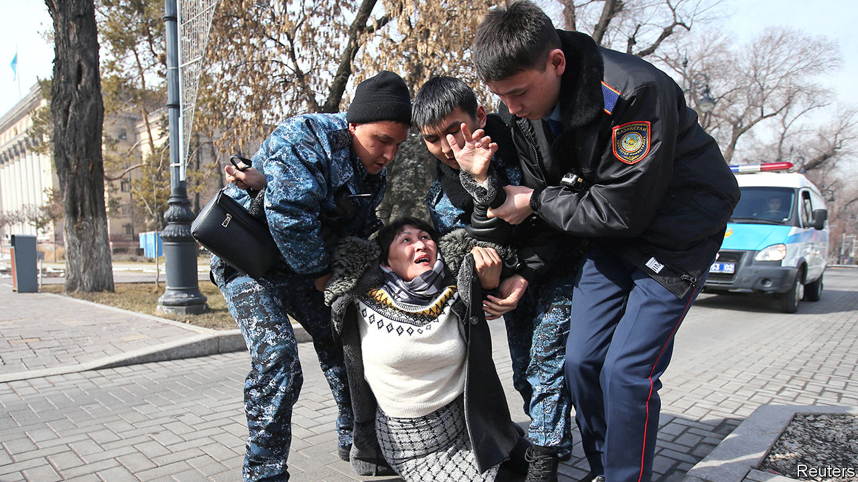

THE PRESIDENT of Kazakhstan, Kassym-Jomart Tokayev, likes to bang on about political reform. The oil-rich Central Asian country’s rubber-stamp parliament needs an opposition, he says, and its citizens need greater freedom to form political parties and hold peaceful protests. But when Zhanbolat Mamay, a 31-year-old documentary-maker, took Mr Tokayev at his word and tried to set up a new force called the Democratic Party, he found himself behind bars after complaining about harassment of his supporters. When the party called off its founding congress and called for a public protest instead, a further 70 members were detained. The handful who made it to the protest site, including Mr Mamay’s wife, were arrested on the spot.

It was a busy weekend for the police, who detained scores more demonstrators at separate protests organised by Democratic Choice of Kazakhstan, a banned movement led by a rich Kazakh, Mukhtar Ablyazov, who lives in France. In Almaty the detainees included Erik Zhumabayev, a disabled man who attended a demonstration in his wheelchair. A prominent activist, Dulat Agadil, died in custody in Nur-Sultan, the capital, a few days later. That brought more protesters onto the streets, leading to more arrests.

The detentions followed the government’s publication of a bill ostensibly intended to loosen restrictions on free assembly, but which critics say would actually impose new ones. Some 5,000 people were arrested at pro-democracy rallies last year. The demonstrations began after Nursultan Nazarbayev, Kazakhstan’s strongman of 30 years, abruptly resigned, handing power to Mr Tokayev with little pretence of a democratic transition. Mr Nazarbayev, who still pulls the political strings, has never shown any tolerance of dissent. Mr Tokayev likes to paint himself as a reformer, poised to overhaul the old order. The latest clampdown sends “a clear message” that liberalisation is not on the cards, says Mr Mamay, who was released after two days’ detention. He plans to try again to form his new party, but no doubt hopes not to have to do so from a cell.

This article was downloaded by calibre from <https://www.economist.com/asia/2020/02/29/kazakhstans-president-says-democracy-is-on-its-way>

|  |  |  |  |
| --- | --- | --- | --- |
| Previous | Articles | Sections | Next |

|  |  |  |  |
| --- | --- | --- | --- |
| Previous | Articles | Sections | Next |

#### The old men and the seats

# A botched power grab leaves Malaysia without a government

The 20-year feud between Mahathir Mohamad and Anwar Ibrahim is roiling politics again

Feb 29th 2020 | KUALA LUMPUR

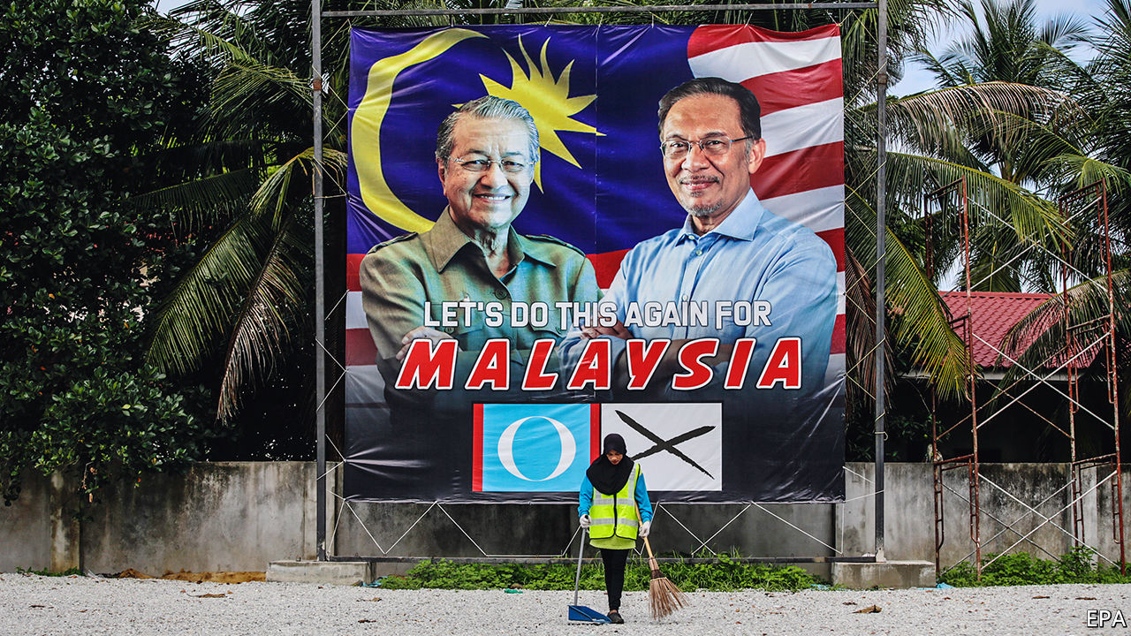

THE PICTURES showed Mahathir Mohamad, the prime minister, working calmly at his desk. “Just another day in the office”, read the accompanying caption, tweeted on February 25th. Yet outside the doors of his office there was pandemonium. The day before, Dr Mahathir had resigned as prime minister and as leader of Bersatu, one of the parties in the governing coalition. The king, however, had promptly reappointed the 94-year-old as a caretaker while he and all Malaysia tried to work out whether any of the various contenders to form a new government could command a majority in parliament.

The drama began with a failed attempt at a parliamentary coup. Bersatu announced that it would leave the ruling coalition, Pakatan Harapan, as did 11 malcontents from another of the alliance’s components, Parti Keadilan Rakyat (PKR). These rebels had planned to form a government with the support of the opposition, but were wrongfooted when Dr Mahathir—whose backing the ringleaders seem to have expected—instead resigned.

The chaos stems from a simmering dispute over how long Dr Mahathir should stay on as prime minister and who should succeed him. He is a towering but controversial figure, having served as prime minister from 1981 to 2003 as the head of the United Malays National Organisation (UMNO), the ruling party from independence in 1957 until 2018. Horrified by corruption within more recent UMNO governments, Dr Mahathir left the party and set up Bersatu. But he only became Pakatan Harapan’s candidate for prime minister at elections in 2018 because Anwar Ibrahim, the leader of PKR, a much bigger party, was in jail after a prosecution that PKR insisted was politically motivated. After winning the election, Dr Mahathir secured a pardon for Mr Anwar and promised to hand power to him soon. But soon gradually turned into two years, prompting much grumbling from Mr Anwar’s camp.

What is more, rumours began to circulate that, whenever Dr Mahathir did step down, he was hoping to be succeeded not by Mr Anwar, but by Azmin Ali, another senior figure in PKR. It is Mr Azmin who leads the faction that broke away from PKR this week. But the extent of Dr Mahathir’s involvement in that rupture, if any, remains a mystery. “Did he have a change of heart, or did he get cold feet?” asks a mystified political adviser.

At the heart of this soap opera are both personal and political divisions. Dr Mahathir and Mr Anwar have a fraught history. Dr Mahathir sacked Mr Anwar as his deputy in 1998, after the two clashed over how best to respond to the Asian financial crisis. Mr Anwar was beaten up in jail and later convicted on trumped-up charges of sodomy (a crime in Malaysia) and corruption. He became a figurehead for those campaigning for reform and led opposition to UMNO in between stints in prison.

That experience led Mr Anwar to change his ideological stance as well as his party. About 69% of Malaysia’s 32m people are bumiputras: Malays and other indigenous groups. A further 24% are ethnic Chinese and 7% are Indian. Bumiputras have tended to support UMNO because it champions and defends policies to boost them economically. Bersatu does too. Much of the rest of the population resents the privileges accorded to Malays. The Democratic Action Party (DAP), another component of Pakatan Harapan, represents Chinese interests. PKR, although led by Mr Anwar, a Malay, has members from all of Malaysia’s biggest ethnic groups and makes noises about multiculturalism and meritocracy.

The ideological tensions among the parties in Pakatan Harapan worsened as Malay voters turned away from the government. That is probably a function of the struggling economy, which grew by only 3.6% year-on-year in the last quarter of 2019, its slowest pace in a decade. Shortly after the coalition won power, 63% of Malays thought the country was “going in the right direction”, according to the Merdeka Center, a pollster. Within a year that had plummeted to 24%. The coalition has lost five by-elections to opposition candidates. Claims from UMNO and the other big opposition party, PAS, that Pakatan Harapan was neglecting Malay voters clearly resonated with the electorate. That, in turn, seems to have alarmed Bersatu and the defecting members of PKR.

Dr Mahathir is presenting himself as a unifying figure again, who could rise above all this infighting. “If I am allowed, I will try to form an administration that doesn’t side with any party. Only national interests will be prioritised,” he said this week in a televised address. But it is doubtful that he can reassemble his fractured government, since Mr Anwar has now laid claim to the job of prime minister. The remaining parties in Pakatan Harapan seem inclined to side with Mr Anwar, since they fear that their influence will diminish under a broader coalition led by Dr Mahathir. In theory, the opposition could try to form a government, with UMNO and PAS as its mainstays. But they are far short of the necessary 112 seats in the 222-member parliament and would probably prefer a snap election anyway.

That leaves Mr Anwar scrabbling to clinch enough support from mercenary parties from Sabah and Sarawak, states in Malaysia’s bit of Borneo. He might also entice some migrants from Bersatu or win back a few PKR rebels. If he fails to do so, however, the consequences are likely to be fatal for his 20-year-old ambition to become prime minister. Voters, already put off by the endless bickering within Pakatan Harapan, have presumably been even less impressed with the frantic horse-trading of the past few days. ■

This article was downloaded by calibre from <https://www.economist.com/asia/2020/02/29/a-botched-power-grab-leaves-malaysia-without-a-government>

|  |  |  |  |
| --- | --- | --- | --- |
| Previous | Articles | Sections | Next |

|  |  |  |  |
| --- | --- | --- | --- |
| Previous | Articles | Sections | Next |

#### The trumpets sound

# Of all Sri Lanka’s conflicts, the one with elephants is the oldest

The fight between people and pachyderms is growing ever more intense

Feb 29th 2020 |

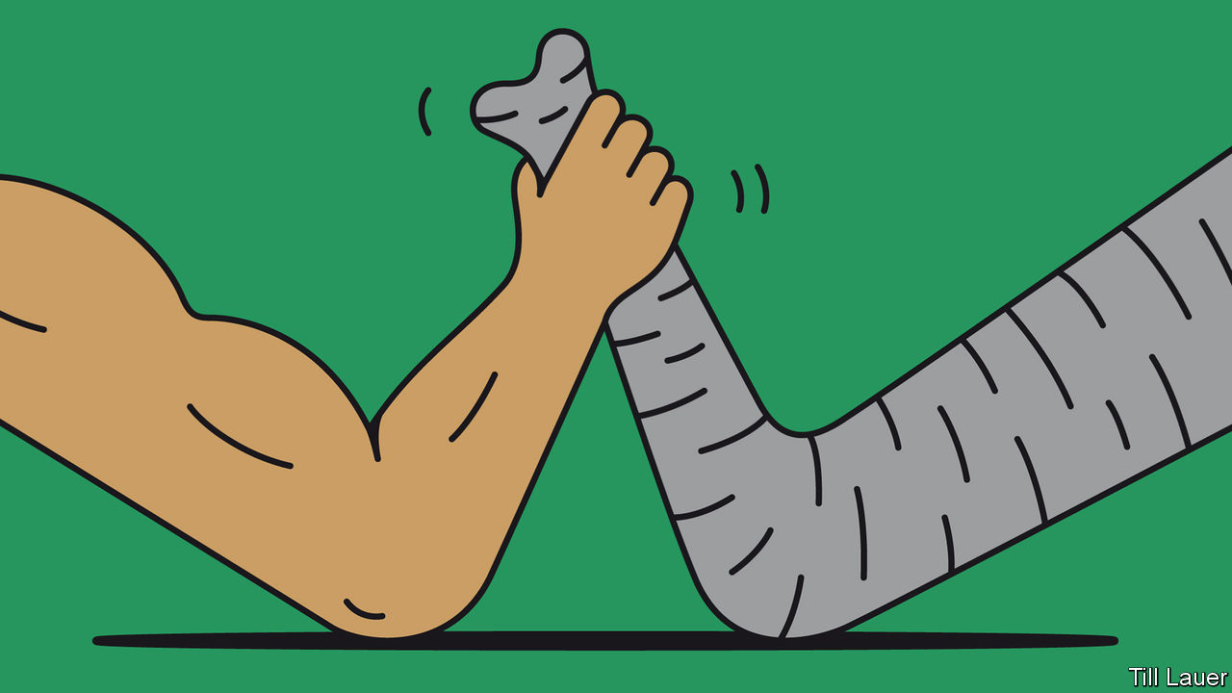

AS TROPICAL DUSK turns to night outside Galgamuwa, fireflies are not the only points of light around Lalith’s little rice paddy, the last field in the valley waiting to be harvested. On one side, bonfires are blazing in neighbours’ fields. On the other, Lalith’s nephew is shining a torch out of one of the impressive tree houses that dot this part of the country. And in the middle of his paddy, seated around embers that are boiling a kettle, Lalith and friends are playing a furious card game that resembles whist.

Two dozen men are helping in all: this is Lalith’s watch against elephants emerging from the forest at night. Growing rice is like laying out dinner. A herd of cows and their calves can snaffle a year’s livelihood in a matter of minutes.

Sri Lankans’ relationship with wild elephants is as ancient as it is complex. Curiously biddable and formidable in war, the animals were of great value to Sinhalese kings, who used them to build imposing monuments. The Portuguese brought the first Sri Lankan elephant to Europe: fed on cake, it died of dyspepsia and lies buried in the Vatican Gardens. British settlers used elephants to clear forest for their tea plantations.

As John Gimlette, a writer on Sri Lanka, puts it, elephants have served as tractor, limousine, warhorse and executioner. Today very few remain enslaved, but 6,000-plus wild animals roam the countryside. There, “human-elephant conflict” has always been an issue. Humans have been chasing away elephants for as long they have been growing crops; elephants have long flattened both. So how to explain an alarming increase in human-elephant collisions in just the past couple of years? Until recently 200-250 elephants died at human hands every year. But in 2018 the toll climbed to 319, and to 386 last year. Over the same period, human fatalities have risen sharply, to 114 last year.

Prithiviraj Fernando, who runs the Centre for Conservation and Research (CCR), says it is the baneful consequence of a kind of arms race. Finding that increasingly fearless elephants could not be chased away with shouts or stones, villagers in recent years have used huge firecrackers, subsidised by the government, which sound like bombs going off. The elephants have learned to ignore them. They deal with electric fences by, for instance, uprooting trees and dropping them on the wires. Some law-breaking villagers pepper animals with shot, set snares to catch trunks or legs, or plant explosives in pumpkins that mangle animals’ mouths and lead to horrific deaths by starvation.

Only last week, in another area near Galgamuwa, a villager rigged a fence to mains electricity, killing a bull. Meanwhile, under a recent minister, Sarath Fonseka, the Department of Wildlife Conservation began calling for more guns to drive away elephants. Field Marshal Fonseka found a similar approach effective against humans when he commanded the Sri Lankan army during the brutal civil war that ended in 2009.

Peppered, taunted and maimed, elephants have unsurprisingly grown more aggressive, readier to charge when threatened than to run away. Relocating peccant pachyderms to national parks, another strategy popular with politicians, is also ineffective. Elephants, as Mr Fernando puts it, do not recognise park boundaries. They will sometimes travel hundreds of kilometres to return to their home range.

Persecution has proven disastrous for both species. Clearly, something needs to be done. In just under half of Sri Lanka, elephants and people live near each other. Meanwhile, fragmentation of forests and development stand in the way of the alimankada, the elephantine pathways that criss-cross the island and that the animals insist on following.

Permanent electric fences around national parks and fields are of no help to man or beast. CCR’s solution is to protect settlements but fence fields only during the growing season. After the harvest, the land is for the elephants. Around Galgamuwa, villagers have long been receptive to a more flexible approach, even if politicians do not see what is in it for them.

The animals seem to appreciate a kindly touch. In the middle of his paddy, Lalith and his neighbours demonstrate their technique, passed down for generations. They sing to the animals: “Go away, little babies, go away. But once we’ve gathered the harvest, anything we leave is yours.” How on earth, Banyan asks, can that work? It just does, Lalith replies. After all, he adds, “We’re still here, and so are the elephants.”

This article was downloaded by calibre from <https://www.economist.com/asia/2020/02/29/of-all-sri-lankas-conflicts-the-one-with-elephants-is-the-oldest>

|  |  |  |  |
| --- | --- | --- | --- |
| Previous | Articles | Sections | Next |

|  |  |  |  |
| --- | --- | --- | --- |
| Previous | Articles | Sections | Next |

#### The endangered tourist

# Fewer and fewer Japanese want to see the world

Only 24% of them even have a passport—the lowest proportion among rich countries

Feb 29th 2020 | TOKYO



NO FEWER THAN 191 countries admit Japanese visitors without a visa. That is twice as many as wave through Kuwaitis, for example, and five times the number that let in Nepalese without hesitation. By that measure, Japan’s chrysanthemum-decorated passport is the most welcomed in the world. Yet only 24% of Japanese possess one—about half the proportion of Americans who have a passport (see chart). Why do so few Japanese take advantage of their freedom to wander the globe?

On paper, Japanese are venturing abroad more often. They went on roughly 20m overseas trips in 2019, up from 19m in 2018. But that figure is inflated by people travelling for work and by frequent flyers. The share of people who hold a passport has been slowly falling, from 27% in 2005. Morishita Masami, who chaired a government committee to promote outbound travel, estimates that at least two-thirds of Japanese are lukewarm about the idea of leaving the country. Several factors deter them: miserly annual leave, concerns about safety, the inferiority of foreign food and, most of all, a crippling fear of the embarrassment of not being understood. Sluggish wage growth and a weak yen have made travel less affordable. Even pensioners, who have plenty of free time and disposable income, are travelling less.

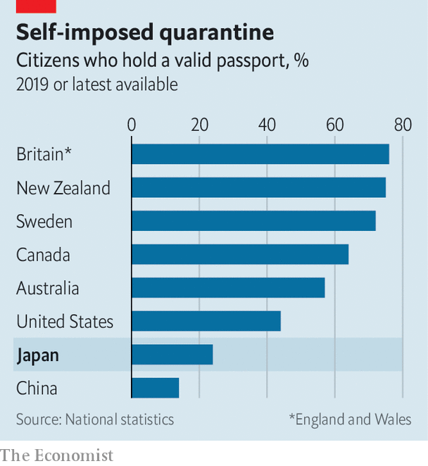

In the 1980s and 1990s Japanese were keen to explore the world. Students backpacked for weeks with their copies of Chikyu no arukikata (“How to walk the Earth”), a popular travel guide. A strong yen made foreign jaunts affordable. But interest has been dwindling since the late 1990s. They are “just one of many” leisure options, Ms Morishita explains.

The number of Japanese studying abroad has also fallen, from 82,945 at its peak in 2004 to 55,969 in 2016. The shrinking population of young people is partly to blame. Also, “It costs about ¥4m ($36,000) a year to study abroad,” notes Nakamura Tetsu of Tamagawa University, a prohibitive sum for most. Meanwhile, Japan’s labour crunch makes foreign study less useful. “You don’t need an education abroad to get a good job,” says Suematsu Kazuko of Tohoku University. A survey in 2019 found that 53% of Japanese students are not interested in studying abroad, the highest ratio among the seven countries covered.

This article was downloaded by calibre from <https://www.economist.com/asia/2020/02/29/fewer-and-fewer-japanese-want-to-see-the-world>

|  |  |  |  |
| --- | --- | --- | --- |
| Previous | Articles | Sections | Next |

|  |  |  |  |
| --- | --- | --- | --- |
| Previous | Articles | Sections | Next |

#### A tale of two neighbourhoods

# Donald Trump and Narendra Modi hug as Delhi burns

Neither America’s president nor India’s prime minister had much to say about a bout of sectarian rioting

Feb 27th 2020 | DELHI

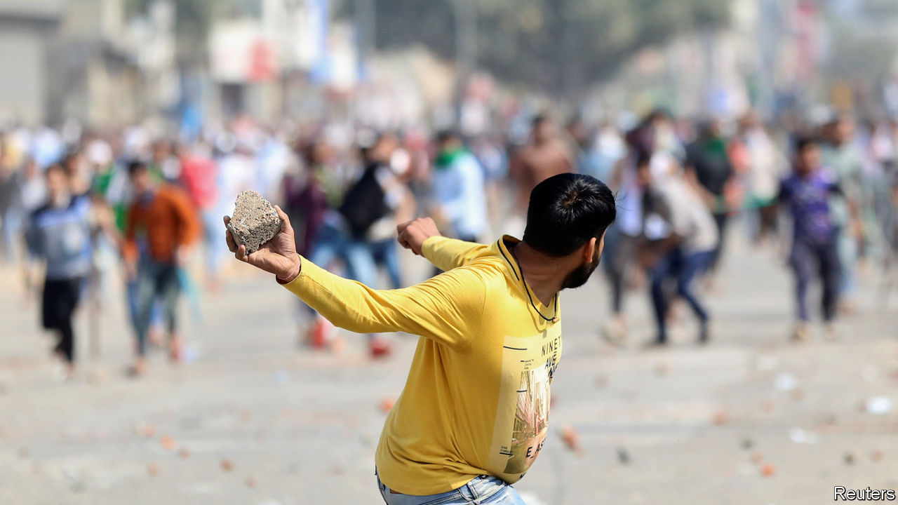

THE CONTRAST could not have been starker. At one end of the city, Donald Trump and Narendra Modi, America’s president and India’s prime minister, were celebrating a new “strategic partnership”. With the shared passion of politicians eager to shift voters’ attention, the two leaders exchanged hugs and compliments. The other side of India’s sprawling capital was feeling a different kind of warmth: it was on fire. Slum districts in the north-east of the city had erupted in riots that left at least 34 dead, dozens injured and many properties torched.

Most of the victims were Muslims, a largely impoverished group that makes up 14% of India’s population (and 13% of Delhi’s). Ironically, in a flattering speech, Mr Trump had praised India for its commitment to freedoms and its tradition of religious tolerance. Yet it is the policies of Mr Modi’s own Hindu-nationalist government that created the current polarised atmosphere. A particular thorn has been its insistence on pursuing a national head count which, combined with new citizenship rules that discriminate according to religion, has raised fears that millions of Muslims may be stripped of their rights. Inflammatory rhetoric from Mr Modi’s party makes things worse. During local elections in the capital in February, one of its candidates led crowds in chants of “Shoot the traitors!” in reference to groups protesting the citizenship law.

The trigger for the riots appears to have been a rally by another local politician, who declared that if a sit-in by Muslim women protesting against the citizenship rules was not lifted by the time Mr Trump left India, his supporters would no longer remain peaceful. Soon after, mobs went on the rampage in Muslim neighbourhoods, often with police looking mutely on or, say many witnesses, aiding the attackers. Both sides soon resorted to shooting; most of the fatalities, which included two policemen, were caused by gunfire.

The police, which in Delhi are controlled by the central government, only deployed in strength on February 26th. On the orders of a court, they also began registering complaints of incitement. Mr Modi’s national-security adviser toured affected districts, giving his “word of honour” that residents could feel safe. The prime minister himself, after three days of silence, belatedly tweeted a plea for calm.■

This article was downloaded by calibre from <https://www.economist.com/asia/2020/02/27/donald-trump-and-narendra-modi-hug-as-delhi-burns>

|  |  |  |  |
| --- | --- | --- | --- |
| Previous | Articles | Sections | Next |

|  |  |  |
| --- | --- | --- |
| Asia | Sections | Middle East and ... |

China

Surveillance technology: Code red

.

Remote learning: Getting to know your teacher

.

Chaguan: Globalisation under quarantine

.

|  |  |  |
| --- | --- | --- |
| Asia | Sections | Middle East and ... |

|  |  |  |  |
| --- | --- | --- | --- |
|  | Articles | Sections | Next |

#### Code red

# To curb covid-19, China is using its high-tech surveillance tools

Non-state firms are best-equipped to track people’s movements and contacts

Feb 29th 2020 |

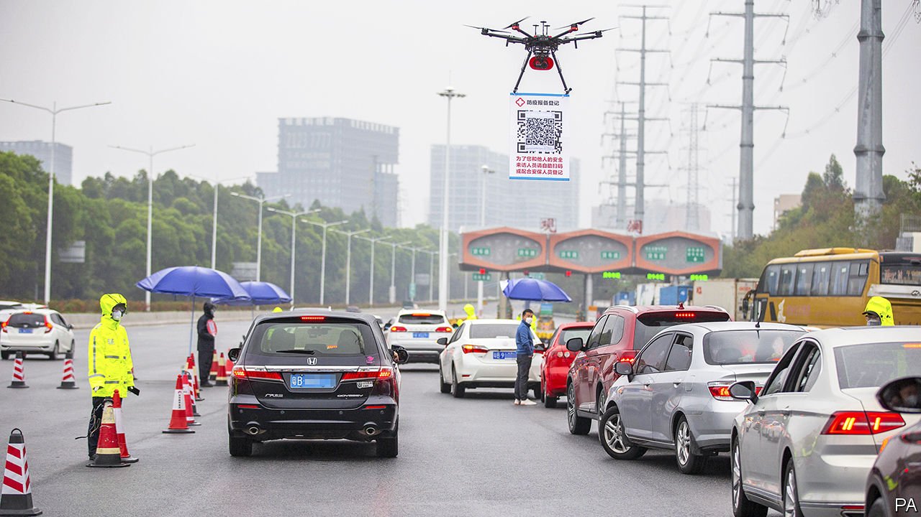

WHEN THE covid-19 virus started spreading in China, and the government began locking down the country, Shen Dacheng’s friends called her a prophet. Her short story “Miss Box Man”, published in 2018, is set in a world of virus-induced fear. The rich live in sealed containers which protect them from the pathogen. For the rest, life is a constant series of compulsory blood tests and hosings-down with disinfectant. Those found with the virus are seized. Some are killed on the spot. Sensors are hidden everywhere, looking out for carriers.

China’s non-fictional epidemic has echoes of that dystopia, minus the caskets and the killings. Take Ms Sun, who lives with her son and husband in the eastern city of Hangzhou. The city’s health-check app flagged her as a possible carrier of the virus after she reported a runny nose through its self-assessment form. She had just returned from her native province in the north-west, where she had met people from Hubei, the province at the centre of the outbreak that has infected more than 65,000 people in China and killed about 2,600 others since December.

The red colour of the QR code on Ms Sun’s “Hangzhou Health Code” app indicated that she was supposed to be undergoing 14 days of self-quarantine. Had the code been yellow, it would have meant she was a lower risk and had to isolate herself for seven days. For free passage around the city, people must produce their phones at checkpoints and show they have a green QR code. Pictured is another method of keeping tabs on people: drivers have to scan the code held up by a drone to register for entry into the city, in this case Shenzhen.

Ms Sun’s app did not offer her a chance to explain that she has chronic rhinitis, a common nasal condition. Only after an appeal to the local government and a visit from neighbourhood officials was her red status changed to green, allowing her to move around Hangzhou again.

Much of China’s success so far in containing the virus’s spread outside Hubei has depended on mobilising legions of people to man checkpoints armed with clipboards and thermometer guns, or to go door-to-door making note of sniffles. But as the daily number of newly confirmed cases of covid-19 continues to fall in China, and the government struggles to get the economy going again after more than a month of paralysis, officials will rely more heavily on surveillance technology to prevent a resurgence of the virus. It will enable them to adopt a more tailored approach, allowing most people to resume their normal lives while monitoring those who might be infected.

Smartphones, which are carried by most working-age Chinese, will be powerful tools. They are already used extensively by police to track people’s movements and monitor their online behaviour. Covid-19 offers the government an incentive and an excuse to exploit their capabilities more fully, this time in pursuit of data that could help the clipboard-carriers identify their targets. As other countries worry about a possible pandemic of covid-19, they will watch China to see whether its digital snooping can provide lessons in how to control the virus’s spread.

It is often assumed that the surveillance systems used by China’s security services are highly integrated and offer an abundance of up-to-the-minute intelligence on almost every citizen. In the far-western province of Xinjiang, there may be some truth in this. Data culled from smartphones and ubiquitous facial-recognition cameras are used to identify people there whom the authorities regard as threatening: devout Muslims or those with a fondness for Xinjiang’s non-Han cultures. Such information has helped the government round up more than 1m people and put them in “re-education centres”.

But those efforts involve only a single province. Creating such systems is far harder when it entails data-sharing between provinces, or between provincial and central authorities. Co-operation is undermined by competition for favour in Beijing. The boss of a foreign artificial-intelligence developer in China says that fusing datasets within a single firm is often quick, but not if it involves co-operation between different institutions. “The person in charge is unwilling to take the risk,” he says, and usually reckons that doing nothing is safer than sharing.

Even with the best of technology and the most joined-up of bureaucracies, tracking covid-19 would be difficult. Other diseases that have caused global alarm this century, such as Ebola and SARS, have been easier to monitor because those infected have quickly shown symptoms, unlike those with the covid-19 virus.

A “close-contact” app being developed with much fanfare by a state-owned firm, China Electronics Technology Group Corporation, therefore should be viewed with scepticism. (The company is also responsible for much of the surveillance technology deployed in Xinjiang.) The app is supposed to provide officials with data drawn from the National Health Commission, the Ministry of Transport, China Railway and the Civil Aviation Administration of China to track citizens’ travel, health and contacts with infected people. But it is not clear how work on this is proceeding, if it is at all.

For now, China’s digital monitoring methods for covid-19 are a hodgepodge of disjointed efforts by city and provincial governments, as well as the technology giants Alibaba and Tencent. Witness the self-assessment system that ensnared Ms Sun. It is being rolled out by Ant Financial, an Alibaba affiliate that runs Alipay, a ubiquitous payment app. Two hundred cities are now using it, says Alibaba, after its trial in Hangzhou. Ant Financial eventually plans to offer it nationwide.

A representative of Ant Financial says the app, which is bundled with Alipay, is merely a conduit for data compiled by the government. Tencent’s WeChat, a social-media platform, offers a similar app using data from the same source. It has been introduced in Tencent’s home town, Shenzhen. Such non-state firms may be best-equipped to harness data to good effect in the battle against the virus. Unlike government bodies, they have a cohesive nation-wide view of their customers and ready access to intimate details about them.

Both Alipay and WeChat harvest their users’ location data. Through WeChat, Tencent knows who its users talk to. WeChat Pay and Alipay know who receives their users’ money. Both Tencent and Ant Financial know what travel tickets their users have bought through the companies’ respective apps. They have better real-time awareness of what Chinese people are doing and discussing than the government itself.

People in China, as well as in democracies, worry about how tech companies use the data they garner from their customers. But if covid-19 becomes a pandemic, they may well become more inclined to forgive a more nosy use of personal data if doing so helps defeat the virus. ■

This article was downloaded by calibre from <https://www.economist.com/china/2020/02/29/to-curb-covid-19-china-is-using-its-high-tech-surveillance-tools>

|  |  |  |  |
| --- | --- | --- | --- |
|  | Articles | Sections | Next |

|  |  |  |  |
| --- | --- | --- | --- |
| Previous | Articles | Sections | Next |

#### Getting to know your teacher

# The coronavirus is causing massive disruption to education in China

Could teacher-pupil relations change for the better?

Feb 29th 2020 | BEIJING

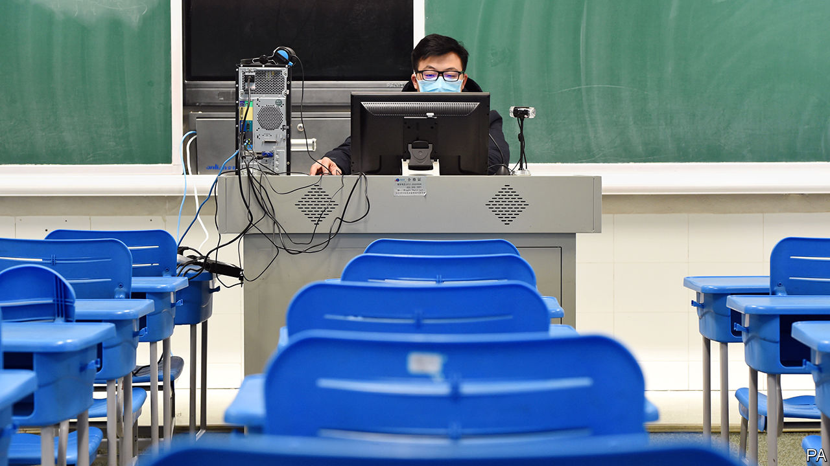

“DON’T DELETE your browser history,” Lin Kai warns his 11-year-old son, who is supposed to be live-streaming lectures delivered by his schoolteachers. Mr Lin has reason to be anxious. To curb the spread of covid-19, the authorities have closed schools and universities indefinitely. But “study must not stop”, says the education ministry. Under its orders, the country’s biggest exercise in remote learning is under way, watched over by parents. Mr Lin, who lives in the eastern city of Hangzhou, has caught his son being distracted by online games. He wants his son to know that he will inspect the browser for evidence of such naughtiness.

There are other ways to enforce discipline. Liu Weihua, who teaches at Wuhan University of Technology, cold-calls his students during live streams. With sit-down exams now impossible, his grading system places more emphasis on how students perform in classroom discussions, Mr Liu explains. These are conducted using video-conferencing platforms such as Dingtalk by Alibaba, a tech giant, and Ketang by Tencent, a competitor.

Slow internet speeds at home are no excuse for shirking, says Yue Qiu, a secondary-school teacher in Beijing. If connections are too wobbly for video calls, students can download audio files and assignments. Parental supervision is encouraged. The municipal government of Beijing has decreed that, in households with two working parents, one is entitled to stay home without any loss of pay.

In poor rural areas, where some households lack internet access, instruction by television fills the void. Since February 17th China Education Network, a state-run service, has been broadcasting classes every weekday from 8am to 10pm. The first lesson of the day is aimed at pupils in the first year of primary school. Programmes for older children air in the afternoon and evening. All core subjects, such as mathematics and Chinese, are covered.

The disruption is felt most keenly by pupils in the final year of secondary school. That is the year leading up to the gaokao, the notoriously hard university-entrance exam. Many parents fret that online learning is a poor substitute for classroom instruction. Hou Kaixuan, who will sit the gaokao in the northern city of Zhangjiakou this summer, eagerly awaits the re-opening of his school. “I’m simply more productive in a physical classroom,” he says.

Not all his classmates agree. Kaixuan observes that some of them study just as hard at home as in school, and take perverse pleasure in the fact that others must be slacking off. (It helps that very little new material is taught in the last year of secondary school. The emphasis is on revision.)

When schools and universities eventually re-open, classrooms may be different, says Mr Yue, the teacher in Beijing. The teacher-student relationship will become “less hierarchical”, he predicts. That is because China’s prolonged experiment with online learning is reducing the typical reserve between instructor and pupil. Teachers who were previously reluctant to give out their contact details on WeChat, a messaging app, now rely on it to respond to students’ queries. At Mr Yue’s school, students may even call their teachers to ask for feedback. If he is right, such a breaking-down of barriers could be one of the few happy by-products of the epidemic. ■

This article was downloaded by calibre from <https://www.economist.com/china/2020/02/29/the-coronavirus-is-causing-massive-disruption-to-education-in-china>

|  |  |  |  |
| --- | --- | --- | --- |
| Previous | Articles | Sections | Next |

|  |  |  |  |
| --- | --- | --- | --- |
| Previous | Articles | Sections | Next |

#### Chaguan

# Covid-19 is teaching hard lessons about China-only supply chains

At the very least, an emotional decoupling is under way

Feb 29th 2020 |

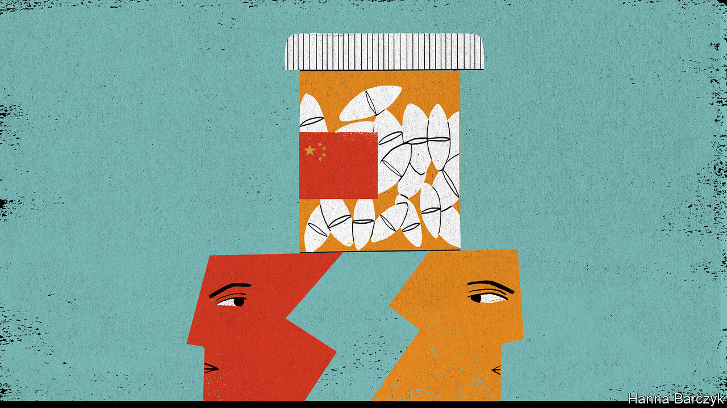

UNTIL ABOUT the third week of January, only a few pharmaceutical executives, drug-safety inspectors and dogged China hawks cared that a large share of the world’s supply of antibiotics depends on a handful of Chinese factories. These include a cluster in Inner Mongolia, a northern province of windswept deserts, grasslands and unlovely industrial towns. Then came the covid-19 outbreak, and quarantine controls that locked down factories, ports and whole cities across China.

Chinese leaders insist that they are well on the way to conquering the virus, allowing them to reopen “leading enterprises and key links with important influence” in global supply chains. A victory over the novel coronavirus will once again demonstrate “the notable advantages of leadership by the Communist Party of China”, President Xi Jinping told 170,000 officials by video-conference on February 23rd. But even if all those boasts come true, foreign governments and business bosses will not quickly forget a frightening lesson: for some vital products, they depend on one country.

Where once only a few specialists worried about the market share enjoyed by the industrial chemists of Hohhot or Shijiazhuang, China’s dominance of the active pharmaceutical ingredient (API) sector is now the subject of hard questions in Washington’s corridors of power and the chancelleries of Europe. Ending the world’s dependence on Chinese APIs would not be a technical challenge. China has not been dominant for long. America’s last penicillin fermenter closed in 2004, as clusters of Chinese factories, many state-owned or subsidised, offered efficiencies that foreign rivals could not match. Rather, change would involve upending well-established political and economic theories, starting with the wisdom of allowing private companies to seek out the best-value goods, with little heed paid to their origin.

There is much speculation about whether covid-19 will accelerate trends in America and other Western countries to decouple from China. In truth, a rush to diversify in certain sectors is more likely, and even such a hedging of bets would build on trends that have been visible for some time.

The US-China Economic and Security Review Commission, a congressional body, held hearings in July 2019 on threats and opportunities created by China’s medical industries. The tone quickly veered towards the doomy. A senior Pentagon official, Christopher Priest, declared that “the national-security risks of increased Chinese dominance of the global API market cannot be overstated.” He invited the hearing to imagine China interrupting supplies of irreplaceable drugs, such as those that protect troops against anthrax. Another witness, Benjamin Shobert, a health-care strategist at Microsoft, noted that mutual dependency was once seen as a reason to believe that Sino-American relations were stable and safe. But in an age of rising distrust, if those same calculated dependencies were to become a source of fear, then “much of what has supported the modern era of globalisation is no longer valid.”

For implacable China hawks like Peter Navarro, who advises President Donald Trump on trade, the covid-19 crisis is a told-you-so moment. On February 23rd Mr Navarro told Fox Business, a television channel, that America had outsourced “far too much” of its supply chain for essential medicines. “We have got to get it back onshore,” he said. Mr Navarro, an economic nationalist and vocal tariff advocate, is little loved by America’s trade partners. Yet his talk of nations needing to control certain forms of production finds an echo in rich-world capitals.

Joerg Wuttke, the president of the European Union Chamber of Commerce in China, says China’s dominance in sectors like pharmaceuticals and pesticides is a topic of concern when he visits officials in Berlin, Brussels and elsewhere. It does not help that China has shown itself willing to use trade to bully other countries during political disputes, as when it denied the export of rare earths to Japan in 2012. He does not expect firms to leave China altogether, because it drives global growth in so many sectors. But Mr Wuttke expects the epidemic to intensify European discussions about industrial policy. “The globalisation of putting everything where production is the most efficient, that is over.”

James McGregor, a China veteran who heads the Chinese operations of APCO, an American consultancy, watched businesses putting ever more eggs in the China basket for a decade. Hit by rising labour costs, trade tensions and now the virus, companies have concluded that they need to diversify—though many are struggling to find countries with China’s infrastructure and adaptable labour force. Against that, some firms that are in China to sell to China are expanding production there, in part to avoid the uncertainty of tariffs. The most capable high-tech companies see China as “the market of the future” for such promising industries as autonomous vehicles, robotics and the internet of things. They may be rewarded for their faith. “We are going to see the Chinese government be extraordinarily nice to companies once this virus is over,” suggests Mr McGregor.

## Foreign trade without foreigners

One visible impact of the virus may be to speed changes at the top of firms. Multinationals have increasingly appointed Chinese executives (often Western-educated) to run their China operations. The epidemic may accelerate departures among the foreigners who remain. Air pollution has already driven many away. Some old-timers feel less welcome in a China taking a nationalist, authoritarian turn. Now they are living alone after evacuating their families, or in temporary exile abroad scrambling to find children school places in home countries they barely know. “A lot of my contemporaries don’t need much of a push” to leave, says a long-time China hand. Even if covid-19 burns out soon, it has clarified how the world is growing warier of China. Few firms can afford to leave completely. But an emotional decoupling is under way.■

This article was downloaded by calibre from <https://www.economist.com/china/2020/02/29/covid-19-is-teaching-hard-lessons-about-china-only-supply-chains>

|  |  |  |  |
| --- | --- | --- | --- |
| Previous | Articles | Sections | Next |

|  |  |  |
| --- | --- | --- |
| China | Sections | Europe |

Middle East and Africa

Israeli politics: Take three

.

Israel: In search of a one-party solution

.

The death of Hosni Mubarak: A soldier’s tale

.

South Africa’s budget: Comrade cosmonaut

.

African trade: Africa’s beef with America

.

|  |  |  |
| --- | --- | --- |
| China | Sections | Europe |

|  |  |  |  |
| --- | --- | --- | --- |
|  | Articles | Sections | Next |

#### Take three

# Will Israel’s third election in a year finally produce a government?

The polls predict more deadlock

Feb 29th 2020 | JERUSALEM

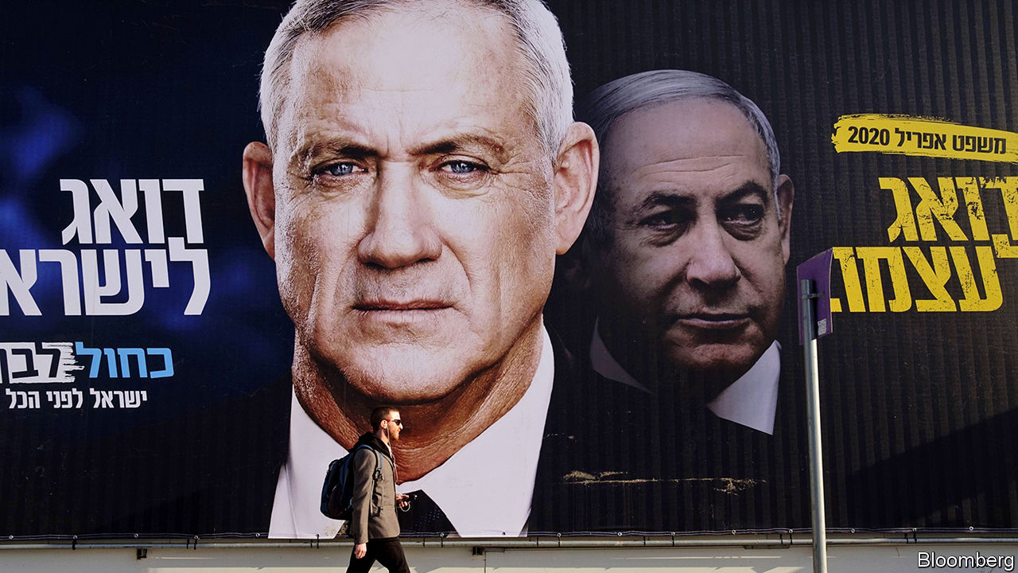

THE BLUEPRINTS had been gathering dust for 25 years. No Israeli leader, not even Binyamin Netanyahu, prime minister for the past decade, was willing to face the international criticism that would follow from building 3,500 new homes near Jerusalem, in the occupied West Bank. The new district would cut off the Palestinian part of Jerusalem from the rest of the West Bank, ending any possibility of a viable Palestinian state with Jerusalem as its capital. So the plans were put on the shelf—until February 25th, when Mr Netanyahu publicly dusted them off.

It is no mystery why Mr Netanyahu changed his mind. Israel is holding a general election on March 2nd, its third in a year. The last two, in April and September 2019, failed to produce a government. The prime minister thinks the only way for his bloc of nationalist and religious parties to eke out a majority this time is by mobilising the base. He is under pressure from his main rival, Benny Gantz. The former general and leader of Blue and White, Israel’s largest party, has been pursuing “soft-right” voters by matching many of Mr Netanyahu’s campaign promises.

Israelis appear exhausted by a campaign that has been running, on and off, since December 2018, when the first of the three elections was called. That one left Mr Netanyahu one seat short of a majority. His coalition lost seats in the September re-run, which produced a majority opposed to his rule. Still, Mr Gantz was unable to form a government. Since then, despite Mr Netanyahu’s gimmicks, such as promising to decriminalise the recreational use of cannabis, and Mr Gantz’s rightward shift, the polls have hardly budged.

The main issue is still Mr Netanyahu himself. Israel’s longest-serving prime minister is a polarising figure. He has kept Israel safe, forged closer ties to Arab states and overseen a flourishing economy. But in November he was indicted on charges of bribery and fraud for allegedly receiving illegal gifts and trading political favours for positive news coverage. His trial will begin on March 17th. Mr Netanyahu denies any wrongdoing and blames his legal troubles on lefty prosecutors, police and journalists (though he appointed the police chief who investigated him and the attorney-general who charged him). Critics accuse him of sowing division and demonising Arabs for political gain.

Mr Gantz, a bland campaigner, has struggled to fire up voters—or bring the opposition together. The parties that want to see Mr Netanyahu go range from Yisrael Beitenu, a fiercely nationalist outfit, to the Joint List, an alliance of Arab-majority parties. There is no prospect of them sitting together in a coalition. Mr Gantz says Arab parties “won’t be a part of my government”. He failed even to convince the right-wingers in his own party to serve in a minority government with outside support from the Joint List. Their antipathy to Arab-Israeli politicians, who are eager to play a bigger role (see article), apparently outweighs their animus against Mr Netanyahu.

On other issues, Mr Netanyahu and Mr Gantz are not so far apart. Both candidates say they will implement Donald Trump’s peace plan for Israel and the Palestinians, which was prepared in close co-ordination with the prime minister’s advisers and allows Israel to annex West Bank settlements and the Jordan Valley. Mr Netanyahu has already met American officials to draw up new maps. Once that task is completed, he will “immediately” apply sovereignty over the land in question. Mr Gantz says he would move forward “in co-ordination with the international community”. But annexation may be put on hold if the election produces another stalemate.

Israel’s election commission is already preparing for a possible fourth vote, in September. That might suit Mr Netanyahu, who would like to show up in court as a sitting prime minister. But most Israelis, including many of Mr Netanyahu’s allies, want to avoid another election. Though things have been running smoothly under the interim government, it cannot pass a budget or make big decisions. The monthly outlays for government ministries have automatically reverted to those in the 2019 budget, making it harder to build new infrastructure, fund social programmes or raise taxes to shrink a deficit that reached 3.7% of GDP last year. The lack of a budget “will not only affect government offices, but also the entire economy”, warned the accountant-general in November.

If they cannot form a government on their own, Mr Netanyahu and Mr Gantz will come under pressure to team up. A unity government featuring Likud and Blue and White was discussed after the last election. Mr Netanyahu agreed to split the prime minister’s term with his rival, but insisted on going first. Mr Gantz has ruled out serving under Mr Netanyahu while he is facing criminal charges. The prime minister’s allies could force him to the sidelines—though it is just as likely that the indomitable Mr Netanyahu will defy the odds, and hang on to his office. ■

This article was downloaded by calibre from <https://www.economist.com/middle-east-and-africa/2020/02/29/will-israels-third-election-in-a-year-finally-produce-a-government>

|  |  |  |  |
| --- | --- | --- | --- |
|  | Articles | Sections | Next |

|  |  |  |  |
| --- | --- | --- | --- |
| Previous | Articles | Sections | Next |

#### In search of a one-party solution

# A growing number of Jews are voting for Arabs in Israel

What many Israelis want is a party that spans the Jewish-Arab divide

Feb 29th 2020 | KFAR SABA

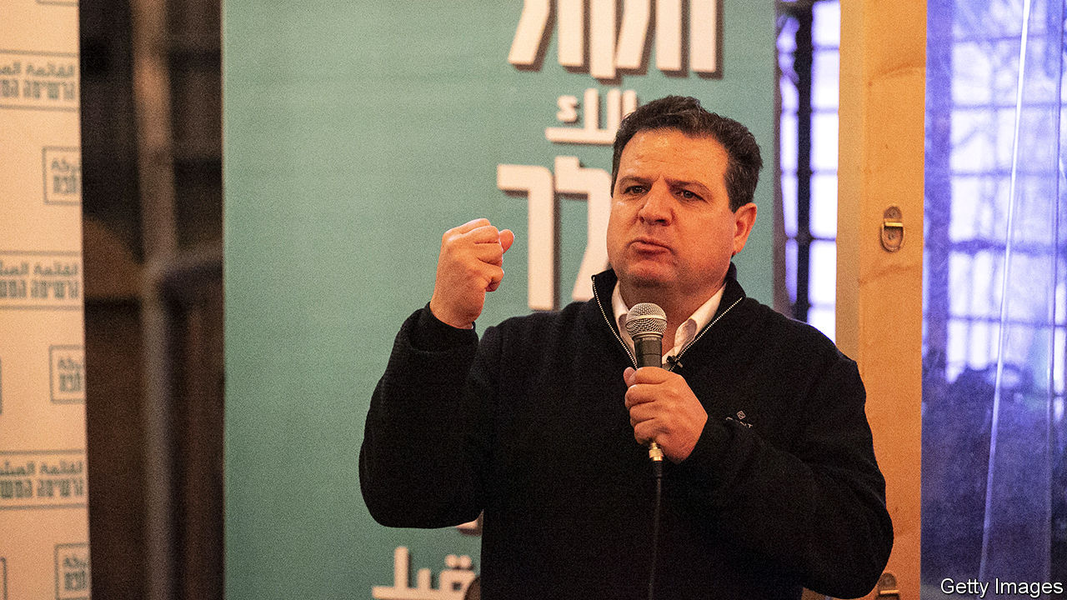

THE AUDIENCE in Kfar Saba, a Jewish city near Tel Aviv, came from as far away as the Golan Heights in the north and Beersheva in the south. They crowded onto the terrace of a packed penthouse to hear a politician who promised to stop missiles from Gaza and counter hatred of Jews. With the crowd’s support, the politician continued, he could achieve peace between Israel and the Palestinians via a two-state solution. None of that would have been unusual, except that the politician was Ayman Odeh (pictured), a jovial lawyer who heads the Joint List, a bloc of Arab-Israeli parties.

After decades representing insular parties on the periphery of Israeli politics, Arab politicians have entered the mainstream. The Joint List is the country’s third largest bloc. It is courting the Jewish vote ahead of parliamentary elections on March 2nd. It has removed more pugnacious candidates and sees a place for itself in a centre-left government. Balad, the bloc’s most radical party, has put a Jew (of Iranian origin) on its list of candidates. The Joint List’s billboard campaign has an inclusive message. Posters in Yiddish promise ultra-orthodox Jews an end to conscription. Amharic ones vow to tackle police brutality against Ethiopians. “Let’s go together,” read the Hebrew ones.

The outreach seems to be working. In the election last September the Joint List increased its support in Jewish areas by 60% compared with the election in April, albeit from a very low base. Dahlia Scheindlin, a pollster, predicts it could increase again, perhaps giving the Joint List an extra seat (it currently has 13). Jews attending a packed hustings in Tel Aviv spoke of abandoning Meretz, a left-wing Zionist party that has pushed Arab candidates down its list. Right-wing fearmongering against the Arab “enemy within” is attracting Jewish sympathy. A settler in a skullcap said he feared he would be branded a traitor if his neighbours found out he was attending an event for the Joint List.

Mr Odeh says it is not so hard to imagine an Arab-Israeli prime minister. But his appeal has its limits. Two-thirds of Israeli Jews want to bar Arab parties from government. Over 40% oppose living next to an Arab, let alone voting for one. Yuppies flinch at the Joint List’s communist origins. Left-wing secular Jews are turned off by its Arab nationalist and Islamist cheerleaders. And the Joint List is bad at practising the equality it preaches. Just one of its 13 parliamentarians is Jewish. Still, the interest Mr Odeh is piquing indicates a growing demand for a party that truly spans Israel’s Jewish-Arab divide. Voters will have to wait a bit longer for that.

This article was downloaded by calibre from <https://www.economist.com/middle-east-and-africa/2020/02/29/a-growing-number-of-jews-are-voting-for-arabs-in-israel>

|  |  |  |  |
| --- | --- | --- | --- |
| Previous | Articles | Sections | Next |

|  |  |  |  |
| --- | --- | --- | --- |
| Previous | Articles | Sections | Next |

#### The soldier’s tale

# Hosni Mubarak, ex-despot of Egypt, died on February 25th, aged 91

Three suffocating decades in power were ended by revolt

Feb 27th 2020 |

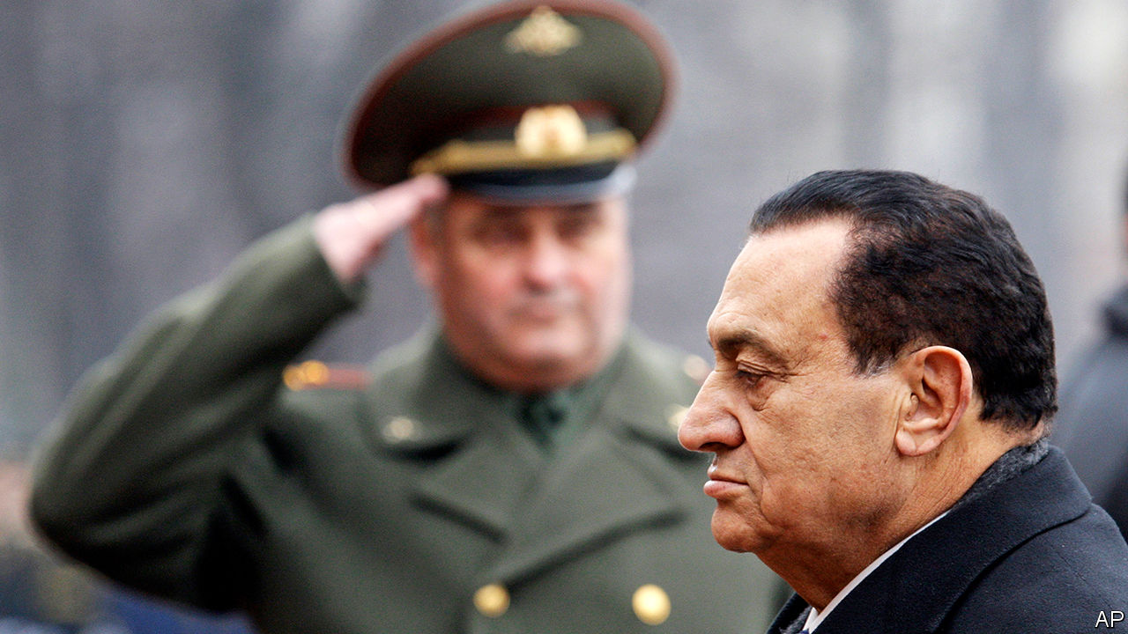

BACK IN 1981, when assassins’ bullets felled Anwar Sadat at a military parade and propelled Hosni Mubarak to Egypt’s highest office, no one dreamed he would fill it for longer than his two predecessors put together. As Sadat’s vice-president, the former air-force commander had kept the low profile of a stolid, trusted retainer. This was not by accident. Mr Mubarak was a military man to the core. To his dying breath he held to the code of silent dutifulness that marks Egypt’s officer class, a praetorian guard that has run the most populous Arab state—with a brief interruption—since seizing power in 1952. In one of his last speeches as president, a week into the 2011 uprising that would soon end his rule, he vowed not to flee into exile as Tunisia’s dictator had done weeks earlier. “Egypt and I shall not be parted until I am buried in her soil,” he said. And so he shall be. Mr Mubarak died in Cairo on February 25th, aged 91.

Like many officers of his generation, Mr Mubarak owed to the armed forces his escape from the provincial working class, and shared their grudge against Egypt’s cosmopolitan elite. He was a squadron leader in the early 1960s, when Egypt’s then president, Gamal Abdel Nasser, sank the country in a ruinous effort to bolster the republican side in Yemen’s civil war. The distraction left Egypt ill-prepared for the six-day war of 1967, when Israeli raids destroyed most of its aircraft on the tarmac.

Mr Mubarak’s new job was to rebuild that shattered force. His grim determination, which bore fruit in a respectable showing during the October war of 1973, when Egypt seized back lost territory, won him notice from above.

As president he held rigidly to his predecessor’s course, maintaining peace with Israel and close ties to America, while slowly winning back the favour with fellow Arabs that Sadat had lost by consorting with the “Zionist enemy”. This brought rewards in foreign aid, but Mr Mubarak’s risk-aversion in domestic politics carried a heavy cost. The economy stalled and schools and courts floundered as the population surged. His lack of imagination was reflected in bureaucratic inertia, compounded by unrestrained security agencies and an ever-expanding network of ex-army men rewarded with provincial governorships, board memberships and the like. Talent slowly drained from Egypt’s government as Mr Mubarak rewarded loyalty over competence. His principal officials were grey, uninspiring figures.

A brief period of political liberalisation in the 1980s, which allowed Islamist groups to surface, was followed by a brutal clampdown. The screws turned even tighter after Mr Mubarak narrowly escaped assassination (one of several attempts) in 1995. His intelligence chief, Omar Suleiman, had suggested that he have his own car flown to a summit in the Ethiopian capital, Addis Ababa. Jihadists ambushed the convoy on the road from the airport. The bulletproof vehicle saved Mr Mubarak’s life. In subsequent years his police imprisoned as many as 30,000 suspected jihadists, while he posed to the West as a bulwark against the fundamentalist menace.

In person he was vigorous, priding himself on his average but enthusiastic squash-playing. He led a no-drinking, no-smoking life, but it was far from plain, with several rococo palaces and a fortune salted away abroad. His jet-black hair was maintained with dye, and the stripes on his suits were stitched, by London tailors, with the tiny repeated letters of his own name. He was good-humoured in a brusque sort of way, but the bonhomie fell flat in public. When Queen Elizabeth invited Mr Mubarak for a state visit, his gift to her was a machine-made carpet with a computer-generated design showing the faces of Prince Charles and Princess Diana.

After the revolution Mr Mubarak spent years on trial for murder and corruption. He was convicted and sentenced to life in prison, but the ruling was overturned on appeal. Then, in 2013, came the coup that ended Egypt’s brief democratic experiment, along with efforts to hold Mr Mubarak accountable. Abdel-Fattah al-Sisi, the general who seized power, grew paranoid about challenges to his rule—among them, unlikely as it may seem, nostalgia for Mr Mubarak. Better he simply be forgotten. After decades in the public eye Mr Mubarak lived out his final days in quiet seclusion.

In a pair of rare interviews last year he reminisced about his days as a soldier and statesman. He spoke far less about his presidency. Whatever his thoughts, Mr Mubarak, his black hair long since faded to grey, offered no public reflection on the failures that caused millions of his countrymen to turn on him. Did he blame his sons, whose greed and ambition alienated not only his people but, crucially, his fellow officers? Did he blame his glib intelligence men, or the ever-plotting Muslim Brothers, or his gutless American allies? The stolid soldier gave nothing away. ■

This article was downloaded by calibre from <https://www.economist.com/middle-east-and-africa/2020/02/27/hosni-mubarak-ex-despot-of-egypt-died-on-february-25th-aged-91>

|  |  |  |  |
| --- | --- | --- | --- |
| Previous | Articles | Sections | Next |

|  |  |  |  |
| --- | --- | --- | --- |
| Previous | Articles | Sections | Next |

#### Tito time

# Wise words are not enough to fix South Africa’s economy

The reformist finance minister bumps up against political reality

Feb 27th 2020 | JOHANNESBURG

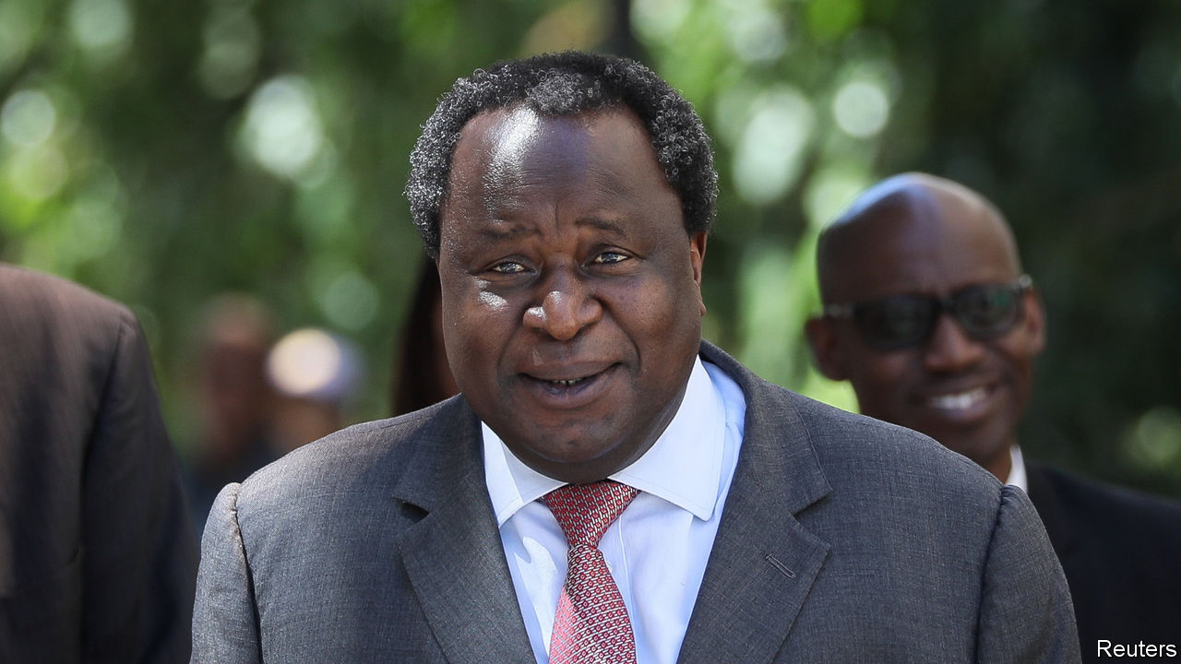

TWO DAYS before he outlined South Africa’s budget, Tito Mboweni shared a Photoshopped picture of himself in a spacesuit. The caption read: “man on a mission”. It was characteristic skylarking by the finance minister, an ebullient reformer who spends much of his time warning colleagues in the ruling African National Congress (ANC) that unless the economy is overhauled the country faces ruin.

On February 26th political gravity brought Mr Mboweni down to earth. His budget was billed as the most important since the end of apartheid in 1994. South Africa’s public finances are in a sorry state, a result of sluggish growth and lavish state spending, especially on public-sector wages. Debt was just 27% of GDP in 2008. A decade later it was 57%, and is set to rise to 66% over the next year, warned the finance minister. But it is unlikely that his comrades were paying attention.

Mr Mboweni announced some sensible policies aimed at speeding growth, such as making it easier to start a business and giving more power to cartel-busters. He also set aside more money for the public prosecutor to go after corrupt officials.

Then there was Eskom, a state-owned electricity utility that epitomises South Africa’s struggles. Decades of mismanagement, outright theft, and contracts and jobs for pals have left it broke and unable to keep the lights on. About a third of its capacity is out of action because of breakdowns. Rolling blackouts that regularly shut factories, shops and mines are pushing the economy towards recession. Mr Mboweni promised to make it easier for independent firms to sell power into the national grid. Many have heard that before.

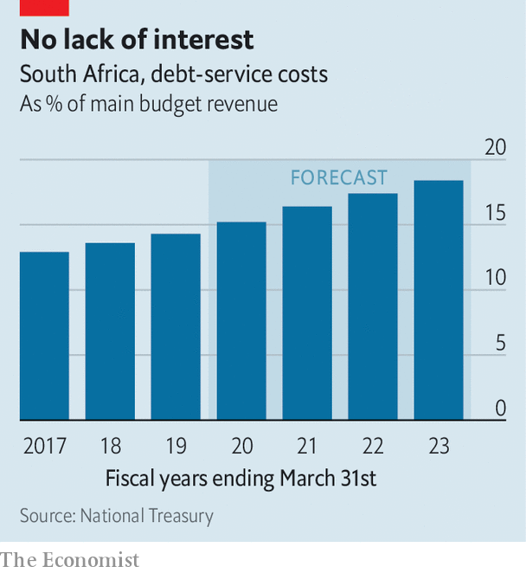

Most importantly, Mr Mboweni outlined his plan to reduce the country’s budget deficit—forecast to be almost 7% of GDP next year. Duties on some alcoholic drinks will increase. But most of the reduction in borrowing will be made by cutting spending by 261bn rand ($17.2bn) over the next three years. Savings on the wage bill are supposed to provide 160bn rand.

The hope for Mr Mboweni and President Cyril Ramaphosa is that these steps will be enough for South Africa to avoid a downgrade this year by Moody’s, the only one of the three main credit-rating agencies not to rate the country’s debt as “junk”.

The president and the finance minister must still get their proposals through a thicket of vested interests. COSATU, a federation of trade unions, warned before the budget that cuts to members’ pay would mean “war”. Meanwhile, powerful figures on the left of the ANC, such as Gwede Mantashe, the energy minister, are blocking efforts to reform Eskom.

Mr Ramaphosa is reluctant to pick a fight with the opponents of reform, partly because he fetishises consensus, but also because he has an eye on the ANC’s National General Council meeting in June. Two of his predecessors, Thabo Mbeki and Jacob Zuma, were “recalled” from office by the party before they had concluded their terms. Party insiders believe that the ANC’S rules would not allow opponents of the president to oust him at this year’s gathering. But they may try nonetheless.

Even if they do not try, South Africa remains in peril. Those in the ruling party face a clear choice: wise up and cut spending on their own or, in the not too distant future, do so under the thumb of the IMF. ■

This article was downloaded by calibre from <https://www.economist.com/middle-east-and-africa/2020/02/27/wise-words-are-not-enough-to-fix-south-africas-economy>

|  |  |  |  |
| --- | --- | --- | --- |
| Previous | Articles | Sections | Next |

|  |  |  |  |
| --- | --- | --- | --- |
| Previous | Articles | Sections | Next |

#### Africa’s beef with America

# Why African farmers struggle to export to the United States

Seemingly generous trade terms aren’t as helpful as they appear

Feb 29th 2020 |

HUNGRY AMERICANS chomping into one of Philadelphia’s famous cheesesteaks may soon get a taste of Africa. Last week MeatCo, Namibia’s state-owned meat firm, shipped 25 tonnes of beef to Philadelphia. It was the first ever export of red meat from Africa to the United States. Namibian meat producers are delighted. America is the world’s second-biggest meat market; the average American wolfs down more than 100kg a year. Yet this is a rare success. Negotiations began 18 years ago.

The shipment will be duty-free under the Africa Growth and Opportunity Act (AGOA), which was introduced in 2000 to boost economic growth in Africa by stimulating exports to America. Yet 20 years later only about 1% of America’s imports come from sub-Saharan Africa, and much of that is oil. The fact that it took two decades to export a single piece of red meat helps explain why AGOA has had so little impact, and how it could be improved.

A few countries, including Lesotho and Mauritius, have been given a leg-up. Whereas most of America’s clothes imports from China are hit with a duty of about 20%, those from Africa under AGOA are duty-free. That has helped Lesotho boost its global exports of textiles and clothing from $143m in 2000 to $549m in 2017. But many African countries are better at growing things than making them. Agriculture accounts for 54% of employment in sub-Saharan Africa, compared with 11% for industry. Yet apart from a few commodities such as coffee, tea and cocoa, agricultural exports to America are still quite small. Why is that?

One barrier is safety standards. Compliance can be costly, sometimes entirely offsetting the benefits of lower tariffs under AGOA. And because there is no global standard for food safety, exporters often have to shell out to comply with different ones in Europe and America. Harmonisation of rules would help enormously.

AGOA was meant to open America’s food market to Africa. But while most agricultural products from Africa can enter tariff-free, the small print limits imports of much of what the continent grows. Some crops are still hit with import taxes. And even though the threat to American farmers is negligible, the United States imposes quotas on imports of African products including cotton, sugar, dairy products, peanuts and tobacco. Processed foods that contain milk, such as chocolate, get caught up in these too. Imports above the allocated quota are hit with steep tariffs—350% for tobacco. America allocates most of its quotas to long-standing trading partners. This year Namibia secured a quota for its debut shipment of beef. (Without that it would have been taxed at 26%.) Yet its quota of 860 tonnes is tiny, amounting to just 0.008% of American beef production.

For some products African producers are simply not competitive because of a lack of investment, poor roads and ports and their vast distance from rich markets. But African companies already export far more agricultural products to Europe than to America, suggesting that America’s quotas matter. With better access to markets, firms might then invest more in improving their competitiveness.

The European Union also has a preferential trade scheme for the poorest countries, called Everything But Arms. Unlike AGOA, it does not impose quotas. But it largely rules out products if they include too many bits and bobs made in wealthy countries. This is a problem for manufacturers, which may need to import cheap components if their finished products are to be competitive. Worse, these rules are “mind-bogglingly complex”, says Kimberly Elliott of the Centre for Global Development (CGD), a think-tank.

In Britain, too, trade with Africa is on the agenda. Boris Johnson, the prime minister, has declared that Uganda’s beef cattle “will have an honoured place on the tables of post-Brexit Britain” for the first time. If Mr Johnson is serious about accelerating imports from the poorest African countries, then he should set up a scheme that learns from others: more comprehensive than America’s, yet simpler than Europe’s.

In the long run, big emerging markets may be more important to Africa. The CGD reckons that poor countries would be able to export three times more if they were given unrestricted access to Brazil, China and India as well as the OECD, than if they were given full access to the OECD alone.

Still, little can be achieved unless African exporters take the bull by the horns and force their way into new markets. Once again, Namibia’s MeatCo is leading the charge. Last year it sent the first-ever shipment of African beef to China. ■

This article was downloaded by calibre from <https://www.economist.com/middle-east-and-africa/2020/02/29/why-african-farmers-struggle-to-export-to-the-united-states>

|  |  |  |  |
| --- | --- | --- | --- |
| Previous | Articles | Sections | Next |

|  |  |  |
| --- | --- | --- |
| Middle East and ... | Sections | Britain |

Europe

Extremism in Germany: The threat within

.

Jean Vanier: Feet of clay

.

Austria’s Jews: Charity confiscated

.

Tech in Serbia: Return of the geeks

.

Italy’s troubled steel factory: Down at heel

.

|  |  |  |
| --- | --- | --- |
| Middle East and ... | Sections | Britain |

|  |  |  |  |
| --- | --- | --- | --- |
|  | Articles | Sections | Next |

#### The threat within

# Germany is belatedly waking up to the threat of far-right terrorism

It has surged far more than elsewhere in Europe

Feb 29th 2020 |

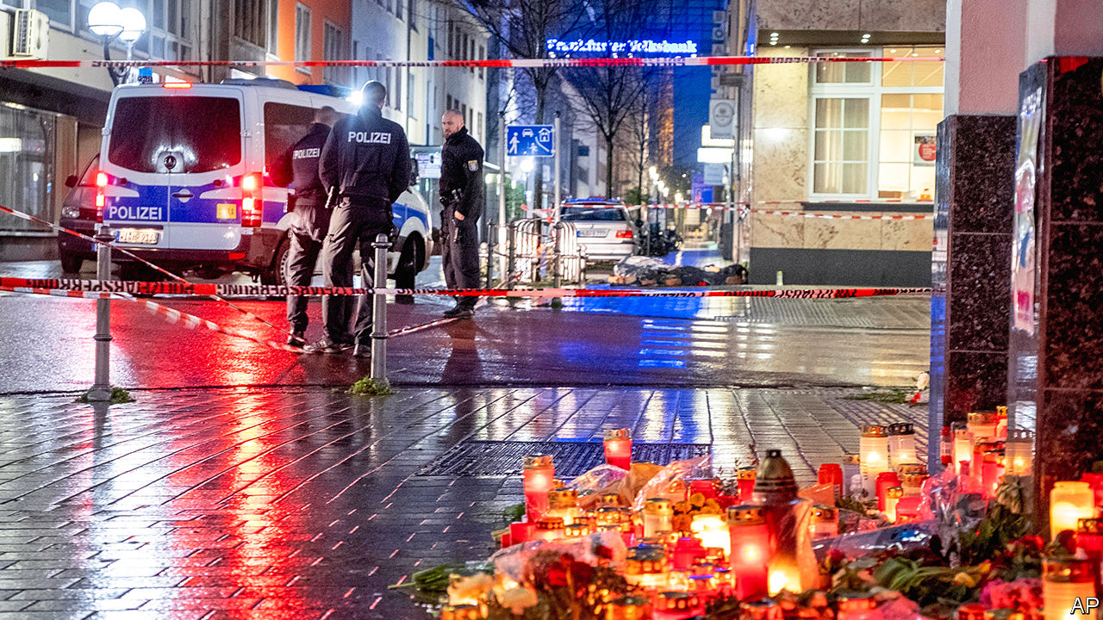

FIVE BULLET-HOLES still scar the window of Karamba Diaby’s office in Halle, a city in eastern Germany. No one knows who fired at the empty building, where Germany’s only black MP meets constituents and does routine political work. But Mr Diaby’s staff do not doubt that the attack, in mid-January, was racially motivated. A week after the incident Mr Diaby got an email warning him to expect the fate of Walter Lübcke, a pro-refugee politician murdered last June. The anonymous threat was signed off with a “Sieg Heil”.

Right-wing extremism in various guises has troubled parts of Germany for decades. The Amadeu Antonio Foundation, an outfit that monitors such activity, says it is responsible for 208 deaths since 1990. But a recent string of incidents has left nerves especially jangled. On Yom Kippur, three months before the attack on Mr Diaby’s office, Stephan Balliet, a young man armed with home-made 3D-printed weapons, tried to break into a synagogue in Halle to massacre worshippers; when that failed he killed two people at random instead. On February 19th in Hanau, near Frankfurt, 43-year-old Tobias Rathjen killed nine immigrants and ethnic-minority Germans during a shooting rampage, before killing himself and his mother. A few days earlier 12 men were arrested for planning attacks on mosques in the hope of igniting “civil war”. Local officials across Germany are physically and verbally intimidated. Many have quit.

Ministers have belatedly acknowledged that far-right terrorism is Germany’s gravest security threat. Officials count over 32,000 right-wing extremists in the country; over 1,000 are considered to be primed for violence. The Centre for Research on Extremism at the University of Oslo calculates that between 2016 and 2018 the number of severely violent far-right incidents in Germany, most of them targeting immigrants or non-whites, far outstripped those elsewhere in Europe (see chart). And that was before the recent surge.

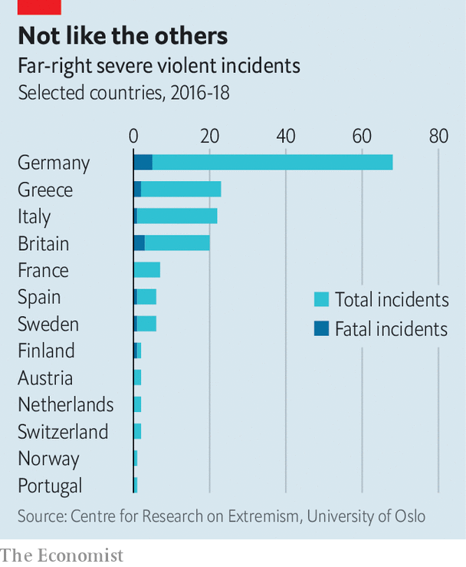

Police and security officials have become much better at tackling organised right-wing threats since botching their response to the National Socialist Underground, a murderous neo-Nazi terrorist cell active in the early 2000s, says Daniel Koehler of the German Institute on Radicalisation and De-radicalisation Studies. Yet as the response evolves, so does the danger. Underground far-right networks remain a serious threat; the suspect in the Lübcke killing had a decades-long history in them. But the attackers in Halle and Hanau were both loners who were radicalised online, had no known connection to established far-right groups and were unknown to the German authorities.

Online groups can, to an extent, offer a sense of community that other extremists find in marches, concerts or martial-arts clubs. They can also nurture “communal delusions” says Miro Dittrich at Amadeu Antonio. These often straddle national boundaries. That helps explain why Mr Balliet, marinated in a toxic brew of online chatrooms, racist memes and the misogynistic subculture of “incel” (“involuntary celibacy”), broadcast his attack live on Twitch, an American video-streaming gaming website, and chose to deliver his anti-Semitic diatribes and obscure online references in English. He sought to inspire others abroad, just as he had been motivated by comparable attacks in El Paso and Christchurch. At a candlelit vigil after the Hanau attacks, protesters chanted Nazis raus! (“Nazis out!”), a common response to far-right atrocities in Germany. Yet the recent attacks look less like a specific national concern than local instances of an overlapping set of transnational phenomena.

That creates problems for the domestic intelligence services. Having long relied on American and British spooks to alert them to online transgressions, Germany’s underresourced security apparatus remains woefully ill-equipped to manage internet-based radicalisation, says Mr Koehler. There are plans to expand the powers of agencies, and to set up an early-warning system for right-wing radicals. A bill agreed by the cabinet shortly before the Hanau attack would oblige platforms like Facebook to report illegal content. But it is not clear that any of this would have pulled the Halle or Hanau perpetrators from their shadowy, global online underworld.

Protesters have found a more visible target in the Alternative for Germany (AfD), a far-right party that one Green has called “the political arm of hate”. The AfD vigorously rebuts any claim that it bears part of the blame for right-wing terror. Yet some of its officials, especially in eastern Germany, routinely deploy the sort of racist, quasi-apocalyptic imagery found in the darker reaches of the internet. Björn Höcke, leader of the AfD’s extremist Flügel (“Wing”) grouping and head of the party’s branch in Thuringia, uses language so incendiary that a court has ruled he may be described as “fascist” without fear of legal consequence. Right-wing terrorists “want to be the hero of a movement,” says Mr Dittrich, “and the AfD plays a role in normalising their ideas”. A poll found that 60% of Germans held it partly responsible for Hanau.

The AfD has also, says Mr Koehler, “dissolved social boundaries between extremist societies and the conservative right.” On one hand it pals around with radical groups like the Identitarian Movement and Pegida, an Islamophobic outfit whose bi-weekly event Mr Höcke recently addressed in Dresden. On the other, says Valentin Hacken, from Halle Gegen Rechts, a campaigning group, it drags mainstream conservatism in its direction. The Thuringian branch of the centre-right Christian Democrats recently voted with Mr Höcke to eject the state’s left-wing government, triggering a scandal that has upended German politics. All this, as Mr Diaby’s staff testify, opens the door to ideas and language that were once considered taboo.

For all that, the AfD is a legal party that holds seats in all 16 of Germany’s state parliaments, plus the Bundestag. Its ideas will have to be tackled in democratic debate rather than through policing and suppression. Extremists in countries like New Zealand have proved perfectly capable of finding motivation for killing sprees without the spur of far-right parties in parliament. Germany’s history gives the country a special responsibility to tackle right-wing extremism in all its forms. But that does not isolate it from threats that look increasingly international in character. ■

This article was downloaded by calibre from <https://www.economist.com/europe/2020/02/29/germany-is-belatedly-waking-up-to-the-threat-of-far-right-terrorism>

|  |  |  |  |
| --- | --- | --- | --- |
|  | Articles | Sections | Next |

|  |  |  |  |
| --- | --- | --- | --- |
| Previous | Articles | Sections | Next |

#### Feet of clay

# Scandal topples the reputation of the founder of L’Arche

Jean Vanier preyed on vulnerable women

Feb 29th 2020 |

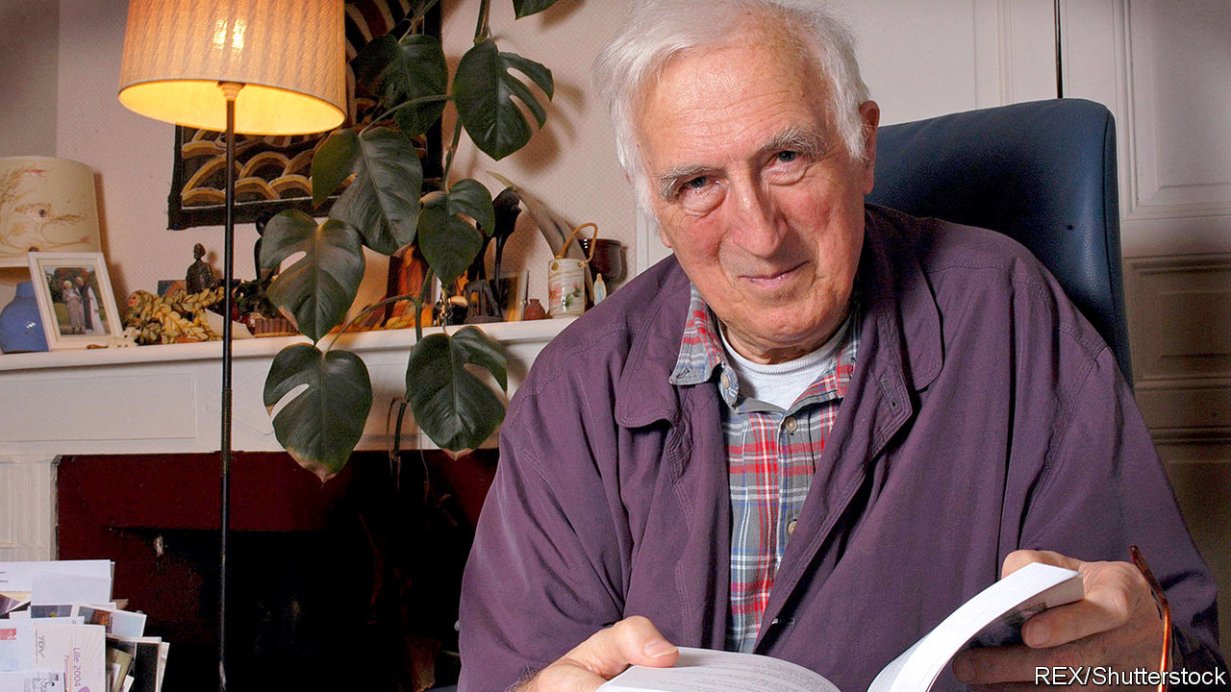

SINCE SAINTS are so rare in the modern world, they are elaborately treasured. When Jean Vanier died in May 2019 he drew praise and admiration from all sides, including Pope Francis, prominent American clergy—and The Economist. He had founded a network of small house-based communities, known as L’Arche (The Ark), in which people with disabilities and those without ate, lived, worked and prayed together. There are now 154 such communities around the world. Their humane approach to care has been widely copied.

Yet as much as Vanier’s concept, his personality inspired people. Here was a Canadian academic, with no training, who built up L’Arche after 1964 from one derelict house at Trosly-Breuil, in northern France, because he felt Jesus asked it of him. In his habits of asceticism, joyfulness and prayer he seemed a model of holiness for lay men and women. He wrote of how the simple goodness of his charges inspired him, too, to be a better man. But all this hid another life, which has now been exposed in a report by L’Arche International itself.

It now appears that for more than 30 years, from 1970 to 2005, Vanier had sexual relationships with at least six women that were “manipulative”, “coercive” or “non-consensual”. Some, it is said, were workers at L’Arche; some were nuns. His hold over them was emotional and psychological; the encounters were dressed up as mystical or spiritual experiences, as “Jesus and Mary”, and were “special”, not to be revealed. So powerful was his personality, as well as the regard of outsiders for him, that even after his death the women hesitated to speak out.

Now that they have, it is clear that Vanier followed the lead of Fr Thomas Philippe, the man who had encouraged him to come to Trosly-Breuil and found L’Arche in the first place. Philippe, his spiritual mentor, had long indulged in “deviant theories and practices”; again, it was L’Arche itself that exposed this, more than two decades after his death in 1993. Vanier, at L’Arche, joined in.

When Philippe’s perversions came to public attention in 2015, Vanier wrote to his followers about them. The revelations, he said, “hit me like a terrible storm”. He had been “totally in the dark”; he could “only weep” with the victims, and say “I do not understand.” Alas, he understood all too well.

This article was downloaded by calibre from <https://www.economist.com/europe/2020/02/29/scandal-topples-the-reputation-of-the-founder-of-larche>

|  |  |  |  |
| --- | --- | --- | --- |
| Previous | Articles | Sections | Next |

|  |  |  |  |
| --- | --- | --- | --- |
| Previous | Articles | Sections | Next |

#### Charitable confiscation

# A Rothschild heir sues Vienna

The latest chapter in the history of Jews in Austria

Feb 29th 2020 | VIENNA

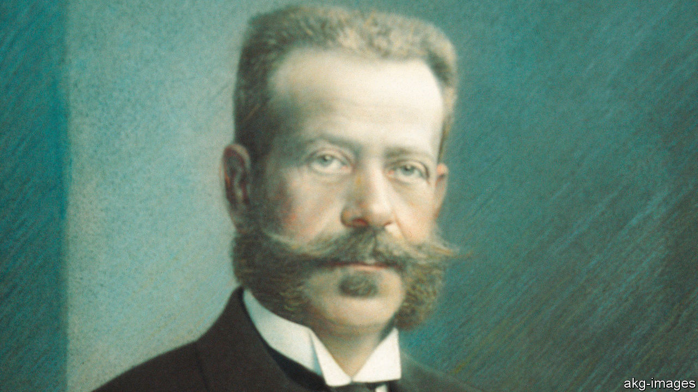

AUSTRIA’S TRAGEDY is that only a tiny number of Vienna’s Jews returned after the second world war to the city, once the glittering home of Sigmund Freud, Gustav Mahler, Stefan Zweig and Arthur Schnitzler. Some 150,000 Jews lived in Vienna at the turn of the 20th century; today the city’s Jewish community is only around 7,000, many of them new immigrants from eastern Europe or Russia. The unofficial Jewish royal family, the Rothschilds, never returned to Vienna full-time.

One Rothschild descendant, Geoffrey Hoguet, travelled from his home in New York to Vienna this month on a family mission (Mr Hoguet is a distant cousin of the Rothschilds who own a stake in The Economist). He is taking the city of Vienna to court over the way the municipality has managed a charitable trust set up by his great-grandfather, Albert Freiherr von Rothschild, to honour the will of his childless brother Nathaniel. The first hearing took place on February 20th.

Mr Hoguet is dismayed by how the city of Vienna has dealt with the Nathaniel Freiherr von Rothschild’sche Stiftung für Nervenkranke, a foundation set up in 1907 to pay for hospitals for the treatment of the mentally ill, which was expropriated by the Nazis in 1938 and taken on by the newly independent second republic in 1956. The foundation was once fabulously rich, with an endowment estimated at €120m ($130m). Nathaniel’s gift is the biggest charitable donation ever made in Austria.

Mr Hoguet wants to re-establish a 12-member committee (of which the Rothschilds would nominate nine) to manage the foundation. By retaining control over the foundation, Vienna was “in effect perpetuating the Nazi Aryanisation programme”, says his court filing. Mr Hoguet also wants to nullify the sale in 2002 of the Maria Theresa Schlössl, a baroque palace that was one of the world’s earliest psychiatric hospitals—which, he claims, the city sold to itself at a “grossly undervalued” price. And he aims to nullify a clause added in 2017 stipulating that the foundation’s wealth would go to the city of Vienna if it were ever dissolved.

The city insists that it has always dealt responsibly with its Nazi history. Its lawyer told the court that the foundation’s wealth had dwindled to €8m by the time the Nazis annexed Austria. He claimed the city invested €500m-600m in the foundation over the years, so that it could run its hospitals. Yet the presiding judge, Ursula Kovar, reprimanded the city, calling “massively alarming” the clause it added making itself the sole beneficiary of the foundation’s wealth in case of its dissolution. On her recommendation, the two sides have now agreed to negotiate.

Mr Hoguet says he remains attached to Austria, and to the many friends he has made in the Alpine republic. He used to work for Creditanstalt, a big Austrian bank founded by his ancestor. Until recently his family still owned lots of land. Last year they parted with the last chunk, selling about 7,000 hectares (17,300 acres) of forest in Lower Austria.

The sale marked the end, after more than 200 years, of the physical presence of the Rothschilds in Austria. Yet Mr Hoguet’s ancestors would approve of his fight for their posthumous rights. Although he was an exile in America at the time of his death in 1955, his great uncle Louis, the last male Austrian Rothschild, chose to be buried at the Central Cemetery in Vienna. ■

This article was downloaded by calibre from <https://www.economist.com/europe/2020/02/29/a-rothschild-heir-sues-vienna>

|  |  |  |  |
| --- | --- | --- | --- |
| Previous | Articles | Sections | Next |

|  |  |  |  |
| --- | --- | --- | --- |
| Previous | Articles | Sections | Next |

#### Return of the geeks

# An unexpected tech boom in Serbia

And there’s lithium too

Feb 29th 2020 | BELGRADE

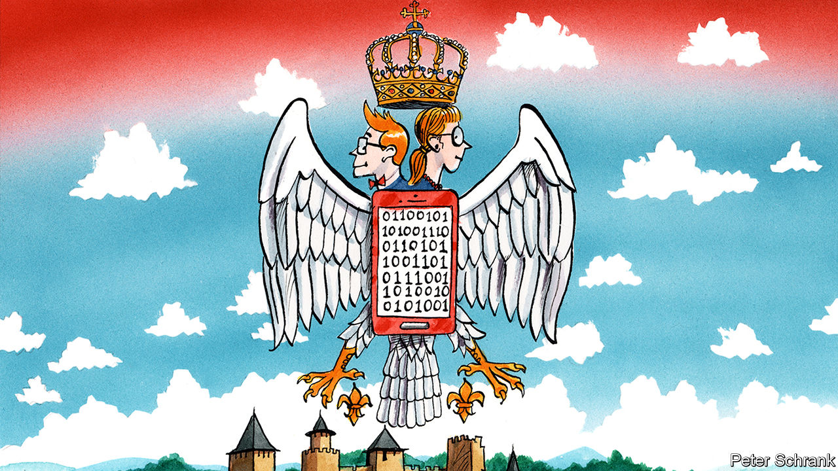

IT WAS MID-JANUARY and the Serbian capital was covered in toxic smog. Belgraders peered into their phones to check an app informing them about the air quality. It was “hazardous”, but if they were at a bus stop there was one thing to celebrate. Though they could barely see 200 yards, they could tell when their bus was arriving, as timings had just been added to Google Maps, years after most other European capitals. The digital revolution is at last arriving for Serbs. And as Europe goes green, more good news may be on the way. Serbia is sitting on one of the continent’s largest reserves of lithium, an essential ingredient for the batteries of electric cars.

Tech accounts for at least 6% of Serbia’s GDP. It employs some 45,000 people. Foreign firms have spent more than $500m on Serbian startups in the past six years, says Zoja Kukic of the Digital Serbia Initiative (DSI), which champions the sector’s interests. Last year’s exports are expected to have reached €1.4bn ($1.5bn), an increase of 55% on 2017. The real figure could be much higher, says Nebojsa Djurdjevic, head of the DSI. Foreign-exchange rules mean that payments are often sent to companies set up abroad, and no one can keep track of an estimated 10,000 freelancers who often operate alone.

Educated Serbs are leaving in droves—but not if they work in tech. It is one of the few sectors that draws skilled people back home. Many industry heads, including Dragan Tomic, who runs Microsoft’s Belgrade development centre, are diaspora Serbs who have returned with skills, contacts and capital. Mr Djurdjevic graduated in electronics in 1990. From his class of about 70, some 40 left. Ten are now back.

One part of Serbia’s government is still enmeshed in the wars of the past. It has only just agreed to reinstate long-severed rail and air connections to Kosovo, which it refuses to recognise. But another part has invested $79m in digital infrastructure, reforming regulatory frameworks and creating tax breaks to woo investment. Primary schools now teach coding. The country’s education system is churning out 5,000 graduates a year primed for tech jobs.

Blockchain and games development are already big parts of Serbia’s digital economy. Top Eleven, a football game produced by Nordeus, Serbia’s best-known tech company, has 219m registered users. But fintech, biotech and AI are increasingly important, though they still find it hard to attract investors at home.

While digital tech is Serbia’s current boom industry, lithium may be the next. Rio Tinto has invested $200m to explore a site near Loznica. Marnie Finlayson, its general manager for Serbia, says that the ore would be processed on the spot; it would be Europe’s biggest supplier. Unlike many other lithium mines, this one would be close to where it is needed. Fiat cars are Serbia’s second biggest export. Ms Finlayson says that by 2035 Rio Tinto expects 50% of cars to be electric. If Rio Tinto’s board gives the go-ahead, production would begin in 2025. With all the ancillary industries, she says that might add “a couple of percentage points to GDP”. ■

This article was downloaded by calibre from <https://www.economist.com/europe/2020/02/29/an-unexpected-tech-boom-in-serbia>

|  |  |  |  |
| --- | --- | --- | --- |
| Previous | Articles | Sections | Next |

|  |  |  |  |
| --- | --- | --- | --- |
| Previous | Articles | Sections | Next |

#### Down at heel

# The travails of “ex-Ilva”, Europe’s largest steel plant

A rescue plan may be on the way

Feb 29th 2020 | TARANTO

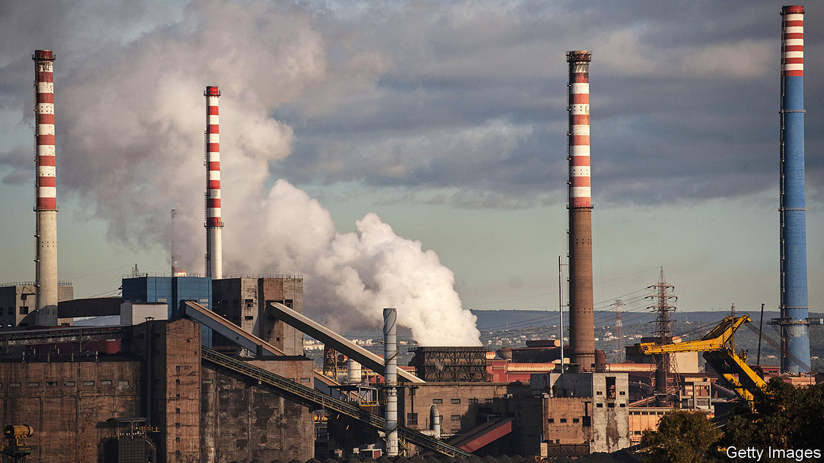

DR GRAZIA PARISI has been working for four hours without a break at her paediatric surgery. “I’ve seen between 30 and 35 children—all with coughs,” she says. It is Monday. The previous week, from Wednesday to midday on Friday, Taranto, in Italy’s far south, had endured a succession of what the locals call “wind days”. That is when the wind blows from the north-west, through Europe’s biggest steelworks on the outskirts, and into the city.

“There is a mathematical correlation between wind days and the [number of] respiratory ailments I treat,” says Dr Parisi. The closer her patients live to the steelworks, the more acute their symptoms. Several of her patients had spent part of the weekend at the local hospital and some had even been admitted, such had been the seriousness of their ailments.

Things used to be even worse, before the factory’s new owners, ArcelorMittal, a multinational, covered its giant stockpiles of coal and iron. But, says Luciano Manna, an environmental campaigner, the wind still picks up plenty of mineral dust from the factory’s waste dumps. Commonly known, by reference to its earlier owners, as the “ex-ILVA”, the steelworks is the size of a small town or a large suburb. It covers 15 square kilometres (six square miles).

The Italian government has set February 28th as the deadline for an agreement with ArcelorMittal on the fate of the factory, one of Europe’s worst environmental black spots. The firm leased the site in 2018 under an agreement whereby it undertook to clean up the plant and inherited—from the government commissioners then managing the place—immunity from prosecution for environmental crime as it did so.

But last November ArcelorMittal withdrew from the deal after the maverick Five Star Movement (M5S), which is in a governing coalition with the centre-left Democratic Party (PD), succeeded in getting the immunity lifted. Critics of the firm argue that it has failed to invest enough in the clean-up, a charge the company rejects. Dr Parisi wants the steelworks shut down. She is not alone: a pledge by the M5S to close the plant helped it win 48% of the votes in Taranto at the last general election, in 2018.

On one side of Taranto’s Piazza Gesù Divin Lavoratore, the walls between the shops and bars are clad in a textured stone that catches whatever dust may be in the air. Run a finger over the stone and it comes away red. “Iron oxide”, says Ignazio D’Andria, owner of the Mini Bar. “That’s why all the apartment blocks here are painted red or pink or some other dark colour—so you can’t see the mineral dust.” His bar is in Tamburi, a district built for the steelworkers and their families that begins almost at the perimeter of the giant complex. Tamburi gets the worst of the pollution, but locals say that plenty of mineral dust finds its way into the centre of Taranto when the wind blows across the city and out to sea.

According to a gold dealer who has the shop next door to the Mini Bar, six of the children from homes on the piazza suffer from learning difficulties. That would be consistent with a study published in 2016, which found that the IQs of children from Tamburi were on average 13 points lower than those of children living 15km away. But the threats the ex-ILVA poses are not just to health and the environment.

## Jobs, too

“It’s a social bomb,” says Giuseppe Romano, the local secretary of the left-wing CGIL-FIOM trades union federation. The factory employs more than 8,000 people. Another 4,000 work for its suppliers. If the ex-ILVA were to close altogether, thousands of other jobs would be lost as the turnover of bars, shops and other businesses shrank. And that in a province where one worker in six is already unemployed.

Taranto and the province to which it belongs form part of Puglia, the “heel” of the Italian “boot”, a region of mixed fortunes in recent years. It has enjoyed a tourism boom but has been hit by the spread through its olive groves of an insect-borne disease, Xylella fastidiosa. Searching for sources of income and employment to replace the steelworks in the event of its demise, the local authorities have sponsored plans for the founding of a university at Taranto, for more shipbuilding and for an aquarium. There is talk of encouraging more cruise liners to berth in its ample port. And in January Taranto became the first city in Italy to offer houses for sale for a token €1, on condition that the buyers renovate and live in them. The plan aims to revive the historic but dilapidated old town on an island between a lagoon and the Mediterranean.

Mr Romano hopes a way can nevertheless be found “to make steel without killing people”. The question is how much. He calculates that a thousand workers are needed to produce a million tonnes of steel. The market in Europe is glutted. Last year the steelworks produced just 4.3m tonnes against a capacity of 9m-10m and a government target of 8m.

Negotiators are reportedly close to a deal that would involve ArcelorMittal continuing to operate the works, possibly in partnership with the government, on the understanding that one of the existing blast furnaces is renovated and a new electric one built. Such a deal would represent a defeat for the M5S—a party already wracked by bitter internal divisions that has seen its popularity collapse since 2018. But it would reduce the pollution, though not eliminate it. And it would save thousands of jobs.

Still, it is clear that, if the factory is to operate at a profit and without becoming an endless drain on the resources of the long-suffering Italian taxpayer, thousands more jobs will have to go. ■

This article was downloaded by calibre from <https://www.economist.com/europe/2020/02/29/the-travails-of-ex-ilva-europes-largest-steel-plant>

|  |  |  |  |
| --- | --- | --- | --- |
| Previous | Articles | Sections | Next |

|  |  |  |
| --- | --- | --- |
| Europe | Sections | International |

Britain

The future of research: The £18bn question

.

Heathrow: It won’t fly

.

The politics of pop: Taking back control

.

Farming after Brexit: A green and poorer land

.

Barricaded Britain: Beauty or safety?

.

Shooting ranges: The legal battlefield

.

Life expectancy: Groundhog day

.

Menstruation: Scotland’s free periods

.

Bagehot: The man who dares to be dull

.

|  |  |  |
| --- | --- | --- |
| Europe | Sections | International |

|  |  |  |  |
| --- | --- | --- | --- |
|  | Articles | Sections | Next |

#### The £18bn question

# Britain’s great research bonanza

The government has promised to double funding. How should it spend the dosh?

Feb 29th 2020 |

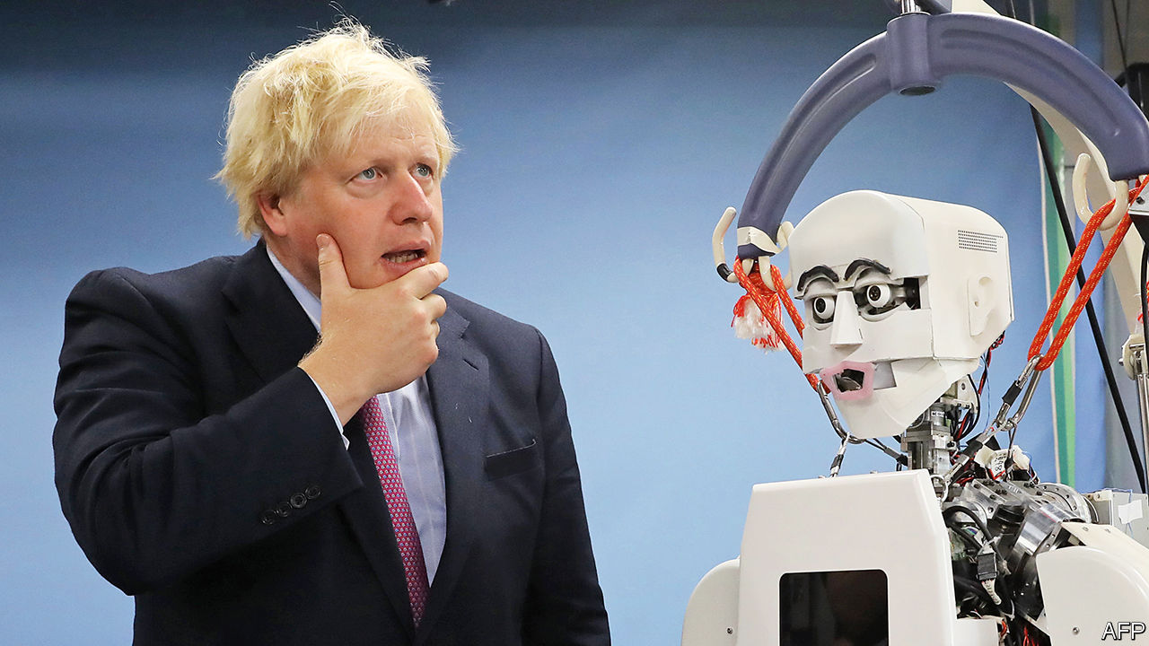

SINCE HE BECAME prime minister, Boris Johnson’s speeches have been studded with references to the glory of British science. Sometimes they are to cutting-edge facilities (“a place in Oxfordshire that could soon be the hottest place in the solar system”), sometimes to those who work in them (Britain will become a “supercharged magnet to attract scientists like iron filings”) and sometimes to the “colossal” investment his government will deliver. The last, at least, is not Johnsonian hyperbole: during the general election, the prime minister promised to more than double annual spending on research and development (R&D) to £18bn ($23bn, or roughly 0.7% of GDP) by 2024-25—a figure that may rise further still in the forthcoming budget.

The decision to splurge on research is part of the government’s attempt to answer the central question it faces: What next? Downing Street believes that for Britain to be successful outside the European Union it will have to build on its assets, not least its excellent science and research. On the basis of the citation impact calculated by Scopus, researchers in Britain are the most influential in the world. Despite accounting for just 7% of global publications, they produce more than 14% of the most highly-cited work. The government has loosened visa rules for foreign researchers and plans to cut the red tape they face. As Dominic Cummings, the prime minister’s chief adviser, has put it, the aim is to make “Britain the best place in the world to be for those who can invent the future.”

To make this happen, the government could just do what it is doing now but on a grander scale. UK Research and Innovation (UKRI) gives most of the government’s money to the best universities and people. The highest-ranked research receives four times as much cash as the next best under the main funding stream. This makes the system particularly susceptible to the “Matthew Effect”, meaning the best research attracts more funding, becoming better still, thus attracting more funding, and so on. Nearly half of public R&D money ends up in the “Golden Triangle”, as Oxford, Cambridge and London’s best universities are commonly known. As a result, Britain has three universities in the Times Higher Education global top ten, a league table determined largely by research quality. That is more than twice as many, per person, as America has.

And yet research excellence is not the government’s only aim. As he announced the extra money, Mr Johnson promised it would unleash a “new wave of economic growth” and “level up” industry in the regions. The goal, as a Tory MP puts it, is not to “to tip a load of money into telescopes to explore the outer regions of space, which will do fuck all for our economy”. Instead, it is to increase Britain’s dismal productivity growth, particularly in the regions, thus delivering jobs and higher wages.

Until relatively recently, British policymakers believed it was better left to the private sector to turn academic ideas into marketable products. Government spending on applied research, it was argued, would not only direct taxpayers’ money towards an area in which decisions were best made by the private sector, but also risked crowding out private investment. So although Britain spends around the average in the OECD club of mostly-rich countries on basic research, with excellent results, it is unusually frugal when it comes to the applied variety; spending just 0.1% of GDP on it, compared with 0.3% in America and 0.4% in Germany.

But as David Willetts, a former Conservative universities and science minister, has written, low R&D investment in the public and private sectors provides a strong argument for raising spending on applied research, to which the top universities will have a weaker claim. Britain’s poor productivity—around a fifth lower than Germany, France and America—provides another one. The example of countries like South Korea and Germany suggests that, rather than repelling private investment, well-directed public money can in fact prompt businesses to increase R&D spending.

Some Tory think-tankers have suggested the government should establish research institutes across the country—and particularly in towns that have just turned blue—in an attempt to give them a sense of purpose. Such an approach would create jobs supported by public money, but it would not do much else. Richard Jones, a science-policy expert at the University of Sheffield whose writing has influenced Downing Street, cites government nanotechnology investment in the mid-2000s as an example of how not to do things. Some £50m was split between 24 centres to bring the technology to market. Unsurprisingly, none went on to do anything of note.

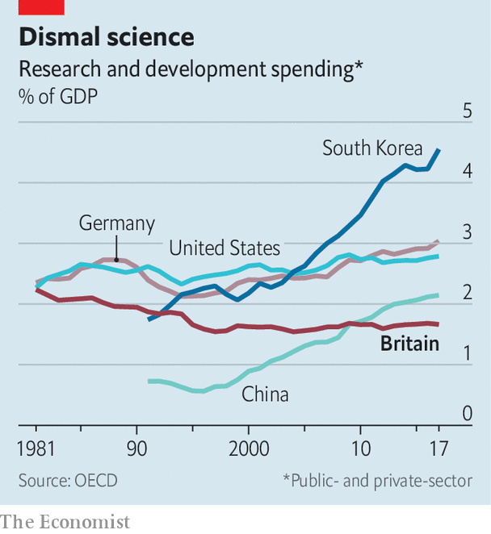

There are better ways to spread the cash. As Mr Jones notes, the regions that currently have higher levels of private R&D than public R&D, and thus where there is probably scope to increase public spending, include the Midlands and the north-west. These parts of the country have the additional benefit of cheaper property and looser planning regimes than Oxford, Cambridge and London, thus lowering the cost of expansion. The National Audit Office, an official watchdog, has criticised the government for not taking into account the running costs of new research facilities when deciding where to place them. Those decisions dictate where funding goes for decades to come. Cities in these regions will have a good claim to new institutions.

Doubling the research budget provides a lot of money to experiment with. A number of existing schemes are likely to grow. UKRI’s drearily-named “Strength in Places” fund, a £236m pot which is disbursed on the basis of academic excellence and economic considerations, could easily be beefed up. Another likely beneficiary, despite a decidedly mixed record so far, is the “catapult” programme. Based on Germany’s Fraunhofer Institutes, albeit with considerably smaller budgets, Catapults require a mixture of business, university and government investment. The most successful one—the AMRC in Sheffield—is home to the local university, as well as Boeing, Rolls-Royce and McLaren Automotive.

Putting more money into applied research outside the golden triangle is unlikely to supercharge Britain’s ability to win Nobel prizes or suck in the world’s top scientists. But done the right way, it might just fulfil other ambitions more relevant to voters, and thus to the government’s re-election chances. ■

This article was downloaded by calibre from <https://www.economist.com/britain/2020/02/29/britains-great-research-bonanza>

|  |  |  |  |
| --- | --- | --- | --- |
|  | Articles | Sections | Next |

|  |  |  |  |
| --- | --- | --- | --- |
| Previous | Articles | Sections | Next |

#### It won’t fly

# The expansion of Heathrow airport is scotched on climate grounds

The Court of Appeal sends the government back to the drawing board

Feb 29th 2020 |

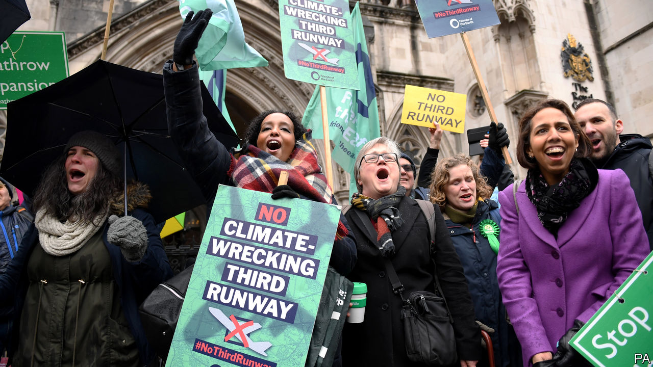

THE PARIS climate agreement, forged in 2016, has not made a huge difference to the world so far. But on February 27th it got its biggest break yet: the Court of Appeal in London found against the government and in favour of a coalition of groups that oppose the expansion of Heathrow Airport on grounds of climate, noise, air pollution and economic growth. The court said that the government should have taken the Paris agreement into account. The government is not going to appeal.

After a decade of lobbying by business, the government embraced the third-runway scheme in 2016. Chris Grayling, transport secretary at the time, said in a witness statement that the Paris agreement was “not relevant” to the scheme: the government had assessed it under a previous agreement. But that agreement was less stringent than the Paris one.

The decision does not put an end to airport expansion: it leaves room for the government to go back to the drawing board and come up with a plan that takes the Paris agreement into account. Businesses will argue passionately that airport expansion is essential to the growth that the government needs in order to finance its expensive schemes to build infrastructure elsewhere in the country. “Without expansion,” says Adam Marshall of the British Chambers of Commerce, “firms risk losing crucial regional connectivity and access to key markets across the world.” Insisting that it would fight the decision, Heathrow Airport invoked Johnsonian language: the runway “is essential to achieving the prime minister’s vision of Global Britain…Let’s get Heathrow done.”

But if there is to be airport expansion, there is a good chance now that it will not happen at Heathrow. Boris Johnson has long been a passionate opponent of the third runway, famously promising when he was mayor of London to “lie down in front of those bulldozers and stop the construction”. During the election campaign, he said that he would “find some way” to block it. He has also been under pressure to do something to show he is taking seriously COP26, the climate conference that Britain is due to host later this year. Giving up on Heathrow’s expansion would be a powerful gesture.

Mr Johnson is not, by and large, an enthusiast for judicial activism. But with this controversial judgment, the Court of Appeal may have done him a favour.

This article was downloaded by calibre from <https://www.economist.com/britain/2020/02/29/the-expansion-of-heathrow-airport-is-scotched-on-climate-grounds>

|  |  |  |  |
| --- | --- | --- | --- |
| Previous | Articles | Sections | Next |

|  |  |  |  |
| --- | --- | --- | --- |
| Previous | Articles | Sections | Next |

#### The politics of pop

# The BBC is taking back control of Eurovision

Britain tries to avoid another musical humiliation

Feb 29th 2020 |



BRITAIN IS IN a frenzy of popular participation. Its voters have gone to the polls in three general elections and a referendum in five years. Politicians attempting to “take back control” from institutions they deem unaccountable invoke the will of the people. Yet in one area of long-running controversy, the people are being disenfranchised. On February 27th, it was announced that James Newman, a singer-songwriter, will represent Britain at the Eurovision Song Contest in May. In a departure from recent form, Britons had no say in the choice; it was imposed by the BBC—which, unlike some Britons, has apparently not had enough of experts.

The policy is undoubtedly elitist. Yet the trouble with voters is they can back the wrong horse. Last year they plumped for Michael Rice, a former talent-show contestant who came last in the final, winning 11 of a possible 960 points. That proved the system’s Waterloo after two woeful decades, during which Britain earned the ninth-lowest tally of points of 49 competing countries. In 2003, Britain’s entry won no points at all.

Apathy may be to blame. Only 1.2m viewers tuned in to the selection show in 2019, down from 5.2m a decade earlier. By contrast, two-fifths of Swedes tune in to pick their contestant. That dedication seems to have paid off: Sweden tops the 20-year chart. For a democracy to produce the right outcomes, it may require mass participation.

Technocracy has been tried before. A panel of BBC bigwigs and music-industry types picked contestants between 2011 and 2015. None made the top ten. Bringing Engelbert Humperdinck, then 76, out of semi-retirement was particularly questionable. He finished 25th. “You can’t pick a hit by committee,” insists an industry wallah. This time the decision has been outsourced. BMG, a record label, picked both song and performer.

Britain’s problems ultimately lie with another sort of democracy, the pan-European telephone vote which—combined with the verdict of an expert panel—decides the contest’s ultimate winner. That Greece keeps voting for Cyprus may not entirely be explained by the Cypriots’ undoubted lyricism. In a popularity contest, it helps to be popular. But the only countries who consistently back Britain are Ireland and Malta. Brexit will hardly have won more friends. Britain should focus less on its routines and more on diplomatic footwork.

This article was downloaded by calibre from <https://www.economist.com/britain/2020/02/29/the-bbc-is-taking-back-control-of-eurovision>

|  |  |  |  |
| --- | --- | --- | --- |
| Previous | Articles | Sections | Next |

|  |  |  |  |
| --- | --- | --- | --- |
| Previous | Articles | Sections | Next |

#### Agriculture after Brexit

# British farmers fret about losing their protection and their subsidies

Many could soon have reason to regret voting for Brexit

Feb 29th 2020 |

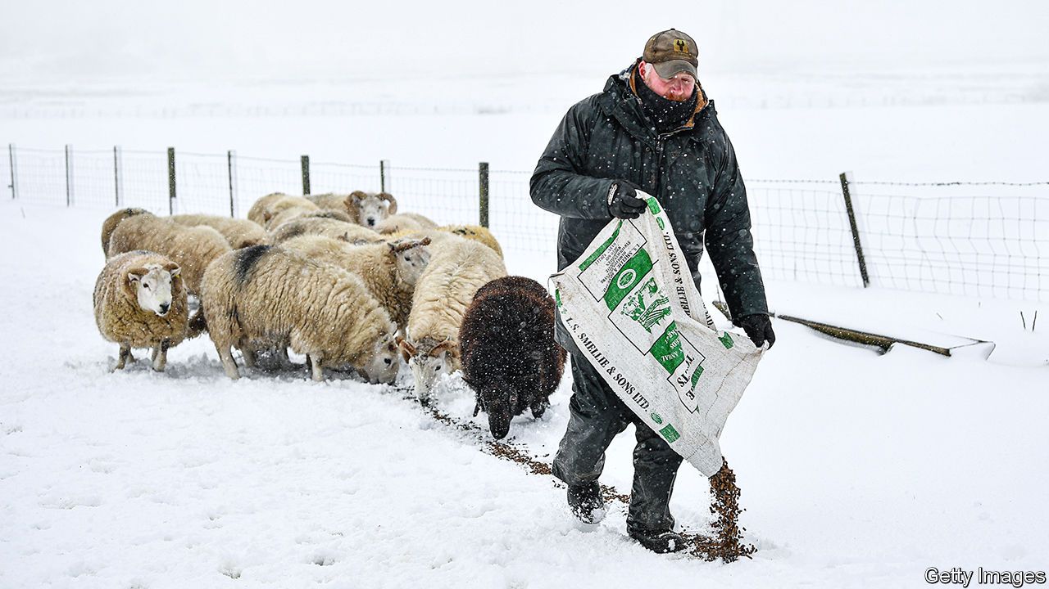

IT IS A TRUISM that farmers like Conservative governments. The party has deep roots in the shires and has traditionally supported country pursuits. Yet the present Tory government worries farmers. Their biggest concern is about whether and how it will replace their £3bn ($3.9bn) of annual subsidies under the European Union’s common agricultural policy, which make up nearly two-thirds of total farming income. They are right to fret. Some Tories believe that escaping the ludicrously lavish and protectionist CAP is among the biggest benefits of leaving the EU.

Drenched by recent floods, farmers will have drawn little comfort from this week’s conference of the National Farmers Union (NFU). George Eustice, newly promoted to the job of secretary of state at the Department for the Environment, Food and Rural Affairs, spoke enticingly of a prosperous future, but also of the biggest change in agricultural policy in half a century. Much of his agenda is commendable, notably tying subsidies to environmental and other public goods rather than ownership of land. And he promised that any changes would be phased in over seven years.

But there was a sting in the tail. The day before delivering his speech, Mr Eustice announced sharp and progressive cuts in direct payments to farmers, starting in 2021. Those due to get under £30,000 will see a reduction of just 5%, but the cuts will rise in steps to 25% for those collecting over £150,000. And this attack on the squirearchy may be just the beginning. The government is committed to keeping total subsidies unchanged only for the term of the current parliament.

In future, subsidies will be doled out in three tiers under the broad heading of “environmental land management”: one to incentivise such measures as pest control, hedge planting and soil improvement, a second for local actions like tree planting and creating habitats and a third to foster general landscape improvement. These may be sensible goals, but the red tape involved in monitoring them could be even more intrusive than today’s system of direct support. Imposing such an avowedly green agenda may also sound to farmers decidedly unTory.

And then there is the prospect of future trade deals that may lead to cheaper imports. Mr Eustice told the NFU that, in response to farmers’ concerns, he was amending the agriculture bill to include regular assessments of food security. He also promised to pay particular attention to food safety and animal welfare. Yet his bill offers no guarantees on food standards. And whereas his predecessor, Theresa Villiers, vowed in January to stick to the EU ban on importing such horrors as chlorinated chicken from America, Mr Eustice has made no such pledge, suggesting instead that there is “a discussion to be had” on food standards.

This ambiguity is surely deliberate. Next week the government will publish its guidelines for future trade talks with America, hoping thus to put pressure on Brussels to soften its negotiating position in the EU-UK trade talks that start on March 2nd. Washington’s priority in any trade negotiations will be to prise open the British market for American agriculture. Minette Batters, the NFU’s president, argued this week that letting in cheaper food which it would be illegal to produce in Britain would be “morally bankrupt” and “insane”. But she may have a fight on her hands.

Farmers are mindful of the experience of New Zealand, which scrapped most of its farm subsidies in the 1980s. Agriculture is now thriving there, but the transition was long, painful and, to quote Mr Eustice once more, chaotic. Yet if the future looks frightening, farmers share responsibility for shaping it: like turkeys voting for Christmas, a substantial majority of them backed Brexit in June 2016.■

This article was downloaded by calibre from <https://www.economist.com/britain/2020/02/29/british-farmers-fret-about-losing-their-protection-and-their-subsidies>

|  |  |  |  |
| --- | --- | --- | --- |
| Previous | Articles | Sections | Next |

|  |  |  |  |
| --- | --- | --- | --- |
| Previous | Articles | Sections | Next |

#### Beauty or safety?

# Anti-terror barricades spread beyond big cities

And the government wants still more

Feb 29th 2020 | CAMBRIDGE

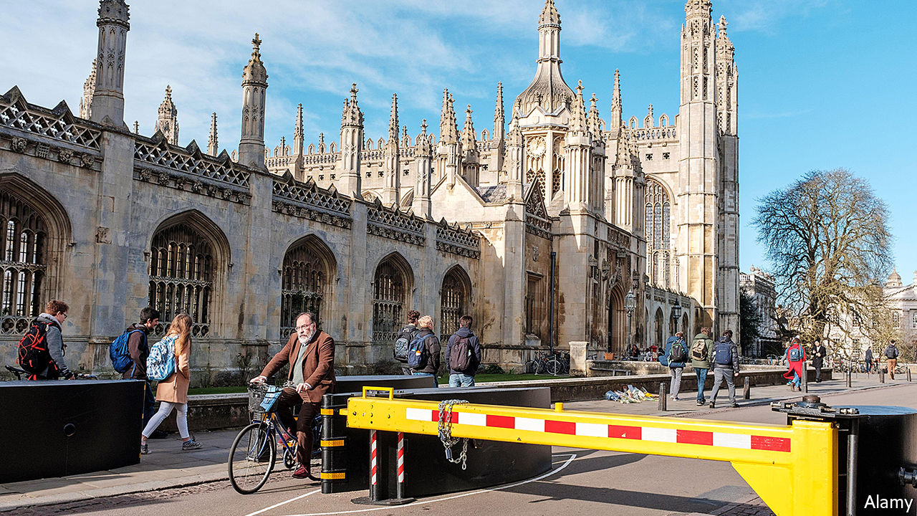

THE CORPUS CLOCK is a mechanical marvel. Plated with 24-carat gold, the 1.5m-wide timepiece is accurate once every five minutes. The rest of the time tourists are able to enjoy the macabre grasshopper which sits atop it, munching the minutes as they pass. At least, that is, when they are not having to dodge vans making three-point-turns near the recently installed barrier at the bottom of King’s Parade, designed to stop terrorists from targeting the centre of Cambridge.

Common for years in big cities, such protection is spreading across the country. Cambridge is one of a number of smaller towns and cities—including Canterbury, Windsor and York—that have recently installed it. They may be ahead of the trend. On February 24th the government opened a consultation on a new duty to protect, which would require businesses and public authorities to put in place measures to guard the public from attacks.

The government also wants to make public spaces more beautiful. The Cambridge example suggests reconciling these two desires may prove difficult. Susan Grossey, a local resident, accepts the need for security measures, but not for a large, ugly barrier in the centre of town: “I mean, King’s is our most beautiful street. And that view of King’s College is iconic. Why? Why would they do that?” Many worry that “temporary” protections have a habit of turning into permanent measures. A petition calling for the barrier’s removal or replacement swept past 1,000 signatures, prompting a debate at the local council.

Yet the choice between beauty and safety is not always so stark. At their best, barriers may not be beautiful, but they are invisible. Local authorities can choose from any obstacle that meets standards set by the International Organisation for Standardisation. And many newer ones are designed to be as surreptitious as possible. Marshalls, a manufacturer, specialises in less off-putting barricades, including the Rhinoguard Giove Protective Planter, which is, in effect, an enormous plant pot able to withstand an unladen 7.5-tonne lorry travelling at 50mph. The firm says revenues from its unobtrusive obstacles have risen by more than 50% since 2017.

It is easier to combine beauty with security when designing from scratch. The “hostile vehicle mitigation measures” around the Welsh Assembly in Cardiff are, for instance, mostly disguised as steps. All of England’s police forces have at least one “designing-out crime” officer to advise local planners on how to integrate security measures. Their job is harder when it comes to adapting existing spaces, says Paul Jeffrey of the Perimeter Security Suppliers Association, a trade group. “Retrofitting is an absolute nightmare,” he notes. It is something many other places, besides Cambridge, may be about to discover. ■

This article was downloaded by calibre from <https://www.economist.com/britain/2020/02/29/anti-terror-barricades-spread-beyond-big-cities>

|  |  |  |  |
| --- | --- | --- | --- |
| Previous | Articles | Sections | Next |

|  |  |  |  |
| --- | --- | --- | --- |
| Previous | Articles | Sections | Next |

#### Gun laws

# Britain’s shooting ranges could be in trouble

A verdict raises questions about the future of a gentlemanly pursuit

Feb 29th 2020 |



NAKED FROM the waist up, save for a red baseball cap, rapper Ard Adz (pictured) wields an alarming looking assault rifle. In a video uploaded to social media 14 months ago, he makes his way around a rudimentary obstacle course, firing at crude cut-outs. Such were the joys of Full Metal Jacket Ranges—a “premier outdoor shooting range” in Waltham Abbey, Essex—until it shut at the end of 2018, when Daniel Hammond, the operation’s boss, was called in front of Wood Green Crown Court, accused of a range of firearm offences.

Britain has some of the tightest gun laws in the world. Since the Dunblane massacre in 1996, most types of firearm have been illegal. Shotguns and small-bore rifles are permitted with a certificate. But one exemption remains. Section 11/4 of the Firearms Act permits air weapons and miniature rifles (of the sort Mr Adz was using) to persons “conducting or carrying on a miniature rifle range”. Certification is not needed. The exemption dates back to the discovery during the Boer War that the British were lousy shots: ranges were supposed to improve their aim.

The carve-out formed a key part of Mr Hammond’s defence. He was tried on a number of charges, including possessing a firearm without a licence. This was nonsensical, Mr Hammond argued, because as a shooting-range manager he should be exempt from the need for a licence. The jury agreed, and on February 26th decided Mr Hammond was not guilty of this charge. A verdict was due on two remaining charges as The Economist went to press.

The decision may end up damaging Britain’s gentlemanly shooting community, which is headed by the National Small Bore Rifle Association (NSRA) and the country’s very own National Rifle Association (NRA). Founded in the 19th century to improve public marksmanship, these governing bodies maintain close ties with the military, run their own ranges and affiliate with rifle clubs. They also police new ranges, issuing certificates to those who meet their specifications.

They did not think Mr Hammond’s outfit was up to scratch. Expert witnesses from the two organisations argued the exemption ought not to apply to Mr Hammond as the range he ran was “untidy” and failed to meet safety requirements. “Earth mounds that had been built weren’t high enough, and bullets were leaving the range,” argued the prosecution. “Bullets could potentially go on to the motorway, a café, a hotel and even a housing estate below.” But although the practice has been for range-owners to get certificates from these organisations, the law does not require it.

The defence believed the real issue was class. What went on was “no more and no less than what people are doing up and down the country,” argues Terence Boulter, Mr Hammond’s barrister, “though they might not be dressed like this, they might be wearing tweeds.” Mr Hammond sees the court case as an attempt to keep guns away from the working-class and ethnic minorities. Andrew Mercer, secretary general of the NRA, rejects that interpretation: “I’d find it hard to believe that the Crown Prosecution Service would spend money from the public purse on the basis of snobbery.”

Regardless of their motivation, the verdict is a problem for the shooting bodies, since it raises questions about the future of the exemption on which they rely. “We’ve never had any problem with this before,” said an NRSA representative during the case. “It could potentially be a bit of a muddle, couldn’t it?” The Law Commission, a quango, has argued for removing the exemption, and the judge in Mr Hammond’s case is expected to outline his view of inadequacies in the law as it stands. Mr Boulter says the exemption was something people didn’t want to talk about: “Why? Because it allows you to do what you want.”

That may not be true for much longer. Mr Hammond may have unwittingly provoked Britain’s gun lobby to shoot themselves in the foot. ■

This article was downloaded by calibre from <https://www.economist.com/britain/2020/02/29/britains-shooting-ranges-could-be-in-trouble>

|  |  |  |  |
| --- | --- | --- | --- |
| Previous | Articles | Sections | Next |

|  |  |  |  |
| --- | --- | --- | --- |
| Previous | Articles | Sections | Next |

#### Groundhog Day

# Health inequality in England was bad. It has got worse

The Marmot Review revisited ten years on

Feb 29th 2020 |

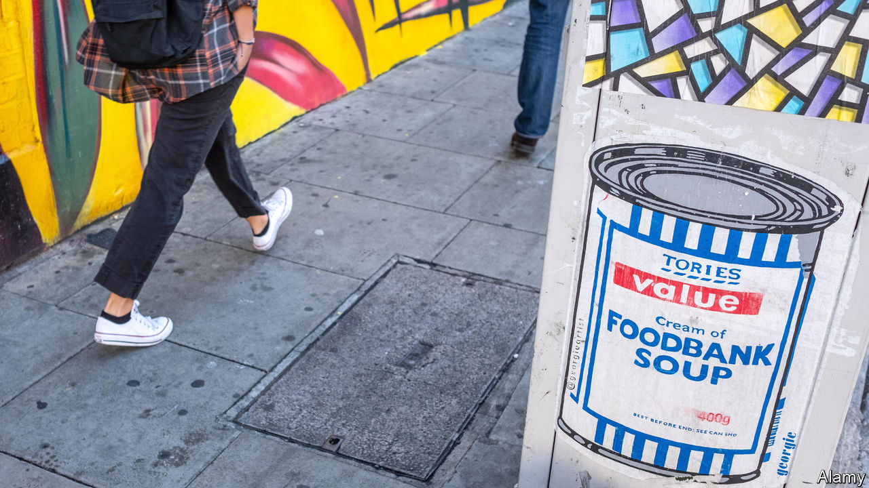

TEN YEARS ago the Marmot Review, a study commissioned by the government, asked a big, complicated question: why do some people in England live longer, healthier lives than others, and what can be done to reduce the gap? The answer it found was simple. Some people lived longer because they were better-off. To change this, it concluded, the government would have to reduce social inequality.

A new report by its author, Sir Michael Marmot of University College London, reviews the past decade’s changes. The numbers speak for themselves. In the three decades leading up to the first report, life expectancy at birth for men increased by a year every four years. Between 2011 and 2018 that rate slowed to a year every 15 years. For women the decline was even starker, from a year every five-and-a-half years to one every 28 years. And for the very poorest women, things have gone backwards. Life expectancy for those in the most deprived areas has declined by 0.3 years from 2010-12 to 2016-18. All women born later in the past decade are expected to have fewer healthy years than those born at the start of it.

Moreover, both men and women under the age of 50, particularly between 45 and 49, have seen mortality rates tick up (see chart). Sir Michael suggests that this could be related to suicide, alcohol use and rising drug toxicity, making it the British version of rising mortality rates among poor Americans, termed “deaths of despair” by Anne Case and Sir Angus Deaton, two economists who study the phenomenon.

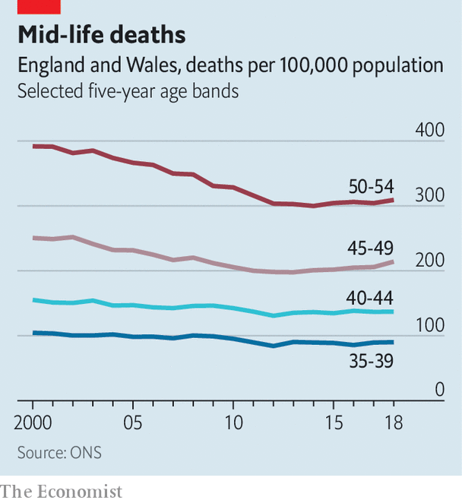

What happened? The report stops short of putting the blame squarely on austerity, though it notes government spending has declined sharply in the past decade. One reason women may have suffered more than men is that spending cuts hit them harder. Research by the House of Commons library found that the majority of reductions have been borne by women, because the benefits they were likelier to receive saw deep cuts. Regional differences matter too. Poorer areas in the north are even more likely to have worse health than those in the south-east. “I invite you to speculate that it is highly likely that some of these [cuts] will have had an adverse effect on health,” says Sir Michael.

Yet the link between austerity and poor health is hard to pin down. David Sinclair of the International Longevity Centre, a think-tank, points out that several European countries underwent a period of austerity in the 2010s without drastically worsening health outcomes. And increases in life expectancy have slowed across the rich world, notes David Buck of The King’s Fund, another think-tank, though the slowdown in Britain has been sharper than most. Both Davids agree with Sir Michael that to improve public health governments must spend not just on health services but also on education, child support and community services. The health secretary, Matt Hancock, also welcomed the report. “He said ‘we’re committed to levelling up’, and levelling up, and levelling up. He said levelling up four times I think,” says Sir Michael, referring to the government’s plan to boost poor parts of the country. “And in case I hadn’t got it: ‘levelling up’.” ■

This article was downloaded by calibre from <https://www.economist.com/britain/2020/02/29/health-inequality-in-england-was-bad-it-has-got-worse>

|  |  |  |  |
| --- | --- | --- | --- |
| Previous | Articles | Sections | Next |

|  |  |  |  |
| --- | --- | --- | --- |
| Previous | Articles | Sections | Next |

#### Menstruation

# Free period products in Scotland

Another way in which the difference between Scotland and England is growing

Feb 29th 2020 |

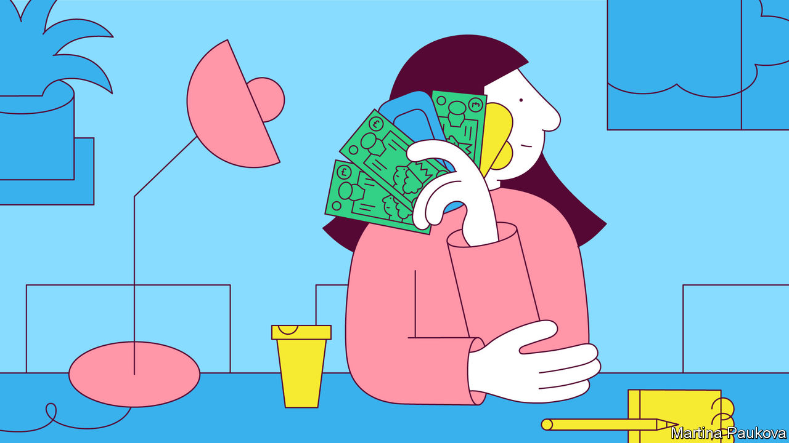

WHEN MICHELLE FISHER was a teenager, money was tight, and she had to ration the number of tampons she used. Despite experiencing extremely heavy periods, she would use only one or two a day. Once, she bled through onto a chair at school. “Even to this day when I’m buying products it still feels like I need to ration myself as an after-effect of being so restricted growing up.”

Ms Fisher shared her experiences in the course of a consultation on a bill that would make Scotland the first country in the world to offer free period products to all women. The Period Products Bill has just passed its first legislative hurdle, and if it becomes law, which looks likely, the Scottish government will be obliged to provide free sanitary pads and tampons to “anyone who needs them”. Many countries have cut taxes on sanitary products, and Scotland is not the only place to give them out free in schools. But this bill offers the widest provision of pads in the world, costing £24m a year, according to the government.

The woman behind the bill is Monica Lennon, a Labour member of the Scottish Parliament. She initiated the first conversation about the cost of periods in the Scottish chamber’s history; in 2020 she has grey-haired male MSPs talking about bloody tampons. Earlier this month the ruling Scottish National Party abandoned its concerns about period tourism flooding over the English border, so the bill has the support of all parties and looks set to cycle through Parliament.

The prevalence of women in Scottish politics seems to be one reason why Scotland looks like achieving a world first on this issue. The Scottish cabinet is more than half female (compared with a quarter at Westminster’s top table), and Scotland has had a female first minister, Nicola Sturgeon, for five years. She championed the introduction of free period products in schools in 2018.

The measure is also an indication of the Scottish government’s appetite for radical social legislation, points out Mark Diffley, an independent polling consultant in Edinburgh. Scotland has provided free university tuition and personal care, banned smoking in public places and set a minimum price on alcohol. Such measures are increasing the distance between Scotland and England—which, as far as the SNP is concerned, is all to the good.

This article was downloaded by calibre from <https://www.economist.com/britain/2020/02/29/free-period-products-in-scotland>

|  |  |  |  |
| --- | --- | --- | --- |
| Previous | Articles | Sections | Next |

|  |  |  |  |
| --- | --- | --- | --- |
| Previous | Articles | Sections | Next |

#### Bagehot

# Keir Starmer, a serious Labour man

Labour may be about to embrace the Anglosphere’s first post-populist

Feb 29th 2020 |

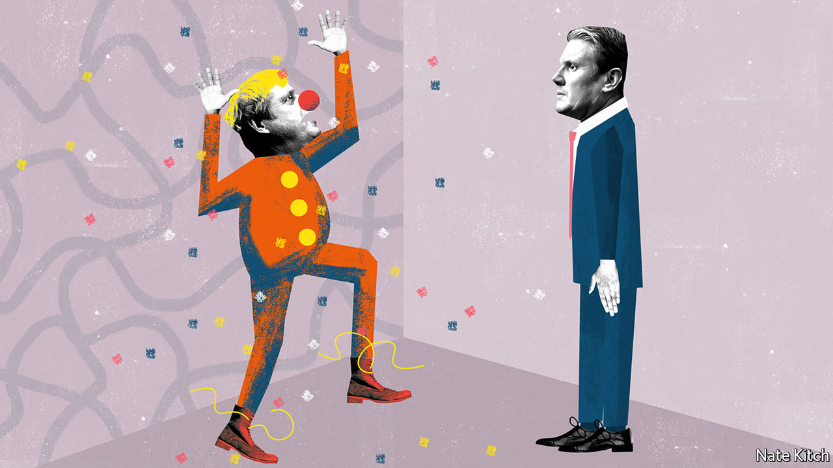

JEREMY CORBYN’s election as leader of the Labour Party in 2015 was an early warning that the populist virus was spreading to the Anglo-Saxon world. The next few years saw Donald Trump win the White House, Britain vote to leave the EU, and, after three years of gridlock, Boris Johnson take over the Conservative Party on a promise of getting Brexit done “do or die”. Could Mr Corbyn’s retirement from the leadership on April 4th bring about another big change in politics?

The populist fires are burning brighter than ever in the United States, where Democratic activists love Bernie Sanders for the same reasons that Corbynistas loved Mr Corbyn, and with the same disregard for their hero’s electability. But the fires seem to be dying down in Britain. The latest YouGov/Sky poll of Labour Party members shows Sir Keir Starmer, a former barrister and director of public prosecutions, beating Rebecca Long-Bailey, a left-winger who is his principal rival for the leadership, by 53% to 31% of first-preference votes.

Sir Keir is the polar opposite of the charismatic populists who bestride much of the world. People who know him agree on two basic facts. The first is that he is a thoroughly decent human being—a family man with none of the hauteur that can afflict prominent politicians. The second is that he’s very serious. The most common words used to describe him are competent, credible, diligent, cautious and even boring.

His position as front-runner suggests that it is possible to recover from even a serious dose of populism. Pessimists have worried that populism is self-reinforcing, that converts respond to defeat not by moderating their position but by demanding madder music and stronger wine. But the party is clearly sobering up after its catastrophic defeat in December. More than 100,000 people have joined or re-joined since the election, in part to have a say over the next leader, and many long-standing members, including prominent Corbynistas such as Paul Mason, have concluded that winning elections matters more than ideological purity.Sir Keir is only one of a new wave of moderates. On February 6th Liam Byrne, a one-time Blairite, defeated two left-wing candidates, backed by Momentum and big unions, to win the party’s nomination for mayor of the West Midlands.

Sir Keir’s lead also suggests that British politics will be configured differently from American politics. While America, if Mr Sanders wins the Democratic nomination, will see a competition between two forms of populism, in Britain a populist prime minister will square up against a technocrat. If politics is best when it is a study in contrasts, then Britain is in for a feast.

Boris Johnson and Sir Keir could hardly be more different. Mr Johnson was born into the heart of the British establishment. Sir Keir is the embodiment of the meritocracy. His father was a toolmaker and his mother a nurse who gave up work because she contracted a rare disease that eventually paralysed her. Sir Keir was the only one of four siblings to pass the 11-plus and was the first member of his family to go to university. Mr Johnson is a charismatic politician who can light up a room with his presence. Sir Keir has cultivated an air of high seriousness which verges on dullness. Mr Johnson is a big-picture man who can capture the mood of the times with a single phrase (“Get Brexit done”) but who is often weak on detail, sometimes with catastrophic consequences. Sir Keir is a forensic lawyer who masters his briefs.

Sir Keir’s approach to winning the nomination has been a study in careful triangulation. He has gone out of his way to praise both Tony Blair and Mr Corbyn. “Don’t trash the last Labour government and don’t trash the last four years,” is a mantra. He has surrounded himself with people from all sides of the party, including Simon Fletcher, a former chief of staff to Mr Corbyn, and Jenny Chapman, a former vice-chair of the Blairite pressure group, Progress. By couching his politics in vague terms—he wants to be both “radical” and “relevant”, for example—he has given himself maximum freedom of manoeuvre.

While it is hard to define what Sir Keir stands for politically, it is clear what he isn’t: a populist. He personifies the “blob” that populists accuse of frustrating the will of the people. He is a leading human-rights lawyer who has not been afraid to take on even the most unpopular cases. In 2008 he won one on behalf of two terrorist suspects that led to control orders—restrictions on the liberty of unconvicted people—being declared unlawful.

Being dull will not by itself turn Sir Keir into a winner. Competence is compelling only in pursuit of a goal. He needs to articulate a vision of the future and to acquire—or reveal—a killer instinct. His first test will be whether he has the courage to deny Ms Long-Bailey the shadow chancellorship and give it to somebody from the right of the party, such as Yvette Cooper.

But his seriousness may prove an asset. The world may lose patience with the larger-than-life personalities of populist leaders. A Trump-Sanders match-up for the American presidency will exhaust normal people’s appetites for bellowing and finger-jabbing. A hard Brexit next January, accompanied by queues of lorries at ports and empty shelves, may confront voters with the consequences of Mr Johnson’s “do or die” rhetoric. A coronavirus pandemic would put a premium on diligence and expertise.

The last time Labour elected a leader who personified cautious competence was in 1935. Winston Churchill, Mr Johnson’s great hero, and his superior in flamboyance among other traits, dismissed Clement Attlee as a modest man with much to be modest about. Aneurin Bevan, the leader of the left, said that “things happened to him. He never did anything.” But during his 20 years as leader Attlee brought the party from the socialist wilderness into the mainstream, beat Churchill in 1945 and led one of the 20th century’s great reforming governments. History is made by colourless men just as much as colourful ones. ■

This article was downloaded by calibre from <https://www.economist.com/britain/2020/02/29/keir-starmer-a-serious-labour-man>

|  |  |  |  |
| --- | --- | --- | --- |
| Previous | Articles | Sections | Next |

|  |  |  |
| --- | --- | --- |
| Britain | Sections | Business |

International

Speech at work: None of your business

.

|  |  |  |
| --- | --- | --- |
| Britain | Sections | Business |

|  |  |  |  |
| --- | --- | --- | --- |
|  | Articles | Sections | Next |

#### None of your business

# Companies are increasingly worried about what their employees say

The boundaries between people’s work and private lives are increasingly blurred

Feb 29th 2020 |

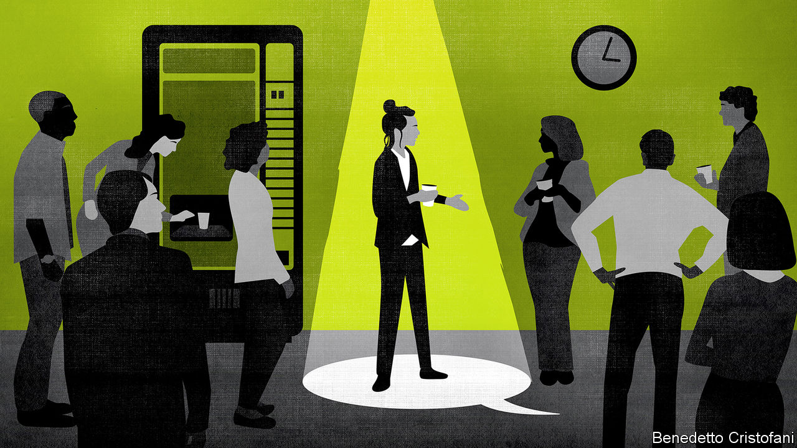

LAST DECEMBER a British employment tribunal ruled that the Centre for Global Development, a think-tank, had acted legally when it did not renew Maya Forstater’s contract because she had tweeted that a person’s biological sex is immutable. Ms Forstater, a researcher, had tweeted several messages critical of the idea that natal males can become women. She did so from her personal account but listed her employer in her Twitter profile. After colleagues complained to the human-resources department about her conduct online, she was asked to add the disclaimer “views are my own”. She did so. According to her employer, co-workers objected to her posting a picture of herself at a protest with a banner that said “Woman, noun, adult human female”.

Trans-rights activists cheered, and women’s-rights and free-speech advocates were horrified, because a precedent had been set. In court, Ms Forstater had argued that her conviction that men cannot become women should be protected in the same way as a religious belief would be. The judge disagreed, ruling that her “gender-critical” views were “not worthy of respect in a democratic society,” and did not qualify for protection.

By contrast, another British tribunal ruled in January that ethical veganism did. Jordi Casamitjana was dismissed from the League Against Cruel Sports, an animal-welfare charity, after disclosing that its pension fund invested in companies involved in animal testing. Mr Casamitjana is appealing against his sacking. He says that he was fired because he is a vegan on ethical grounds. If he proved that to be the case, his firing would be discriminatory. His employer says he was fired for gross misconduct and that his beliefs were irrelevant.

A confluence of technological and cultural change has made such cases almost inevitable. Thanks to Twitter and other social networks, employees have many more opportunities to broadcast their opinions; off-colour comments that would once have been uttered in a bar now ricochet around the world. Companies that strive to demonstrate their progressive character are likely to find that troublesome.

Meanwhile, the nature of belief has changed. People in rich countries are less likely to say that they belong to a church. Even in America, which is more pious than most, the proportion of people who say they have no religious affiliation has climbed from just 6% in the early 1970s to 22%, according to the Pew Research Centre. Among millennials, who represent more than a third of the workforce, the proportion is twice as high. Yet the hole left by the decline of organised religion has been filled by a diversity of other beliefs, held just as fervently. Companies and courts must grapple with the question: how far should laws written to protect employees against discrimination on religious grounds be applied to those beliefs, too?

The case law on religious discrimination is well established. Legal judgments about job requirements often turn on the question of whether an employer could have made a reasonable adjustment to accommodate a person’s religious beliefs. A school in Denmark that fired a Jehovah’s Witness in 2018 who refused to dance around a Christmas tree was found guilty of unlawful discrimination because it could easily have accommodated such wishes. But in 1994 a Dutch casino was allowed to sack a Christian croupier who refused to take customers’ cash because doing so was an essential part of the job.

Many Western countries also ban discrimination on the basis of “belief”, though none defines the term clearly. Increasingly, non-religious workers want similar protections to those afforded to religious groups, says Peter Daly, an employment lawyer involved in the cases of both Ms Forstater and Mr Casamitjana. British courts are leading in this area.

The bar for beliefs to qualify for protection was lowered in 2006 when Britain removed the requirement for such beliefs to be “similar” to religious ones. Then, in 2009, a tribunal ruled that Tim Nicholson’s belief in man-made climate change was akin to a religious conviction and should enjoy the same protections.

Mr Nicholson had been head of sustainability at Grainger PLC, a property-investment firm, until he was made redundant. Grainger claimed this was a result of changing staffing needs. Mr Nicholson argued that his redundancy was the result of his environmental beliefs: he often urged executives to improve their green credentials. The firm’s lawyer claimed that Mr Nicholson’s views were opinions, as opposed to beliefs that enjoyed special protections. But the fact that his daily life was guided by his convictions, influencing how he travelled and lived, helped convince a judge that his was a belief worthy of protection, a decision that has been influential in much of Europe.

The ruling set five criteria for a protected belief. It must be genuinely held; be more than an opinion or viewpoint based on the present state of information available; be a weighty and substantial part of life; attain a certain level of cogency, seriousness, cohesion and importance; and be worthy of respect in a democratic society and compatible with human dignity and the rights of others. The last criterion was set explicitly narrowly to rule out particular noxious beliefs. White Supremacy has failed on that test.

Over the past decade European tribunals have concluded that various non-religious beliefs clear the bar. Anthroposophy, opposition to hunting, Darwinism, faith in the “higher purpose of public broadcast journalism” and ethical veganism have been ruled in. Being sympathetic to China, disliking asylum-seekers and the conviction that 9/11 and 7/7 were “false flag” operations have been ruled out. On vegetarianism and Marxism countries disagree.

It is illegal in most European countries, particularly former communist ones, and some American states, to fire someone for their political beliefs. Several Silicon Valley employees have used such laws in California to argue that they were fired for being conservatives. But most Americans enjoy no protection of their political beliefs at work. In 2004 a woman in Alabama was legally fired from a housing-insulation company for having a John Kerry bumper sticker on her car. In December a man playing Father Christmas at a mall in Georgia was replaced after photos emerged online of him wearing a pro-President Trump baseball cap while on duty (he claims it was a joke). Christopher Olmsted, an employment lawyer in California, expects political disputes on the workfloor to heat up as elections approach later this year.

Employers say they need to restrict the expression of certain views in order to create inclusive workplaces. Consider the sacking of James Damore, a Google engineer, in 2017 after he penned the “Google Memo”, which argued that women were biologically less suited to tech jobs. Diversity officers at many firms protested, arguing that firing someone with views that are different from the norm was the opposite of inclusivity. Human-resources and employment lawyers defended the dismissal as the only way to protect employees from hostility and the company from litigation—and bad press.

But firms are increasingly concerned about what their employees say and write outside the office. In 2018 a film director was fired by Disney for tweets in which he joked about rape, sent years before the company hired him. In 2019 a “greeter” for ASDA, a supermarket, was dismissed for Islamophobia after sharing a Billy Connolly video on Facebook (a comedian whose work is sold by ASDA). Both have since been reinstated, but only after hassle, and “all because their employers had a panic attack over what was happening on social media,” says Jodie Ginsberg, the outgoing CEO of Index on Censorship, a charity. Pascal Besselink, a Dutch employment lawyer, estimates that about one in ten on-the-spot firings in the Netherlands are now related to social media. Few have garnered much attention because companies tend to settle disputes quietly. Even when firms are in the right they prefer to stay out of the limelight, so will buy off fired employees in exchange for their silence.

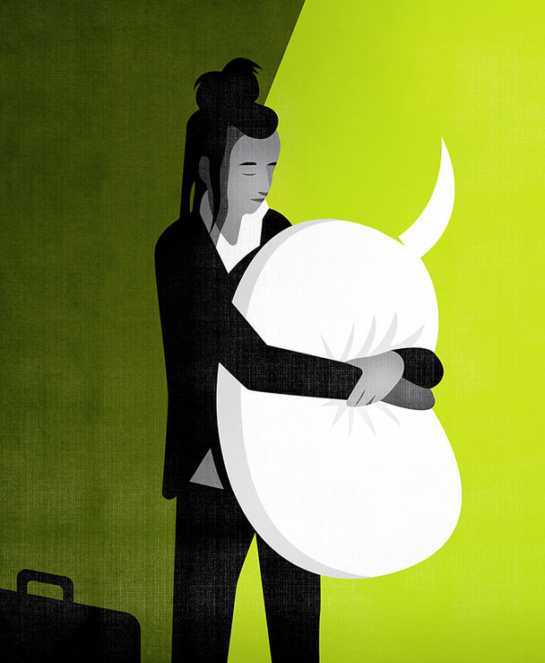

The courts are puzzling their way through such cases. Last August the Australian High Court upheld a decision by the Department of Immigration to fire a public servant who had sent thousands of anonymous tweets critical of her employer. More complex are firings over posts that are unrelated to work but which are deemed to bring an employer into disrepute.

Employee activism can be particularly tricky. Amazon employees recently claimed to have been threatened with dismissal for criticising the firm’s climate policies to journalists. Google has been accused of trying to silence dissenting voices, including those that criticised the firm’s response to sexual harassment and its secretive work in China. The firm denies any claims of retaliation, which would be unlawful, but does not dispute that it has reduced the frequency and changed the scope of its “Thank God It’s Friday” town halls, once a celebration of free speech.

## Loose lips bring pink slips

To forestall conflicts, firms are moving to spell out their expectations in codes of conduct and social-media policies. The level of detail varies. Intel simply asks employees to “use common sense”. General Motors’ 12-page social-media policy includes a reminder that “your online communications will not be excused merely because they occurred outside of work hours or off GM premises.” There are few limits to what an employer can demand in its terms of employment, says James Laddie, a barrister. But social-media use is now so widespread that extreme restrictions, such as blanket bans on Twitter, are no longer realistic. “It’s yet to be tested what view a tribunal would take on someone fired for refusing to abide by such a ban. They may well say ‘we don’t care what your T&C restricts’, it’s not fair to dismiss someone for speaking their mind.”

In the midst of all these prescriptions, Pam Jeffords of PwC wonders whether companies might more usefully replace demands for “respect” with requests for “civility” in employment conditions. “It’s not realistic to demand I respect someone who believes women don’t have a right to drive,” she says, “but it’s reasonable to ask me to be civil.”

The workplace is where most discrimination disputes emerge. It is where people are most likely to spend time with those with whom they fundamentally disagree. Most employers simply want a pragmatic approach to regulating speech at work that allows people to get on with their jobs while avoiding both the courts and the media. That is easier said than done. ■

This article was downloaded by calibre from <https://www.economist.com/international/2020/02/29/companies-are-increasingly-worried-about-what-their-employees-say>

|  |  |  |  |
| --- | --- | --- | --- |
|  | Articles | Sections | Next |

|  |  |  |
| --- | --- | --- |
| International | Sections | Finance and ... |

Business

ASML: Industrial light and magic

.

Luxury goods: Unbedevilling Prada

.

Social networks: A friendly portrait

.

Bartleby: When rank leads to rancour

.

Diversity in America Inc: The benefits of being bold

.

Oil in North America: Of tar sands and shale beds

.

Schumpeter: Bob Iger’s magic kingdom

.

|  |  |  |
| --- | --- | --- |
| International | Sections | Finance and ... |

|  |  |  |  |
| --- | --- | --- | --- |
|  | Articles | Sections | Next |

#### Industrial light and magic

# How ASML became chipmaking’s biggest monopoly

A low-key Dutch company has cornered a critical link in the global electronics supply chain

Feb 29th 2020 | VELDHOVEN

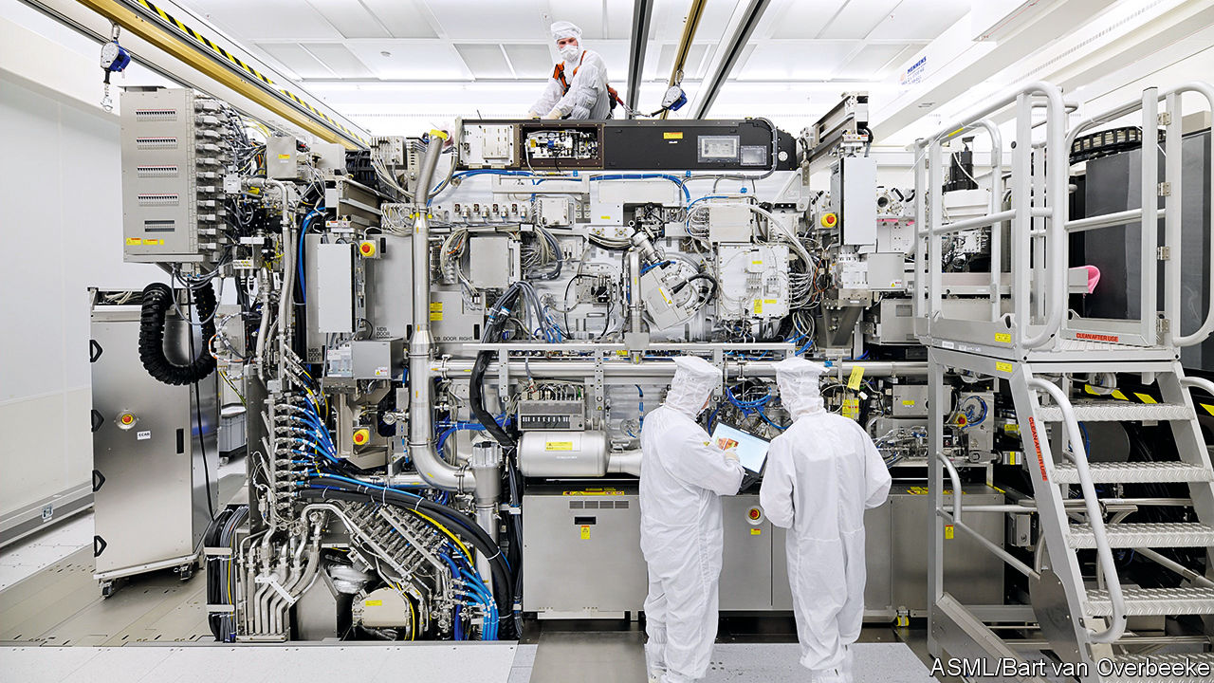

ASK PEOPLE to pinpoint the centre of the digital economy and many will finger Silicon Valley, populated by Apple, Google, Facebook and too many sexy startups to count. Others may nod at the area around Seattle, where Amazon and Microsoft are based. Some could suggest Shenzhen, China’s technology hub. Few would point to a nondescript suburb of Eindhoven, the Netherlands’ fifth-biggest city. Yet on closer inspection, the case for Veldhoven looks compelling. It is home to ASML, the world’s sole manufacturer of the most advanced equipment critical to modern chipmaking. If chips make the world go round, ASML may be the closest the multi-trillion-dollar global tech industry has to a linchpin.

ASML is not the only maker of photolithographic machines, which use light to etch integrated circuits onto silicon wafers. It competes with Canon and Nikon of Japan. But the Dutch firm’s market share has nearly doubled, to 62%, since 2005. And it alone has harnessed “extreme ultraviolet” (EUV) light, with wavelengths of just 13.5 nanometres (billionths of a metre). Shorter wavelengths allow the etching of smaller components—vital for chipmakers striving to keep pace with Moore’s Law, which posits that the number of components that can be squeezed into a given area of silicon doubles roughly every two years. The world’s three leading chipmakers—Intel in America, Samsung in South Korea and the Taiwan Semiconductor Manufacturing Company (TSMC)—have become as reliant on ASML’s wares as the rest of the technology industry is on theirs.

The company’s performance reflects this increased dependence. Its revenues grew by 8% in 2019, to €11.8bn ($13.2bn), despite a slump in the highly cyclical semiconductor business. Although EUV devices accounted for only 26 of the 229 lithography machines the firm sold in 2019, they made up a third of sales by revenue. The firm expects this to rise to three-quarters by 2025, as other chipmakers upgrade from existing “deep ultraviolet” technology.

With neither Canon nor Nikon pursuing EUV technology, investors have concluded that ASML will enjoy its nanoscopic monopoly for a while. Since 2010 its market capitalisation has grown tenfold, to around €114bn (see chart). It has nearly doubled in the past year alone. ASML is worth more than Airbus, Siemens or Volkswagen. Its share price has suffered along with others as covid-19 rattles global markets, but its longer-term outlook appears as bright as the white-walled cleanrooms where its machines take shape. Its shares trade at a mouthwatering 32 times forward earnings, double or more those of its biggest customers.

Times were not always so good. The firm started life in 1984 as a joint venture between Philips, a Dutch electronics giant, and ASM International, which made semiconductor equipment. Early on it occupied a few wooden huts on Philips’s Eindhoven campus. Jos Benschop, ASML’s technology chief, is candid about its early troubles. Its first products were obsolete as soon as they were released, he says, and the firm struggled to find customers. It was kept alive by Philips, itself facing financial difficulties, and by subsidies from the Dutch government and the EU’s predecessor.

In 1995 it listed its shares in New York and Amsterdam. Shortly afterwards the firm bet that EUV lithography would be the future of chipmaking. Big chipmakers planned to be using its machines by around 2007. They were to be disappointed—repeatedly. So were ASML’s shareholders, as the company discovered that EUV light is frustratingly difficult to work with. Working out the kinks took much longer than expected, admits Mr Benschop. The firm’s first prototype machines were sent to IMEC, a research institute in Belgium, in 2006. Commercial clients did not start using the technology until 2018.

Earlier generations of kit employ lasers to produce light directly. But as wavelengths shrink, things get trickier. Inside a cutting-edge EUV machine 50,000 droplets of molten tin fall through a chamber at its base each second. A pair of lasers zap every drop, creating a plasma that in turn releases light of the desired wavelength. The mirrors guiding this light, made of sandwiched layers of silicon and molybdenum, are ground so precisely that, if scaled to the size of Germany, they would have no bumps bigger than a millimetre. Because EUV light is absorbed by almost anything, including air, the process must take place in a vacuum. To get into the production facilities, your correspondent had to don a special suit and leave his notebook behind, lest it shed unwanted fibres.

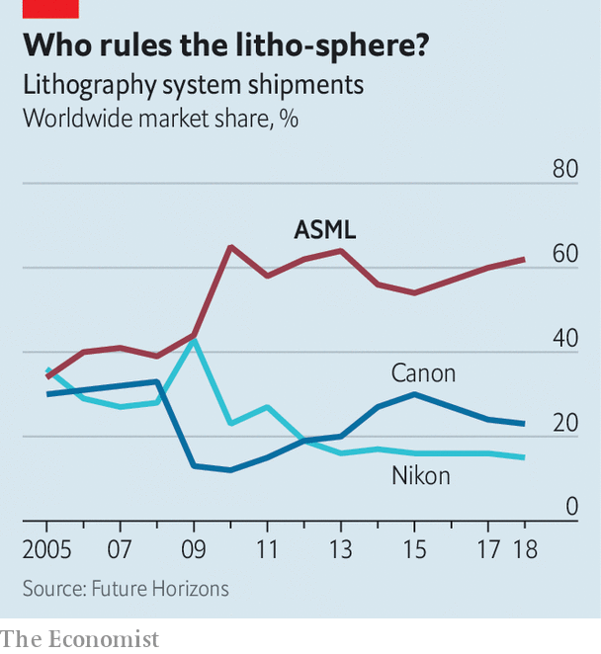

The machines, weighing 180 tonnes and the size of a double-decker bus, are themselves a testament to the electronics industry’s tangled supply chains. ASML has around 5,000 suppliers. Carl Zeiss, a German optics firm, fashions its lenses. VDL, a Dutch company, makes the robotic arms that feed wafers into the machine. The light source comes from Cymer, an American company bought by ASML in 2013. ASML is, in turn, one of hundreds of firms that supply the chipmakers themselves. But it is so vital that Intel, Samsung and TSMC have all chipped in to finance its research and development in return for stakes in the firm.

Appreciation of ASML’s dominant position has not been confined to customers or investors. Politicians share it, too. EUV lithography is on the Wassenaar list of “dual-use” technologies that have military as well as civilian applications. China is keen to foster advanced chipmaking firms of its own, an ambition that America is trying to thwart. In 2018 ASML received an order for an EUV machine from a Chinese customer, widely thought to be the Semiconductor Manufacturing International Corporation, China’s biggest chipmaker, whose factories are currently a couple of generations behind the state of the art. Under American pressure, the Dutch government has yet to grant ASML an export licence.

ASML would hate to surrender access to the Chinese market, which is bigger than most and as captive. Being kept out of China may, in the long run, endanger ASML’s dominance—if it leads a Chinese rival unable to secure ASML kit to build its own, and sell it to others. Last April ASML said that six employees, including some Chinese nationals, were involved in pilfering trade secrets from its American office in 2015. The firm disputes the suggestion that the theft was linked to the Chinese government.

Right now, though, China needs ASML more than ASML needs it. Of all the suppliers required for an advanced chip factory of the sort its authorities want built, “ASML’s technology is the most difficult to replicate”, says Pierre Ferragu, a technology analyst at New Street Research. Malcolm Penn of Future Horizons, another consultancy, thinks that it would take a Chinese rival a decade or more to catch up—and by then the cutting edge would have moved on again. The Dutch are already working on new EUV machines with better optics, which can process more silicon wafers per hour. These are due to ship in 2023—this time, ASML hopes, with no delays. ■

This article was downloaded by calibre from <https://www.economist.com/business/2020/02/29/how-asml-became-chipmakings-biggest-monopoly>

|  |  |  |  |
| --- | --- | --- | --- |
|  | Articles | Sections | Next |

|  |  |  |  |
| --- | --- | --- | --- |
| Previous | Articles | Sections | Next |

#### Unbedevilling a fashion house

# Prada hires Raf Simons as co-creative director

The Italian luxury group tries to revive its creative spark—and its financial fortunes

Feb 29th 2020 | BERLIN

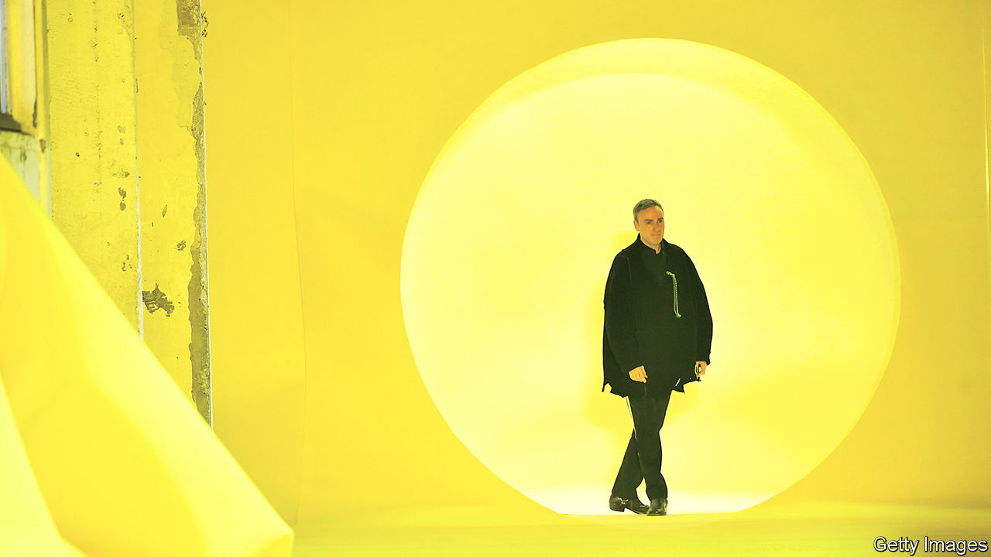

FOR YEARS after it listed its shares on the Hong Kong stock exchange in 2011, Prada’s business looked considerably blander than its iconoclastic blend of ugly chic, counterculture, politics and fashion. No longer. Its share price rose by a quarter in the three months to January, faster than at bigger luxury groups such as France’s LVMH or Kering. Investors liked the look of its new partnership with L’Oréal, a cosmetics giant, and of investments in online sales. But their enthusiasm was based chiefly on an expectation of more radical change: either a takeover by a bigger luxury conglomerate or an internal overhaul.

A buyer has yet to signal interest. But on February 23rd Prada announced that Raf Simons, a cerebral industry star from Belgium who used to be the creative head of Christian Dior, a French label owned by LVMH, and of Calvin Klein, an American brand, will join the company. He will work alongside Miuccia Prada, the granddaughter of the company’s founder, as co-creative director. The duo will unveil their first joint collection in September. Both emphasised their intention to double down on creativity—and prevent the suits from calling all the shots.

Both Ms Prada and her husband, Patrizio Bertelli, the group’s chief executive, have strong personalities. They also own 80% of Prada. For the arrangement to work, the trio “must get on very well”, says Luca Solca of Bernstein, a research firm. It helps that they have known each other since 2005, when Mr Simons worked for Jil Sander, a German label then part of the Prada empire.

A good rapport alone will not guarantee Prada’s revival. That, Mr Solca notes, requires undoing past mistakes. Some, like its drab online presence and recent uninventiveness, which Mr Simons is to tackle, are being reversed. Other errors, notably efforts to narrow its offering and to ape rivals like Hermès and Chanel, and their high prices, have yet to be.

With all luxury firms infected this week by the new coronavirus, which hurts their lucrative Chinese sales, it is hard to discern what investors make of Mr Simons’s arrival. Those holding out hope of an acquisition may at least comfort themselves that, at 4% of LVMH’s market value, Prada remains a tasty morsel—which a talented haute-couturier like Mr Simons makes tastier still.

This article was downloaded by calibre from <https://www.economist.com/business/2020/02/29/prada-hires-raf-simons-as-co-creative-director>

|  |  |  |  |
| --- | --- | --- | --- |
| Previous | Articles | Sections | Next |

|  |  |  |  |
| --- | --- | --- | --- |
| Previous | Articles | Sections | Next |

#### A friendly portrait

# A journalist offers an inside look at Facebook’s rise

Steven Levy’s new book about the social network is largely sympathetic

Feb 29th 2020 |

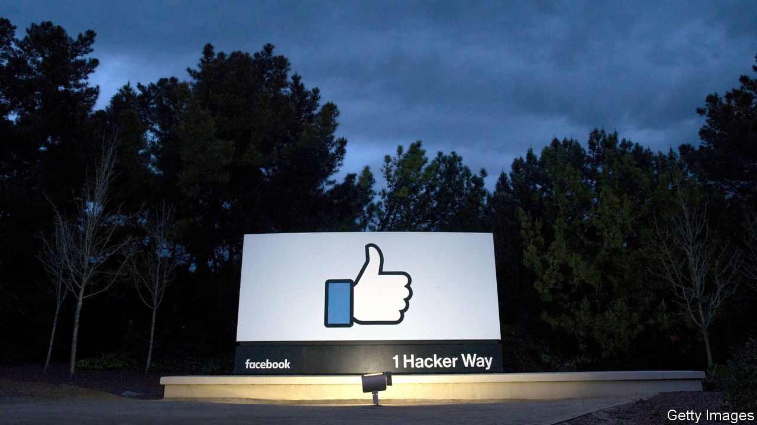

Facebook: The Inside Story. By Steven Levy.Blue Rider Press, 583 pages.

“I WOULD ALWAYS say to regulators,‘Look, bad things happen in human society, therefore bad things happen on Facebook’.” So said Chris Kelly, an ex-Facebooker once in charge of the social network’s privacy policies, to Steven Levy, a veteran technology journalist whose book about Facebook was published on February 25th. Mr Kelly was recounting conversations with officials in 2007, amid early rumblings about Facebook’s seamier side—specifically the ease with which children could find questionable content, such as a group named “I’m Curious About Incest”.

More than a decade on, Facebook claims 2.5bn people—a third of humanity—as users. The charge sheet against the company has grown as well. It has been accused of spreading fake news, facilitating paedophilia, and allowing countries to interfere in each other’s elections. Mr Levy’s book offers a ringside view of the growth of one of the world’s biggest companies, and of the backlash it has provoked. Other books, and even a Hollywood film, have chronicled the firm’s rise. But Mr Levy’s effort is fresh, up-to-date and insiderish. Thanks to the indulgence of the firm’s boss, Mark Zuckerberg, he had the run of its California headquarters and its denizens.

Such access can be a reporter’s blessing. It has long been apparent from the outside that Facebook grew so quickly that its employees had little time to grapple with all the implications, even those that would become central to the business. But it is still noteworthy to hear interviewees confirm as much to Mr Levy in their own words. Carolyn Everson, an advertising executive at Microsoft, was poached to head advertising sales at Facebook in 2011. Ms Everson assumed that her new employer knew what it was doing—after all, it was already raking in hundreds of millions of dollars. She was quickly disabused of that notion: “[Facebook] didn’t have everything figured out…everything was brand-new and [they were] still building.”

In 2008 Mr Zuckerberg hired Sheryl Sandberg, a Google executive, to be Facebook’s chief operating officer, handing off responsibility for everything not directly related to building Facebook’s product. (It would take him a decade, writes Mr Levy, to realise that such a division of labour was a mistake.) Facebook’s board upbraided both of them for not spotting a Russian misinformation campaign designed to influence America’s election in 2016. When subsequently asked by Mr Levy whether he thought she had “let him down”, Mr Zuckerberg offers only a pause, followed by a non-committal response.

The author’s access risks putting him in thrall to his subject. He is not afraid to chronicle Facebook’s failures. But his tone is occasionally fawning. He recounts how Mr Zuckerberg reacted to a question about the wisdom of Instagram’s founders selling their photo-sharing app to Facebook “as if he were a chess grandmaster, startled by a move from an inferior player who suddenly shifted the board to his disadvantage”. At times Mr Levy can seem too quick to accept the tech industry’s macho self-image, for instance in his description of an internal team charged with driving new users to Facebook as “a data-driven Dirty Dozen armed with spreadsheets instead of combat rifles”.

In recent years Facebook has hired legions of moderators to check up on its users, and fortified them with automated monitoring systems. But its chief defence against accusations of harm is one to which Mr Levy seems mostly sympathetic: that from the crooked timber of humanity, no straight thing was ever made, not even a social network. It is a belief that Mr Zuckerberg seems to hold sincerely. It is tactically useful, too, because while it contains more than a grain of truth, it also minimises the firm’s culpability.

In the end, Mr Levy sees Mr Zuckerberg as a Utopian genius undone by the world’s lamentable wickedness; a man who “set out to connect a world that was perhaps not ready to be connected”. Not everyone will be so generous.■

This article was downloaded by calibre from <https://www.economist.com/business/2020/02/29/a-journalist-offers-an-inside-look-at-facebooks-rise>

|  |  |  |  |
| --- | --- | --- | --- |
| Previous | Articles | Sections | Next |

|  |  |  |  |
| --- | --- | --- | --- |
| Previous | Articles | Sections | Next |

#### Bartleby

# When rank leads to rancour

How not to give employee feedback

Feb 29th 2020 |

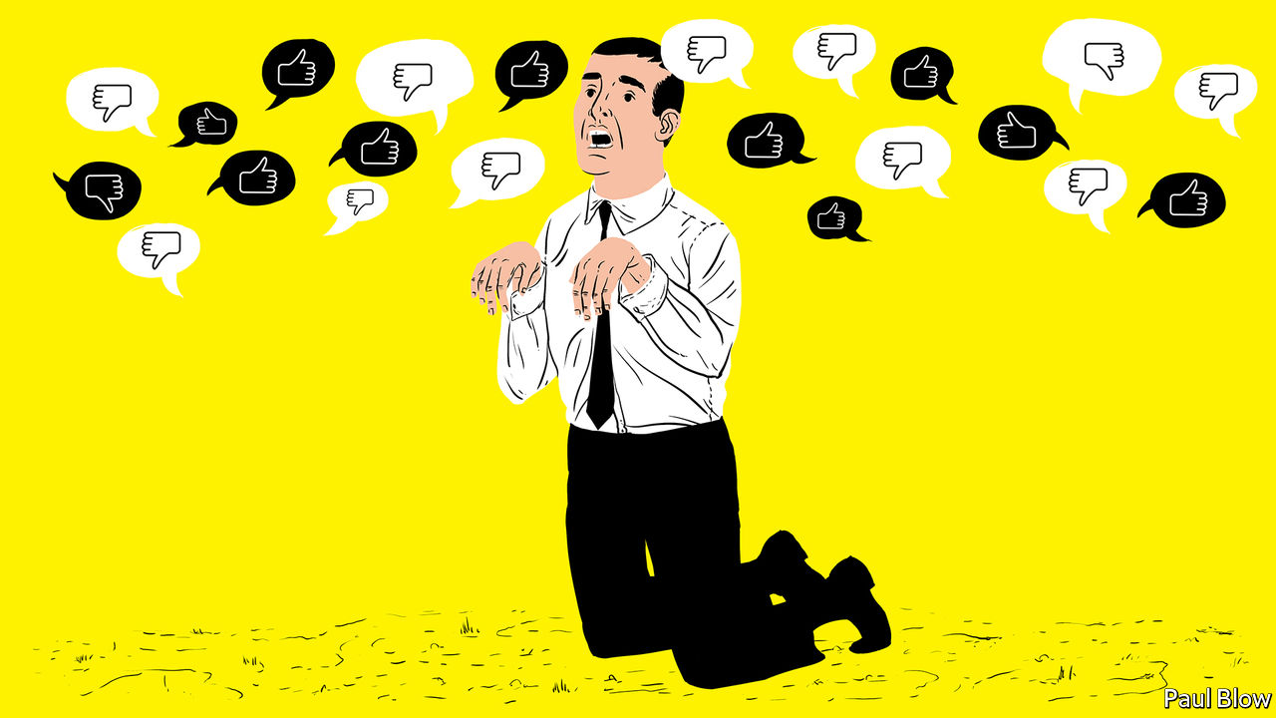

IN DAVID MAMET’S film, “Glengarry Glen Ross”, a group of American property salesmen are forced into a contest to maximise sales. The top two will get prizes; the bottom two will be fired. The play comes across as a critique of the corrupting effect of “dog-eat-dog” capitalism and putting performance above all else. But is competition between employees an effective way of improving overall outcomes for business?

Jan Woike, from the Max Planck Institute in Berlin, and Sebastian Hafenbrädl, of the IESE business school in Barcelona, try to answer the question in an article* for the Journal of Behavioural Decision Making. They tested whether performance ranking helped or hindered group effort.

Their approach was to use a “public goods” game in which participants are given tokens which they can invest. They had the choice of investing in an individual project or investing collectively. Two different versions of the game were played. In both games returns were higher if everyone collaborated. But in one version, investing in the individual project improved the relative ranking of the participant, even though the returns to both the individual and the group were lower.

Participants in the game included some students and some experienced managers. The researchers observed no significant difference in the way the two groups played the game. What mattered was the form of feedback. In one version of the game, individuals were told how well they scored and how well they were performing relative to the rest of the group. In another, they were informed about how well the group as a whole was performing, relative to the maximum possible return.

Predictably, the second feedback mechanism led to more co-operation. Less obviously, information on individual performance relative to fellow group members led players to favour moving up the pecking order over not just their group’s collective returns, but also over their material wellbeing. They were willing to forgo guaranteed financial gains; achieving “status” was more important.

As the authors note, this result has implications for most organisations. “Ranking feedback, which is often used in organisational settings, prompts people to perceive even situations with co-operative outcome structures as competitive,” they write. People may not be innately co-operative or competitive; they may simply respond to cues set by the organisation they work for.

Destructive competition would be a particular problem for those companies which use so-called “agile” management approaches, in which staff from different departments are organised into teams and asked to work together. Instead of being agile, such teams may wrestle themselves to a standstill.

The research also raises more questions about a management approach, dubbed “rank and yank”, under which all employees are rated yearly and those who fall into the lowest category are liable to lose their jobs. Ranking systems of this kind, associated with Jack Welch’s tenure as boss of GE, an engineering giant, from 1981 to 2001, have been the subject to increased academic scrutiny. Study after study suggests that they hurt overall performance, not least by lowering productivity.

Businesses need to compete with their rivals but within the firm, co-operation is normally much more useful than competitive rivalry; a house divided against itself, cannot stand, as Abraham Lincoln said. Competitive ranking seems not just to reduce co-operation and foster selfishness but also to discourage risk-taking. Such findings have prompted many bosses to yank “rank and yank”. Microsoft abandoned it in 2013.

The Economist is a genuinely co-operative place (although Bartleby is locked in a Darwinian struggle with Schumpeter for the right to a full-page column). If it wasn’t, journalists would be reluctant to pass on contacts or story tips to their colleagues, and section editors would constantly rubbish the suggestions of their peers [as it is, we only do it occasionally, ed.].

In “Glengarry Glen Ross” two of the salesmen conspire to rob the office, steal some of the best sales leads and sell them to a rival business. If you set up a dog-eat-dog system, you risk having the hounds turn around and bite their owner.

* “Rivals without a cause? Relative performance feedback creates destructive competition despite aligned incentives”

This article was downloaded by calibre from <https://www.economist.com/business/2020/02/29/when-rank-leads-to-rancour>

|  |  |  |  |
| --- | --- | --- | --- |
| Previous | Articles | Sections | Next |

|  |  |  |  |
| --- | --- | --- | --- |
| Previous | Articles | Sections | Next |

#### The bamboo ceiling

# Indian v Chinese bosses in America Inc

A provocative study examines Asians in American corner offices

Feb 29th 2020 | NEW YORK



“A CAREER BOOK about Asians? Aren’t they doing fine…?” So begins “Breaking the Bamboo Ceiling”, a tome by Jane Hyun published in 2005. Because Asian-Americans had higher incomes and education levels and committed fewer crimes than their average compatriot, they were seen as a model minority. Despite this, they rarely rose to the top of companies. A mix of individual, cultural and organisational barriers—the “bamboo ceiling” of the book’s title—seemed to halt their rise.

Fifteen years later Asians are still under-represented. Some 11% of associates at American law firms are Asian, but only 3% of partners are. In technology Asians make up over 30% of the workers but less than 15% of bosses. In 2017 Asians made up roughly 6% of the country’s population but only 3% (16) of the bosses of S&P 500 firms.

Some prominent Asians run big companies. Arvind Krishna is IBM’s new boss. Satya Nadella runs Microsoft and Sundar Pichai leads Alphabet. But few other Asians have joined their ranks—and, revealingly, these stars all have Indian roots. There are fewer South Asians in America than East Asians, but they still made up 13 of those 16 Asian S&P 500 CEOs.

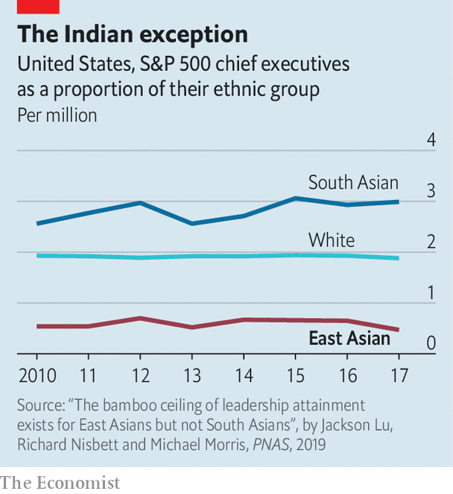

Why are there so few Asians among America’s business elite? And if a bamboo ceiling is to blame, why do South Asians break through more easily? These questions are the focus of a study by Jackson Lu of MIT Sloan School of Management and colleagues, who surveyed hundreds of senior executives and business-school students. They found that while discrimination exists, it is not destiny. South Asians endure greater racism than East Asians but still outperform even whites (if success is weighed against share of population). Their research also rules out lack of ambition: a greater share of Asians than whites strive for high-status jobs.

That leaves culture. The researchers conclude that South Asians tend to be more assertive than East Asians in how they communicate at work, which fits Western notions of how a leader should behave. The same propensity for confident discourse featured in “The Argumentative Indian”, a book by Amartya Sen, a Nobel-prizewinning economist. The researchers attribute East Asians’ reticence to Confucian values of modesty and respect for hierarchy. Sometimes boldness and bombast are needed to break bamboo.■

This article was downloaded by calibre from <https://www.economist.com/business/2020/02/29/indian-v-chinese-bosses-in-america-inc>

|  |  |  |  |
| --- | --- | --- | --- |
| Previous | Articles | Sections | Next |

|  |  |  |  |
| --- | --- | --- | --- |
| Previous | Articles | Sections | Next |

#### The giant next door

# Canadian tar sands offer lessons for American shalemen

The two countries’ oil industries are becoming more alike

Feb 29th 2020 | NEW YORK

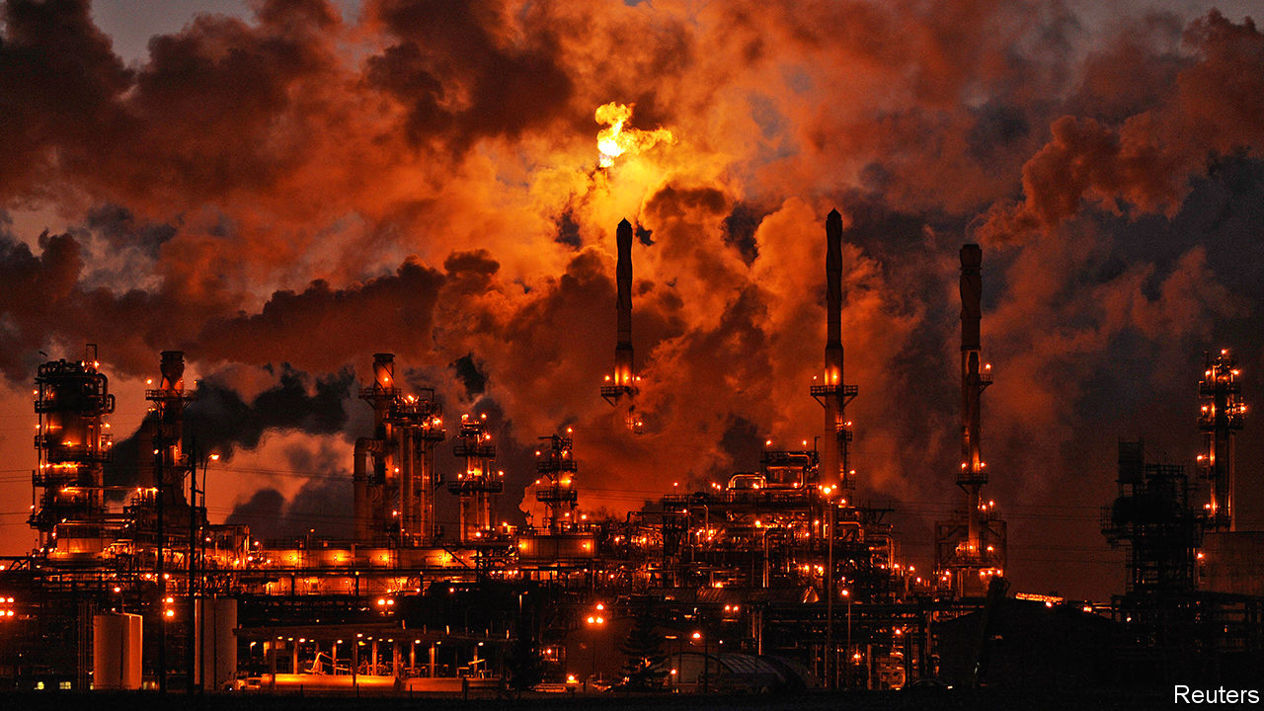

ALBERTA HAS lured many an oilman in recent years. Tapping new wells of thick Canadian bitumen and processing it into crude is expensive, but the break-even oil price for operating an existing one can be as low as $25. Large reserves and low depletion rates mean that companies can offer measured growth and attractive dividends. Instead of lubricating profits, however, Canada’s tar sands are bunged-up with protests against new pipelines. Most international oil firms have fled. The latest firm to retreat is Teck Resources. On February 23rd the Canadian company scrapped plans for a C$20bn ($15bn) oil-sands mine. Canada has not yet aligned “climate policy considerations” with “responsible energy sector development”, wrote Teck’s boss, Don Lindsay. Without regulatory approvals, an investment partner, new pipelines and a high oil price, Teck might as well have sought the Moon.

Things are looking rather different south of the border. Fracking a virgin shale bed is simpler—and cheaper—than mining a new tar pit. American crude production surged by 94% from 2011 to 2018, hitting Canada twice over: by pushing down the oil price and sucking away investment. Canadian oil output rose only two-thirds as fast. Chevron and ExxonMobil are among the global energy giants to pump capital into America’s vast Permian basin in Texas and New Mexico; the pair will present spending plans to investors in March.

But frackers, too, have headaches. Many have grown fast but spent faster. Returns tend to be meagre, as the quick decline in a well’s output has led firms to drill new ones. Low gas prices have hurt firms specialising in fracked gas most, though oilier producers have also struggled. An analysis of the top 39 public shale oil companies by Rystad, an energy-data firm, found that cashflow from operations exceeded capital spending at just one in four firms in the third quarter of 2019.

Now American companies may begin to behave more like Canadian ones, says Benny Wong of Morgan Stanley. Investors have urged frackers to grow more slowly and return more cash to shareholders. Top shale firms are listening. In November Pioneer Natural Resources raised its dividend and said it would pursue more modest growth. On February 18th Concho Resources and Devon Energy, two companies with assets in the Permian, told investors that capital spending would be lower this year. The companies raised their dividends by 60% and 22%, respectively.

Shale firms’ slowing growth may reflect geological and technical limits, too. Bob Brackett of Bernstein, a research firm, points out that productivity per square foot declined in all but one of America’s main shale basins last year. As the richest wells are depleted, remaining sites will require higher prices to be drilled profitably. American government forecasters expect domestic oil production to reach 14m barrels a day by 2022, then plateau. Others expect it to taper off sooner. Scott Sheffield, Pioneer’s boss, told investors last year that the OPEC cartel of oil-producing countries probably does not need to worry about further growth in American output.

America may turn more Canadian when it comes to regulations, too. Unlike Justin Trudeau, Canada’s prime minister, who has struggled to balance oil interests with environmental ones, President Donald Trump has simply ignored conservation and the climate. He has allowed drilling on federal lands and eased rules for planet-cooking methane emissions. But the shalemen’s political problems may mount. Low gas prices led to a surge of flaring last year, prompting a Texas regulator to propose curbing the practice, which would inconvenience firms. On February 24th the Supreme Court heard a suit to block a new shale-gas pipeline that would cut beneath the Appalachian Trail, America’s longest hiking path. Democratic presidential candidates including Bernie Sanders, the front-runner, want to ban fracking.

In Canada the premier of oil-rich Alberta argues that provinces should be freer to develop oil projects within their borders. It is not impossible to imagine a world in which oil states battle a more restrictive national government in America, too. ■

This article was downloaded by calibre from <https://www.economist.com/business/2020/02/29/canadian-tar-sands-offer-lessons-for-american-shalemen>

|  |  |  |  |
| --- | --- | --- | --- |
| Previous | Articles | Sections | Next |

|  |  |  |  |
| --- | --- | --- | --- |
| Previous | Articles | Sections | Next |

#### Schumpeter

# Bob Iger, king of Disneyland

Three lessons from one of Hollywood’s most successful bosses

Feb 27th 2020 |

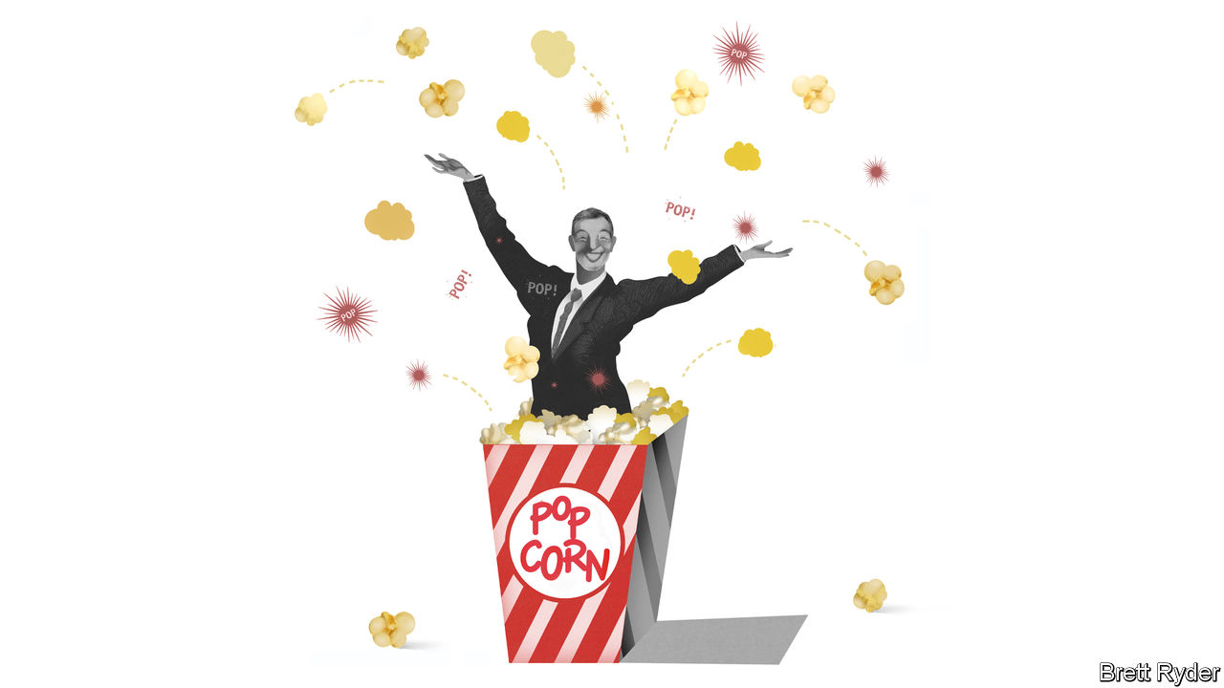

“I DON’T KNOW if the word disrupter was the right word to use back then, but I’ve always been willing to take some chances.” That is how Bob Iger recently explained his approach to running Disney. In his 15-year tenure Mr Iger’s bets have turned the American entertainment company from a moderately profitable business threatened by digital upstarts like Netflix and Amazon into one of the world’s most formidable content-and-technology powerhouses. Profits quadrupled from $2.5bn in 2005 to $10.4bn in 2019. Disney’s market capitalisation rocketed from $48bn to over $230bn. This track record has made Mr Iger one of the most lionised (and best-paid) corporate bosses on Earth.

On February 25th Mr Iger once again displayed a fondness for disruption by announcing his departure from the corner office, effective immediately. He had toyed with the idea of retiring several times, only to change his mind. In 2016 his heir apparent was pushed out. Mr Iger has extended his own contract twice since then, and was expected to remain CEO for another couple of years. He will remain as executive chairman, focusing on the firm’s creative process, until the end of 2021 but has handed day-to-day running of the firm to Bob Chapek, a safe pair of hands who most recently ran Disney’s amusement parks.

The abrupt move sent the firm’s share price tumbling by 4%. To ease investors’ nervousness, Mr Chapek would be wise to heed three lessons from his predecessor. Other executives, in Tinseltown and elsewhere, should pay attention, too.

Mr Iger’s first insight was that quality products matter—or, in Hollywood lingo, content is king. Mr Iger had no truck with the notion, espoused by some pundits, that content would become commoditised as power shifted irreversibly from creators to distributors. This belief in content led Mr Iger to collect one beloved franchise after another, in a buying spree that verged on the foolhardy. Soon after taking over in 2005 he spent $7.4bn to buy Pixar, the animation studio famous for “Toy Story” movies. Three years later he bought Marvel Entertainment, with its stable of comic-book superheroes such as the Avengers, for $4bn. In 2012 he pipped Rupert Murdoch, boss of the Fox media empire, by acquiring Lucasfilm, home of “Star Wars”, for another $4bn or so. The three acquisitions alone have so far earned Disney revenues of $36bn. Last year alone Disney’s billion-dollar blockbusters included “Avengers: Endgame” (Marvel), “The Lion King” (Walt Disney Pictures), “Frozen 2” (Pixar) and “The Rise of Skywalker” (Lucasfilm). They helped Disney grab over a third of the American film market, and global box-office takings of over $10bn. His fourth purchase, of Mr Murdoch’s 20th Century Fox in 2019 for $71bn, is by far his most ambitious (and potentially most problematic).

The second thing to learn from Mr Iger’s reign is to trust acquired talent. At most firms in most industries, when a big company buys a small, nimble one, the buyer’s managers defend their turf and foist headquarters culture onto the acquisition. Mr Iger’s Disney instead let Pixar lift its middling in-house animation team. This hands-off approach and respect for the achievements of others helped persuade control freaks like George Lucas, the founder of Lucasfilm, and Isaac Perlmutter, the reclusive chairman of Marvel, to hand over their cherished possessions.

The third lesson is also the most important. A bit of paranoia can be productive. No boss succeeds without supreme self-confidence, and Mr Iger is no exception. However, he has shown time and again that he is willing to question his own judgment and to revise strategies as the business landscape evolves. When on a visit to Disneyland in Hong Kong around the time he took over as CEO Mr Iger noted that Chinese crowds preferred newer Pixar character’s to Mickey Mouse, he set reverence for Walt Disney aside and went about modernising the firm’s roster.

Nowhere was this clearer than in his embrace of digital streaming. Convinced that digital disruption was “not a speed bump” but an existential threat, he bet Disney’s future on a shift from its historic business-to-business model of distribution to the fast-growing direct-to-consumer model pioneered by Netflix. This shift was driven in part by the decline in the traditional approach of bunching content into pricey bundles for pay television, a trend that has hit Disney’s ESPN sports division hard. But it was a huge gamble. He needed to persuade his board, which had to accept putting existing profitable businesses at risk, and investors, who had to swallow big outlays today in exchange for uncertain digital dividends tomorrow.

On November 12th the firm launched Disney+, a streaming service, in America and a handful of other markets. By the end of the day it had 10m subscribers. Since then it has chalked up another 20m. Add a further 30m people who pay to watch Hulu, an older streaming service Mr Iger took control of in 2019, and more people fork over money to Disney every month than pay for cable TV from Comcast or AT&T.

## The Iger sanction

Mr Iger leaves his successor a company in good shape, but also in the midst of two transformations: digital and, with 20th Century Fox to fold in, organisational. Both will soon test whether Mr Chapek has learned Mr Iger’s lessons. He certainly appears to share his mentor’s belief in the importance of brands and content, dating back to childhood visits to Walt Disney World. A big test of his respect for talented types with strong opinions will be convincing Kevin Mayer, the go-getting head of Disney’s direct-to-consumer business whom many expected to get the top job, to stay put. The even greater challenge of integrating a behemoth like 20th Century Fox, a bigger acquisition than Pixar, Marvel and Lucasfilm combined, will require a degree of adaptability that would have strained the old boss himself. As it is, Mr Iger has bowed out before his most epic plot has unspooled. ■

This article was downloaded by calibre from <https://www.economist.com/business/2020/02/27/bob-iger-king-of-disneyland>

|  |  |  |  |
| --- | --- | --- | --- |
| Previous | Articles | Sections | Next |

|  |  |  |
| --- | --- | --- |
| Business | Sections | Science and ... |

Finance and economics

Covid-19 and market turmoil: Spread and stutter

.

Covid-19 and China’s economy: Marching orders

.

Buttonwood: Benchmark blues

.

Americans’ personal finances: Land of the frugal

.

The information economy: Data, data everywhere

.

European Union trade: Hulk Hogan

.

Who wants to run a bank?: Bank bosses in Europe

.

Free exchange: Motive power

.

|  |  |  |
| --- | --- | --- |
| Business | Sections | Science and ... |

|  |  |  |  |
| --- | --- | --- | --- |
|  | Articles | Sections | Next |

#### Spread and stutter

# Markets wake up with a jolt to the implications of covid-19

Could market turmoil add to the economic disruption?

Feb 27th 2020 |

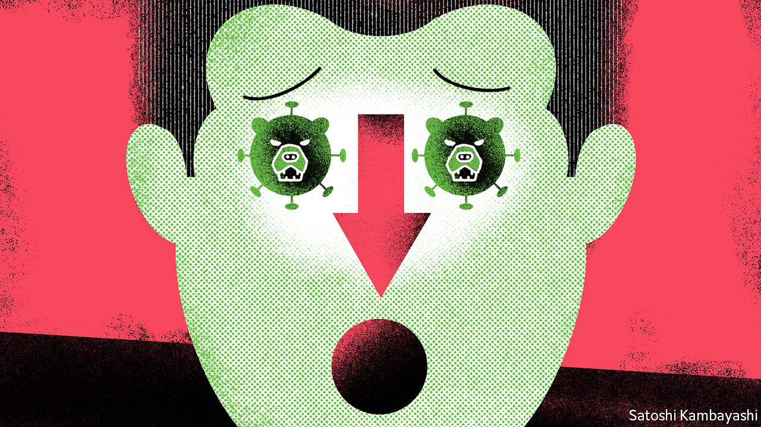

WHEN AMERICA, the hub of global capital, is this far into an economic expansion and a bull market, investors feel two conflicting impulses. They hope that the good times will last, so they are reluctant to pull their money out. They also worry that the party may suddenly end. This is the late-cycle mindset. It reacts to occasional growth scares—about trade wars or corporate debt or some other upset. But it tends not to take them seriously for long.

Covid-19 is a grave threat to the market’s poise. News from Italy of the biggest coronavirus outbreak outside Asia led to a 3.4% decline in the S&P 500 index of American stocks on February 24th, the biggest one-day fall for two years. The rout encompassed global stockmarkets, which were down sharply from highs reached earlier in February. As The Economist went to press, the markets remained nervy. In the face of such uncertainty, more days like Monday are to be expected.

Investors have, sensibly, tried to calculate which assets are most exposed to the shock. Copper, an economic bellwether, plunged. The worst-hit stocks were of firms that rely on far-flung supply chains, such as carmakers; or are directly affected by restrictions on travel, such as airlines; or are most exposed to a China-led global slowdown, such as oil firms. Investors scrambled for safe assets. Gold reached a seven-year high. The dollar rallied. The yield on ten-year Treasury bonds fell to an all-time low of 1.29% on February 27th.

But there is also an uneasy sense that the virus could trigger a bigger rupture in financial markets that have been going up by so much for so long that pockets of dangerous risk-taking are bound to exist. Two worries are top of mind: the opaque edifice of financial instruments that rely on low volatility, and the swollen credit markets.

Start with the first, volatility. Equity-market instability might feed on itself. The VIX, which measures the expected volatility implied by the price of options on the S&P 500 index, vaulted from around 15 to above 27 in a matter of days (see chart 1). Some investment strategies are particularly sensitive to it. For example when volatility is low, they allow for a bigger weighting of equities in portfolios. But when it rises and stays high, some investors are forced to unload some of their holdings—creating yet more volatility. Some exchange-traded funds whose value is linked to the VIX saw outflows. It is likely that at least some investors have been betting on continued near-dormant volatility. The resilience of such strategies could be tested.

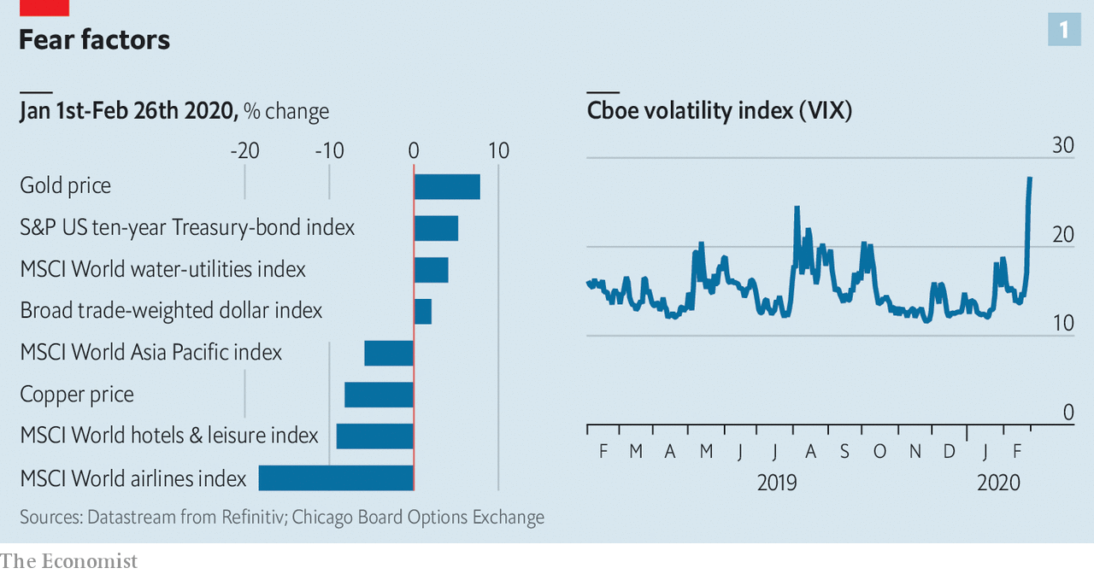

A bigger worry is credit markets and in particular corporate debt, which has soared over the past decade. A sharp rise in borrowing costs would hurt firms that need to roll-over maturing bonds and would also rattle America’s huge private-credit markets. The last big global growth scare, in late 2018, caused a panicky sell-off that briefly threatened to become a credit-crunch. So far the interest-rate spread over Treasuries demanded by investors to hold high-yield corporate paper has widened to 4.3 percentage points, with much of the impact felt by energy-sector bonds (see chart 2). That is cause for concern, not alarm. But new issuance has halted—by February 26th Wall Street had gone three days without any high-grade offerings, according to Bloomberg. If that continues there will be a corporate liquidity squeeze.

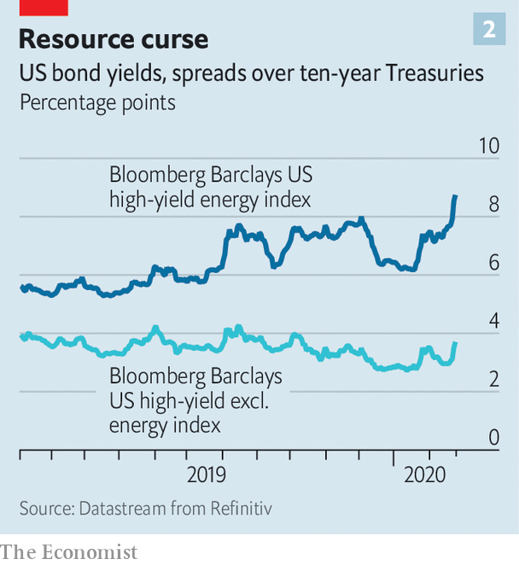

Interest-rate cuts cannot do much to remedy the disruption. But they can help to soothe credit markets. Easier policy from the Federal Reserve has in the past—notably in 1998—been fuel for a late-cycle rally in risk assets in the face of formidable headwinds. A fortnight ago, just a single interest-rate cut from the Fed was priced in by the markets, says Kit Juckes of Société Générale, a French bank. Now two are. “We may be pricing in a third, if not a fourth, within a few weeks unless there’s a dramatic change in the covid-19 news.”■

Read more:Covid-19 is now in 50 countries, and things will get worse (February 27th)  
To curb covid-19, China is using its high-tech surveillance tools (February 27th)  
Covid-19 presents economic policymakers with a new sort of threat (February 20th)  
How China’s coronavirus epidemic could hurt the world economy (February 13th)

This article was downloaded by calibre from <https://www.economist.com/finance-and-economics/2020/02/27/markets-wake-up-with-a-jolt-to-the-implications-of-covid-19>

|  |  |  |  |
| --- | --- | --- | --- |
|  | Articles | Sections | Next |

|  |  |  |  |
| --- | --- | --- | --- |
| Previous | Articles | Sections | Next |

#### Covid-19 and China’s economy

# With its epidemic slowing, China tries to get back to work

Officials shift their focus to reviving growth. But that isn’t easy

Feb 27th 2020 | YIWU

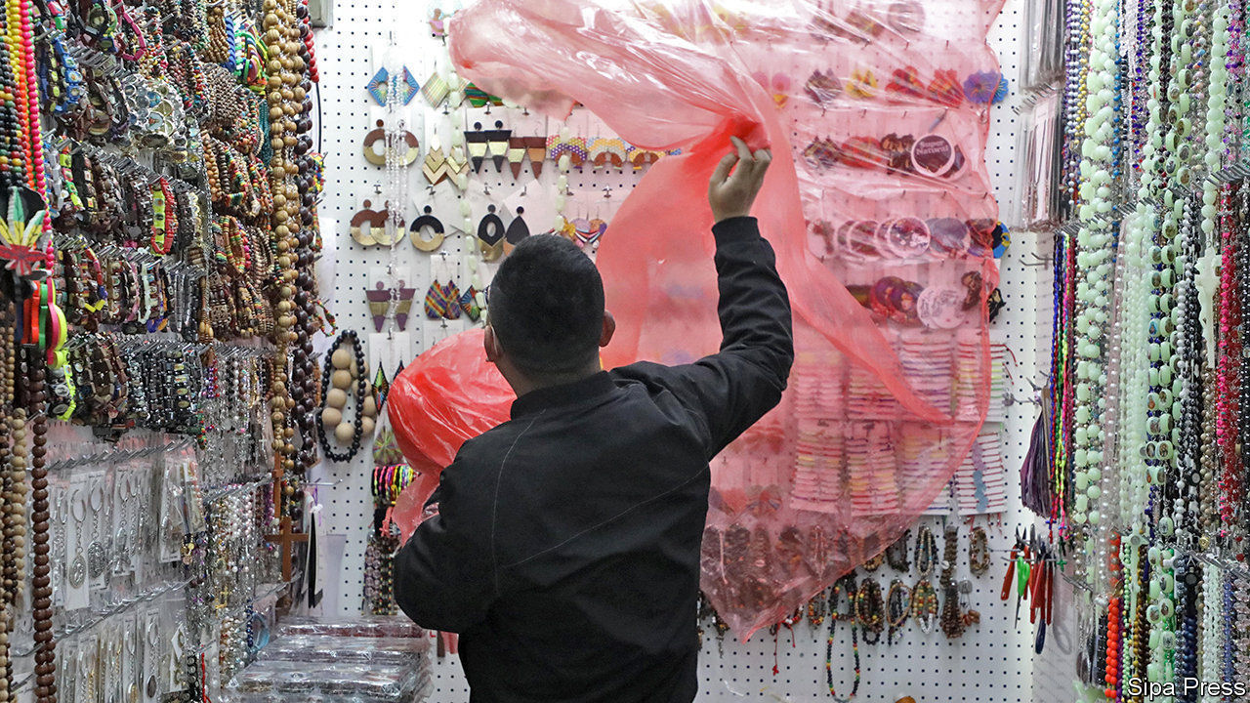

IF CHINA IS the world’s factory, Yiwu International Trade City is its showroom. It is the world’s biggest wholesale market, spacious enough to fit 770 football pitches, with stalls selling everything from leather purses to motorcycle mufflers. On February 24th, as is customary for its reopening after the lunar new year, performers held long fabric dragons aloft on poles and danced to the beat of drums, hoping to bring fortune to the 200,000 merchants and buyers who normally throng the market each day. But these are not normal times. The reopening was delayed by two weeks because of the covid-19 virus, the crowd was sparse and the dragon dancers, like everyone else, donned white face-masks for protection. The ceremony complete, business began. All those entering the market had to pass health checks and were told to be silent during meal breaks, lest they spread germs by talking.

The muted restart of the Yiwu market resembles that of the broader Chinese economy. The government has decided that the epidemic is under control to the point that much of the country can go back to work. That is far from simple. More than 100m migrant workers remain in their hometowns, and officials are trying hard to transport them to the factories and shops that need them. Yiwu has chartered trains and buses to bring in workers from around the country. It also wants to lure in buyers from around the world: it has offered to pay for their flights and accommodation if they arrive before February 29th.

The market is, little by little, getting busier. But merchants have a big challenge in fulfilling orders. Wang Meixiao, who sells plastic jewellery, says her factories do not yet have enough workers to operate. Many are unwilling to trek across the country only to endure 14-day quarantines at their destinations. “I tell my customers they just have to wait another couple of weeks, but that’s a guess,” she says.

Since the outbreak of the virus, economists and investors have tried to grasp the basics of epidemiology, analysing such matters as the potential incubation period of the disease. Recently, they have turned back to more familiar terrain, tracking the state of the economy. To gauge whether output is resuming, economists have been examining an array of daily figures, including coal consumption, traffic congestion and property sales. All have started to rise (see chart), but remain far below healthy levels. One gauge has been far more upbeat—unrealistically so. China’s stockmarket fell by more than 10% after the coronavirus spread in late January but has since recovered that ground, partly on a belief that the government will unleash a big stimulus to boost growth. So far, though, it has only offered targeted support: loan extensions, tax cuts and subsidised rents.

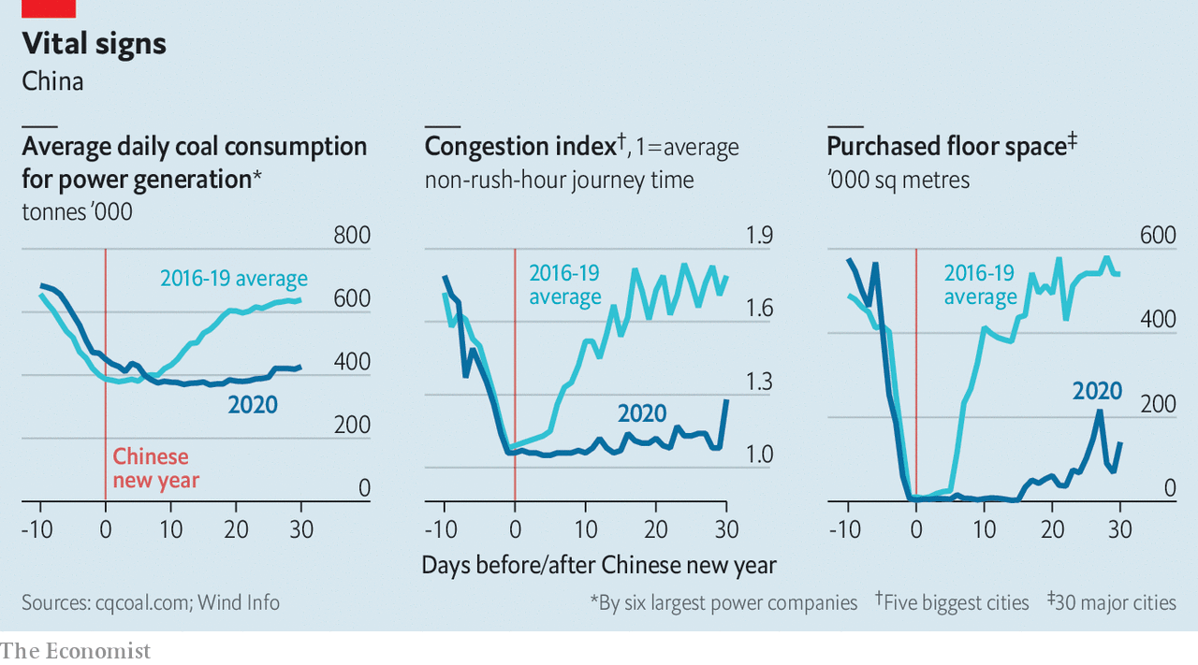

Yet China has unquestionably shifted its focus, as underlined on February 23rd when President Xi Jinping spoke via teleconference to 170,000 cadres around the country. In areas where the virus is no longer a big danger, it is time for companies to resume operations, he said. So along with reporting the number of new infections every day, officials now report on the number of reopened businesses. The province of Zhejiang, a manufacturing hub and home to Yiwu, leads the country, with 90% of its large industrial firms having restarted. But many of these are running at low capacities. “The government, enterprises, workers—everyone is making a gamble in restarting,” says Jason Wang, an executive with a company that sells winter coats.

Like factory managers around the country, Mr Wang is taking precautions. Workers have their temperatures monitored throughout the day. They are required to keep empty seats between them in the canteen. Inside the factory, they must always wear masks. But the pressure is intense. The government has told companies that if any of their workers become infected, they may be forced to shut.

All being well, many analysts think that China’s businesses will be back to full capacity by the end of March. Economists at big banks forecast that this resumption could allow first-quarter growth to reach about 4%, year on year. That would be the weakest since quarterly records began, but anything above zero will inevitably raise questions about the credibility of the data. The risks are also changing as the virus hits other countries. China now faces the prospect of much weaker global demand and the danger that the epidemic, controlled within its borders, re-enters from abroad.

Even if the world can slow the spread of the virus, Yiwu is testimony to some of the ways in which people far and wide will feel its economic effects. Agnes Taiwo, a businesswoman from Lagos, arrived in China just as the government started its fight against the epidemic. She had hoped to make a bulk purchase of children’s shoes and get back to Nigeria by early February. Nearly one month on, she has not been able to complete her order. And her return to Nigeria has been complicated because EgyptAir, the airline she flew on, has cancelled all flights to China. “This is serious,” she says. It is a sentiment that many others around the world are starting to share. ■

This article was downloaded by calibre from <https://www.economist.com/finance-and-economics/2020/02/27/with-its-epidemic-slowing-china-tries-to-get-back-to-work>

|  |  |  |  |
| --- | --- | --- | --- |
| Previous | Articles | Sections | Next |

|  |  |  |  |
| --- | --- | --- | --- |
| Previous | Articles | Sections | Next |

#### Buttonwood

# Why active bond investors can beat the index when active equity investors can’t

Benchmark blues

Feb 29th 2020 |

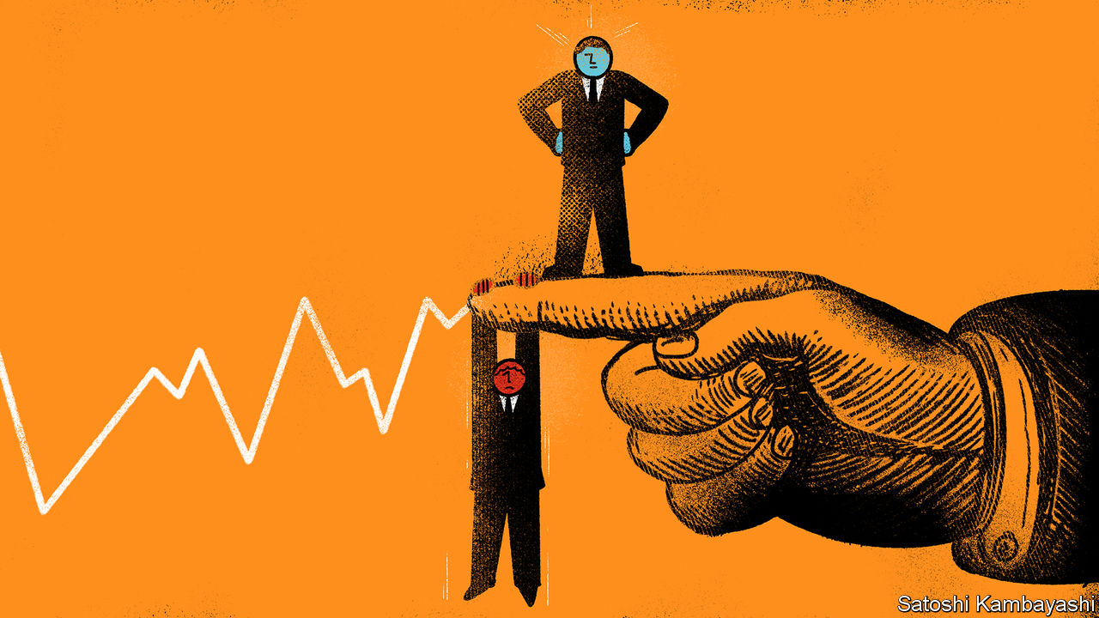

IMAGINE A WORLD in which the stockmarket has only two constituents: Gurgle, a firm that has risen quickly, and Genial Motors, a mature company. Both have 100m of shares outstanding, each worth $1. That gives the market a value of $200m. Further imagine that there are two investors of equal size in the market. Both own the same no-cost index fund. Each has wealth of $100m, split between Gurgle and Genial stock.

After a year Gurgle triples in value to $3 a share, while Genial stays at $1. The market has doubled to $400m. Three-quarters of its value is in Gurgle stock. Both investors still hold 50m shares of each firm. Their total holdings are now worth $200m each: $150m-worth of Gurgle; $50m of Genial. They have shared in the market’s surge. This is a quality of passive investment in an index weighted by value. If some stocks soar in price, you share proportionately in their success.

But say our investors were active rather than passive, with one holding 100m shares of Gurgle and the other 100m of Genial. The Gurgle investor triples his wealth; the Genial investor’s wealth is unchanged. Simple maths mean that if one active investor beats the index, another must be beaten by it. And since active equity managers have higher fees than passive ones, active investing is on average a losing game in real life. Few beat the index consistently. But there is a twist. This does not hold for active bond investors. Most beat the index. There is a kink in the logic of index investing that active bond investors are able to exploit.

In an idealised version of passive investing, the universe of securities remains unchanged from start to finish. But in the real world the index changes from time to time. New firms come to the market via initial public offerings (IPOs). Existing firms may issue more stock or retire some. A few are taken private. And a benchmark like the S&P 500 is not the whole market, but the largest listed firms in it. An index fund must occasionally buy stocks that gain enough mass to qualify for the index and sell stocks that fall out of it. So it is not entirely passive. Index funds must trade—and active investors can trade ahead of them.

In practice, the turnover in stocks within equity indices is not large enough to handicap the passive funds against active managers. IPOs are increasingly rare. Traffic in and out of indices is light.

Bonds are different. A share is a perpetual security, but bonds have finite lives. Most of them are quite short: the average maturity of a Treasury bond is six years. So there is a lot of movement in and out of a bond index. An index fund has to trade a lot just to match the index.

There is simply more scope in bond markets for winning investors to find willing losers to bet against. A lot of institutional investors are constrained in what kind of bonds they are allowed (or need) to hold. They may be barred from holding corporate bonds or bonds that are not rated investment grade. Or they may need to hold bonds of certain maturities for regulatory reasons.

The managers of foreign reserves, for instance, prize liquidity, so hold mostly short-term bonds. Banks face capital charges on corporate bonds, so prefer to hold government bonds. Insurance companies have long-lived promises to policyholders to live up to. That creates a particular thirst for long-dated bonds. In all, there are a lot of bond-buyers with goals other than beating the index from one year to the next. An analysis* by Jamil Baz, Helen Guo, Ravi Mattu and James Moore of PIMCO, a giant bond-fund manager, put the proportion of bonds held by such “non-economic” players at around half. Active managers can win by holding maturities that are less in demand, by tilting towards corporate bonds in the index, or by making off-index bets on junk bonds—in short by doing all the things constrained bond-buyers cannot, or will not, do.

A tragic flaw of bond indices is that they reward profligacy. Big issuers of bonds have a bigger weight. So high-debt Italy looms larger in global bond benchmarks than thrifty Germany. In equity indices there is some relationship of weight in the index to economic success—or at least to investor enthusiasm. Gurgle-like shares enter the index and make up more of its heft; Genial Motors-like shares diminish in weight, until eventually they slip out. Smart active investors can trade ahead of such entries and exits. But it is slim pickings. With bonds, there are more opportunities for active investors to win.

* “Bonds are different” (April 2017)

This article was downloaded by calibre from <https://www.economist.com/finance-and-economics/2020/02/29/why-active-bond-investors-can-beat-the-index-when-active-equity-investors-cant>

|  |  |  |  |
| --- | --- | --- | --- |
| Previous | Articles | Sections | Next |

|  |  |  |  |
| --- | --- | --- | --- |
| Previous | Articles | Sections | Next |

#### Household savings in America

# Why America’s personal-saving rate is unusually high

Land of the frugal

Feb 29th 2020 | SAN FRANCISCO

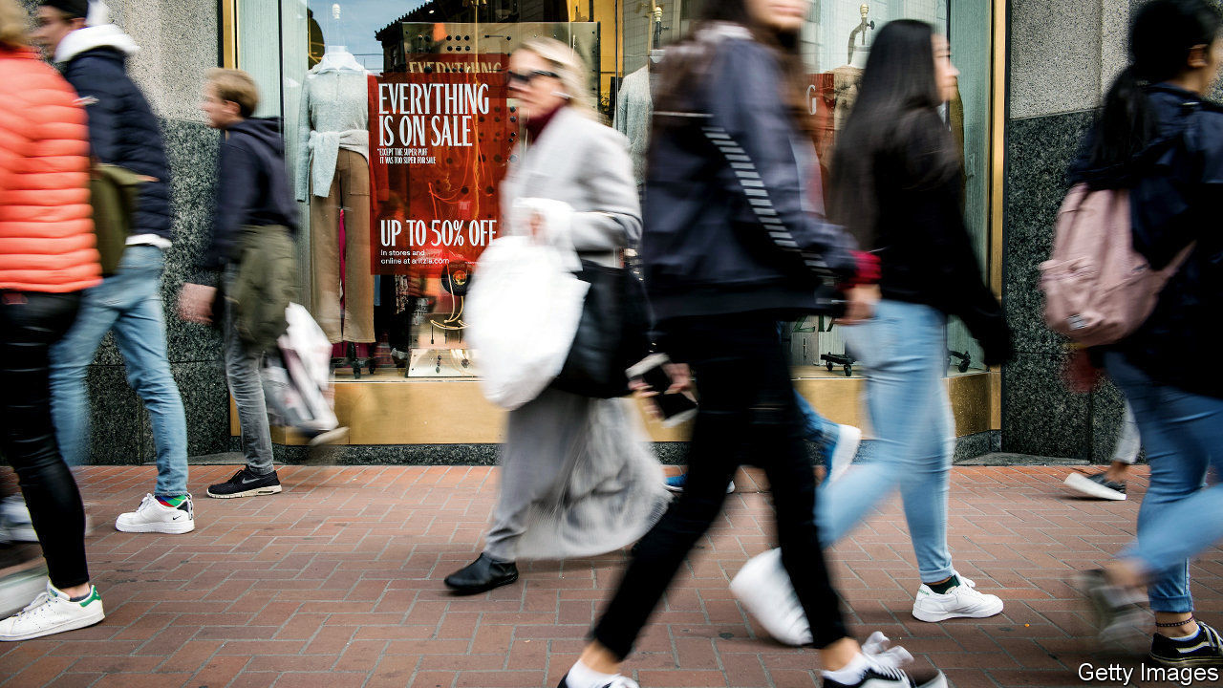

NO WONDER advertisements implore Americans to spend, spend, spend. These days they are positively Swabian, saving a much bigger share of their post-tax incomes than they have done for most of the past three decades (see chart). This is more than just an economic curiosity. Many households’ savings end up in Treasury bonds, reducing the government’s borrowing costs. Savings allow households to consume more later or to cushion the blow of a misfortune. But why is their propensity to save so high today?

Saving typically rises during the bad times and falls during the good. The financial crisis of 2007-09 prompted Americans to pull back on spending and pay down debts. The share of disposable income squirrelled away rose from 3% in 2005 to 8% in 2010-12. These days the economy is much stronger. The unemployment rate, at 3.6%, is at a five-decade low, while consumer confidence is high. As other countries have recovered from the crisis, their personal-saving rates have tumbled. But America’s remains high, and has risen in recent years. Goldman Sachs, a bank, says that the personal-saving rate is four percentage points higher than it “should” be, given the strength of the economy.

One commonly heard explanation for higher saving relates to inequality. Poorer people may save little or nothing—research from the Federal Reserve suggests that 12% of adults would be unable to cover a $400 emergency expense. Rich people, by contrast, tend to save a big share of their income. A body of evidence suggests that in recent years the rich have taken a greater share of total income, thereby dragging the overall personal-saving rate upwards. Still, rising inequality is at best an incomplete explanation for America’s savings puzzle. As the chart shows, saving was far higher in the 1970s, yet inequality was lower.

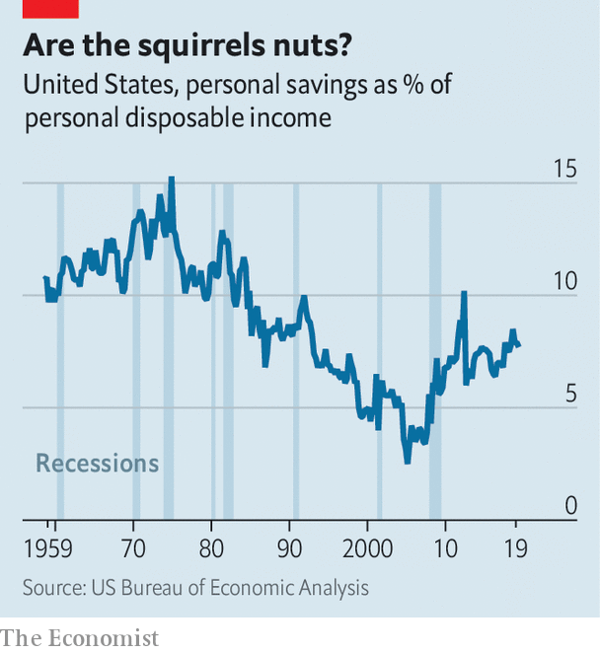

The financial system may play a more important role. In recent years many Americans have found it more difficult to access credit. From 2008 banks tightened lending standards on consumer and credit-card loans. The median credit score for both mortgages and car loans is higher than it was before the crisis. It is now more difficult for middle-income households to spend beyond their means.

Another possible factor is that, despite a strong economy, households remain deeply uncertain about the future. There is good evidence that Americans are worried about the threat to their jobs from automation and import competition. The on- and off-again trade war may be another source of anxiety. A widely watched measure of economic uncertainty, based on analysis of newspaper articles, last year hit an all-time high—and it may rise further if the covid-19 outbreak worsens. All this encourages prudent behaviour. According to the Fed, the share of people saying that “liquidity” (in plain English, having rainy-day money) is the most important reason for saving has been rising since the mid-2000s. Americans could be stashing the cash for some time yet. ■

This article was downloaded by calibre from <https://www.economist.com/finance-and-economics/2020/02/29/why-americas-personal-saving-rate-is-unusually-high>

|  |  |  |  |
| --- | --- | --- | --- |
| Previous | Articles | Sections | Next |

|  |  |  |  |
| --- | --- | --- | --- |
| Previous | Articles | Sections | Next |

#### The information economy

# Rethinking how we value data

Looking at the world’s most precious resource through new eyes

Feb 29th 2020 |

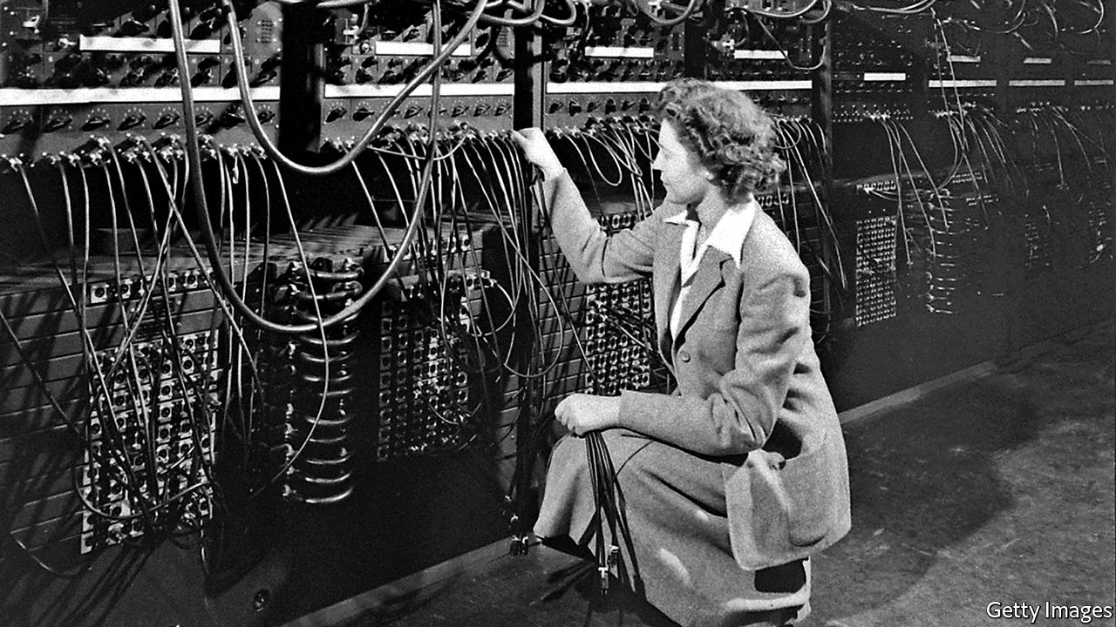

EVERYONE KNOWS that data are worth something. The biggest companies in the world base their businesses on them. Artificial-intelligence algorithms guzzle them in droves. But data are not like normal traded goods and services, such as apples and haircuts. They can be used time and again, like public goods. They also have spillover effects, both positive, such as helping to improve health care, and negative, such as breaches of personal information. That makes them far from easy to value.

A new report, led by Diane Coyle, an economist at the University of Cambridge, attempts to address this by understanding the value of data and who stands to benefit from it. She says market prices often do not ascribe full value to data because, in many cases, trading is too thin. Moreover, while much of society’s emphasis is on the dangers of misuse of personal data, the report chooses to highlight data’s contribution to “the broad economic well-being of all of society.” That gives it a much deeper value than a simple monetary one.

She outlines a variety of data types and uses. Some may be more useful in aggregate, others for individual purposes. For example, a patient’s medical records may be most valuable when they are combined with everyone else’s, while web-browsing history has value when it is used individually to bombard a person with advertisements. Timeliness also matters: phone-location records flowing in real-time for a car GPS-navigation system are useful for ten minutes, while today’s retail-sales transactions help forecast next year’s demand.

As yet the data economy does not distinguish such features well. Ms Coyle argues that a new mindset is needed, as well as institutions, such as data trusts, to ensure information is fairly distributed. Personal information should not be regarded through the lens of “ownership” but “access rights,” she says. Hence, people may control how it is used, but should not treat it as a winning ticket to be monetised.

That should apply more broadly, she argues. For governments, the right strategy may be to make data freely accessible. Estimates for the value of open government data range from less than 0.1% to more than 7% of GDP. Companies also should consider privileging access to personal data above ownership of it. Try telling that to the tech giants, though. However data are valued, they have no doubt about how valuable exclusive control is to them.

This article was downloaded by calibre from <https://www.economist.com/finance-and-economics/2020/02/29/rethinking-how-we-value-data>

|  |  |  |  |
| --- | --- | --- | --- |
| Previous | Articles | Sections | Next |

|  |  |  |  |
| --- | --- | --- | --- |
| Previous | Articles | Sections | Next |

#### EU Trade

# The European Union’s trade policy will involve some tough negotiations

Is Phil Hogan the person for the job?

Feb 29th 2020 | WASHINGTON, DC

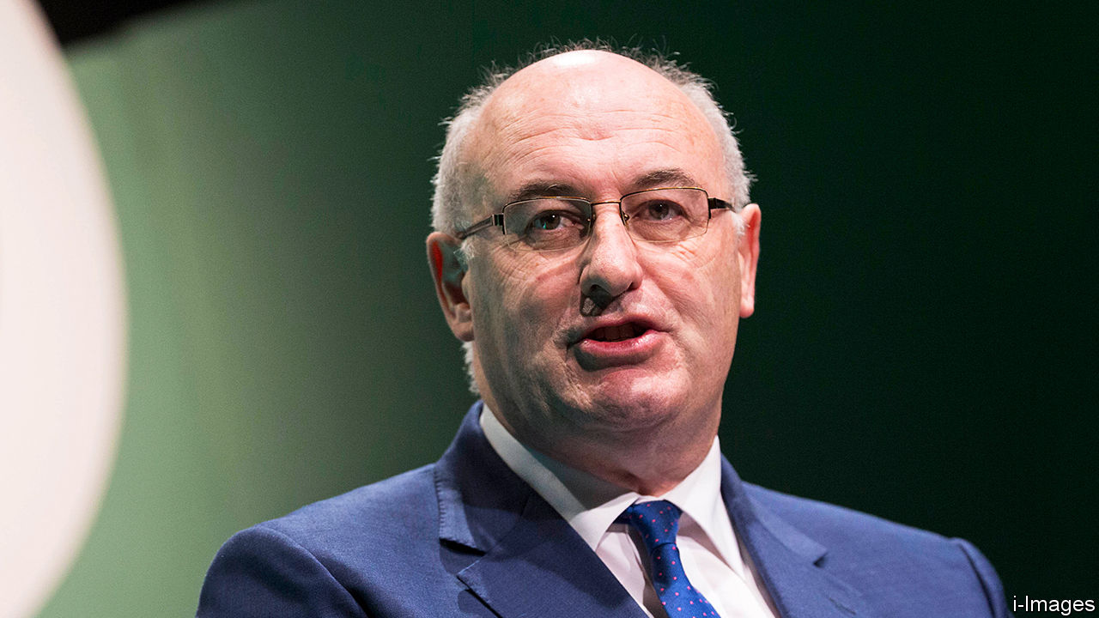

IF THE TRUMP administration’s America is the bully of the global trading system, the European Union is the finger-wagging school prefect. Instead of threatening tariffs, its leaders have called for countries to play fairly. As a trade war has raged between America and China, the EU suggested a rules-based solution. When the Trump administration wrecked the system of solving disputes at the World Trade Organisation (WTO), the EU led the search for a fix. As the world’s biggest exporter of services and second only to China for goods, it has a sizeable stake in preserving order.

Enter Phil Hogan, the EU’s burly trade commissioner since December 2019. The EU is still a stickler for rules and the multilateralism that Mr Hogan says is “in our DNA”. But he wants to wield a bigger stick. “We have to stand up for our rights more assertively and aggressively, in my view,” he tells The Economist. By this he means defending the EU against unfair trading practices. The challenges range from concerns about China’s state-led system of capitalism to fears that the EU’s trading partners are not living up to their commitments.

Part of his brief involves continuing efforts to rescue the system by which the WTO solves disputes. Meanwhile he will have to manage the tense transatlantic relationship. If the job was not daunting enough, he will help negotiate what he hopes will be an “amicable” trade deal with Britain.

Mr Hogan’s reputation as a canny politician willing to make tough decisions—his nickname in Irish politics was “the enforcer”— suggests that he may be right for the job. On behalf of his home county of Kilkenny, where he entered Irish politics at the age of 22, he haggled effectively (for example, ensuring that the region’s salt depot was in Kilkenny, partly so that in case of ice the local roads would be salted first). He is “no flat tyre”, as one Leinster admirer puts it. Later he drew controversy when in 2011, as Ireland’s Minister for Environment, Community and Local Government, he was put in charge of introducing unpopular water charges. It damaged his reputation. But as a consolation prize, the Irish government backed him as the EU’s agriculture commissioner.

His experience over the following five years meant that he became intimately acquainted with the EU’s most sensitive spots. Alongside Cecilia Malmström, then the EU’s trade commissioner, he boasts of concluding no fewer than 15 trade agreements. According to some of the negotiators who were on the opposite side of the table, while he could be both charming and funny, his strategies to avoid giving concessions could be deeply frustrating. In some cases, he simply declined to show up.

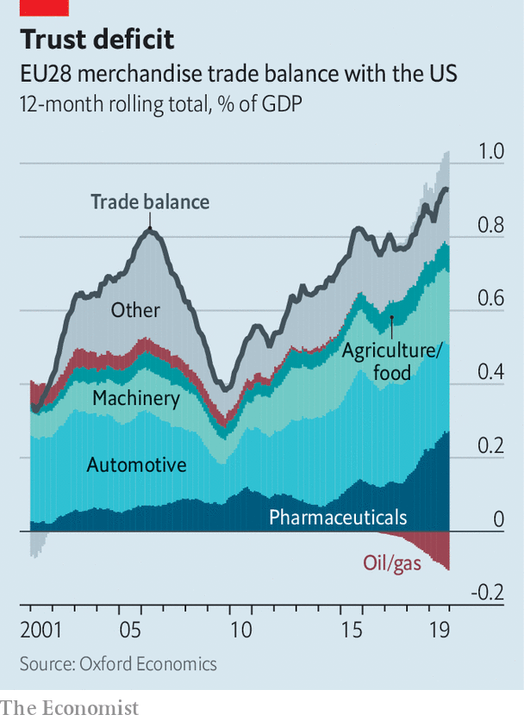

The American government may roll its eyes at the talk of a tougher EU trade regime. Some in America could accuse the bloc of being too timid about using tariffs to get its own way with trading partners, and too weak to overcome the protectionist instincts of its member states. They ask why, if the EU is so concerned about the demise of the WTO’S dispute-settlement system, it ignored America’s complaints about it for so long? Where, they ask, was the EU while America was filing WTO disputes against China? Tough talk is cheap, results will require action.

Mr Hogan’s first priority is to add muscle to the EU’s defences. From May 1st he will oversee a new “chief trade-enforcement officer”, as well as new enforcement unit dedicated to making sure that existing trade deals are implemented properly. The European Commission is proposing new rules that would sharpen the EU’s teeth, including an amendment to enforcement regulations that would allow tariffs against other governments blocking the WTO’s dispute-settlement system. On the topic of the WTO’s appellate body, Mr Hogan acknowledges some of the American concerns, but adds that he would love to see detailed proposals for solutions to the problems from the Trump administration.



Whether he can maintain stable trade relations with America is another matter. He raised hackles in September after an interview in which he promised to teach Mr Trump “the error of his ways”. Then in a meeting in January he seems to have clashed with Robert Lighthizer, the United States Trade Representative. If he tries to bring more assertiveness into the EU’s side of the transatlantic relationship it could end badly. Stephen Vaughn, an ex-colleague of Mr Lighthizer, warns that attempts to play hardball “could backfire”.

The Americans want, above all, broad access to the EU’s agricultural market—more than the lobsters, scallops and nuts that are on offer. (Seafood technically counts as an industrial product.) But as Mr Hogan knows well from his previous job, anything much broader than dismantling a few non-tariff agricultural barriers is unpalatable to member states.

He remains upbeat about the transatlantic relationship. “I think that we’re in a better place now than we were some months ago,” he says. On February 14th a tariff announcement related to a dispute over aircraft subsidies was milder than expected. A reduction in car tariffs could be on the table, he adds, if member states agree. His challenge is not just to get trade partners to play by the rules. It is to get his own side on board, too. ■

This article was downloaded by calibre from <https://www.economist.com/finance-and-economics/2020/02/29/the-european-unions-trade-policy-will-involve-some-tough-negotiations>

|  |  |  |  |
| --- | --- | --- | --- |
| Previous | Articles | Sections | Next |

|  |  |  |  |
| --- | --- | --- | --- |
| Previous | Articles | Sections | Next |

#### Who wants to run a bank?

# Bank bosses in America stick around longer than those in Europe

A slew of changes show how uncomfortable the hot seat can be

Feb 29th 2020 |

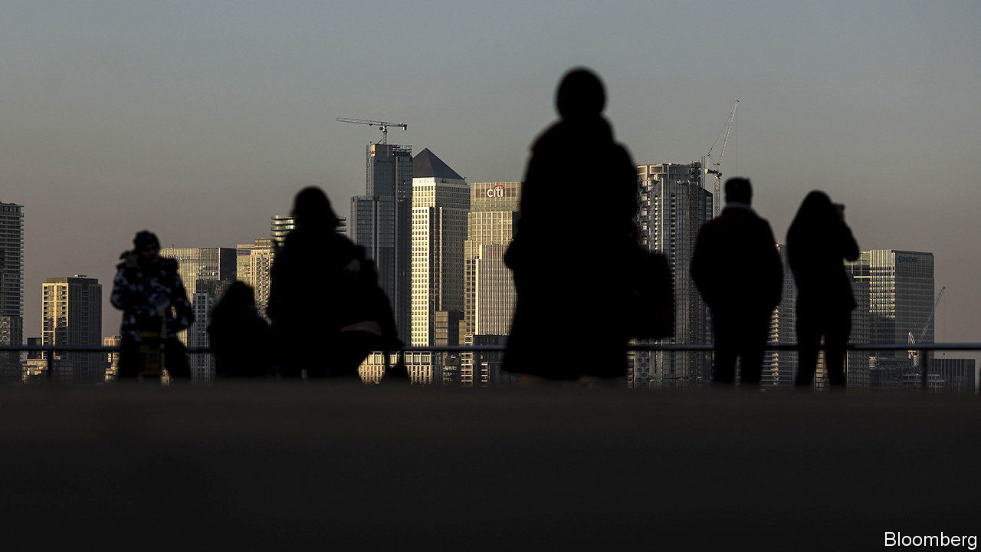

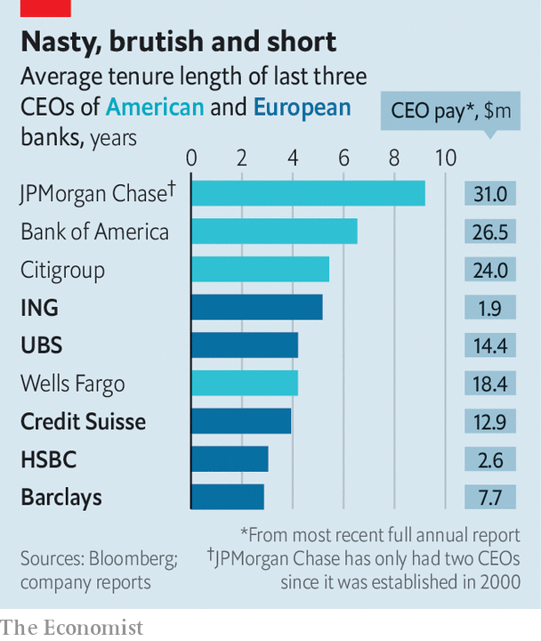

IT IS ALL change at the top of Europe’s biggest banks. Many have either recently put in a new boss, or are desperately searching for one. Barclays is reportedly looking for a replacement for Jes Staley. Unicredit’s Jean Pierre Mustier declined to throw his hat in the ring to lead HSBC. Is it surprising? The ouster of Tidjane Thiam from Credit Suisse in February highlights how uncomfortable the hot seat can be. In Europe the tenure of bank bosses is short, the job is gruelling, and the average pay is far less than in America. Europe’s bankers may yearn to try their luck across the Atlantic. Sadly for them, their American counterparts know they have a nice gig. They cling on for dear life.■

This article was downloaded by calibre from <https://www.economist.com/finance-and-economics/2020/02/29/bank-bosses-in-america-stick-around-longer-than-those-in-europe>

|  |  |  |  |
| --- | --- | --- | --- |
| Previous | Articles | Sections | Next |

|  |  |  |  |
| --- | --- | --- | --- |
| Previous | Articles | Sections | Next |

#### Free exchange

# How to get more innovation bang for the research buck

Narrow incentives such as citations can skew behaviour

Feb 29th 2020 |

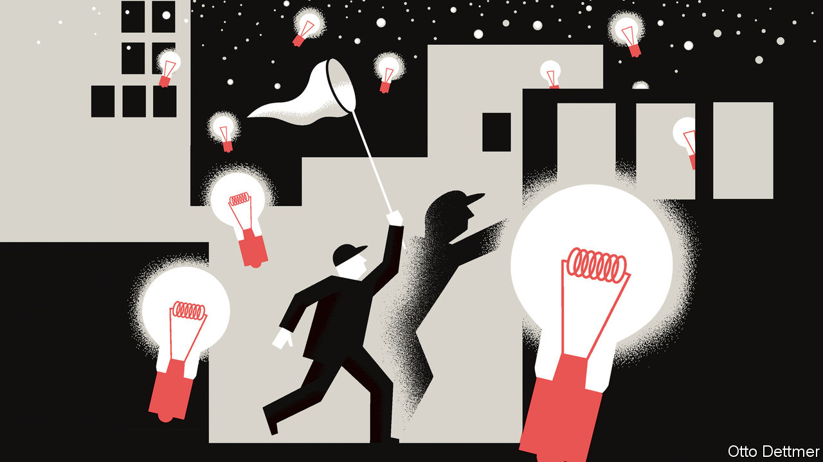

ABOUT A DECADE ago, a few economists began asking whether the rich world’s prolonged spell of lacklustre growth might have something to do with a shortage of new ideas. Tyler Cowen of George Mason University suggested that when it came to discovery, humanity may well have plucked all of the low-hanging fruit. Robert Gordon of Northwestern University scoffed at recent technological contributions, noting that none was nearly as important to human welfare as the humble toilet. Progress since—in gene editing, artificial intelligence and even rocketry—seems impressive. But the radical change and roaring growth enabled by the innovations of the 19th and 20th centuries continue to elude rich economies. Before abandoning hope, though, it is worth considering that it may be the motivation we provide our innovators, rather than a shortage of ideas, that is the problem.

The argument that humanity has run out of big ideas (or nearly so) makes a degree of intuitive sense. Fundamental forces of nature, like the theory of electromagnetism, can only be discovered and exploited once. Scanning through available evidence, it certainly seems like breakthroughs are ever harder to come by. In a paper by Nicholas Bloom, Charles Jones and Michael Webb of Stanford University, and John Van Reenen of the Massachusetts Institute of Technology (MIT), the authors note that even as discovery has disappointed, real investment in new ideas has grown by more than 4% per year since the 1930s. Digging into particular targets of research—to increase computer processing power, crop yields and life expectancy—they find that in each case maintaining the pace of innovation takes ever more money and people.

Humans, though, have mistakenly believed their understanding of the universe to be complete many times before. In a new paper by Jay Bhattacharya of Stanford University and Mikko Packalen of the University of Waterloo, the authors quote the Nobel-winning physicist Albert Michelson, who, in a speech in 1894, reckoned that “the more important fundamental laws and facts of physical science have all been discovered”. Within a few years of his remarks, theories of relativity and quantum mechanics revolutionised physicists’ understanding of the universe. We do not know what we do not know.

If there are more powerful ideas waiting to be discovered, why is investment in new research experiencing such diminishing returns? One factor could be the growing burden of knowledge. Intellectual progress has created a mound of know-how which must be mastered before an innovator can even begin to push the frontier forward. Benjamin Jones of Northwestern University has found that the average age at which great scientists and inventors produce their most important work rose by six years over the course of the 20th century, thanks to the need for more early-life investment in education. But although important thinkers begin their careers later than they used to, they are no more productive later in life. Education, while critical to discovery, shortens the working lives of great scientists and inventors.

Yet it is also worth assessing the incentives researchers experience during their careers. Most of the benefits of new knowledge flow to people other than those responsible for discovering it, such as those who build on new ideas or make use of inventions. Societies therefore come up with ways to motivate researchers who might otherwise labour at more self-serving tasks. Patents and copyrights, for instance, grant creators temporary monopoly control over their work so they can capture at least some of the monetary gains it generates. Universities and research institutes link promotions and pay to research productivity, as measured by the number of citations published papers receive. Prizes and awards create additional incentives to do exceptional work.

But these schemes do not always have the desired effects. Intellectual-property protections make it more difficult for others to make their own contributions by building on prior work. Barbara Biasi of Yale University and Petra Moser of New York University studied the effects of an American wartime policy that allowed domestic publishers to freely print copies of German-owned science books. English-language citations of the newly abundant works subsequently rose by 67%.Too closely linking career progress to success in publishing can also skew behaviour. Over the past half century, Messrs Bhattacharya and Packalen note, promotions and pay for research scientists have increasingly been determined narrowly by the numbers of citations their works have received. Such metrics probably push research in a more conservative direction. While novel research is more likely to be cited when published, it is also far more likely to prove a dead end—and thus to fail to be published at all. Career-oriented researchers thus have a strong incentive to work towards incremental advances rather than radical ones. Similarly, Pierre Azoulay of MIT, Gustavo Manso of the University of California, Berkeley, and Joshua Graff Zivin of the University of California, San Diego, find that medical researchers funded by project-linked grants, like those offered by the National Institutes of Health, an American government research centre, often pursue less ambitious projects, and thus produce breakthrough innovations at a much lower rate, than researchers given open-ended funding.

## The social sciences

Not all incentives must be material in nature. Some economic historians, such as Joel Mokyr of Northwestern University, credit cultural change with invigorating the innovative climate in industrialising Britain. A “culture of progress” made intellectual collaborators of commercial rivals, who shared ideas and techniques even as they competed to develop practical innovations. Changing culture is no easy matter, of course. But treating innovation as a noble calling, and not simply something to be coaxed from self-interested drudges, may be a useful place to start. ■

This article was downloaded by calibre from <https://www.economist.com/finance-and-economics/2020/02/29/how-to-get-more-innovation-bang-for-the-research-buck>

|  |  |  |  |
| --- | --- | --- | --- |
| Previous | Articles | Sections | Next |

|  |  |  |
| --- | --- | --- |
| Finance and ... | Sections | Books and arts |

Science and technology

Cardiology: The heart’s digital twin

.

Armed forces: War on attrition

.

Planetology: Beneath the surface

.

Defending delivery drones: Incoming!

.

Geomythology: Fossilised folk tales

.

|  |  |  |
| --- | --- | --- |
| Finance and ... | Sections | Books and arts |

|  |  |  |  |
| --- | --- | --- | --- |
|  | Articles | Sections | Next |

#### Cardiology

# Digital twins of hearts could help diagnose and treat cardiac disease

Making a virtual heart

Feb 29th 2020 | SHEFFIELD

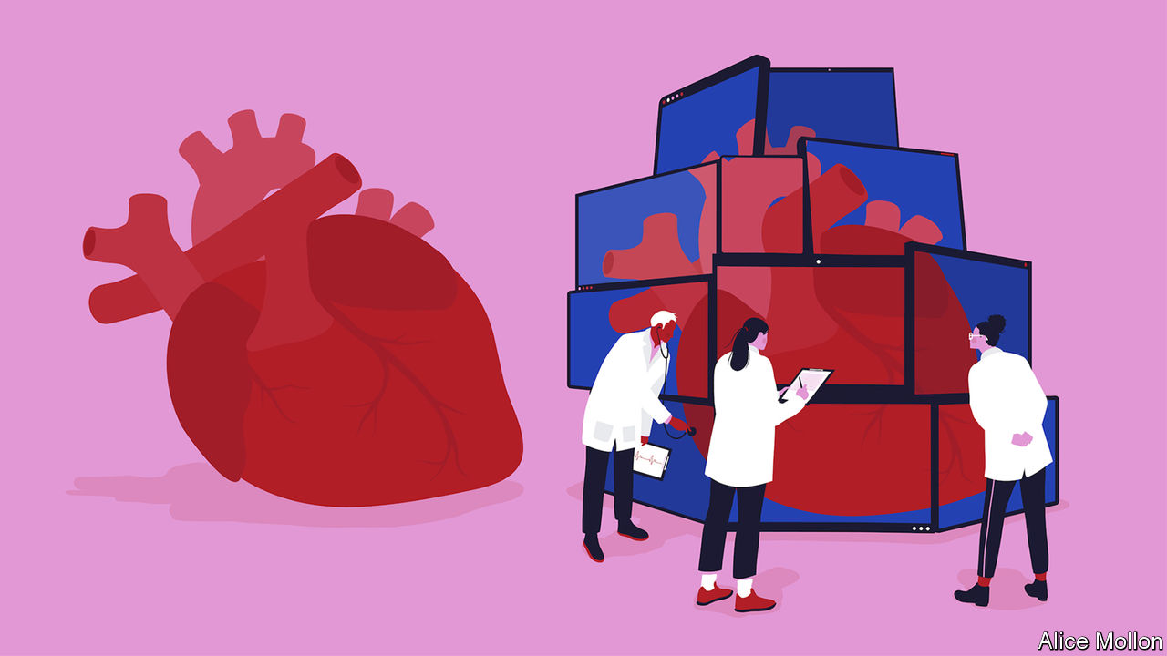

IF YOU TRAVEL on a modern airliner, the chances are that each of the jet engines powering it will have a virtual copy residing in a computer on the ground. This copy, known as a digital twin, will be updated constantly with information from sensors that measure the engine’s performance and check for signs of wear and tear. Digital twins allow engineers to service engines as and when needed, rather than sticking to rigid schedules, and let them carry out preventive maintenance by fixing things before they break. Their use is increasingly common—not only in aerospace, but also in carmaking, construction and factory planning. If an international team of researchers have their way, similar twins will soon keep an eye on another important piece of equipment, the human heart.

Building a digital twin of a patient’s heart would first require that person to don a variety of sensors. The data from these would then be turned by specialised software into a computer simulation of the pumping organ. This simulation would show detailed information about how the heart is working, and the way blood is flowing within it. And, in the same way that digital twins in industry are employed by engineers, virtual hearts could be used by doctors to help with their diagnoses and to determine what treatments might be necessary. A twin could then keep track of how a patient responded to those treatments.

## Heart of the matter

The idea of creating digital heart-twins comes from a cardiac-research programme called ECHOES, led by Frank Rademakers of University Hospitals Leuven, in Belgium. Several European and American research groups are involved, including the Universities of Sheffield and Bristol in Britain and, in America, Harvard and Stanford, along with firms such as ANSYS, a computer-simulation company, and GE, which makes jet engines and medical devices.

An important part of ECHOES is the development of miniaturised sensors that will allow people to wear the monitoring equipment throughout their daily lives, rather than just in a clinic or a doctor’s surgery, says Tim Chico of the University of Sheffield, who leads the British arm of the project. This will permit heart function to be simulated in a variety of circumstances, including walking, sleeping and climbing stairs, rather than just for the brief period when a patient is undergoing clinical examination. Although some portable cardiac devices are already available—small electrocardiographs worn on a belt, for example, with leads that attach to a patient’s chest to trace the rhythm and electrical activity of the heart—these tend to be used for just a couple of days. Digital twins would draw data from a broader suite of sensors, and for longer.

Some of the monitoring could be done by existing or adapted consumer products, such as health apps on smartphones and fitness trackers, adds Dr Chico. Other sensors, with more sophisticated capabilities, are being developed by ECHOES’ members. These include a wearable ultrasound scanner which Jan d’hooge and his colleagues at the University of Leuven are working on. An ultrasound scanner is a device that employs high-frequency sound waves to create images of parts of the inside of the body. The idea, says Dr d’hooge, is that both the transmitters which produce the ultrasonic pulses and the receivers which pick up the returning echoes can be woven into textiles used to make items of clothing, such as vests. He is optimistic that it will thus be possible to create garments capable of conducting heart scans, and that these might be washable.

All this would help cardiologists like Dr Chico a lot. It is often hard for patients to describe their symptoms fully, and hospital tests might not reveal a complete picture—especially as people tend to be under stress when those examinations are carried out. To start with, the data used to model and update a digital heart-twin will be recorded by the collection device and uploaded therefrom at intervals. Eventually, though, it should be possible for them to be transmitted directly to a medical centre, just as data from a jet engine are transmitted to an engineering base.

While wearable heart scanners are several years away, some elements needed to build digital heart-twins are close to deployment. Rod Hose, a former aerospace engineer who is now an expert in medical modelling at the University of Sheffield, led a recent project called EurValve, which developed a system to help doctors treat people with heart-valve disease. EurValve gathered a variety of data about patients’ conditions from scans and other hospital tests, and combined these with other information acquired from those patients when they were at home, via health-tracking watches produced by Philips, a Dutch technology group. The EurValve system, which the researchers hope will soon be put into clinical practice, can model the severity of disease and predict the outcome of heart-valve-replacement surgery.

A digital twin of the whole heart will allow simulation of the treatment of a particular individual for many other conditions, as well. That will give a clearer idea, in a particular case, of the likely outcome of an intervention. It might show, for instance, what type of operation is best suited to a patient’s condition, or if drugs and regular check ups are more appropriate.

As more and more patients have their heart twins analysed, machine learning, a form of artificial intelligence that is good at pattern recognition, will be used to study the outputs. This should make the system yet more accurate, and help with unusual and rare cases that a cardiologist might not have seen before. Just as pilots can relax knowing that a digital twin is keeping an eye on their engines, doctors will benefit from a new depth of knowledge about how their patients’ hearts are working. ■

This article was downloaded by calibre from <https://www.economist.com/science-and-technology/2020/02/29/digital-twins-of-hearts-could-help-diagnose-and-treat-cardiac-disease>

|  |  |  |  |
| --- | --- | --- | --- |
|  | Articles | Sections | Next |

|  |  |  |  |
| --- | --- | --- | --- |
| Previous | Articles | Sections | Next |

#### Training elite marines

# How to decide in advance who will pass advanced military training

Physical toughness is important. Personality more so

Feb 29th 2020 |

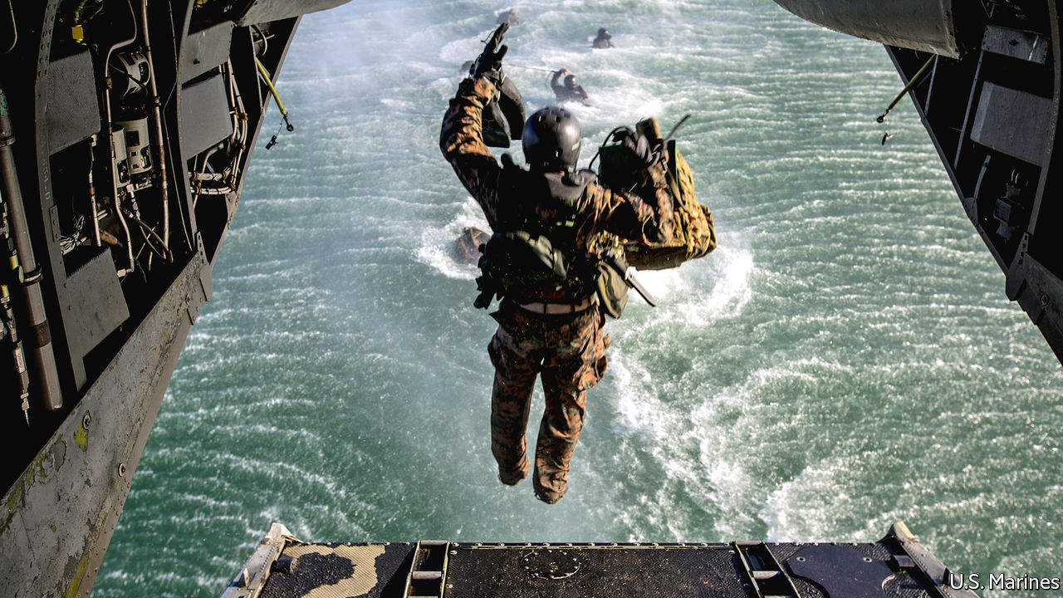

IT GOES WITHOUT saying that to be a marine you have to be tough, both physically and mentally. But which is more important? And, more specifically, which is the bigger obstacle to successful training? Working on behalf of America’s marine corps, Leslie Saxon, of the Keck School of Medicine of the University of Southern California, has been trying to find out.

The elite of the marine corps is a group called Force Reconnaissance. These troops are employed in special operations, both “green” (in which having had to engage the enemy is deemed a failure) and “black” (where such engagement is the whole point). Initial training to join the force, open only to those already marines or naval doctors, lasts 25 days. Among other things it requires volunteers to tread water for nearly an hour, to run eight miles (12km) while carrying more than 50lb (about 23kg) of equipment, and to swim 100 yards (90 metres) with their hands and feet bound. Only half of those who volunteer for this training complete it. Of those who do not, roughly half are failed by the judges for posing a safety risk or for having a medical problem that stops them completing the course. The other half, though, drop out of their own volition.

That high drop-out rate is both expensive and vexing for Force Reconnaissance’s recruiters. They therefore turned to Dr Saxon to find out what is happening, so that they can take steps to reduce the losses.

To gather the relevant data she picked 121 trainees and provided each of them with two devices: an iPhone and an Apple Watch (a wrist band that both tells the time like a conventional watch and watches what the wearer gets up to). She loaded the phones with an app that asked participants a range of demographic and psychological questions at the start of their training. From the answers to these she generated, for each volunteer, scores for the five main personality traits recognised by psychologists—openness, conscientiousness, extroversion, agreeableness and neuroticism—and also for ego resilience (ability to control anger and to control impulses when stressed), positive affect (a person’s tendency to experience positive emotions when facing challenges), satisfaction with life and level of psychopathy. The watch, meanwhile, monitored the number of steps its wearer took, and kept track of both heart rate and calorie expenditure.

Once volunteers began training they received further, daily questionnaires on their phones. They were asked to rate their pain, both mental and physical, on a scale of one to five. They were asked if they thought of quitting and if they thought their instructors wanted them to graduate. They were also asked about their sleep, their hydration, their nutrition and their own confidence that they would graduate.

Dr Saxon’s sample proved pretty representative in their rates of completion of the course. As she reports in the Journal of Medical Internet Research, 56% were successful, 23% dropped out of their own volition and 21% were removed for a mixture of medical, safety and performance reasons. Analysing the data for those who dropped out, Dr Saxon found that neither performance on physical standards, such as hikes or aquatic training, nor physiological measures of heart rate, work output, hydration, nutrition and sleep duration predicted who would throw in the towel. Nor, among psychological factors, were conscientiousness, neuroticism, openness or agreeableness relevant. But extroversion (or, rather, introversion) was. Using scores for that parameter and also for positive affect, Dr Saxon was able, retrospectively, to predict with 70% accuracy who would drop out.

She also showed when the towel was most likely to be thrown. A majority of droppings out happened just before a series of timed drills, conducted in a deep-water pool, in full uniform. These drills are designed to test candidates’ ability to perform tasks underwater, holding their breath, in a chaotic environment.

What the marine corps’ trainers will do with this information is not yet clear. They could use it to winnow out likely failures before the course starts, though that might seem unfair to introverts who would nevertheless have made it. Or they might choose to identify those who need a bit of encouragement to throw themselves into both the literal and metaphorical deep end, on the presumption that, having done so, they will then take the rest of the course in their stride. Either approach would, presumably, reduce the drop-out rate. What you can be sure of, though, is that the course itself will not be made any easier.■

This article was downloaded by calibre from <https://www.economist.com/science-and-technology/2020/02/29/how-to-decide-in-advance-who-will-pass-advanced-military-training>

|  |  |  |  |
| --- | --- | --- | --- |
| Previous | Articles | Sections | Next |

|  |  |  |  |
| --- | --- | --- | --- |
| Previous | Articles | Sections | Next |

#### Planetology

# The exploration of the Moon and Mars continues apace

Two craft probe beneath these bodies’ surfaces

Feb 29th 2020 |



THIS WEEK has seen the publication of results collected by probes to two heavenly bodies: Chang’e 4, a Chinese mission to the Moon, and InSight, an American mission to Mars. Chang’e 4 landed in January 2019; InSight arrived the previous November. The Chinese team, bowing to the realities of scientific publishing, have presented their results in Science Advances, an American journal. The Americans, however, have chosen Nature Geoscience, a British journal owned by German publishers.

Chang’e 4 is China’s second successful lunar lander, and the first from any country to touch down intact on the Moon’s far side—the part never visible from Earth. Its purpose, other than demonstrating China’s technological prowess, is to investigate the geology of Von Kármán crater in the Moon’s southern hemisphere. To that end it is fitted with a ground-penetrating radar which can peer many metres down.

This radar shows three distinct layers of rock, the top two each 12 metres thick and the lowest 16 metres thick. Below that, the signal is too fuzzy to see what is going on. The upper layer is composed of regolith—crushed rock that is the product of zillions of small meteorite impacts over the course of several billion years, and which covers most of the Moon’s surface. The other two, distinguishable by the coarseness of the grains within them, are probably discrete ejecta from separate nearby impacts early in the Moon’s history that were subsequently covered by the regolith.

InSight (pictured above as an artist’s impression) is intended to probe deeper than this. It is fitted with instruments designed to measure heat flow from Mars’s interior, any wobble in the planet’s axis of rotation (which would probably be caused by an iron core) and Marsquakes. The heat-flow instrument has so far been a washout. The “mole”, a device intended to dig into Mars’s surface, pulling this instrument with it, has refused to co-operate—to the point where the project’s directors are about to take the time-honoured step of hitting it with a hammer (or, rather, with the scoop on the probe’s robot arm) to persuade it to stay in the hole that it is supposed to be excavating. And the wobble detector, though working correctly, has insufficient data to report. So the release this week is mainly about the quakes.

InSight’s seismograph recorded 174 quakes between the craft’s landing and the end of September 2019. The strongest were between magnitudes three and four—just powerful enough, had they happened on Earth, for a human being to notice them. Quakes are a valuable source of information about a planet’s interior. A network of seismographs, as exists on Earth, allows their points of origin to be triangulated, their speed measured and their reflections from subsurface rock layers observed. From all this can be deduced those layers’ composition and depth. With but a single instrument, such deductions are trickier. InSight’s masters do, though, think that two of the quakes originated in Cerberus Fossae, a set of faults 1,600km from the landing site that are suspected of still being seismically active.■

This article was downloaded by calibre from <https://www.economist.com/science-and-technology/2020/02/29/the-exploration-of-the-moon-and-mars-continues-apace>

|  |  |  |  |
| --- | --- | --- | --- |
| Previous | Articles | Sections | Next |

|  |  |  |  |
| --- | --- | --- | --- |
| Previous | Articles | Sections | Next |

#### Drones’ self defence

# As delivery drones multiply, they may need to protect themselves

The Doppler effect will help them to do so

Feb 29th 2020 |

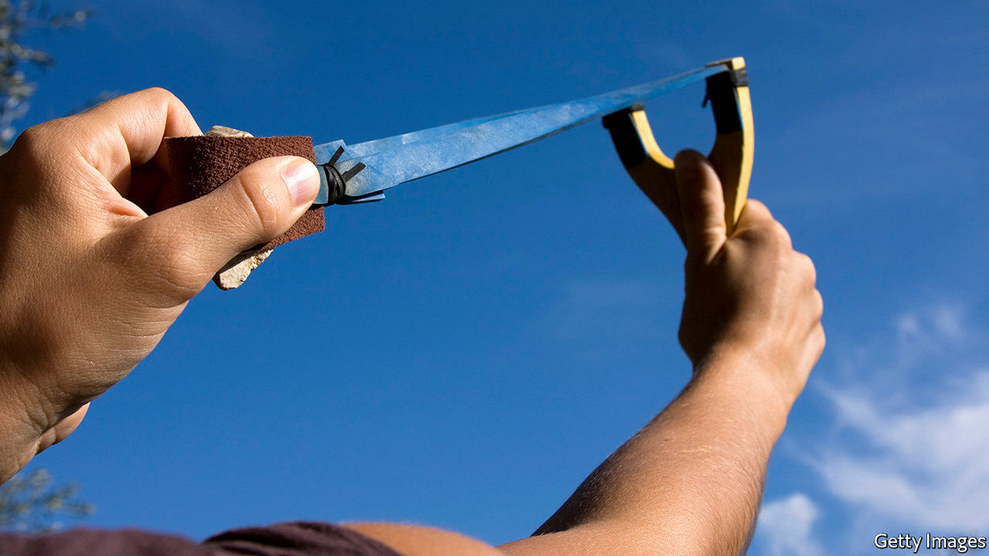

INTERNET SHOPPING makes buying things easier, but has also led to the rise of a new kind of thief: the porch pirate. Porch pirates scour door steps for deliveries that have been made when a householder was out, and nab them. Sometimes, they will stalk delivery vans to do so. Residents of New York City, for example, lose an astonishing 90,000 parcels every day to porch pirates, according to a report in the New York Times.

Porch piracy is a problem that may be solved by the spread of parcel-delivering drones. Because each drone delivery involves a separate journey, rather than having to be fitted into a round, it will be easier for courier and customer to agree on when a drone should arrive than on the arrival time of a van. However Nirupam Roy and Nakul Garg, a pair of engineers at the University of Maryland, worry that drone deliveries are open to a different sort of piracy—hijacking. A drone in flight is easily upset. A well-aimed stone, baseball or similar missile is enough to bring it down, permitting its payload to be purloined. Nor need such stone-throwers have pecuniary motives. Vandalism, or irritation with the very presence of drones, might also provoke pot shots. High-flying drones, like those employed by the police for surveillance, will normally be out of range of such activity. But parcel drones will have to fly low, at least for part of their journeys. To counter this risk the pair therefore propose to build a lightweight, low-power self-defence mechanism which lets a drone sense a missile fast enough to get out of its way.

That is nowhere near as easy as it might sound. Drones are lean machines, provided with only enough battery strength, computing power and payload-carrying capacity to do the job they are designed for. Adding threat-detection measures, such as heavy, power-hungry radar antennae, or spinning lidar units, radar’s optical equivalent, would either reduce range or prevent lift-off in the first place. Dr Roy and Mr Garg think, however, that they have hit on a low-power, lightweight self-defence system suitable for small drones. Instead of employing light or radio waves to detect incoming threats, it harnesses sound waves and the Doppler effect.

The Doppler effect is the frequency shift heard as a source of sound approaches or recedes. It is, for example, the reason the pitch of a police siren changes as a patrol car passes in the street. To take advantage of it Dr Roy and Mr Garg plan to fit drones with diminutive loudspeakers, like those found in smartphones. These would broadcast an ultrasonic tone outward from the drone. Similarly tiny microphones would then listen for reflections from incoming objects. The Doppler shift of these reflections, run through a bit of on-board processing (but far less than that needed for radar or lidar) would give the bearing of the threat, and thus permit the drone to take evasive action.

To test the principle of what they call their DopplerDodge drone defence system, Dr Roy and Mr Garg have constructed a static version in their laboratory, and have been throwing objects of various sizes and shapes at it, as if it were a hovering drone. At the moment, it can detect these objects from distances of up to four metres away. That is pretty close, but would still give a drone a tenth of a second’s notice of an incoming missile. This would be sufficient for it to move itself out of the way. Tests on actual drones will take place shortly, and then, if all goes as planned, the two researchers will attempt to extend the system’s range to 30 metres—a reasonable approximation of a stone’s throw.■

This article was downloaded by calibre from <https://www.economist.com/science-and-technology/2020/02/29/as-delivery-drones-multiply-they-may-need-to-protect-themselves>

|  |  |  |  |
| --- | --- | --- | --- |
| Previous | Articles | Sections | Next |

|  |  |  |  |
| --- | --- | --- | --- |
| Previous | Articles | Sections | Next |

#### Geomythology

# An Australian legend may be the world’s oldest datable story

Geological evidence suggests it originated 37,000 years ago

Feb 29th 2020 |

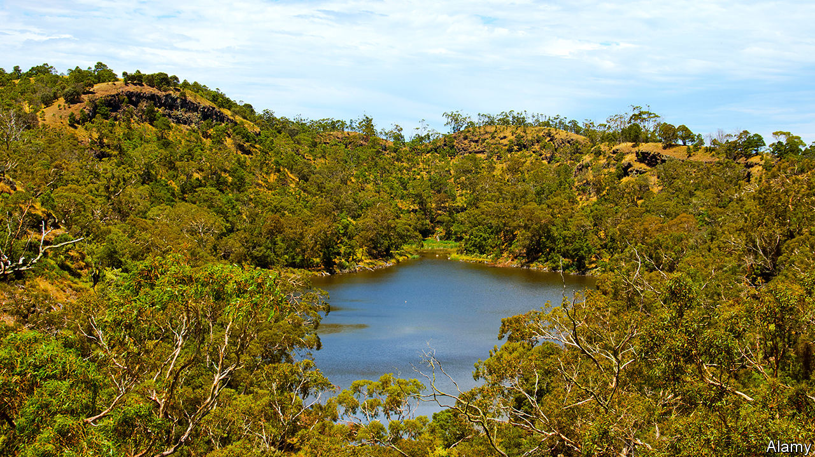

ORAL MYTHOLOGY has tremendous staying power. The Klamath, a group of Native Americans who live in Oregon, tell tales of an underworld god called Llao who fell in love with a mortal woman and grew furious when she refused his advances. He emerged from a mountain to cascade fire down onto her village, but was then attacked by Skell, a sky god who wished to protect human beings. Skell forced Llao back into the earth, and the mountain he had emerged from collapsed on top of him during his retreat. Terrible rains followed, and the hole left behind became a great lake.

An everyday story of deities the world over, then. Except that the mountain in question is Mount Mazama, a dormant volcano, and the body of water is now known as Crater Lake. Geological evidence shows that the eruption which created the lake happened 7,700 years ago. The story of Skell, Llao and the earthly maiden thus seems to be an interpretation of real events that has been passed on intact for almost eight millennia.

Now, however, that record looks set to be broken. For, in the Australian state of Victoria, another group of indigenous people, the Gunditjmara, also tell tales about a local lake-filled volcano. And evidence just published in Geology by Erin Matchan, a geochronologist at Melbourne University, suggests their tales are far older.

The volcano in question is Budj Bim, which is also the name of a central character in these myths. The tales speak of the land and trees dancing as ancestral beings came to life from deep within the ground. One of these beings, Budj Bim, spat liquid fire from between his teeth when he revealed himself.

As is the case with Mount Mazama, Budj Bim the volcano has erupted in a past that is geologically recent but ancient in terms of human history. Exactly how ancient has not, however, been known. Dr Matchan therefore set out to date this event precisely.

To do so she applied a method called argon dating to samples of Budj Bim’s rocks. Argon dating relies on the gradual decay of a radioactive isotope of potassium into non-radioactive argon. Because argon is a gas, which escapes easily from molten rock, the argon “clock” is reset whenever molten rock solidifies. It is therefore a reliable indicator of when lava was erupted.

Dr Matchan’s calculations showed that Budj Bim’s last eruption—which presumably marks the origin of legends about the eponymous being—was 37,000 years ago. That makes Budj Bim the being almost five times older than Skell and Llao, and thus the oldest known protagonist in human story telling.

This article was downloaded by calibre from <https://www.economist.com/science-and-technology/2020/02/29/an-australian-legend-may-be-the-worlds-oldest-datable-story>

|  |  |  |  |
| --- | --- | --- | --- |
| Previous | Articles | Sections | Next |

|  |  |  |
| --- | --- | --- |
| Science and ... | Sections | Graphic detail |

Books and arts

Thomas Cromwell, special adviser: The bedchamber and the axe

.

Photography and memory: Out of shot

.

Lincoln’s second inaugural: Immortal words

.

Johnson: Double-take

.

|  |  |  |
| --- | --- | --- |
| Science and ... | Sections | Graphic detail |

|  |  |  |  |
| --- | --- | --- | --- |
|  | Articles | Sections | Next |

#### The bedchamber and the axe

# Thomas Cromwell, special adviser

Hilary Mantel’s hero is an avatar for contemporary anxieties about government

Feb 27th 2020 |

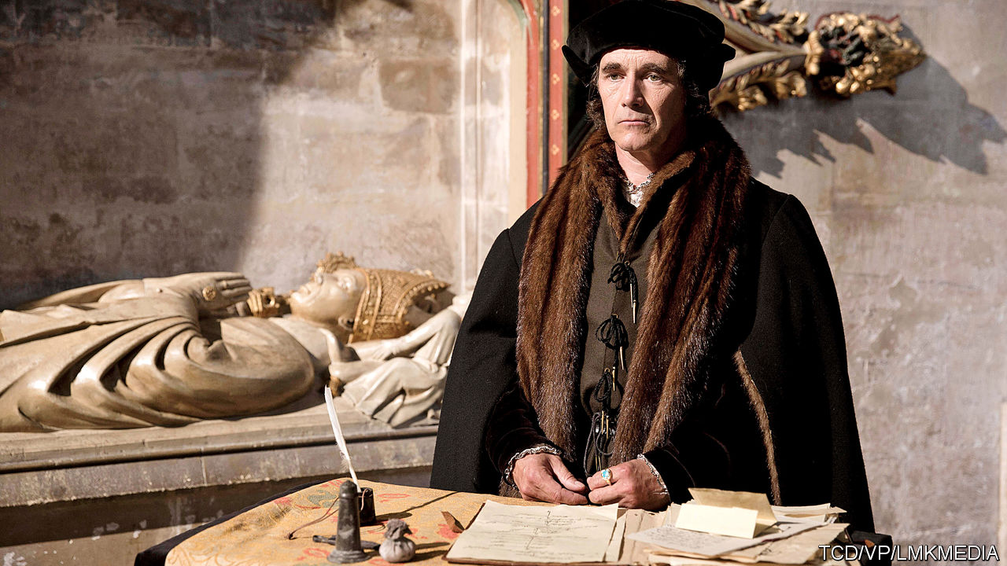

The Mirror & the Light. By Hilary Mantel. Henry Holt; 784 pages; $30. Fourth Estate; £25.

AFTER MORE than ten years, three books and 2,000 pages, as well as two stage plays and a television series (starring Mark Rylance, pictured above), Hilary Mantel’s monumental novelisation of the life of Thomas Cromwell, Henry VIII’s chief minister for much of the 1530s, has reached its conclusion. In hundreds of thousands of minds, he has firmly displaced his distant relative Oliver as the best-known Cromwell in British history.

At the opening of “The Mirror & the Light”, the final instalment in Ms Mantel’s trilogy, Cromwell has reached the apogee of his powers, having just witnessed the dispatch on the scaffold of his frenemy Anne Boleyn, the king’s second wife, along with a claque of hoity-toity courtiers who had disdained him as the jumped-up son of a blacksmith. The book ends with Cromwell himself kneeling before the axe. In between he labours unceasingly in the king’s service, brokers an ill-starred fourth marriage to Anne of Cleves, dissolves monasteries and sows discord between foreign adversaries, all the while trying to mollify Henry’s would-be successors, lest his head be first on a spike when the king dies.

The stunning success of the novels is in large part the result of Ms Mantel’s skill in fashioning a voice and persona that, while never anachronistic, make Cromwell seem eerily contemporary. But then, the politics of his rise and fall are liable to resonate in almost any era: if his rival, Sir Thomas More, was a man for all seasons, Cromwell is a character for the ages.

Had Ms Mantel been writing in the early 1950s, Cromwell’s career might have been seen primarily as a parable of freedom of conscience and Stalinist repression. More refuses to acknowledge the king’s supremacy over the Church of England, and is beheaded. Religious dissidents are flambéed at the stake. In “Bring Up the Bodies”, the second book in the series (published in 2012), Cromwell contorts his victims’ words to damn them like a remorseless secret-police interrogator. “Construction can be put on silence,” he tells one. “It will be.”

In the 1960s or 1970s his story might above all have seemed to be about meritocracy, a tale of the up-and-coming sort seizing control from a complacent noble caste. In the 21st century, it is both those things and more. Brexiteers have sought to draw parallels between their cause and Henry’s break from the papacy, which features in the novels. More fundamentally, Ms Mantel’s saga has chimed with modern neuroses about the nature of government.

Geoffrey Elton, one of the leading historians of Ms Mantel’s period, argued that Cromwell’s time in office marked the transition between the medieval model of government based in the king’s household, and a professional bureaucracy with its own institutional apparatus. The Cromwell of the novels straddles both arrangements. He suavely manages the monarch—“One must anticipate his desires,” he explains in “Bring Up the Bodies”—while attacking his awesome workload with Stakhanovite zeal. He personifies two related features of modern politics: the return of courts and courtiers, and a veneration of professionalism that is in part a response to those informal networks.

## The Tudor West Wing

Since the 1990s, in both Britain and America, the influence of advisers to prime ministers and presidents has expanded at the expense of cabinets, legislatures and civil servants. Bill Clinton entrusted his (failed) health-care reforms to his wife, and developed policy in all-day spitballs with his staff. The situation was fictionalised, even celebrated, in “The West Wing”, a television series that first aired in 1999 and revolved around the personal and political dilemmas of a glamorous, wisecracking coterie of presidential aides.

The Iraq war made such arrangements seem less congenial. The “sofa government” practised by Tony Blair was criticised by the subsequent Butler inquiry into pre-war intelligence. The public grew fascinated, and sometimes repelled, by the power of unelected figures such as Karl Rove and Alastair Campbell. The current administrations on both sides of the Atlantic have only made the 21st-century court more salient. President Donald Trump’s White House is a family affair; his impeachment was in part the result of cronies and freelancers bypassing formal channels. Dominic Cummings, Boris Johnson’s eminence grise, flaunts his informality on the sleeve of his hoodie.

Ms Mantel’s Cromwell is much more decorous than Mr Cummings. Over the course of “The Mirror & the Light” he becomes a baron and then an earl; always conscious of his humble roots, he is fastidious about being addressed correctly. But the basic conditions of his employment are those of the modern courtier. He serves at the pleasure of the ruler, albeit in an age when the ruler’s displeasure could be considerably more bruising than a golden handshake. Yet at the same time he is an avatar for a contrasting type that is now romanticised by many anxious voters: the diligent technocrat.

This counter-trend can be traced to the financial crisis, when central bankers came to the fore in stabilising the global economy—a period that coincided with the writing and publication of “Wolf Hall” (2009), the first novel in the trilogy. More recently, assiduous public servants such as James Mattis, Mr Trump’s former defence secretary, and Dominic Grieve, doomed leader of the anti-Brexit Conservatives, have been lionised across ideological divides for their moderating roles and attention to detail.

## He, Cromwell

In fact, much of the fictional Cromwell’s outlook chimes with that of defenders of the liberal order today. He is an internationalist who is comfortable in a number of languages; a believer in diplomacy rather than war, in sound finances and a proto-welfare state; a champion of rationality against the exploitative superstitions of the Catholic church. In the latest book—the longest of the three, bloated by somewhat belaboured dialogue in the first 300 pages—anger at his reforms sparks the Pilgrimage of Grace, an uprising that took place in the north of England in 1536. In Ms Mantel’s version of events, the rebels are nostalgic for an unchanging past of mythical fecundity, a sentiment that comes laden with the anti-metropolitan rhetoric of the Brexit campaign:

There was a former age, it seems, when wives were chaste and pedlars honest, when roses bloomed at Christmas and every pot bubbled with fat self-renewing capons. If these times were not those times, who is to blame? Londoners probably. Members of Parliament.

One of the author’s achievements is to show competence as a heroic virtue, and good administration to be as worthy of glory as feats of arms (across the trilogy, business meetings are by far the most common type of scene). Early in “Wolf Hall”, she affords Cromwell a blazon—a catalogue of flattering attributes of a sort that, in his own time, would have been used to extol a great beauty or flower of chivalry: “He is at home in courtroom or waterfront, bishop’s palace or inn yard. He can draft a contract, train a falcon, draw a map, stop a street fight, furnish a house and fix a jury…He works all hours, first up and last to bed.”

What marks Ms Mantel’s hero out—and makes his story something of a wish-fulfilment fantasy for modern readers who admire his ends if not his means—is his sheer effectiveness. Almost until the last, he gets things done, whether that is making or breaking royal marriages according to the king’s whim, or replenishing the country’s coffers by expropriating the assets of the church. Ms Mantel’s genius is to make his 16th-century instincts, such as a willingness to decapitate anyone standing in his path, seem as plausible as his more familiar qualities. A courtier, a bureaucrat and a politician, her Cromwell synthesises contrasting approaches to government nearly 500 years after his demise. No wonder he has found a place in the sun. ■

This article was downloaded by calibre from <https://www.economist.com/books-and-arts/2020/02/27/thomas-cromwell-special-adviser>

|  |  |  |  |
| --- | --- | --- | --- |
|  | Articles | Sections | Next |

|  |  |  |  |
| --- | --- | --- | --- |
| Previous | Articles | Sections | Next |

#### Out of shot

# Two exhibitions explore dark moments in Uganda’s past

Violence haunts the pictures of Idi Amin’s era and the Lord’s Resistance Army

Feb 29th 2020 | ARUA

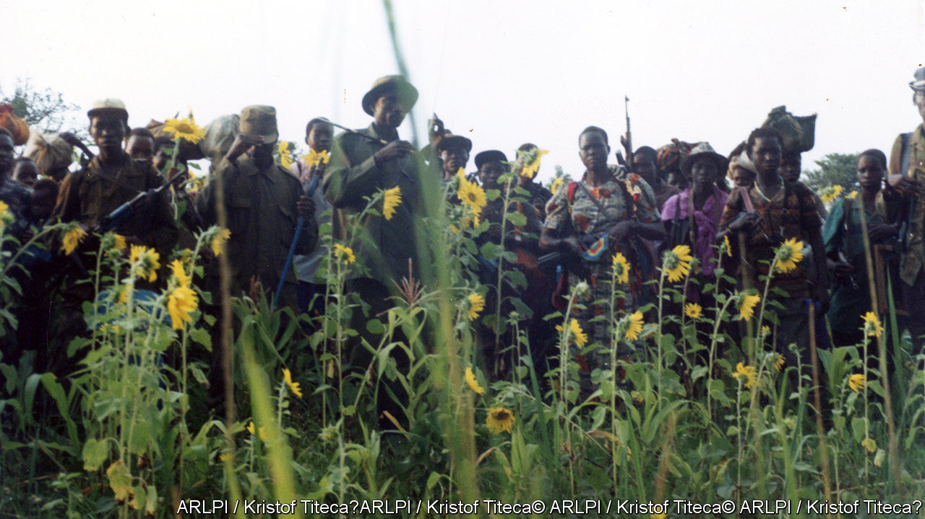

WHEN SARAH BANANUKA’S father and three of her brothers were killed, she was advised not to mourn. These were the early days of Idi Amin’s military dictatorship in the 1970s. Her father had been a local politician under the previous Ugandan regime; soldiers hunted him down like “a loose lion”, she says. To weep publicly would make her a target, too. “There was anarchy in the country,” she recalls.

Little of that terror is visible in “The Unseen Archive of Idi Amin”, a photographic exhibition mounted last year in the Uganda Museum in Kampala and now touring the country. The images, unearthed in an old filing cabinet at the state broadcaster, capture Amin as he hobnobs with dignitaries and dances with crowds. The sense of violence lurking just out of shot is shared in “Rebel Lives”, a very different exhibition recently on view in Antwerp and New York, which gathers pictures taken by members of the insurgent Lord’s Resistance Army (LRA). Both projects shed light on traumatic episodes in Ugandan history; both are haunted by what they do not show.

Photographing Amin was dangerous work. A caption could anger him, even if the image was innocuous. State photographers became “fearful, paranoid, nervous men”, write Derek Peterson of the University of Michigan and Richard Vokes of the University of Western Australia, two of the co-curators of the exhibition, in a forthcoming book. The risks intensified after 1976, when Israeli commandos stormed the national airport at Entebbe and rescued hostages from a hijacked plane. Pictures of the raid were reprinted in a South African magazine; the man who sold them was killed by Amin’s thugs. From then on, negatives were locked away. The cameras still followed him, like theatrical props, but few of the pictures were ever printed.

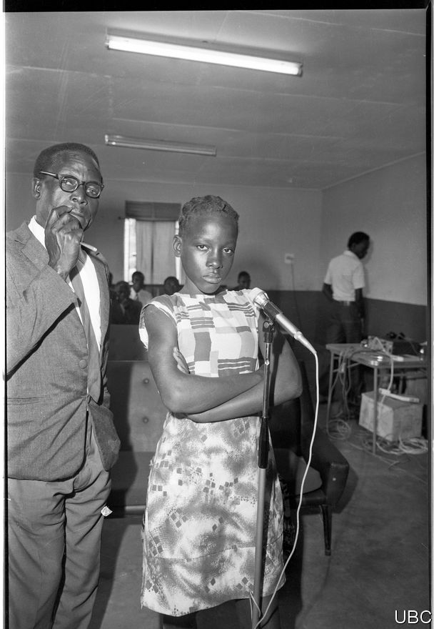

Amin’s victims

Unflattering photos were destroyed, as were most scenes of violence. So the curators give special prominence to images of the regime’s victims, seen in life rather than death. One poignant series captures a military tribunal established to prosecute “economic crimes” such as smuggling and overcharging. The suspects are by turns bewildered or resigned. A teenage girl scowls defiantly at the camera (see previous page). Many of those prosecuted were shot.

But what are viewers to make of the despot playing an accordion or dipping his toes in a lake? At a recent showing in West Nile, Amin’s home region, his son insisted that he had stamped out corruption and “gave Ugandans self-esteem”. Young people sometimes praise him as a leader who stood up to British colonisers and Asian tycoons. Ms Bananuka worries that his “dark side” is missing. “People are seeing Amin dancing,” she says, as though he were merely “a jolly man”.

## Snapshots from the bush

The pictures in “Rebel Lives” (such as the one above) are equally unsettling. They were taken by LRA fighters during its 20-year insurgency in northern Uganda (where peace returned in 2006, though remnants battle on elsewhere). Accounts of the rebellion tend to focus on its leader, Joseph Kony, and the many atrocities he oversaw, depicting the group as a bizarre cult. But the conflict was complex in its origins and intimate in its effects. Many rebels were abducted as children, making them both victims and perpetrators of violence. The photographs, collected by Kristof Titeca of the University of Antwerp, give a glimpse of the war from their perspective.

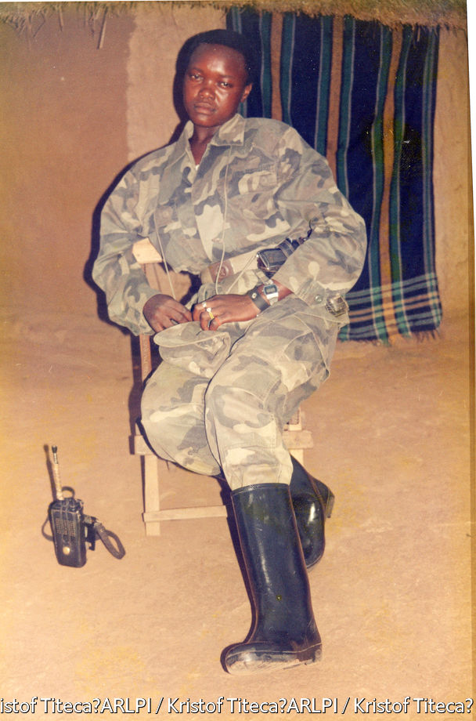

Many were taken by Okello Moses Rubangangeyo, who was kidnapped from school by the LRA and rose through its ranks before escaping. In the dry season, he says, the rebels would pitch camp and learn tactics by watching action movies—Rambo, Arnold Schwarzenegger, Chuck Norris. Some of the pictures are knowing pastiches of their heroes: camouflaged warriors with grenade-launchers and schoolboy eyes. The fighters would smuggle the film out to be developed, then drop the photos on the trail to scare pursuers.

But Mr Rubangangeyo also took pictures as mementoes, or “just to feel happy”, mimicking ordinary life in extreme circumstances. On special days, such as Christmas, the rebels would sling a sheet between two trees and pose in their bush studio, just as their families did at home. In the exhibition and an accompanying book, these visual souvenirs are presented alongside interviews with their subjects, who are now rebuilding their lives. Some have sat for new photos, taken by the Congolese photographer Georges Senga, which echo the pose and composition of the originals. Faces age and soften; old comrades give way to wives, husbands and children.

Mr Rubangangeyo smiles as he looks through these images; they are a chronicle of the only youth he ever had. Still, notes of coercion and loss run through the collection. In one picture, a woman stands stiffly next to a uniformed commander, his hand draped over her shoulder. Today she is seen in a banana garden, alone. “With the name they gave me, I won’t get another man,” she explains in a caption. “That name is: ‘She’s a rebel, she’s from the bush’.” As these exhibitions show, there are silences in history. But there is rarely an escape. ■

This article was downloaded by calibre from <https://www.economist.com/books-and-arts/2020/02/29/two-exhibitions-explore-dark-moments-in-ugandas-past>

|  |  |  |  |
| --- | --- | --- | --- |
| Previous | Articles | Sections | Next |

|  |  |  |  |
| --- | --- | --- | --- |
| Previous | Articles | Sections | Next |

#### Immortal words

# The tragic genius of Abraham Lincoln’s second inaugural

Edward Achorn’s rich history brings the inauguration of 1865 to life

Feb 29th 2020 |

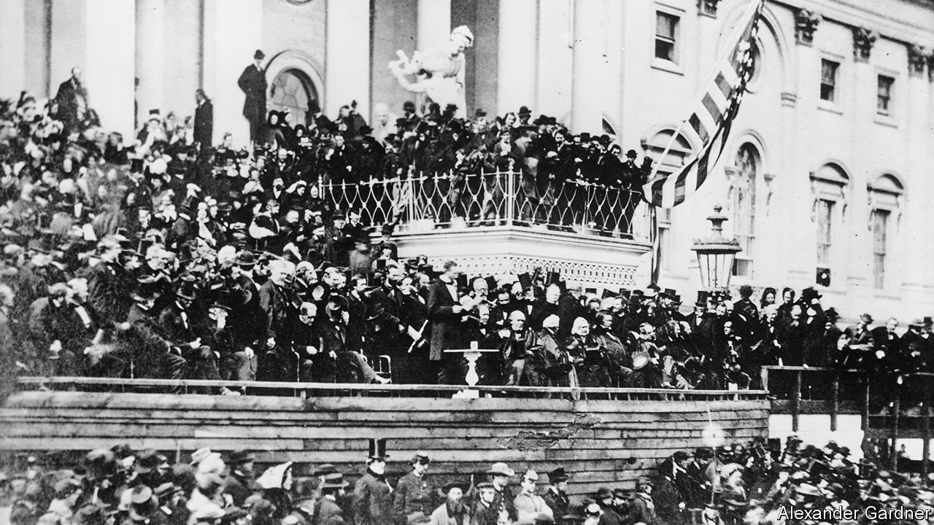

Every Drop of Blood. By Edward Achorn.Atlantic Monthly Press; 336 pages; $28.

A ROTATING PANEL of historians occasionally ranks America’s presidents. The leading contenders tend to be George Washington and Abraham Lincoln; Lincoln usually wins. The accolade is in part the result of his oratorical brilliance, notably the addresses at Gettysburg and at his second inauguration on March 4th 1865 (a month before Robert E. Lee’s surrender). Together, the two speeches constitute a grand aspirational statement about the meaning of the country’s bloodiest war.

Rhetoricians still marvel at Lincoln’s simplicity, authenticity and eloquence. Containing only 700 words (about as many as this review) and lasting under six minutes, the second inaugural was rooted not in utopian expectations of a seamless reunion with the Confederacy, but in the shadow of frightful slaughter on a thousand battlefields. Lincoln (pictured above: look closely) had aged decades in four years. But his faith in democracy and what was right, as he saw them, was firm. Sober and resolute as his nature inclined him, he also embodied what the times required.

By 1865 Lincoln had substituted rationalism and fatalism for the predestination theology of his Kentucky forebears at Little Pigeon Creek Baptist Church. But he still venerated the King James Bible and often quoted it at length. Sceptical about the God it depicted, he nonetheless believed that some power beyond human understanding controlled the destiny of nations. As Edward Achorn writes in “Every Drop of Blood”, though Lincoln was hardly an orthodox Christian, his second inaugural was “the most overtly religious” of any presidential speech to that date. He said America’s “original sin” of slavery required a righteous God to purge both those who wielded the whip and the politicians who permitted it. He noted that northerners and southerners read from the same Bible and prayed to the same God, and both invoked God’s judgment on their adversaries.

The awful presence he described came from Ezekiel and Jeremiah, not from stories of baby Jesus, meek and mild. But afterwards came divine healing:

With malice toward none, with charity to all; with firmness in the right as God gives us to see the right, let us strive on to finish the work we are in; to bind up the nation’s wounds…to do all which may achieve…a just and lasting peace…

As they listened, the African-Americans close enough to hear began murmuring, “Bless the Lord,” the chant growing louder until it erupted into shouts and weeping.

America’s partisan newspapers reviewed the address according to their biases. Lincoln’s opponents dismissed it as specious and naive. His allies seemed confused by the biblicism. Ironically, perhaps, the British press—especially the Times, the Saturday Review and the Spectator—applauded the president’s preference for reconciliation over triumphalism. Lincoln’s assassination 41 days later replaced his policy with a “reconstruction” anchored in revenge. Thus perished a president who, for many Americans, was an almost divine political presence; his magnanimous vision of the nation’s future died with him.

Lincoln’s last days have been the subject of more extensive hagiography than for any other president, so it is tempting to dismiss Mr Achorn’s book, which focuses on the inauguration, as redundant. That would be a mistake. Its strength lies less in the events themselves than in the elaborate detail and rich historical context that he musters. Spring thunderstorms turn the parade route into a muddy quagmire that swallows shoes and ruins dresses. John Wilkes Booth relies on the father of his teenage mistress, a New England senator, for VIP passes to both the inauguration and Ford’s Theatre, giving the murderer more than one chance to get to his victim. Washington’s hospitals overflow with wounded soldiers; prostitutes in its brothels serve the assassin, Confederate agents and federal officials without discrimination. Walt Whitman chronicles the era brilliantly. Freed slaves celebrate jubilantly.

As in some of the plays performed in Ford’s Theatre, minor roles sometimes eclipse major ones in this fascinating account. By the end, as well as mourning Lincoln’s fate, American readers might wish for another chance at politics without malice and with charity to all. ■

This article was downloaded by calibre from <https://www.economist.com/books-and-arts/2020/02/29/the-tragic-genius-of-abraham-lincolns-second-inaugural>

|  |  |  |  |
| --- | --- | --- | --- |
| Previous | Articles | Sections | Next |

|  |  |  |  |
| --- | --- | --- | --- |
| Previous | Articles | Sections | Next |

#### Johnson

# The advantages of speaking a second language

They are hard to measure. But it is a good idea anyway

Feb 29th 2020 |



JUST A FEW generations ago, speaking two languages was supposed to be bad for you. Tests in America found that bilingual people had lower IQs, which seemed evidence enough. Later it became clear that those surveys were really measuring the material poverty of immigrants; members of such families were more likely to be undernourished and understimulated, not to mention the obvious fact that they often sat the tests in a language that was not their best.

How things have changed. In the past decade it has become almost common knowledge that bilingualism is good for you—witness articles such “Why Bilinguals are Smarter” and “The Amazing Benefits of Being Bilingual” by the New York Times and the BBC. Stacks of research papers have suggested that two-tongued people enjoy a variety of non-linguistic advantages. Most notably, they have shown that bilinguals get dementia on average four years later than monolinguals, and that they have an edge in “executive control”—a basket of abilities that aid people doing complex tasks, including focusing attention, ignoring irrelevant information and updating working memory.

Why bilingualism would enhance these capabilities is unclear. Researchers hypothesise that having two languages means suppressing one when speaking the other, a kind of constant mental exercise that makes the brain healthier. This in particular is thought to be behind the finding of a later onset of dementia.

But as intellectual pendulums do, this one has begun to swing again, against the “bilingual advantage”. Though many papers have identified such a bonus, many more have tried and failed to replicate those studies. Roberto Filippi of University College London and his colleagues have spent five years testing more than 600 people, from seven to 80 years old and including some who oscillate between two languages. They could find no statistically significant advantage in any age cohort.

In response to the scepticism, researchers who believe in the advantage have refined their studies—now acknowledging that, beneath their common trait, bilingual people use their languages in varying ways that may account for the incongruent previous results. Does speaking two very distinct languages have a different effect from speaking two very similar ones? What about two dialects? Does speaking more than two provide any additional benefit? Does it matter if subjects live among people who speak their first language or their second?

A recent study by four researchers at the University of the Balearic Islands is a good example. They studied 112 bilinguals using three criteria: the age they acquired a second language; fluency in their two languages (most are not equally adept in both); and the frequency with which they switch between the two options. Frequency of switching, it turned out, was the variable that correlated best with improved executive control. Unlike Mr Filippi’s, other studies have hinted that frequent switching may be a good predictor of the bilingual advantage.

On balance, it seems that if the dividend is real, it is subtle and affected by many other factors. Though wealthy parents have been taken by the notional leg-up, hiring foreign nannies for their offspring and so on, it may be poorer individuals who get the biggest benefit. A study in Hyderabad, for instance, reproduced the finding of a four-year delay in the onset of dementia among bilinguals—except that the gap was six years for those test cases who were illiterate. If switching languages is healthy mental exercise, other highly skilled, cognitively demanding kinds of labour are likely to provide good work-outs, too. People who do other forms of mental multitasking all the time may not get such a big lift from bilingualism, if they get any at all.

The bottom line is that learning another language (or teaching a child one) sometimes confers an intellectual boost, though not always. But that has never been the main reason to do it. A second language expands the number of people you can talk to. It adds to the ways you can say things, and so offers a second point of view on the whole business of expression. Bilingualism may help you understand other people; one study found that bilingual children are better at grasping other perspectives, perhaps because they are always keeping track of who speaks what, a regular reminder that everyone is different. Finally, speaking a second language less well than your first supplies another kind of useful practice: it is a constant exercise in humility.

This article was downloaded by calibre from <https://www.economist.com/books-and-arts/2020/02/29/the-advantages-of-speaking-a-second-language>

|  |  |  |  |
| --- | --- | --- | --- |
| Previous | Articles | Sections | Next |

|  |  |  |
| --- | --- | --- |
| Books and arts | Sections | Obituary |

Graphic detail

Football and inequality: A game of two halves

.

|  |  |  |
| --- | --- | --- |
| Books and arts | Sections | Obituary |

|  |  |  |  |
| --- | --- | --- | --- |
|  | Articles | Sections | Next |

#### A game of two halves

# Globalisation has left lower-league football clubs behind

They are mostly based in Brexit-supporting towns

Feb 29th 2020 |

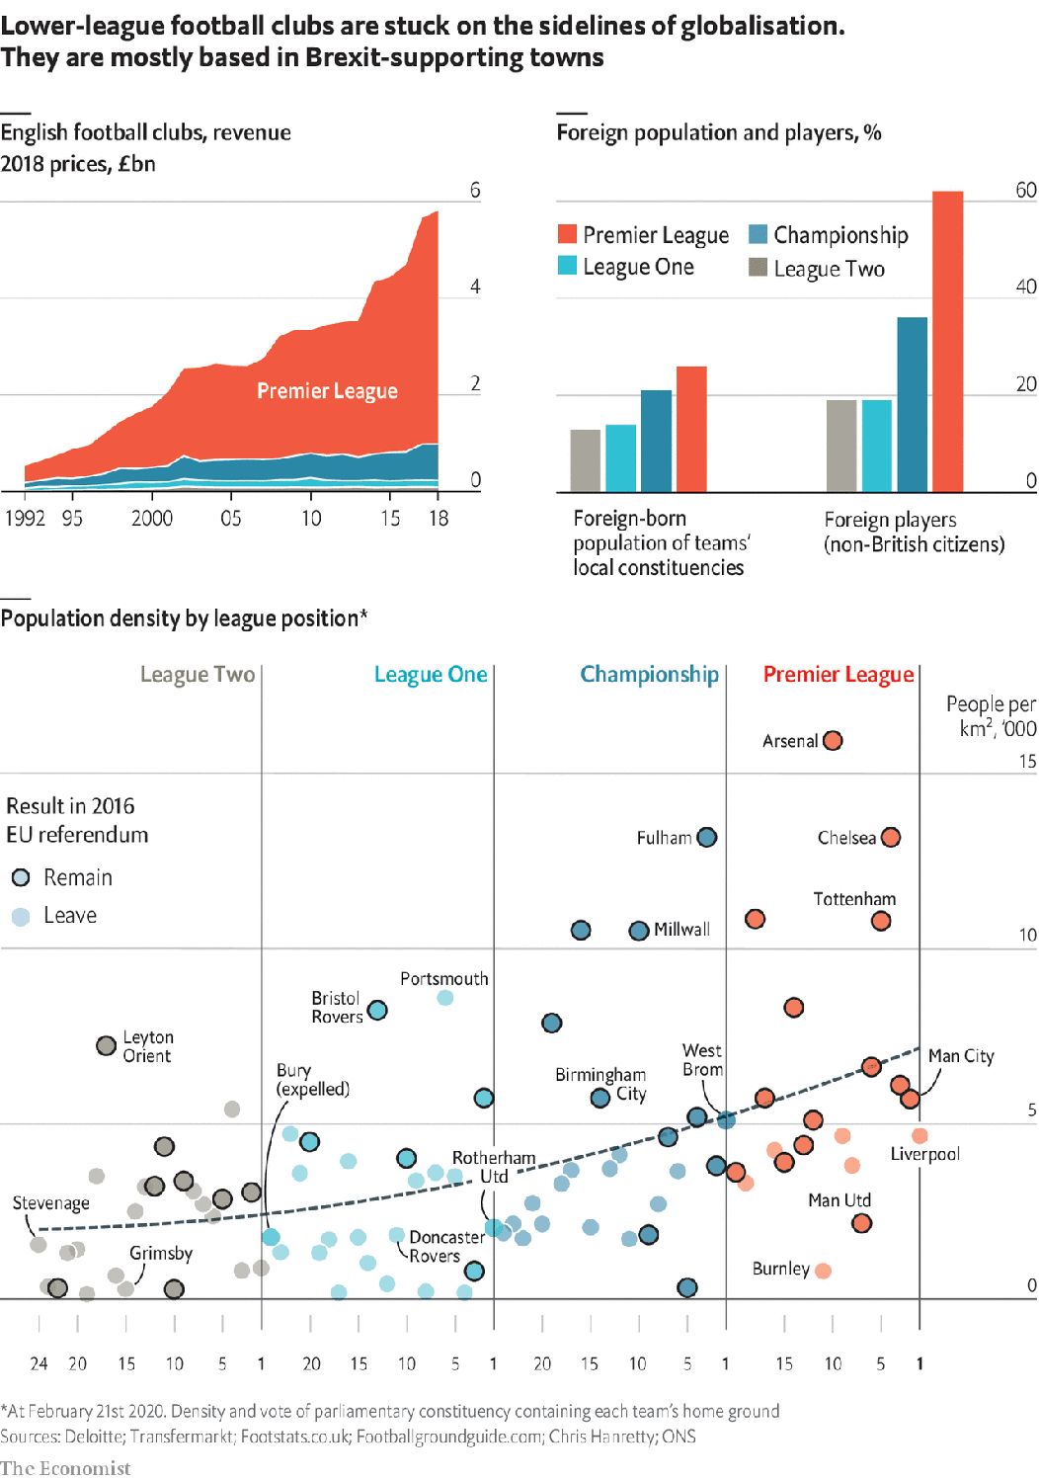

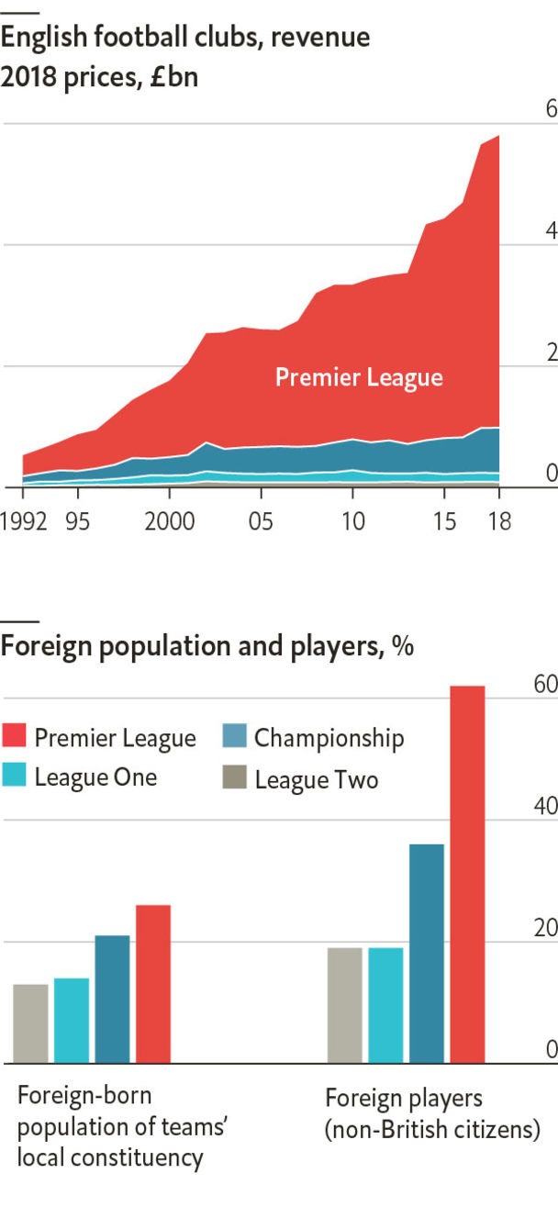

POPULISTS OFTEN decry a “rigged system”, where global “elites” break rules while everyone else falls behind. Their tale got a recent boost from an unlikely source.

On February 14th UEFA, which runs Europe’s continental football contests, said it would expel Manchester City from those events for the next two years. The club, largely owned by Emirati royalty, won the English Premier League (EPL) last year with a costly, star-laden squad. On paper, it complied with rules that ban teams from making big losses, by paying wages using revenue from Emirati corporate sponsors. But UEFA said those firms had improperly subsidised the club, by paying above the market rate. City says the deals were not inflated, and has appealed against the decision.

Meanwhile, English teams without access to foreign capital or accountants have fallen on hard times. Just north of Manchester is Bury, whose local club, Bury FC, was set to start this season in League One. (Confusingly, English football’s second, third and fourth divisions are known as the Championship, League One and League Two.) In August Bury was kicked out of professional football after it failed to service its debts. On February 21st fans entered a new club into the amateur tenth tier.

The diverging paths of Manchester City and Bury reflect a widening economic gap between the top of England’s football pyramid and its base. An investigation by the Times found that 52 of the 72 teams in the second, third and fourth divisions recorded a loss in their most recent accounts. According to Deloitte, a consultancy, in 1992-2018 the revenues of teams in Leagues One and Two grew only a quarter as quickly as those in the Premier League did.

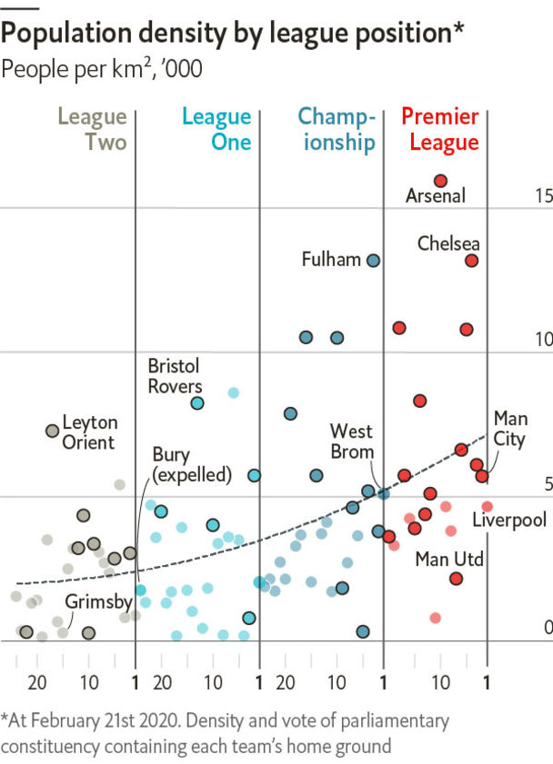

This separation owes in part to differences in regulation. Whereas UEFA’s financial rules have forced elite teams to be profitable, those for lower-ranked clubs are weaker. Many small teams have made big, unwise gambles trying to reach the top division, driving them into the red.

Immigration law has exacerbated the divide, because only stars who regularly represent their national teams can get work permits. That hinders lower-division sides in signing non-Europeans, and limits their appeal to foreign fans. When Grimsby plays Mansfield, audiences in Colombia, Nigeria and Japan have few of their own nationals to support.

Growing inequality in football has mirrored broader trends in British society. EPL teams sit in parliamentary constituencies more than twice as densely populated as those of Leagues One and Two. Economic output per person is 20% higher around such areas. The locals are younger and more likely to be immigrants. Predictably, these differences align with political preferences. In the EPL 70% of teams play in constituencies that voted to remain in the EU. For League Two, that figure is just 29%.

Fans of struggling teams have noted the parallel between their hometowns and football clubs that once served as a pillar of community. “The system...always lets people down at the bottom,” says Zoë Hitchen, a Bury supporter. “It never lets down the people at the top...You can’t split this from what’s happening in the UK at the moment. You can’t split it away from Brexit.” ■

Sources: Deloitte; Transfermarkt; Footstats.co.uk; Footballgroundguide.com; Chris Hanretty; ONS

This article was downloaded by calibre from <https://www.economist.com/graphic-detail/2020/02/29/globalisation-has-left-lower-league-football-clubs-behind>

|  |  |  |  |
| --- | --- | --- | --- |
|  | Articles | Sections | Next |

|  |  |  |
| --- | --- | --- |
| Graphic detail | Sections | Economic ... |

Obituary

Katherine Johnson: The girl who asked questions

.

|  |  |  |
| --- | --- | --- |
| Graphic detail | Sections | Economic ... |

|  |  |  |  |
| --- | --- | --- | --- |
|  | Articles | Sections | Next |

#### The girl who asked questions

# Katherine Johnson died on February 24th

The black mathematician who guided the first manned spaceflights and the first Moon landing was 101

Feb 29th 2020 |

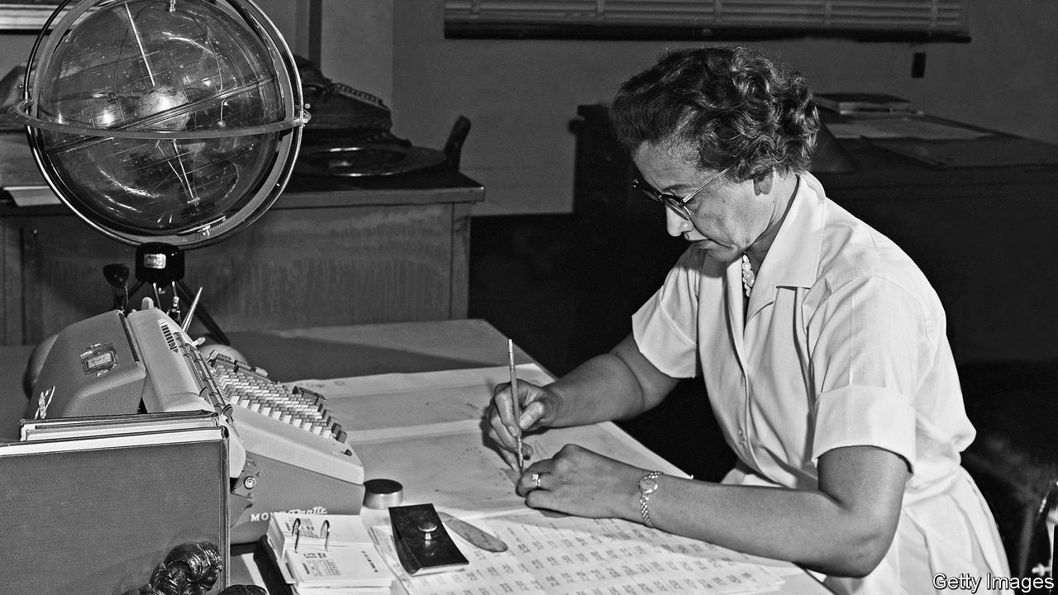

AS SHE RAN her eyes over the flight-test calculation sheets the engineer had given her, Katherine Goble (as she then was) could see there was something wrong with them. The engineer had made an error with a square root. And it was going to be tricky to tell him so. It was her first day on this assignment, when she and another girl had been picked out of the computing pool at the Langley aeronautical laboratory, later part of NASA, to help the all-male Flight Research Unit. But there were other, more significant snags than simply being new.

Most obviously, he was a man and she was a woman. In 1953 women did not question men. They stayed in their place, in this case usually the computing pool, tapping away on their Monroe desktop calculators or filling sheets with figures, she as neatly turned out as all the rest. Men were the grand designers, the engineers; the women were “computers in skirts”, who were handed a set of equations and exhaustively, diligently checked them. Men were not interested in things as small as that.

And, most difficult of all, she was Coloured, and he was White. The lab might be recruiting black mathematicians, but the door was not fully open; her pool was called “Coloured Computing”, and was segregated. As she sat down with the new team that morning, the men next to her had moved away. She was not sure why, but the world was like that, and she refused to be bothered by it. Since the café was segregated, she ate at her desk. There was no Coloured restroom, so she used the White one. A few years back, when the bus taking her to her first teaching job in Marion, Virginia, had crossed the state line from West Virginia, all the blacks had been told to get off and take taxis. She refused until she was asked nicely. But it could be unwise to push a white man too far.

Nonetheless, this engineer’s calculation was wrong. If she did not ask the question, an aircraft might not fly, or might fly and crash. So, very carefully, she asked it. Was it possible that he could have made a mistake? He did not admit it but, by turning the colour of a cough drop, he ceded the point.

She asked more such questions, and they got her noticed. As the weeks passed, the men “forgot” to return her to the pool. Her incessant “Why?” and “How?” made their work sharper. It also challenged them. Why were their calculations of aerodynamic forces so often out? Because they were maths graduates who had forgotten their geometry, whereas she had not; her high-school brilliance at maths had led to special classes on analytic geometry in which she, at 13, had been the only pupil. Why was she not allowed to get her name on a flight-trajectory report when she had done most of the work, filling her data sheets with figures for days? Because women didn’t. That was no answer, so she got her name on the report, the first woman to be so credited. Why was she not allowed into the engineers’ lectures on orbital mechanics and rocket propulsion? Because “the girls don’t go”. Why? Did she not read Aviation Week, like them? She soon became the first woman there.

As NASA’s focus turned from supersonic flight to flights in space, she was therefore deeply involved, though still behind the scenes. This excited her, because if her first love was mathematics—counting everything as a child, from plates to silverware to the number of steps to the church—her second was astronomy, and the uncountable stars. A celestial globe now joined the calculator on her desk. She had to plot the trajectories of spacecraft, developing the launch window and making sure—as soon as humans took off—that the module could get back safely. This involved dozens of equations to calculate, at each moment, which bit of Earth the spacecraft was passing over, making allowances for the tilt of the craft and the rotation of the planet. She ensured that Alan Shepard’s Mercury capsule splashed down where it could be found quickly in 1961, and that John Glenn in 1962 could return safely from his first orbits of the Earth. Indeed, until “the girl”, as he called her (she was 43), had checked the figures by hand against those of the newfangled electronic computer, he refused to go.

That checking took her a day and a half. Later she calculated the timings for the first Moon landing (with the astronauts’ return), and worked on the Space Shuttle. She also devised a method by which astronauts, with one star observation checked against a star chart, could tell where they were. But in the galaxy of space-programme heroes, despite her 33 years in the Flight Research Unit, for a long time she featured nowhere.

It did not trouble her. First, she also had other things to do: raise her three daughters, cook, sew their clothes, care for her sick first husband. Second, she knew in her own mind how good she was—as good as anybody. She could hardly be unaware of it, when she had graduated from high school at 14 and college at 18, expert at all the maths anyone knew how to teach her. But she typically credited the help of other people, especially her father, the smartest man she knew, a farmer and a logger, who could look at any tree and tell how many board-feet he could get out of it; and who had sold the farm and moved the family so that she and her siblings could all get a fine schooling and go to college. And last, at NASA, she had not worked alone. She had been one of around a dozen black women mathematicians who were equally unknown. But when their story emerged in the 21st century, most notably in a book and a film called “Hidden Figures”, she had a NASA building named after her, a shower of honorary doctorates and—the greatest thrill—a kiss from Barack Obama as he presented her, at 96, with the Presidential Medal of Freedom.

This attention was all the more surprising because, for her, the work had been its own reward. She just did her job, enjoying every minute. The struggles of being both black and a woman were shrugged away. Do your best, she always said. Love what you do. Be constantly curious. And learn that it is not dumb to ask a question; it is dumb not to ask it. Not least, because it might lead to the small but significant victory of making a self-proclaimed superior realise he can make a mistake. ■

This article was downloaded by calibre from <https://www.economist.com/obituary/2020/02/29/katherine-johnson-died-on-february-24th>

|  |  |  |  |
| --- | --- | --- | --- |
|  | Articles | Sections | Next |

|  |  |  |
| --- | --- | --- |
| Obituary | Sections |  |

Economic Indicators

Economic data, commodities and markets

.

|  |  |  |
| --- | --- | --- |
| Obituary | Sections |  |

|  |  |  |  |
| --- | --- | --- | --- |
|  | Articles | Sections | Next |

# Economic data, commodities and markets

Feb 29th 2020 |

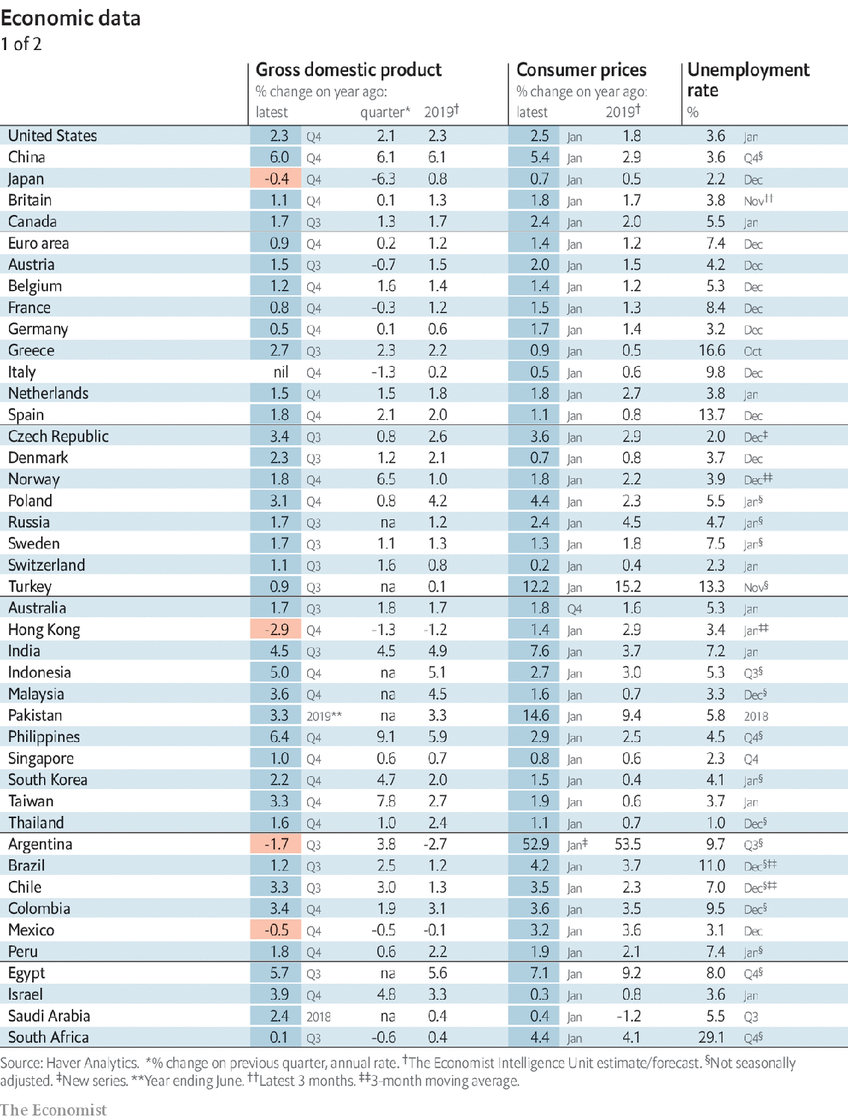

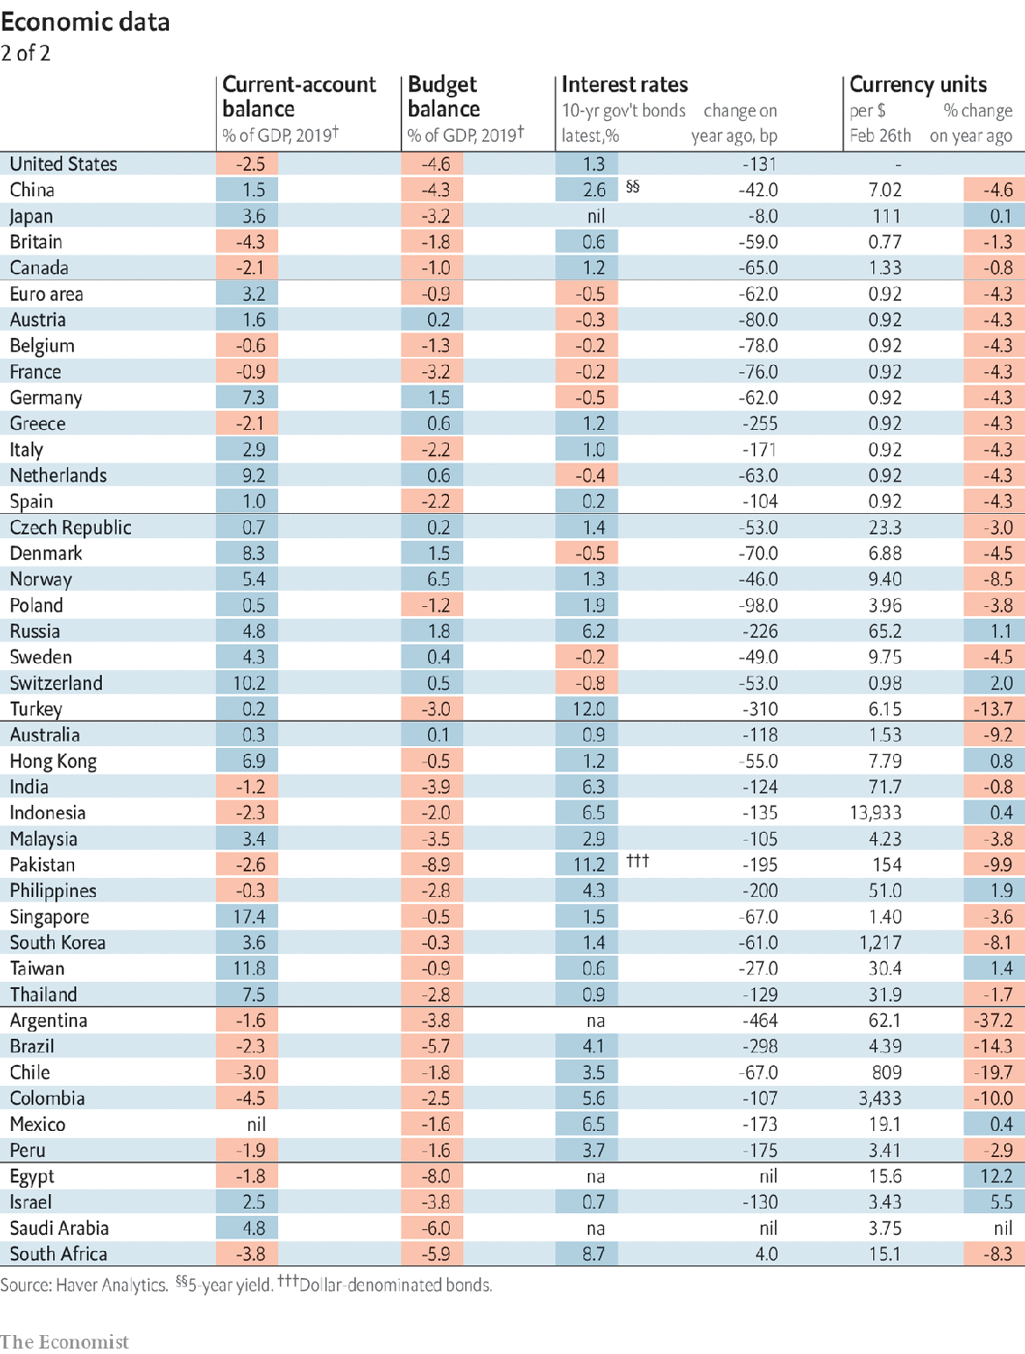

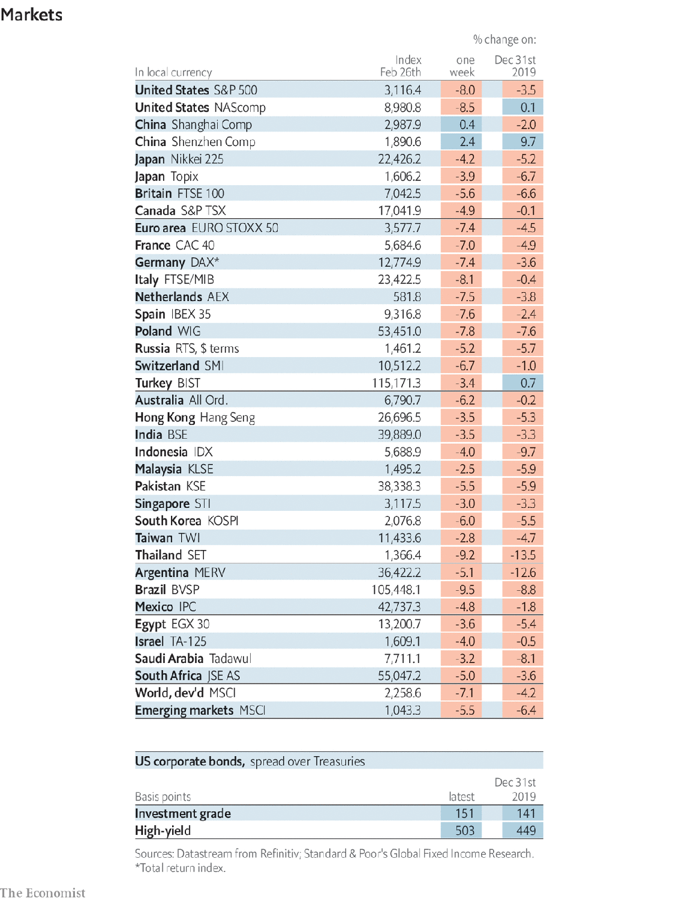

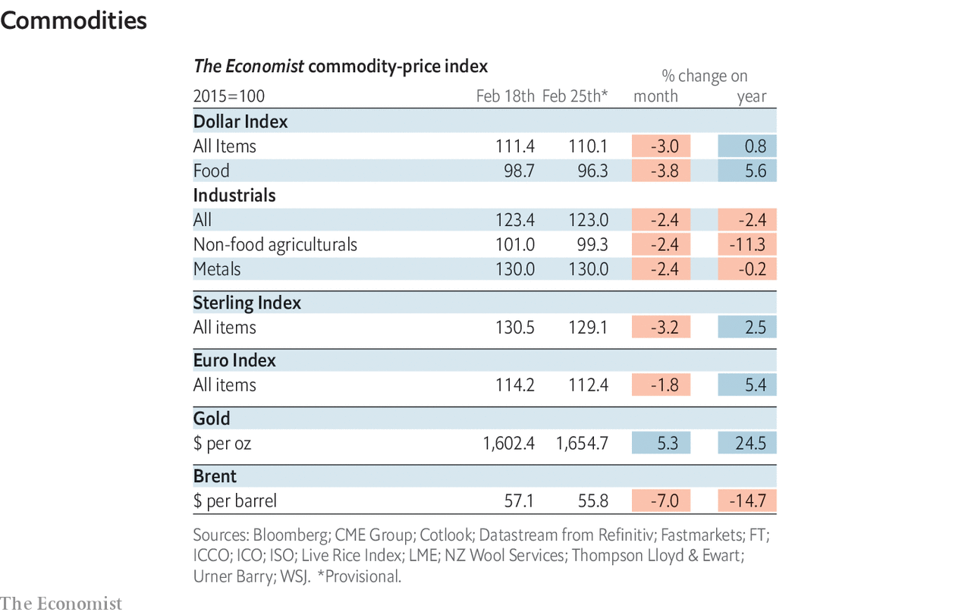

This article was downloaded by calibre from <https://www.economist.com/economic-indicators/2020/02/29/economic-data-commodities-and-markets>

|  |  |  |  |
| --- | --- | --- | --- |
|  | Articles | Sections | Next |